Saturday & Sunday,
May 16 & 17 2026
Ascension of Our Lord
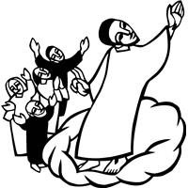
Christ Lutheran Church
“A Place Where You are Always Welcome”
Services: Saturday 5:30 pm and Sunday 10:00 am
Sunday School: 9:00 am (September- May)
600 North Main Street, Stockton, IL 61085 Office: 815-947-2033
Email: christlutheranchurch70@gmail.com http://www.christlutheranstockton.com
Ministers: ALL members of the congregation
Pastor: Rev. Chrissy Salser chrissytherev@att.net 815-988-9450
From Sundays and Seasons.com. Copyright 2017 Augsburg Fortress. All rights reserved. Reprinted by permission under Augsburg Fortress Liturgies Annual License #40643.New Revised Standard Version Bible, copyright 1989, Division of Christian Education of the National Council of the Churches of Christ in the United States of America. Used by permission. All rights reserved.
WELCOME: Thank you for joining us for worship today. We are glad you are with us. Communion will be served in the aisle or in your pew. All are welcome to share this meal. Jesus is our host and invites everyone. Those who would like to come forward, bread and wine will also be available in the front. When directed by the usher, come forward down the center aisle, Pr Chrissy will give you bread (she will be masked and wearing cloves) and then you will take a cup of wine (grape juice) from the tray. After taking communion, you will return to your seat by the side aisle. For those who are unable to come forward, communion elements can be found as you entered worship. At that part of the service, you are invited to take the bread and wine (or grape juice) when Pr. Chrissy leads. On Saturday’s offering is collected as you enter or leave worship. On Sunday we will pass the plate as a response to God’s grace. Online giving is available. Please see QR code on back of bulletin or visit our website.

Introduction: In today’s readings the risen Christ ascends into heaven and his followers are assured that the Spirit will empower them to be witnesses throughout the earth. The disciples were told to not gaze up into heaven to look for Jesus (Acts 1:11); we find his presence among us as we proclaim the word and share the Easter feast. We too long for the Spirit to enliven our faith and invigorate our mission.
Gathering: The Holy Spirit calls us together as the people of God.
PRELUDE
WELCOME AND ANNOUNCEMENTS
THANKSGIVING FOR BAPTISM
P: People of God, in the baptismal waters we travel with Christ from death to life. Our past, our sin, our failure, our doubt, and our shame are drowned and gone here. C: You, O God, wash us clean
P: Our fear, our confusion, our self-righteousness, our despair—ALL are washed away by grace. C: You, O God, wash us clean.
P: Our pride, our hypocrisy, and other people’s opinions of us no longer have the power to define us. C: You, O God, give us new life.
P: The Spirit lives and moves through us now, a great and joyful mystery, so we may bring love and mercy into the world as the body of Christ.
C: You, O God, give us new life.
P: Rejoice that God has claimed us in this baptismal grace, not by our own doing or believing but by God’s mercy alone.
C: You, O God, give us new life.
P: And so, as we worship, we give thanks to God for the gracious gift of baptism that joins us together in Christ by the Spirit’s power.
C: Amen
GATHERING HYMN A Hymn of Glory Let Us Sing! ELW 393
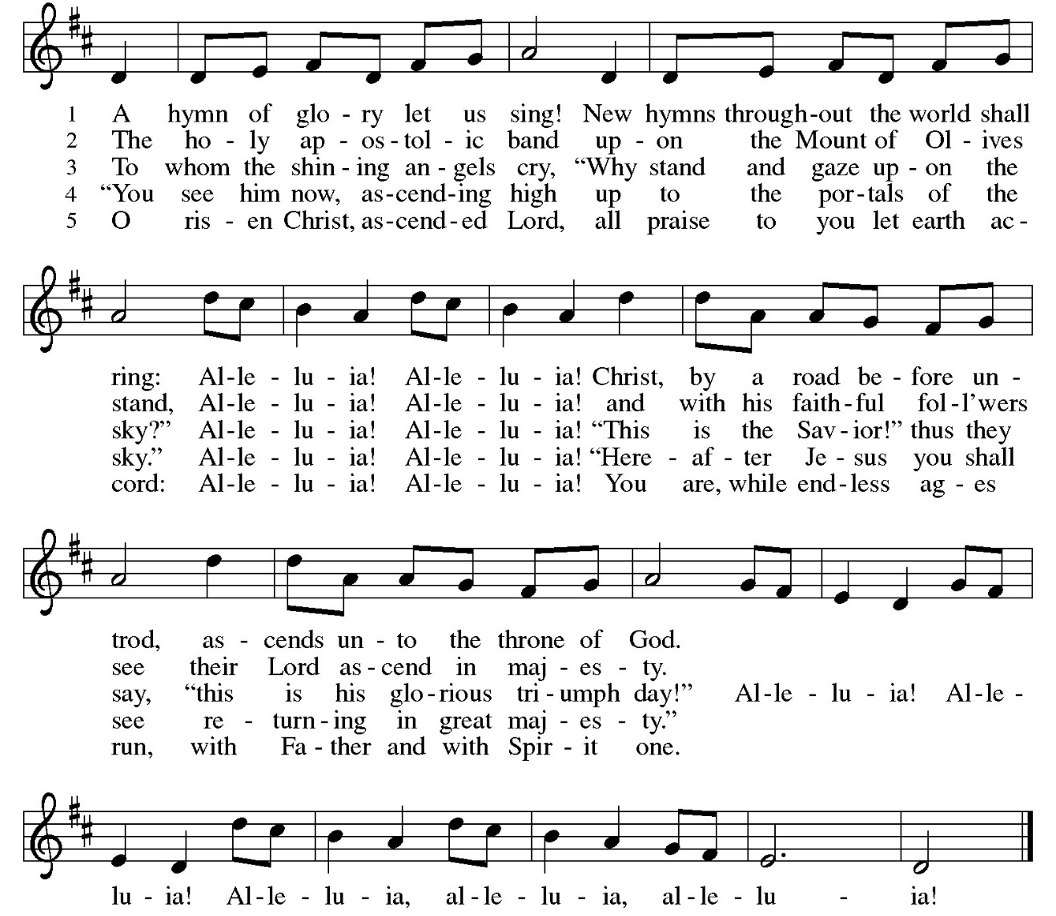

GREETING:
P: The Grace of our Lord Jesus Christ, the love of God and the communion of the Holy Spirit be with you all.
C: And also with you
PRAYER OF THE DAY:
P: Almighty God, C: your only Son was taken into the heavens and in your presence intercedes for us. Receive us and our prayers for all the world, and in the end bring everything into your glory, through Jesus Christ, our Sovereign and Lord, who lives and reigns with you and the Holy Spirit, one God, now and forever. Amen.
Word: God speaks to us in scripture reading, preaching, and song.

First Reading: Acts 1: 1-11
Before he is lifted into heaven, Jesus promises that the missionary work of the disciples will spread out from Jerusalem to all the world. His words provide an outline of the book of Acts.
[Luke writes:] ¹ In the first book, Theophilus, I wrote about all that Jesus began to do and teach ² until the day when he was taken up to heaven, after giving instructions through the Holy Spirit to the apostles whom he had chosen. ³ After his suffering he presented himself alive to them by many convincing proofs, appearing to them during forty days and speaking about the kingdom of God. ⁴ While staying with them, he ordered them not to leave Jerusalem but to wait there for the promise of the Father. “This,” he said, “is what you have heard from me; ⁵ for John baptized with water, but you will be baptized with the Holy Spirit not many days from now.” ⁶ So when they had come together, they asked him, “Lord, is this the time when you will restore the kingdom to Israel?” ⁷ He replied, “It is not for you to know the times or periods that the Father has set by his own authority. ⁸ But you will receive power when the Holy Spirit has come upon you, and you will be my witnesses in Jerusalem, in all Judea and Samaria, and to the ends of the earth.”
⁹ When he had said this, as they were watching, he was lifted up, and a cloud took him out of their sight. ¹⁰ While he was going and they were gazing up toward heaven, suddenly two men in white robes stood by them. ¹¹ They said, “Men of Galilee, why do you stand looking up toward heaven? This Jesus, who has been taken up from you into heaven, will come in the same way as you saw him go into heaven.”
R: The Word of the Lord. C: Thanks be to God.

Psalm: Psalm 47
God has gone up with a shout. (Ps. 47:5)
¹ Clap your hands, all you peoples; shout to God with a joyful sound.
² For the Lord Most High is to be feared: a great king over all the earth,
³ who subdues the peoples under us, and the nations under our feet;
⁴ who chooses our inheritance for us, the pride of Jacob, whom God loves.
⁵ God has gone up with a shout, the Lord with the sound of the ram’s horn.
⁶ Sing praises to God, sing praises; sing praises to our king, sing praises.
⁷ For God is king of all the earth; sing praises with a song.
⁸ God reigns over the nations; God is enthroned on high.
⁹ The nobles of the peoples have gathered as the people of the God of Abraham. The rulers of the earth belong to God, who is highly exalted.
Second Reading: Ephesians 1:15-23
The risen and exalted Christ reigns over the entire universe. The author of Ephesians prays that we are given the wisdom to know the power of the risen Christ and the empowering hope that the knowledge of this inheritance provides.
¹⁵ I have heard of your faith in the Lord Jesus and your love toward all the saints, and for this reason ¹⁶ I do not cease to give thanks for you as I remember you in my prayers, ¹⁷ that the God of our Lord Jesus Christ, the Father of glory, may give you a spirit of wisdom and revelation as you come to know him, ¹⁸ so that, with the eyes of your heart enlightened, you may perceive what is the hope to which he has called you, what are the riches of his glorious inheritance among the saints, ¹⁹ and what is the immeasurable greatness of his power for us who believe, according to the working of his great power. ²⁰ God put this power to work in Christ when he raised him from the dead and seated him at his right hand in the heavenly places, ²¹ far above all rule and authority and power and dominion and above every name that is named, not only in this age but also in the age to come. ²² And he has put all things under his feet and has made him the head over all things for the church, ²³ which is his body, the fullness of him who fills all in all. R: The Word of the Lord. C: Thanks be to God.
CHILDREN’S MESSAGE
GOSPEL ACCLAMATION Thine is the Glory ELW 376
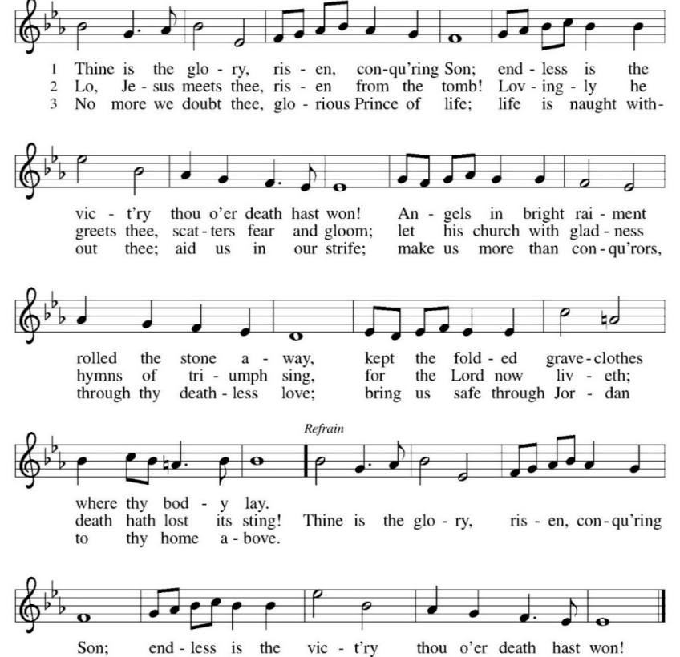
Gospel: Luke 24: 44-53

P: The Gospel according to Luke C: Glory to you, O Lord.
On the day of his ascension, Jesus leaves his disciples with a commission, a blessing, and a promise of the Holy Spirit.
⁴⁴ [Jesus said to the eleven and those with them,] “These are my words that I spoke to you while I was still with you—that everything written about me in the law of Moses, the prophets, and the psalms must be fulfilled.”⁴⁵ Then he opened their minds to understand the scriptures, ⁴⁶ and he said to them, “Thus it is written, that the Messiah is to suffer and to rise from the dead on the third day ⁴⁷ and that repentance and forgiveness of sins is to be proclaimed in his name to all nations, beginning from Jerusalem. ⁴⁸ You are witnesses of these things. ⁴⁹ And see, I am sending upon you what my Father promised, so stay here in the city until you have been clothed with power from on high.”
⁵⁰ Then he led them out as far as Bethany, and, lifting up his hands, he blessed them. ⁵¹ While he was blessing them, he withdrew from them and was carried up into heaven. ⁵² And they worshiped him and returned to Jerusalem with great joy, ⁵³ and they were continually in the temple blessing God.
P: The Gospel of Our Lord. C. Praise to you, O Christ.
MESSAGE
HYMN OF THE DAY Lord, You Give Great Commission ELW 579

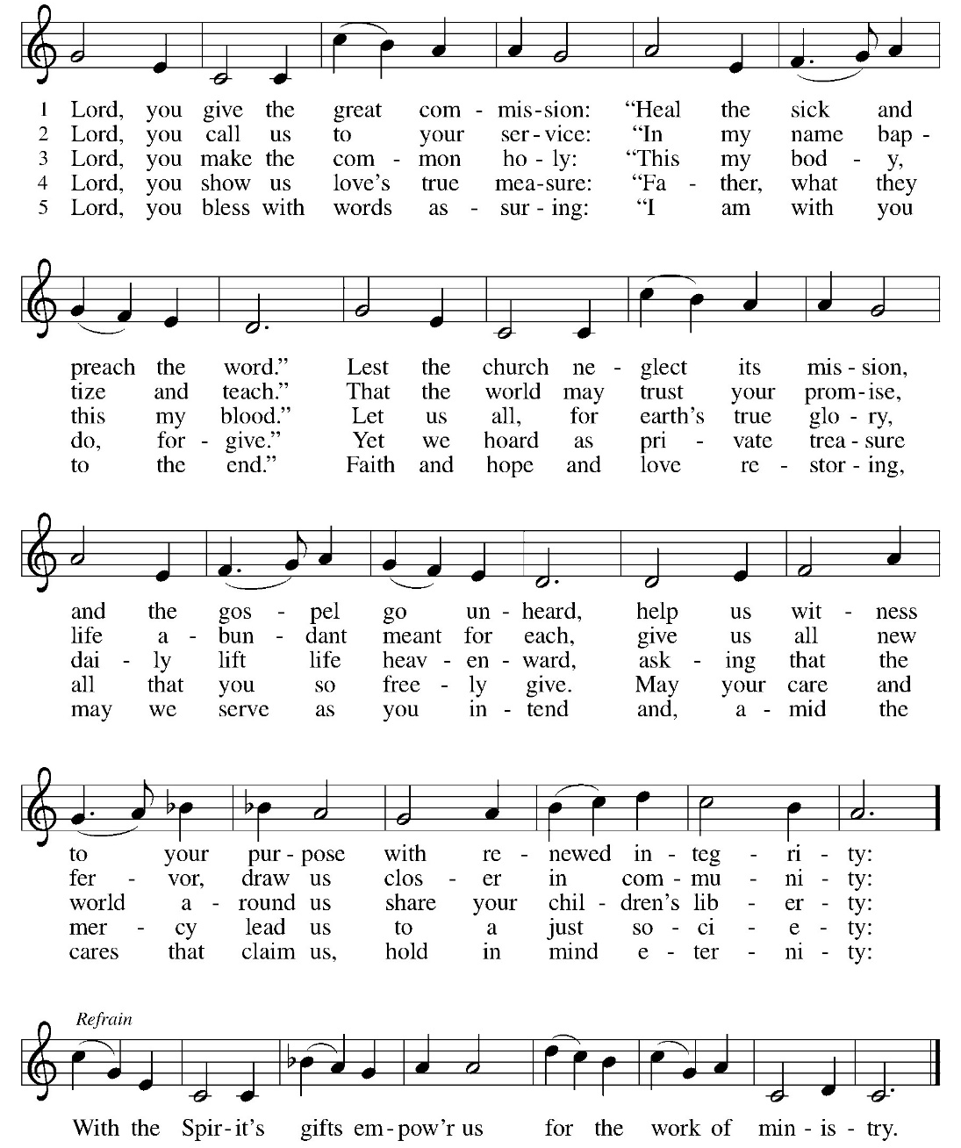

APOSTLES’ CREED:
I believe in God, the Father almighty, creator of heaven and earth.
I believe in Jesus Christ, God’s only Son, our Lord, who was conceived by the Holy Spirit, born of the virgin Mary, suffered under Pontius Pilate, was crucified, died, and was buried; he descended to the dead. On the third day he rose again; he ascended into heaven, he is seated at the right hand of the Father, and he will come to judge the living and the dead.
I believe in the Holy Spirit, the holy catholic church, the communion of saints, the forgiveness of sins, the resurrection of the body, and the life everlasting. Amen
PRAYERS OF INTERCESSION:
P: Merciful God, C: Receive our prayer.
PEACE
P: The peace of Christ be with you always.
C. And also, with you.
OFFERING: Our offering is a significant act of worship; we worship God through our giving. The ministry of this congregation is completely dependent upon your partnership and generosity. Offering is collected as you enter worship on Saturday. We will pass the offering plate on Sundays. Online giving is available.
OFFERING HYMN: You Are My ALL in ALL
- You are my strength when I am weak; You are the treasure that I seek. You are my all in all.
Seeking you as a precious jewel: Lord, to give up, I’d be a fool.
You are my all in all . Refrain

Refrain:
Jesus, Lamb of God. Worthy is Your name.
Jesus, Lamb of God. Worthy is Your name.

- Taking my sin, my cross my shame: Rising again I bless Your name. You are my all in all.
When I fall down, You pick me up; When I am dry you fill my cup.
You are my all in all. Refrain

Refrain:
Jesus, Lamb of God. Worthy is Your name.
Jesus, Lamb of God. Worthy is Your name.
OFFERING PRAYER:
P: Merciful God, C: accept the fruits of our labor, gathered to give you glory. You have set a table before us, a glimpse of that great dawhen we will hunger and thirst no more. Nourish us with the body and blood of Jesus, that goodness and mercy may follow us and bless the world you love. In the name of Jesus, Amen.
COMMUNION LITURGY:
In the night in which he was betrayed, our Lord Jesus took bread, and gave thanks, broke it and gave it to his disciples, saying: take and eat; this is my body, given for you. Do this for the remembrance of me. Again, after supper, he took the cup, gave thanks and gave it for all the drink, saying: this cup is the new covenant in my blood, shed for you and for all people for the forgiveness of sin. Do this for the remembrance of me.
THE LORD’S PRAYER:
Our Father, who art in heaven, hallowed be thy name, thy kingdom come, thy will be done on earth as it is in heaven. Give us this day our daily bread; and forgive us our trespasses, as we forgive those who trespass against us; and lead us not into temptation but deliver us from evil. For thine is the kingdom, and power, and the glory, forever and ever. Amen

INVITATION TO COMMUNION:
P: Come to the table of new life. Receive the risen Lord.
.Please come down the center aisle, take the bread, then receive a cup (wine is dark, juice is light, return to your seats via side aisle.) Those who prefer to take communion in your pews, we will take all together after all are served.
DISTRIBUTION OF COMMUNION:
P: This is the body of Christ given for you. (All take bread).
P: This is the blood of Christ shed for you. (All take the wine).
COMMUNION HYMN: Now All the Vault of Heaven Resounds ELW 367 (P12)

TABLE BLESSING:
P: May the body and blood of our Lord Jesus Christ strengthen you and keep you in God’s grace. C: Amen.
PRAYER AFTER COMMUNION:
P: Holy One, C: through this meal you have made your home among us
and are making all things new. Send us now to speak peace to anxious hearts, to love our enemies, and to bring your healing to the nations.
In the name of Jesus, Amen.

SENDING: God blesses us and sends us in mission to the world.
BLESSING:
P: God Almighty, who is the beginning and the end, Jesus Christ, the firstborn of the dead, and the Spirit, our advocate and peace,
☩ bless you now and forever.
Amen.

SENDING HYMN Crown Him with Many Crowns ELW 855 (P 13)

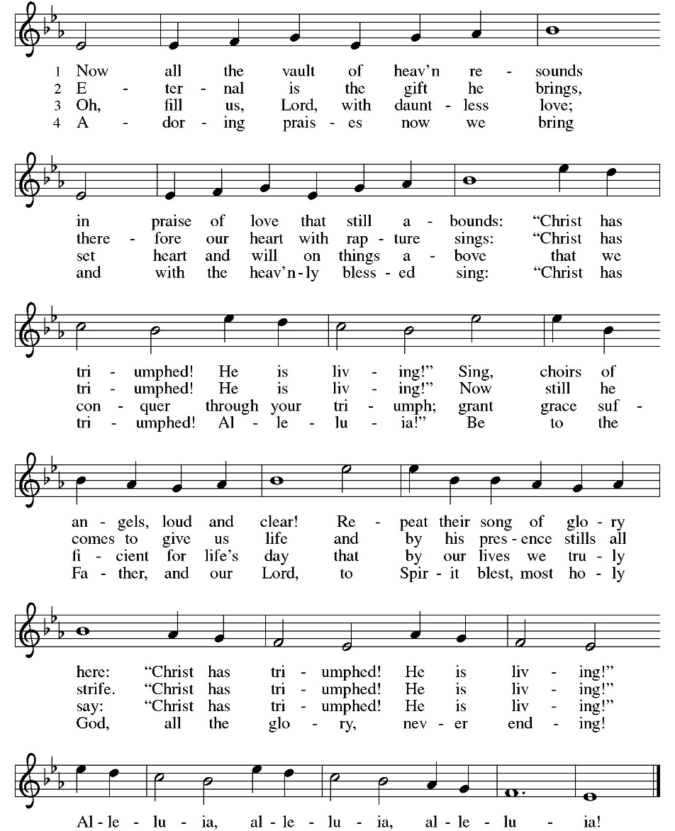

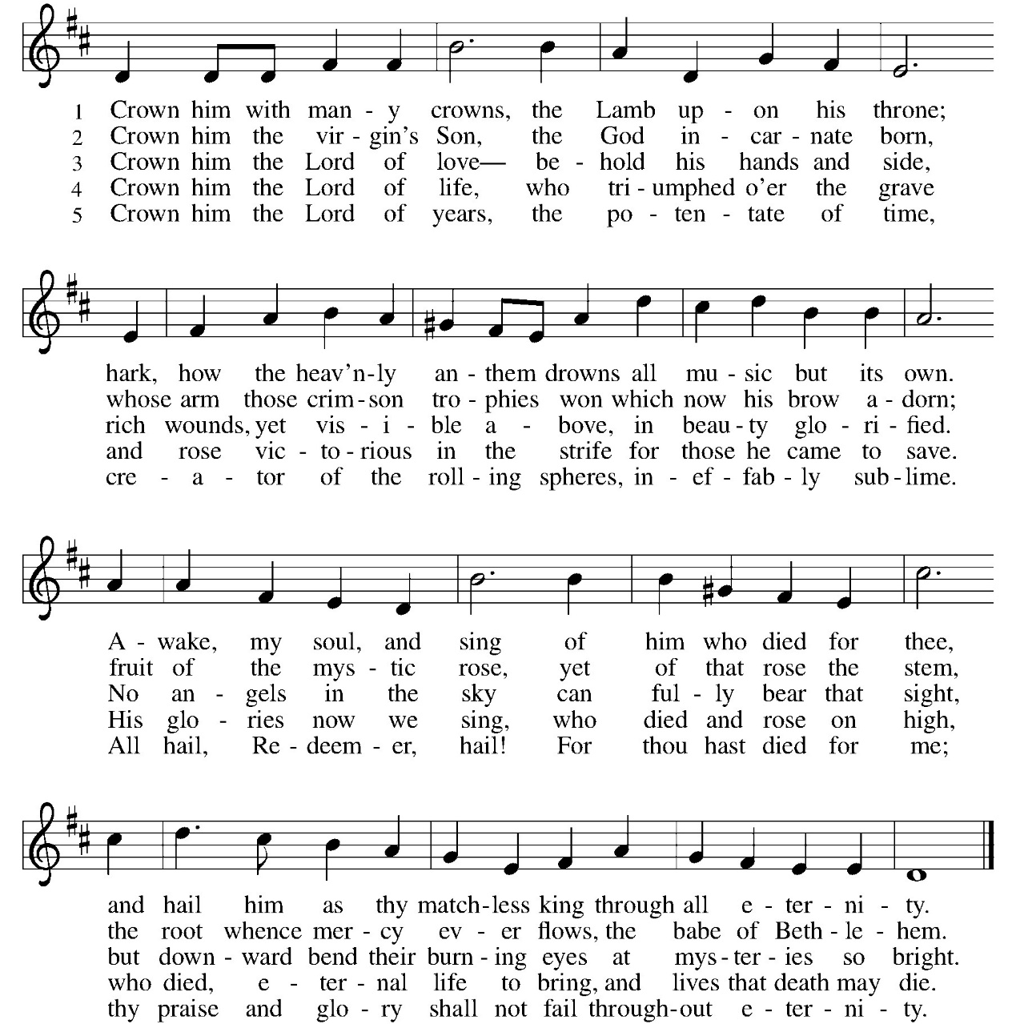
DISMISSAL:
P: Go in peace. Praise the Lord. Alleluia!
C: Thanks be to God. Alleluia!
POSTLUDE

ONLINE GIVING: Your gift has a big impact on our ministries and those we serve. Scan this code or visit our website to give online today
IN OUR PRAYERS TODAY: Teresa Hesselbacher, Elaine Schlicting, Darlene and Walt Steffes, Bob Schreck, Delores Wampfler, Marge and Gerald Arnold, Don & Judy Brudi, Pat Lawfer, Nancy Dittmar, Karen Dick, Angie Broshous, Grayson Raab, Mary Lou Bunker, Lillian Sefford, Cindy Kerchner, Jeanie Taggart, Jody Dascher, Don Kunz, Johnny Blair, Jim Sullivan, John Becker, Cheri Broge, Terry Calhoun, Jesse Tipton, Pastor Lee Leubke (St. Joseph, Freeport), family and friends of Larry Hubb, To add someone to the prayer list please contact Pastor Chrissy
Anderson House Birthdays: Christine May 22, Robert May 22, Becky May 29. Please mail cards or drop off at Anderson House 200 E King Ave. Stockton, IL 61085 or drop off in basket in the back of the church
CELEBRATING BIRTHDAYS / ANNIVERSARIES: Leisa Hubb, Anne Harmston, Daxton Drake, Chris Marek, Susan Leitzen, Tanner Tesmer, Jason Hermann, Tom and Lorie Wright
April Totals: As a way to improve communication around finances, we are sharing following information: *these numbers reflect online giving contribution
2026
 | April | Year to date
Offerings: | $7,818 | $38,645
Expenses: | $12,041 | $45,454
Overall Gain / Loss | ($4,223) | ($6,809)

Thanks be to God for your gifts for the ministry of  Christ Lutheran Church *these numbers do not reflect online giving- only offering in worship |  |  |  | Attendance
Current Expense | $1,292.00 | Building Fund | $10.00 | May 9  May 10 | 12  45
Benevolence  Sunday School  LSSI | $10.00  $20.00  $20.00 |  |  | Sunday School | 20
 |  | Total | $1,352.00
ANNOUNCEMENTS
THE COMMUNITY TABLE: The Community Table is an opportunity for outreach to the local community. This is a bi-weekly meal on the first and third Tuesday of the month at 11:30, here at Christ to gather for food, fellowship and fun. Join us Tuesday (Our one year Birthday!!!! We celebrated our birthday on May 5ths) 19th. Members of the church make donations to cover the cost of the food. A free will offering is collected each meal to support a local organization.

WELCA QUILTERS: We need hand towels, mild hand soap and flannel sheets.
AMAZON WISH LIST: did you know that everyday items used at the church are items you could contribute? Find our list here or on our Facebook page. Thank you!
COWORKERS IN THE GOSPEL: Consider being a part of one our leadership teams. As of this month, three teams will be helping connect council and congregation as we work together to do ministry together. If you are interested in being a part of one of the teams, please see Pr Chrissy or someone on the team.
- Worship team leader is Patsy Holland -anyone who is interested in serving in any area of worship, especially baking communion bread, communion set up, serving or clean up or visiting shut ins.
- The building team will access, and address issues related to the building. Please see Cory Haas, team leader, if you would like to help with the building.

- The Education Team over sees Confirmation, Sunday School and Vacation Bible School. Vacation Bible School is going to happen June 1-5 from 9-11:30If you would like to be a part of the education team please see Leisa Hubb (team leader)

Upcoming Events
- May 16- 8 am Breaking Bread at Copper Leaf Café
- May 16- 5:30 worship
- May 17- 9 am Sunday School
- May 17- 10 am Worship
- May 19- 11:30 am Community Table
- May 20- 9 am Bible Study (Last one until fall)
- May 20- 7 pm Church Council
- May 23- 5:30 pm worship
- May 24- 8:30 am 8th grade confirmation students
- May 24- 9 am Sunday Funday
- May 24- 10 am Confirmation Sunday Worship
- June 1-5 Vacation Bible School – Road Trip with Jesus
- June 2- 11:30 am Community Table
- June 6- No worship
- June 7- 10 am VBS Celebration Worship

