Eco Orca Class MAY 2025 Life Cycles and Lakes
SUNDAY |  |  | MONDAY | TUESDAY | WEDNESDAY | THURSDAY | FRIDAY | SATURDAY
 |  | 27 | 28 | 29 | 30 | 1 | 2 | 3
 |  |  |  |  | 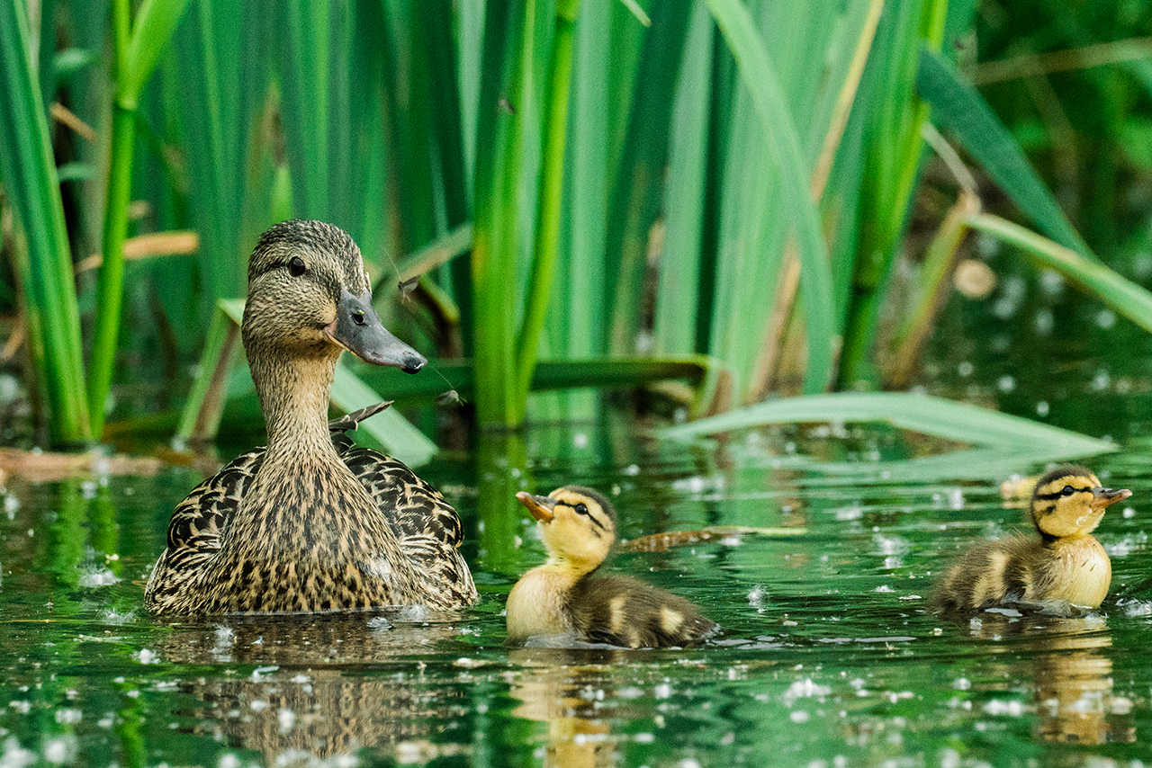 | Ed McGregor Docks Sooke | Taylor  Beach
 | 4 |  | 5 | 6 | 7 | 8 | 9 | 10
 |  |  | Witty’s Lagoon | Esquimalt Lagoon | Royal Roads Trails  No Bus Day | Raptors $16  Full Day Trip | Ruby Creek Trail
 | 11 |  | 12 | 13 | 14 | 15 | 16 | 17
 |  |  | Pro Day-OSC | Saxe Point | Sydney Japanese Garden and Water Park | Wooodside Farm $5 | Lower Sooke River
 | 18 |  | 19 | 20 | 21 | 22 | 23 | 24
 |  |  | Closed  Victoria Day | Swan Lake Nature House $5 | Elk Lake | Matheson Lake Trails | Thetis Lake Trails
 | 25 |  | 26 | 27 | 28 | 29 | 30 | 31
 |  |  | Onsite Activity Day | Esquimalt Lagoon | Glen Lake Water Park | Prospect  Lake | Young Lake  Sooke | 

