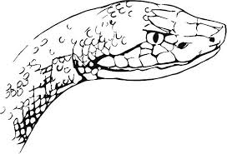

RALEIGH RINGERS SUMMER COPPERHEAD LEAGUE

THIS IS A NHPA SANCTIONED LEAGUE: FOR THOSE WHO ARE NOT ALREADY MEMBERS OF THE NHPA AND THE NC-HPA, THE 2025 FEES ARE $33 (THIS ALLOWS YOU TO PITCH ANYWHERE IN THE UNITED STATES THIS CALENDAR YEAR)

It’s getting time for Lucky Year 13 of the Raleigh Summer League. It is always a great competition. We are going to pitch for 10 weeks. The starting time will be 9:30 am on Thursdays at Athens Drive (where all the Raleigh tournaments are held). We will use the “count all” scoring system during four 50-shoe games, handicapped at 85%. Only members pitching at least 800 shoes can win any award except the percentage patch.

Anyone wishing to give horseshoes a try for their physical activity this summer can pitch for free their first time. If they love the game (and they will), they must join the NHPA and pay the above mentioned membership dues.

Cost (a donation to the NHPA league program) is $10 for 10 weeks. If you are interested e-mail me at pvhighlander@att.net or call at 919-609-5743.

The following is the tentative schedule.

April 24
May 1, 8, 15, 22 and 29
June 5, 12, 19, and 26

Court Directions: Open Hyperlink

35°46'08.9"N 78°42'56.3"W - Google Maps

