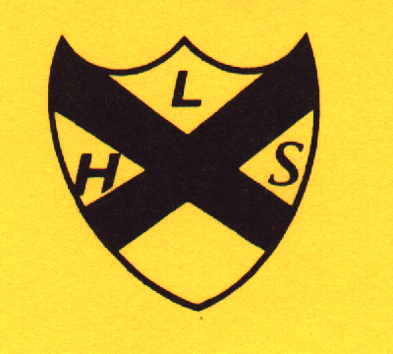Membership Application (Membership No …....)

Title …... First Name …………………… Surname …………….……………………

Address………………………………………………………….

………………………………………………………….………..

Postcode ………………………… Telephone No ………………………….

Email …………………………………………………………….

I enclose a Cheque / Cash of £15 for membership in respect of the Society for the 2024 / 2025 season.

GIFT AID DECLARATION (delete if not applicable)

I want the charity to treat all donations I have made since 6th April 2000, and all donations I make from the date of this declaration until I notify you otherwise as Gift Aid donations.

Dated. ..…/……./…….. Signature ……………………………..

Notes
- You can cancel this declaration at any time by notifying the charity.
- You must pay an amount of income tax and / or capital gains tax at least equal to the tax that the charity reclaims on your donation in the tax year (currently 25p for each £1 you give).
- If in the future your circumstances change and you no longer pay tax on your income and capital gains equal to the tax that the charity reclaims, you can cancel your declaration (see note 1).
- If you pay tax at the higher rate you can claim further tax relief in your Self-Assessment tax return.
- If you are unsure whether your donations qualify for Gift Aid tax relief, ask the charity. Or ask your local tax office for leaflet IR65.

Please notify the charity if you change your name or address.

Your Syllabus Membership Card is both your receipt and your means of entry into the meetings held at the Civic Centre. Please ensure you bring it to all our meetings.

Personal Data

The EU introduced a new General Data Protection Regulations on 28th May 2018, as a new UK Data Protection Act.
The Society holds personal data for members of the Society, collected when a member applies to join the Society. The data held are each member’s name (s), address and phone number.
The new regulations are largely concerned with bulk marketing. Our database is used solely for sending membership renewal reminders. As this activity is an individual communication, our data is not covered by the new regulations.
The basic features of our database are:
- The data is held securely on computer by the Chairman and is not shared with any third party
- An individual member’s data can be accessed by that individual by application to the Chairman
- The data is kept for a period of about three years after a membership lapses.

Leyland Historical Society

C/o 14 Clifton Avenue, Leyland. PR25 3ES
______________________________________________

