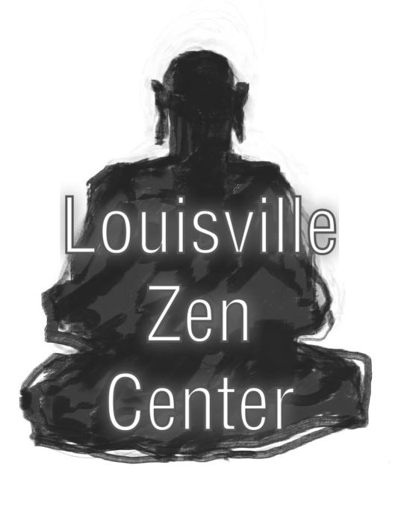 | Louisville Zen Center  P.O. Box 17532  Louisville, Kentucky 40217 | Office Use Only
 |  | Paid:  Check#:  Date:  Initials: | ____________________________
Application for Retreat:
Beginning: |  | Ending: |  | Location : Louisville, KY
Full Time: days | If Part Time, check the sections you wish to attend: |  | Section 1 (7:00am – 9:15am)  Section 2 (10:15am –1:10pm)  Section 3 (2:10pm – 3:55pm Section 4 (6:10pm – 8:10pm)
Full Time: days |  |  |  |  | or 5:10 pm)

Personal Information:
Name:  Street:  City: State:  Country: Postal Code  Check here if this is a new address:  Date of Birth :  Current Occupation: | Home Phone:  Work Phone:  Email:
 | Emergency Contact:
Name:
Relationship:
Home Phone:
Work Phone:

Louisville or Rochester Zen Center Membership Status (check one)
Non-Member Member Length of Membership:
Formal Student Information:
Have you, in a formal ceremony, become the student of a Zen teacher? Yes No
If Yes, Teacher’s Name(s)
Has Roshi Kjolhede accepted you as a student, but you await the ceremony? Yes No
Retreat Experience:
Have you ever attended a Zen retreat or sesshin? Yes No
If yes, please list retreat/sesshin attended in the last 12 months (or the last retreat/sesshin attended):
Event Month/Year | Location | Conducted By | No. Days

If you have applied for an retreat/sesshin in the last 12 months but were not accepted, please list below:
Event Month/Year |  | Location |  |  | Conducted By |  |  |  | No. Days
Along with your completed application, please enclose the following:
1. The retreat/sesshin fee IN FULL: |  |  |  |  |  | 2. A current photograph, unless one has been sent within the last 5 years.  The purpose of this is to help the teacher, monitors, and ZC staff identify you. |  | ATTACH  CURRENT  PHOTO  HERE
Full-time participants:  Per day  2-day retreat/sesshin  4-day retreat/sesshin  7-day retreat/sesshin  Part-time participants:  Per section/day | Member  $ 25.00  $ 50.00  $ 100.00  $ 175.00  $ 7.00 |  |  | Non-Member  $ 35.00  $ 70.00  $ 140.00  $ 245.00  $ 10.00
Note: Participants are invited to make a monetary offering (dana) to the retreat leader at the end of each retreat/sesshin.

Medical Information:
Please answer the questions below in detail, regardless of whether you have done so for a previous sesshin. If necessary, use a securely attached additional sheet of paper, putting the question number in front of each answer.
The purpose of this medical information is to help determine whether attendance at retreat/sesshin will in any way aggravate a serious physical or mental condition, endanger an applicant's health, or affect the smooth functioning of the retreat. For this reason it is extremely important that all information be current, specific, and clearly stated, in regard to both active and inactive conditions. This medical information is solely for the teacher and monitors and will be kept confidential.
- Please list any medical conditions you have that require regular care or medication (include pregnancy, current infections, high or low blood pressure, communicable diseases or chronic headaches): |  |  | Medical Condition:  1.  2.  3.  4.  5. |  |  |  | Medication (if applicable):  1.  2.  3.  4.  5.
- Please list any hospitalizations or major surgeries you have had in the past five years, and any major organs you may have missing: |  |  | Hospitalizations/Surgeries:  1.  2.  3. |  |  |  | Organs Missing:  1.  2.  3.
- Describe any significant problems you are having with your back or legs:

Due to this condition, I need to sit in a chair: Full Time Part Time

- If you have experienced dizziness, fainting, palpitations, or shortness of breath during sitting, please describe the nature of the problem:

- List any dietary restrictions/requirements or food allergies that might affect your retreat, and give some indication of their seriousness (for example, briefly describe the medical condition diagnosed or the nature of your reaction to the food):

Note: if you have a serious food allergy, please also contact the Zen Center directly.
- Describe any other allergies (including drugs):

- Are you in psychotherapy at this time?

Please complete the following if this is your first time completing this form with LZC, or if the information has changed since you last answered these questions:
- Have you ever had counseling or psychotherapy? Or been hospitalized for serious emotional problems? If yes, for how long, for what reason, and what was the outcome? Please also give details of serious psychological problems or crises for which you were not treated.

- Have you ever attempted to take your own life?
PLEASE NOTIFY THE HEAD MONITOR OF ANY MEDICAL OR OTHER CONDITIONS THAT ARISE AFTER YOU HAVE SUBMITTED THIS APPLICATION.
If there are any pressing circumstances, such as difficulty arranging time off from work, that would prevent you from applying to another upcoming retreat, please explain below:

By signing this application, I agree as follows:
- I will finish the entire retreat or portion for which I have applied.
- WAIVER OF LIABILITY: I understand that retreat is a period of rigorous Zen training involving some 8 - 10 hours of formal meditation per day. In accordance with this understanding and in consideration for the Center's accepting me to retreat, I agree that neither the Louisville Zen Center nor any of its employees, officers, trustees, or trainees – nor any person acting as retreat monitor or otherwise supervising, overseeing, or conducting any aspect of retreat – shall be liable to me or to any other person for any loss or injury suffered by me in connection with my participation in retreat, whether or not such loss or injury is caused by any act or omission of the Center or of any of the persons specified above.

Signature: ___________________________________________________ Date: ________________________
Return completed application via surface mail to Louisville Zen Center, P.O. Box 17532,
Louisville, Kentucky 40217. You may also email form to LZC Group Leader: jprincecherry@gmail.com

