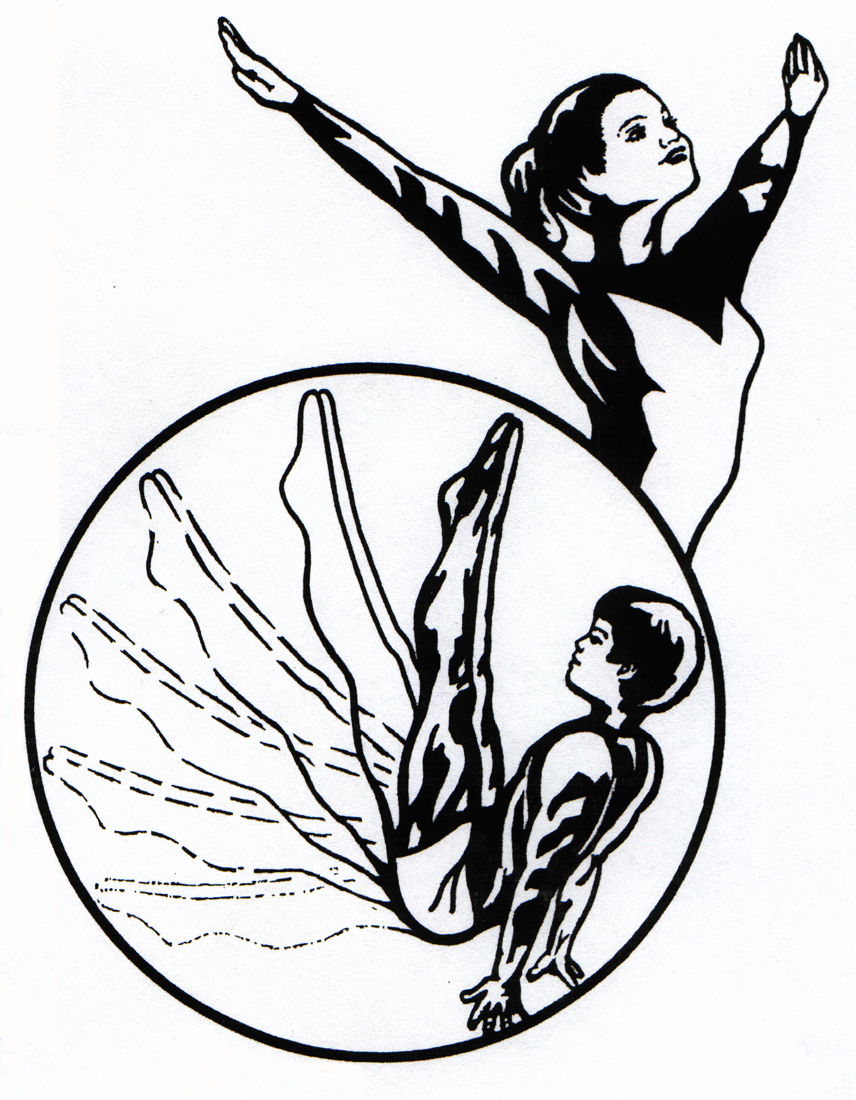

**Recreational**

**Gymnastics**

(Children in first grade and older)

At the **Ohio Gymnastics Institute** your child can be a part of the Future of Gymnastics RIGHT NOW! The Recreational Gymnastics Program at OGI is fun, challenging, and safe. Classes are designed for school age children who are 6 years of age and up. We offer four different skill levels to suit the needs of every child interested in learning Gymnastics. Our highly trained staff and 12 week rotating curriculum will continually provide new challenges and further develop and master the basic skills needed to be successful and safe in the sport of gymnastics. We offer your gymnast an opportunity to receive awards for accomplishments through the National Gymnastics Skills Test Program (NGSTP). With the NGSTP your child’s name is included on a skills chart displayed in our waiting area. This allows you to monitor progress and eliminates confusion regarding our advancements. Children will earn confetti celebrations for advancing to the next level and trophies for completing all skills on the skills chart. Gymnasts may choose to participate in our yearly Inter-Class Competitions and enjoy a competitive experience with other members from our program of the same age and skill level.

**Beginner Gymnastics**

Our entry level class is designed to help each child learn to love and succeed at gymnastics. No previous experience is necessary. This level teaches the building blocks for all gymnastics skills. Children will be taught on each of their gender specific events as well plenty of Trampoline and Tumble Track time. Gymnasts begin developing basic skills and are automatically included in our NGSTP-an awards program designed to help you understand which skills are necessary as building blocks for higher level gymnastics. Each Class is one hour long and meets once a week. Class size is limited to 10 students.

**Novice Gymnastics**

Previous experience is required to enter these classes. Gymnasts must have either passed the Beginner level of the NGSTP or have been evaluated by one of our staff members prior to beginning instruction at this level. These classes are separated by gender and work on a more refined, complex set of skills and routines. Strength and flexibility also become more important at this level. Each class is 1 hour & 15 minutes long and meets once a week. Class size is limited to 10 students.

**Intermediate Gymnastics**

Extensive experience in formal gymnastics training is required for these classes. This level requires a level of fitness as well as an attention to detail that is difficult for the average student to master. Our Intermediate classes keep children challenged while they learn more intricate skills. Classes become longer and more physically demanding as athletes progress through the levels. The challenge of meeting specific performance standards sparks each student to strive for perfection. Each class is 1 hour & 30 minutes long and meets once a week. Class size is limited to 10 students.

**Advanced Gymnastics**

 Gymnasts at the Advanced level are training to their highest potential. These gymnasts must maintain a very high level of fitness as the skills and routines they are training require a great deal of strength and flexibility. Skills are tailored to the specific needs of each student and the level of intensity and effort is controlled by the athlete in a non-competitive environment. Each class is 1 hour & 45 minutes and meets once a week. Class size is limited to 10 students.

**330-652-4386**

[**www.MyTeamOGI.com**](http://www.MyTeamOGI.com)

**OGI’s Jungle Gym**

In the Jungle Gym, preschool aged children learn about movement and gymnastics in a safe, progressive, and fun environment. Our “Animals” are divided into 5 groups to ensure that each child receives the correct instruction for their needs.

**Toddling Turtles**

Toddling Turtles is a "Parent & Child Class" designed as the entry level class for children ages 18 months to young 3 year olds. Typically this will be the first time that this group of children will have someone other than their parents providing instruction. Our curriculum helps children develop confidence and important basic skills. These young athletes work on developing better listening skills and improving eye-hand and eye-foot coordination. They also work on associating counting, rhythmics, color and shape recognition with movement - all in an environment that is safe, fun and challenging. A parent must accompany child for the entirety of the class. Much of the class involves instruction for parents on developmental limitations and expectations for children of this age as well as the proper techniques for assisting your child in developing gross motor and listening skills. Each class is 45 minutes long and meets once a week. Class size is limited to 8 students.

**Bouncing Bears**

Bouncing Bears is designed as an entry level class for children between the ages of 3 & 6 years old (not yet in 1st grade). Children must demonstrate the ability to work independently of parents in a group environment at this level. These classes provide children with a solid foundation for all sports. Children are taught to understand their potential in an environment that stimulates learning through discovery. Children work on basic gymnastics skills as well as specific gross motor skills, kicking, throwing, catching, striking objects, team work and sharing - all cleverly disguised as play in a gymnastics environment. Games are offered in non-competitive formats which encourage the joy of participation, initiative, and individual expression. Each class is 1 hour long and meets once a week. Class size is limited to 8 students.

**Tumbling Tigers**

Tumbling Tigers classes are designed as more advanced level classes for children between 3 & 6 years old (not yet in first grade). These classes require extensive prior movement experience. During classes our "Tigers" are challenged with more complex and refined movements, as well as complicated sequences and skills which require good basics and above average levels of strength and flexibility. Skill development becomes more technical at this level. During these classes these active students learn to refine skills, develop sequences and the ability to correct errors in their performance. Skills become more challenging and complex; games include more specific rules, and students develop a respect for officials and sportsmanship. Strength and flexibility are developed to a higher level and include calisthenics, hold positions, and flexibility work. Each class is 1 hour long and meets once a week. Class size is limited to 8 students. We also offer a Boys Only Tigers class that includes experience on all of the men’s gymnastics apparatus.

**C:\Users\Lauren\AppData\Local\Microsoft\Windows\Temporary Internet Files\Content.IE5\IE5R8V1R\MC900052825[1].wmf Leaping Lions**

You may only join our pride by invitation. Becoming the “Kings & Queens” of the Jungle requires extensive experience. Skills, strengths, flexibilities and sequences are of a very refined nature. These powerful “Lions” develop more complicated and difficult skills as well as beginning level routines. Gymnasts are encouraged to refine skills and develop an appreciation for the aesthetic beauty of gymnastics movement. Competition in various forms is introduced to help children understand how to win with honor and how to accept defeat without losing pride and self-esteem. Each class is 1 hour & 30 minutes long and meets once a week. Class size is limited to 10 students. We also offer Boys Only Lions class that includes experience on all of the men’s apparatus.

**Pouncing Panthers**

Pouncing Panthers is a high energy class with a less structured environment for 4-6 year olds. Panthers follow our Parkour program which includes traditional gymnastics skills, as well as elements from Free-running, Breakdance, Martial Arts and Tricking - all performed in a safe traditional gymnastics environment with equipment and skill restrictions designed to maintain safe skill development. Our curriculum will guide your children into developing confidence, acquiring new skills and improving their strength and flexibility. Athletes use our state of the art parkour equipment along with a variety of traditional gymnastics equipment, trampolines, and our loose foam training pits.

**330-652-4386**

[**www.MyTeamOGI.com**](http://www.MyTeamOGI.com)



**CHEERLEADING**

**OGI has been focused on helping cheerleaders be their best since 1989! Classes are designed for students in 1st grade and older.**

**The Red/White/Blue Squad & Stars/Stripes Squad**

For entry level classes, enroll in our Red/White/Blue Squad.  These classes are designed for cheerleaders who have not yet learned their back handspring and have limited cheerleading experience. 75% of class time is spent on tumbling skills while the remainder of their class time is spent working on jumps, sideline motions, cadence, presentation, strength, flexibility and stunting. Lesson plans are designed to allow students to begin at any time during the year. Each class is 1 hour long and meets once a week. Class size is limited to 10 students.

The STARS & STRIPES squad is for cheerleaders looking for a greater challenge. ALL CHEERLEADERS AT THESE LEVELS must be able to perform either a standing back handspring or a round off back handspring without assistance and must demonstrate minimum levels of skills, strength, and flexibility prior to enrolling in this class. Classes are designed to improve basics, learn advanced tumbling, improve jumps, strength and flexibility and train more advanced stunting. Each class is 1 hour & 15 minutes long and meets once a week. Class size is limited to 10 students.

**Parkour**

Our Parkour classes include traditional gymnastics skills, as well as elements from Free-running, Breakdancing, Martial Arts and Tricking - all performed in a safe traditional gymnastics environment with equipment and skill restrictions designed to maintain safe skill development. This exciting class provides all the basics needed to start "Flippin & Flyin." Our curriculum is taught by certified teachers and our lesson plan system guides your children into developing confidence, acquiring new skills and improving their strength and flexibility. Athletes use our state of the art parkour equipment, along with a variety of traditional gymnastics equipment, trampolines, loose foam training pits and walls to flip and spin off of. Children, 7 and older, and adults of all ages will love it!

**JUST BACK HANDSPRINGS**

These classes are designed for athletes who are in the 1st grade and older. No prior experience is required to enroll in the Just Back Handsprings class. Students in this class train exclusively on the progressions, skills, actions, strengths, positions, and flexibilities that are required to perform both a standing back handspring and a round off back handspring. Each class is 45 minutes long and meets once a week. This class is considered a semi-private lesson with class size limited to 6 students.

**Trampoline & Tumbling**

OGI offers Beginner and Novice level T & T classes. These classes work on forward, backward and sideways tumbling, trampoline skills, strength, flexibility and body awareness. Athletes work at their own pace to master the skills listed on our skills charts earning trophies and certificates along the way. Our 12 weeks of lesson plans and proven curriculum provide both a challenge and fun experience, and keep children safe through skill progression designed to develop strength, flexibility, spacial awareness, and confidence. These students spend more time in the air than on the ground while enjoying our in ground trampolines, 2 tumble tracks and 4 separate tumbling surfaces.

**Our highly trained, knowledgeable, and caring staff provides the best opportunities for your athlete in a safe and challenging environment. Your athlete will love training at our clean, comfortable facility. We have state of the art equipment, great coaches and amazing in ground training pits and trampolines.**

**330-652-4386**

[**www.MyTeamOGI.com**](http://www.MyTeamOGI.com)

**OGI has so much to offer your child!**

* Preschool “Jungle Gym”
* Recreational Gymnastics Classes
* Recreational Cheerleading Classes
* Adult Workouts
* Competitive Team
* Birthday Parties
* Private Lessons
* Wide Variety Equipment
* Safety
* FUN!
* Discounts for siblings
* A fully stocked Apparel Store
* Open Gyms for extra practice
* Clean, comfortable observation area

**Stop by today and see the area’s best opportunity for your athlete’s healthy and happy gymnastics experience!**





**The Ohio Gymnastics**

**Institute**



**GYMNASTICS=**

**FUN WITH BENEFITS**

Our mission is to provide your child with the highest quality of instruction possible at a level of involvement that is appropriate and fun for a developing child.

**CALL TODAY!**

**330-652-4386**

**FAX-330-652-4387**

[**OGIOFFICE@aol.com**](mailto:OGIOFFICE@aol.com)

[**www.MyTeamOGI.com**](http://www.MyTeamOGI.com)