SPECIAL PRESENTATION

Saturday, February 15th at 9:30 AM
Partridge Lane Club House
(immediately following Coffee House)

Estate Planning & Trusts
Presented by Attorney Robert Shepard
Smith-Weiss Shepard and Durmer, PC
Nashua, NH

Insurance Coverage and Your Manufactured Home
Diane Santinelli
Foy Insurance, Manchester NH
SNOW IN THE STREETS

Spring will arrive eventually, but in the meantime…

Please stop blowing/shoveling snow into the streets. Yes, some homes are closer together than others but that doesn’t mean you can put the snow into the street when you are clearing your driveway and walkway. Snow left in the street will become hazardous to vehicles when it freezes during these cold snaps and is a danger to those walkers who are brave enough to face the elements.

Thank You.
The Board of Directors
OTHER NOTICES
LAST CALL
The Hannaford’s pharmacist is offering to set up another date to have various vaccines: Shingles, Pneumonia, Tetanus, Diphtheria & Pertussis (TDaP), Hepatitis A or B, and Hepatitis A & B combination.

Please contact Irene Gagne at 622-1869 if you have any interest in any of these vaccines. Once we see if there is enough interest, we will schedule a date & time and get the necessary forms to those who are interested. IG

MONDAY NIGHT CRIBBAGE CLUB

A reminder that the Monday night cribbage league starts on 4/6 for 20 weeks at PLC with an awards banquet on 8/31. We are not playing 5/25. Cost is $2/week. Anyone interested in joining the group should contact Irene Gagne at 622-1869 by 3/15. If you played last year or have already signed up, please confirm you will continue playing. If you decide not to play, please call. We are currently playing for fun & learning until the end of March.
IG
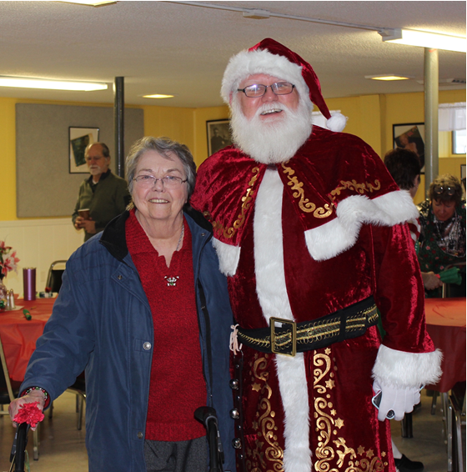
MANCHESTER COMMUNITY COLLEGE

The Manchester Community College is offering FREE functional fitness classes on Mondays & Thursdays from 3/23 to 4/30 at 10 – 11 am.
See flyers in the mail houses & lobbies for more information & how to register. If you have any questions, please call Irene Gagne at 622-1869.
IG
COMMITTEE REPORTS
EVENTS
COMMITTEE
Photo by Cat Pragoff
Didn't we have fun at the Holiday Luncheon on December 22? Allen and Leah Brown and their wonderful crew did a bang-up job of preparing, presenting, serving, and cleaning-up and delicious meal for almost 120 Medvil residents at our two seatings. They are to be commended for their culinary skills as well as the courtesy and grace which they showed to all our members. What a very special group of friends we have at Brown Excavating and Brown's Emporium in Goffstown. Please take a moment when you're in the Village to stop in and say, “Thank you!” if you have the chance.

There are several food events coming up soon—Soup & Chowder on January 22 and an Omelet Breakfast on February 8, for starters. Please keep in mind that only trained service animals (NOT emotional support animals) are allowed in the dining area at Donald Drive Clubhouse, and that these animals must be registered with the office. Service animals are those that have been specially trained to perform certain specific tasks to help a physically disabled person.
Photo by Cat Pragoff

Also in February, we have Meat Bingo on the 22nd. Please check the flyers for more information, and don't forget to sign up at the office so we have enough of everything on hand.

We have a great year of events ahead, so be sure to check your calendars every month!
CP

Photo by Diane Lamarre

FUNDRAISING COMMITTEE

Contact Irene Gagne at 622-1869.

Fundraising Pool

The 1/1 winner was Dolores Daoust for $250. All numbers are being played with a guaranteed winner. There are currently no residents on the wait list.

Please call the office at 497-4440, Option “0” to place your name on the list. It’s only $5/month and you can play more than one number.

Consignment Store/Yard Sale

If you have items to donate please contact Irene. What doesn’t get accepted by the consignment stores or sold on Ebay will be placed in the 4/4/20 yard sale. However, we do not take electronics, TV’s, large appliances, furniture, or exercise equipment. Please do not place any items in the mail houses.

So far, we have sold 5 items on Ebay and have 4 appointments scheduled in February, March, May & June.

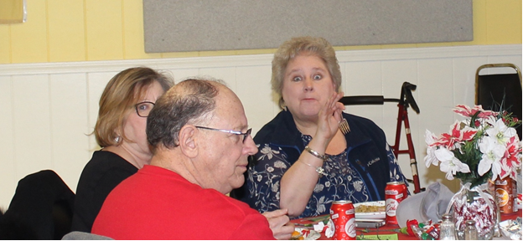
Committee Members

We are a committee of 9. We are looking for more members with fresh ideas and help with yard sales.

Ideas Needed

However, you don’t have to be a committee member to give us suggestions for projects to use our funds for the benefit of the Medvil community – call Irene with suggestions, including cost. IG
Photo by Cat Pragoff
REAL ESTATE COMMITTEE

During the month of January, we had 6 showings, 3 listings, 3 Pending Sales, 0 closings, and 3 Intent to Sells naming Medvil Real Estate as their Realtor. The listings in January were written up and before we could get the pictures and information on our website we had a Purchase and Sales Agreement on each of them. It is a great start for the upcoming year! DK

There are people driving through our community and stopping into the office asking to see our homes for sale. We are always available to show them our listings. We also get website and phone inquiries requesting information about Medvil Cooperative living. Medvil is a sought-after community.

If you are thinking of selling your home, the first
step is to fill out the Intent to Sell form and return it to the office. The second step is to locate a realtor. Please consider Medvil Real Estate to help you sell your home. Sales benefit Medvil community.

Medvil RE Committee - 497-4440 Prompt 2
Website: www.medvilcooperative.com Homes for Sale

Dorrie Kossuth, Chairperson

SINCERE CONDOLENCES
RESIDENT BARDCRAFT
Heartfelt condolences to those who have recently lost a loved one:

- the family of Viola Meighan.
- Mary Wojdylak in the loss of her husband James.
We meet them in the lives they’ve shaped. We enjoy them in the jokes and wisdom they’ve passed down. Be active in the community they’ve built. It is a way of walking with them into the future. It is a way of never losing them.

Linda Robinson, Sunshine Lady
(603)851-5209
HOW BAD IS IT?
An occasional, recurring feature reprinted from a recent issue of HDTV Magazine.
How Bad is it to Have a Drink When You’re on Antibiotics?

Really bad! When you’re sick, you’re already not at your best, and with some antibiotics, alcohol can counteract the healing effects. Drinking may speed up the metabolism of medications, which means your body processes them more rapidly – and you don’t get the full healing dose. Boozy beverages could be particularly dangerous in combination with metronidazole and tinidazole, used to treat bacterial infections, and linezolid, for staph and strep (think heart palpitations or scary-high blood pressure). Even one drink can increase nausea, dizziness, and other common side effects of antibiotics. Mind the alcohol warnings that come with meds, then feel free to toast to your good health once you’ve finished your Rx.

SERENADE OF THE CUBICLE

People talking near my space
Noises falling from each face
Trip my mind and slow my pace
Focus lost without a trace.

They talk and joke and yap some more
They won’t stop till their tongues hit floor
You’d think their lips would grow too sore
To gabble on forevermore.

Author: Alyn Miller
Location: work force

The Medvil Messenger encourages members to submit articles for consideration. Recipes, helpful hints, reminiscences, jokes, poems--please keep it upbeat and positive. Due to space considerations, original material will take precedence over reprints from other sources, including printouts of email pass-arounds. If you submit previously published material, please try to cite a source. We reserve the right to reject material that may offend, divide our community or cause political arguments. Please submit your items to our email: medvilnewsletter@comcast.net Or place a copy in the Messenger mailbox in the Reception Office in the DDC.

Deadline for submissions not from the Board is noon the day of the Board Meeting (3rd Tuesdays.) Board submissions deadline is noon of the Wednesday.

Medvil Messenger Staff: Debbie Cyr, and MB. Wulf

Medvil Messenger Writers this issue: Debbie Cyr, Irene Gagne, Alyn Miller, Cat Pragoff, Linda Robinson

Special thanks to Irene Gagne for additional proofreading.

