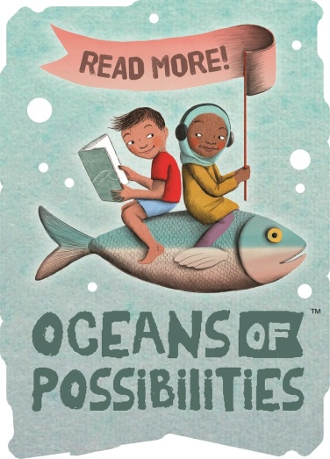
Pigeon District Library
2022 Summer Reading Program
Infant/Elementary/Teen
Registration Form

Name: ________________________________________________
Address: ______________________________________________
_____________________________________________________
Phone Number: ________________________________________
E-Mail: _______________________________________________
Grade Finished 21/22 School Year: __________ Age: __________
School Attended 21/22: __________________________________

Program (please circle one)

Infant/Age 5 K-5/6 Grade 6 Grade/ HS Senior

My Child is interested in attending:
(Please circle the program(s) you plan for your child to attend.)

Weekly STEM Activity: Independent activity for Grade 4-HS
- Younger students with PARENT supervision.

Tuesday Morning: Toddler Story Time@ 10 AM
Elementary Story Time @ 11 AM

Thursday Evening: Story Time (all ages) @ 6 PM

Friday: Buddy Read @ 1PM Weekly Movie @1:30PM

PHOTO RELEASE AND PERMISSION FORM

I hereby grant permission to Pigeon District Library to use photographs of my child taken during SRP events or activities my child is participating in; for publications, news releases, online, and in other communications related to the mission of Pigeon District Library. Local media may also attend an event and take photos for their use. By registering your child, you are giving permission to Pigeon District Library to use these photos, and for your child to participate in the Summer Reading Program Activities.

_____________________________________________________
(Signature of Adult, or Guardian of Children under age 18)
Date: ________________

