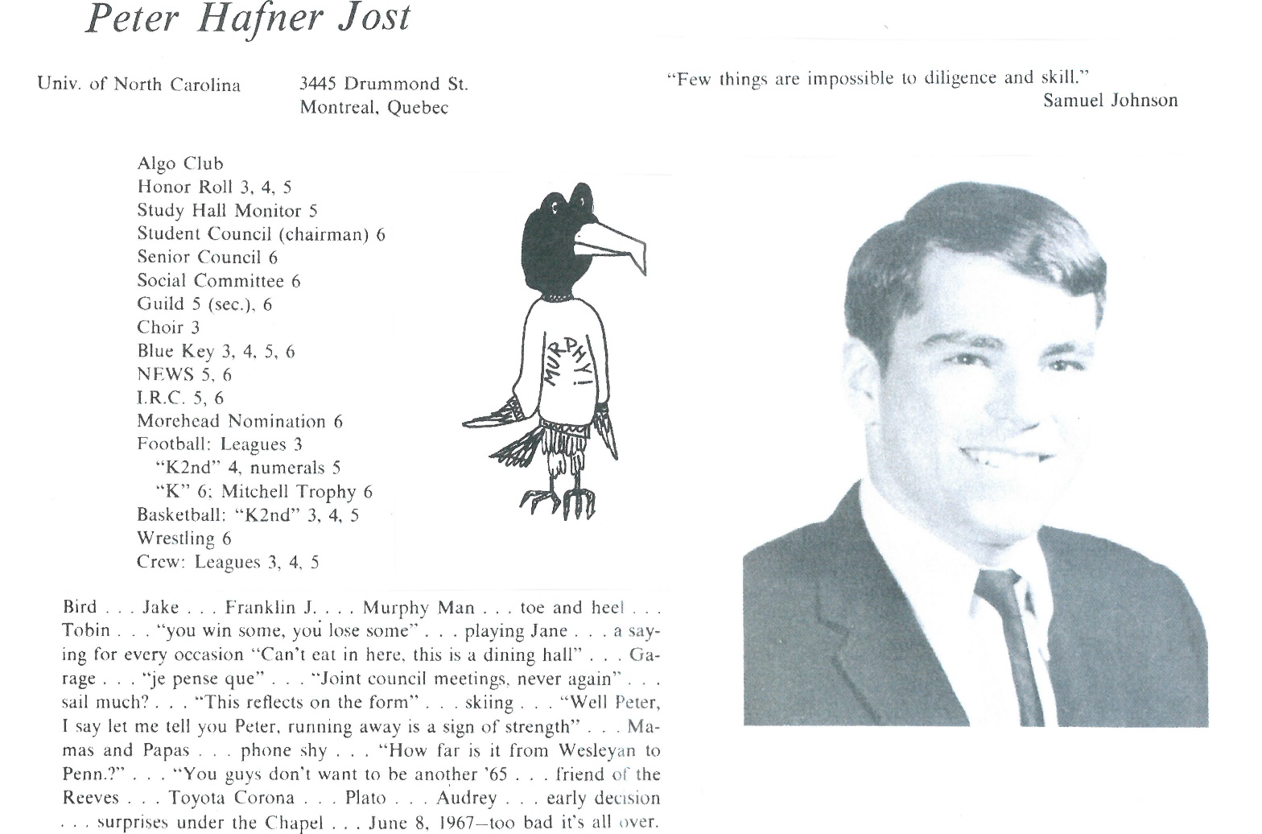

Peter H. Jost

After UNC Chapel Hill, married Beverly Lane from Charleston, SC June 5, 1971 (see attached picture taken September 2016)…worked one year in Chapel Hill for Morehead Foundation (now Morehead-Cain Foundation)…moved to Montreal, Canada and worked in family textile business from 1972-1974…returned to USA in July 1974 to attend University of Virignia School of Law … first child, Kathleen born June 17, 1975…moved to Washington, DC area in May, 1977 and started working as a tax and corporate attorney for law firm of Dickstein Shapiro & Morin in June 1977 … successor firms included Dickstein Shapiro Morin & Oshinsky, Dickstein Shapiro LLP and Blank Rome LLP … profile:

<http://www.blankrome.com/index.cfm?contentID=10&bioID=3312>)

Girl (Alexandra) and boy (Lane) twins born Septmber 1, 1978 … all three children currently married (Kathleen in Somerville, MA where she is a principal of a middle school; Alexandra in Washington, DC where she is a social worker at Bread for the City and Lane in Providence, RI where he commutes to Santander Bank in Boston (Director of Philantrhopy) and our children have given us 6 grandchildren, currently aged 7 months to 8 years …

Or family has enjoyed extensive travel opportunites in France, England, Switzerland, Italy, Spain, Egypt, Turkey, India, China, Argentina, Chile, Myanmar, Thailand, Laos, Cambodia, Sri Lanka and Russia …

Currently (June 2017) near end of 40-year legal career and enjoying time in Georgetown, Washington, DC and fishing, sailing and swimming at Gibson Island on the Chesapeake (often with grandchildren), and additonal travel, most recently to Havana, Cuba (March 2017) and fall 2017 to Vienna, Prague, Dresden and Berlin.



______________________________________________________________

______________________________________________________________ ______________________________________________________________ ______________________________________________________________ ______________________________________________________________ ______________________________________________________________ ______________________________________________________________ ______________________________________________________________ ______________________________________________________________

Attach Picture in .jpg Format

______________________________________________________________

______________________________________________________________

___________________________________________________________________________________ ______________________________________________________________________________________________________________________________________________________________________________________________________________________________________________________________________________________________________________________________________________________________________________________________________________________________________________________________________________________________________________________________________________________________________________________________________________________________________________________________________________________________________________________________________________________________________________________________________________________________________________________________________________________________________________________________________________________________________________________________________________________________________________________________________________________________________________________________________________________________________________________________________________________________________________________________________________________________________________________________________________________________________________________________________________________________________________________________________________________________________________________________________________________