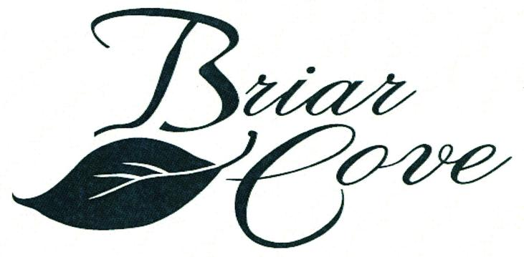 | NEWS  AROUND  THE  NEIGHBORHOOD  SPRING 2016
2016 Board of Directors

Ralph Flens, President Nick DeLaurentis, Director
Joe Arias, Treasurer Ron Szikora, Director
Tom Whiteley, Secretary

The winter season has now passed and we all, I’m sure, are ready for the spring weather.

As required by our community covenants, please insure that the association yours homeowner’s insurance information. This is for your safety as well as your attached neighbor.

This year will be filled with activity as you will see below:
- Briar Cove will continue with the second phase in our painting program for our community this year. The painting program occurs over a three-year period.
- The second phase of our driveway asphalt resealing program will also be done this year. The driveways are resealed every three years and the process is spread over a two year period. Last a non-coal tar sealant was used due to environmental concerns. The driveways will be evaluated as the non-coal tar sealant is not as durable as the coal tar. We plan on using the non-coal tar sealant unless we find a problem during the evaluation.
- The installation of rip-rap along the shoreline of the pond is also on the agenda for 2016. Initially, this project will only be done near/around the pond outlet. The situation with the geese around the pound is under constant review in hopes of finding a good solution to the problem
- The plants installed by the developer in the front landscaped areas will be evaluated and corrective action taken where needed. This program is a new approach and may be spread over several years
- Mastercut and Forever Green will be coordinating their planning/scheduling for lawn maintenance, fertilizing, laying of the new mulch and other work.

The Briar Cove Book Group is in session. We are always looking for new members to join our current six (6) member group. The selection for April is The Residence: Inside the Private World of the White House by Kate Anderson Brower (Meeting Wed, April 20th). The selection for May is The School of Essential Ingredients by Erica Bauemeister (Meeting Wed, May 18th). After May the group will break for the summer and resume in September. Anyone interested in joining may contact Brenda DeLaurentis at 219-322-9059 or Email grmad3@aol.com

PLEASE adhere to the rules (in actuality and spirit) of the Briar Cove Community. If unsure whether your change idea is within the guidelines, please check the rules/covenants in the book that you received at closing. Also, the Welcoming Committee provides a copy of the rules when they visit and welcome the new residents. Peter Bylen, 1st American Management can also be contacted.

YOUR COMMUNITY

Still need a few more votes to pass our three proposed amendments: (1) association responsibility of trees and bushes, (2) board member “good standing” requirements and (3) architectural review committee jurisdiction. Please contact Peter Bylen or any board member for further clarification.

The Briar Cove board meetings are scheduled for April 21, July 21 and October 20. The annual meeting is scheduled for November 17. Please make plans to attend the meetings.

Please get involved in YOUR community. There are a number of active committees that would welcome your time and talent. Also, please consider running for a position on the HOA Board of Directors. There will be two positions up for election this year. If interested, please send a note Peter Bylen, 1st American Management Co. to express your desire to run. A brief resume should be included. Remember this is YOUR community.

PLEASE REMEMBER THE FOLLOWING

- Pick up after your pets whether on your property or your neighbors.
- Please confine your pet to the parkways when walking your pet.
- If you own a home with a basement, please consider putting a rust inhibitor in your sump pump well. This will prevent the pumping of rust colored water on your lawn and /or sidewalks.
- If installing a dish for your TV reception, a Modification Request form must be submitted for approval. If changing vendors and a new dish will be installed, a Modification Request form needs to be submitted for approval.

HELPFUL HINT

As we all know we have been having days (and nights) that have been VERY windy. Please consider putting your address on your garbage/recycling cans and even your grill cover. Your address can be written on the inside of the cover.

Briar Cove is now thirteen years old. The roofs have a 30 year life expectancy but realistically will probably need to be replaced after 25 years. The replacing/repairing of the roofs, shingles is a homeowner’s responsibility. For best results you and your ‘attached’ neighbor should replace the roofs at the same time.

GET TO KNOW YOUR NEIGHBOR

On the second Tuesday of the month, a number of residents gather at a local restaurant for dinner and conversation. If you wish to be placed on the email list/call list, please contact Cindy Dupczak via email: cdupczak@att.net

The next open Board meeting is scheduled for 6:30 pm on Thursday, April 21, 2016. The meeting will be held at the Dyer/Schererville public library in Schererville.

Peter Bylen 1st American Management 219-464-3536 Ext 310 / 800-990-3536
pbylen@1stpropertymanagers.com
www.briarcovehomeownersassociation.com

