Church History
THE HISTORY
1913 – 2019
Steward Temple African Methodist Episcopal Church

The original founders of Steward Temple were ex-slaves who grew up on the Mathison’s Plantation in the St. Hebron community, and relocated after the signing of the Proclamation of Emancipation. Steward Temple African Methodist Episcopal Church then grew out of spiritual meetings that were held in a school house known as Alsace. The school served the community in the 1800s, but no records can be located to determine the number of years, or the actual birth date of the Steward Temple AME Church.

The original Trustees who purchased property for Alsace on August 9, 1913 were Dan Shaw, Perman M. Rittman, and Lewis Robinson. The property was purchased for $50.00. The Original Deeds are on file at the Gadsden County Courthouse and Steward Temple AME Church.

November 22, 1913
On November 22, 1913, the schoolhouse became a Church House, and was named Steward Temple African Methodist Episcopal Church. It was a circuit church with St. Hebron, and continued to be a school. In 1948, the grade school class was moved to the Old Stephens High School. From there the class of 1954 graduated. Church services, however, continued at the site of Alsace School.

To make provisions for a “Highway”, the AS & T Company donated property on Woodward Road to the church for the up-building of God’s Kingdom. During that time, there was a building on the donated property, which housed a sewing factory. The building later served as a church parsonage. The church and the parsonage were both operated with outdoor plumbing.

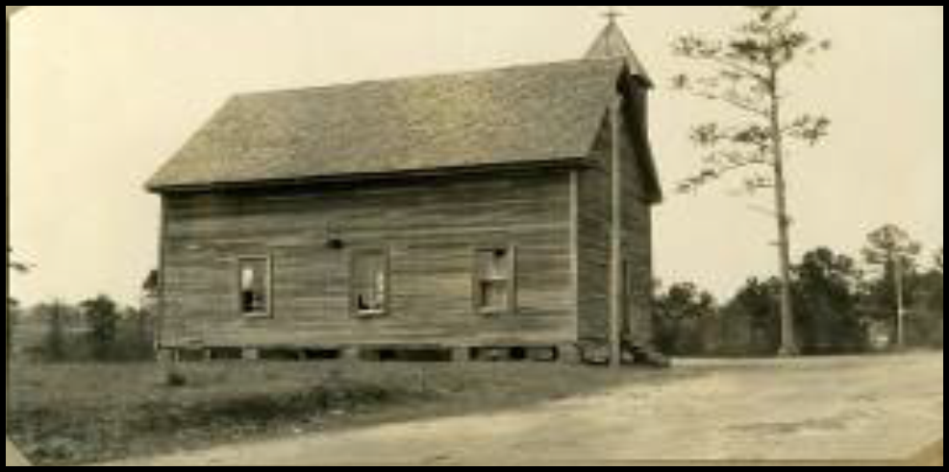

November 14, 1913 – March 15, 1959
From November 14, 1957 to March 15, 1959, Steward Temple held its church services at Second Elizabeth Missionary Baptist Church, during the transitional stages of relocation and rebuilding. Through the years, the Second Elizabeth Church family has worked with us and opened their facilities to us when needed. They are indeed good neighbors and we thank God for all their love and support.

March 29, 1959
On March 29, 1959, Easter Sunday Morning, we marched joyfully into our new church, and became a “Station Church”. The speaker for the occasion was the Reverend Ash, and on that day, he proclaimed our sentiments in his sermon. From “I Kings 8:63”, he preached: “I was glad when they said unto me, Let us go into the house of the Lord”, and what a joy it was! The trustees at that time were as follows: Jimmie Lee Anderson, Tilton Taylor, Fred Williams, Jerry Bouie, Lonnie Taylor, Nellie Peoples and Epsie Simmons. The Church Secretary was Minnie Love. All of these dedicated members have passed on, and we are grateful for the impact that they had on our lives.

The Reverend Thelma Shaw Young, a Retired Presiding Elder of the Florida Conference, was a faithful member of Steward Temple. She was serving on the Usher Board when she accepted her call to preach, and would often speak of those times. Her husband is buried in Steward Temple’s cemetery. The Reverend Peter Rittman accepted his call to preach at Steward Temple. He became an Itinerant Elder, and was a Pastor in the military prior to his retirement. He then became a pastor in the AME Zion Church.

Church Improvements
Many church improvement were done over the years by our previous pastors: the Reverends H. Lawrence, George W. Chambers, E. L. Richardson, Johnnie Bruce, C. Underhill, Herbert Corbin, S. L. Mims, L. J. Flowers, James Gibbs, Herbert Hollingsworth, Matthew Bryant, Walter Gilyard, Ernestine Barkley, Charles Caldwell, Barbara Sutton, Vincent Jones, Margaret Brown, Jerome Griffin, and Shirley Brooks.

Ground Breaking Ceremony
In 1989, the Right Reverend Phillip R. Cousin, facilitated a groundbreaking ceremony, and the congregation began to look forward to growth and expansion. The pastor at that time was Reverend Ernestine Barkley, and the Reverend E. L. Daniels was Presiding Elder.

August 28, 2001
Over a decade later, Reverend Louisa L. Thomas and Brother John A. Thomas arrived with dynamic visionary leadership skills and a “now/later” attitude. Reverend Thomas explained that a “now/later” is candy that is individually wrapped so that one can eat some now and save some for later. Every now and then, she continued, we will have a “now/later” in church improvements—we will enjoy some small improvements now and save the big improvements for later, and so we did. The organization was laid out in a magnificent plan by Reverend Thomas, and we began to call the church “The Temple”. The members were assigned duties, and the name of the church took on a whole new meaning. The gospel was preached and a revival was held. The members returned to the Lord with a new attitude and a greater commitment in the His service and worship.

The process of growth continued. The first “now/later” was for communication. Telephones were installed, and we finally became listed in the Quincy Directory. The morale of the membership was improved by purchasing choir robes for the senior choir and T-shirts for the Youth Department. Over 25 youth and adults participated in a sleep-over in the church and ideas sprang forth for growth and development. As we began to praise the Lord, excitement spread throughout the membership as we enjoyed many “now/laters”. Two dance ministries came forth from the Youth Department, a male chorus was organized which now consist of 12 members. A sanctuary choir was organized by the young adults, and the church continued to grow and grow!

We went beyond the walls. For the first time in history, Steward Temple actually had members to participate in the Christian Education Congress of the AME Church, Orlando, Florida, and the Debutant Masters Ceremony. We were so inspired we promised to return to these events the next year. We did and we will never the same.

At the end of the conference year, our congregation loaded a bus and celebrated our victories in a retreat at the beach in Panama City, Florida. On Sunday morning we returned with the word of God: “It’s On the Table”, Psalms 23:5. The more we feasted on the word of God, the more we discovered what was on His table. The membership increased and the church income doubled that year with great anticipation for the next year. A group called “The Visionaries” was formed and plans were underway for the much-needed renovations.

July 14, 2002
On July 14, 2002 the outcome of “The Visionaries” was presented in a Church Conference and was received unanimously with great joy from the congregation. On October 6, 2002, plans for renovations were presented to The Quarterly Conference. Approval was granted and the momentum was tremendous. The Sermon “Bless the Lord and He Will Bless You” rang loud and clear and it happened. The men of “The Temple” began to rise up. The trees were removed from around the property to make way for construction. Ulysses Moye made arrangements to use the equipment of Mr. Allen Boatright, and there was a community uprising to clear the land. Once the trees were gone, the church became more visible. The men of the church then put up a new sign which indicated that a change had taken place at 85 Woodward Road, and Brother Joe Rittman often reminded the congregation that “You are in The Temple”. We grew higher and higher in the Lord. The church income tripled and we closed this Conference Year, praising God from whom all blessings flow.

August 23, 2002
Reverend Louisa L. Thomas received her second appointment for Steward Temple, and she returned with another pack of “now/laters”. The public address system was upgraded, and speakers were installed in the ceiling. The old dim lights were replaced with chandeliers throughout the sanctuary. The pews were upholstered for the first time in history and the excitement began to mount. The interior and exterior structure of the church was repainted from the ceiling to the floor, and we were looking good. Several contractors were invited out to “The Temple” for strategic planning. The suggestions of all of the contractors were analyzed, and the congregation made a decision to contract Mr. Ed Cox for this work. Ed Cox introduced us to Mr. Don Jones who prayed with us, organized our ideas, drew our plans for church renovations, and encouraged us to go on. Many meetings were held and prayers were prayed as we marched on to victory.

May 7, 2003
By May 7, 2003, we had it all together. The church applied for finances. The loan was granted by Bank of America for more than requested. After going through proper channels with the Church Conference, the Quarterly and the Conference Trustees, the foundation was laid for renovations and expansions. We were totally elated knowing that the best was yet to come!

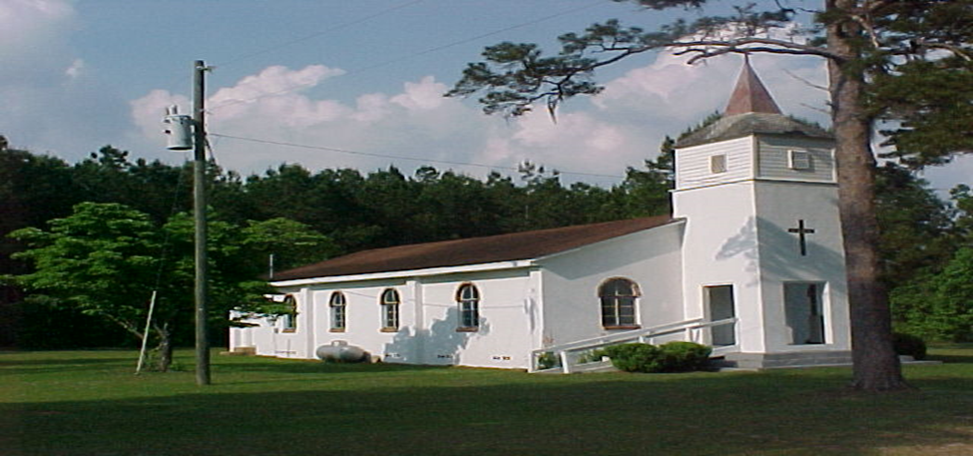

April 15-19, 2004
In April 2004, it was time for church celebration. We held a week-long service for Church Anniversary and God allowed us to experience a glimpse of His Glory. Many of the former pastors returned along with their congregations to help us celebrate. They were: the Reverends Matthew Bryant, Margaret Brown, Jerome Griffin, Barbara Sutton and Shirley Brooks. Our neighboring church, Second Elizabeth and their Pastor, Reverend Charles E. Barney joined in as the excitement filled The Temple. During morning worship, April 25, 2004, we were indeed honored as the Reverend Dr. Samuel Green (who was elected Bishop at General Conference) came to this little town of Quincy, Florida, and delivered a powerful message: “Disabled but not Disqualified” at 11:00 A.M. The Reverend Willie E. Hagan and the Arnett Chapel church family rendered our culminating service at 3:00 P.M., as the Fellowship Mass Choir and Reverend Leroy Colston rendered a hallelujah, down-home song service.

The entire week of Church Anniversary Celebration was a moving experience. At first we were concerned about asking our guest to enter through the side doors, but when the doors opened up and the saints of God came marching in there was great joy. Before the completion of this phase of construction, over 1,000 people had entered God’s House through the side doors. Once the front doors were opened some of us continued to enter through the side doors just for the joy. The saints of God were then coming in from the North, South, East and West. We thank God for what our eyes have seen, and our hearts have felt.

Under Construction
From August 17, 2004 – December 10, 2004, the church was officially under construction, and the vision came alive. We declared every Monday night as “Project Meeting Night”. Richard Taylor, our long-time and dedicated trustee and Chairman of the Board of Trustees was appointed by the pastor to spear-head this project. We met faithfully, discuss every detail openly and made decisions jointly. The membership grew closer and looked forward to our Monday night gatherings. The pastor and the Daughters of Sarah began their search for just the right furniture to bless the Lord’s House.

Church members took “the walk” through the building every Sunday morning before entering the sanctuary, shouting praises to God, and neighbors stopped by throughout the process for the walk through. It was plain to see that the presence of the Lord was in this place. Every day we watch as God built His House. As the walls of “The Temple” expanded God’s people became more and more involved. A vote was taken to include the sanctuary in the renovations and “not neglect God’s House”. The steeple and the cross were wired to shine in the night by our own electrician, Gregory Washington, and they were both lit up during the Christmas Holidays. Everyone that passed Steward Temple was reminded of Jesus, the light of the world. The joy of the Lord spread throughout the community, God was truly glorified.

The finishing touch seemed to have been the parking. The lot was paved. Most all of the trustees met one Saturday morning to mark off parking spaces. Bruce Tribue laid it out according to plan, and the trustees personally painted the lines. Darius Kelly, Mary Alice Kelly (Trueblood), Larry Moye, Melvin Taylor, Richard Taylor were all there. Their laughter could be heard for miles around. Bumper guards were delivered and positioned by Langston Shaw and John Thomas. Langston Shaw got flags donated to our church.

Church Dedication
At the eve of completing the renovations of “The Temple”, a ceremony for dedication was scheduled. With a membership roster of 125 (including youth), a host of friends and a new commitment and determination in the Lord Jesus, the Saints of God marched into their new facilities and sang praises to the Lord.

November 27, 2004
As we waited for the arrival of Bishop McKinley Young and our Church Dedication, we were again honored to host the newly established Quincy District. On November 27, 2004, the First District Planning Session, which now consists of 33 churches, convened at “The Temple”, and organized under the leadership of Presiding Elder Henry R. Griffin and Sister Alberta Griffin, in a history-making event. District planning was completed during this gathering and Steward Temple became the designated site for the 2005 Founder’s Day Celebration of the Quincy District. On February 12, 2005, Founder’s Day Celebration came to pass at “The Temple”, with a repast under “our own vine and fig tree”. The food was prepared by our own caterer, John W. Love, who has been a constant blessing in using his many talents for the Lord.

December 10, 2004
The certificate of occupancy was received. Steward Temple could now officially use the facilities that the Lord has blessed us with. The Lord has added 2,098 square feet to the existing facility, which has made it a state-of-the-art facility with advanced technology. The multipurpose addition includes a fellowship area, kitchen facilities, office space, disabled accessible rest rooms, paved parking, a new steeple, new roof and a baptismal pool on the inside, but the best was yet to come. The furniture was delivered. Computers and fax machines were installed. Church programs are now completed on site, and our first newsletter was sent to press. We are now ready to serve this present age.

Church Services in the Fellowship Hall
The pews were refinished and then moved in our new fellowship area, to allow major upgrades to the sanctuary. Joe Rittman came to help that night, and reminded everybody that “you are in “The Temple”. We worshiped the Lord in the Fellowship Hall while the sanctuary was being transformed. The sanctuary took on a new look, as the old paneling was removed, the ceiling was refinished, and new doors and windows replaced the old ones. The painters then went to work. Richard Taylor, John Thomas, and Melvin Taylor painted the church. They worked by day to finish the job because the sanctuary was being rewired by our well known electrician, Greg Washington. After painting, the old carpet was removed down to the bare floor, and new carpet was laid. Everything was tightly fitted and matched. When the lights were turned on, it was an amazing--wow, what a transformation! The church is now making history in a “New Beginning”, and we are excited in the Lord.

February 19, 2005
Our Church Dedication was celebrated with a “Kick-Off” breakfast in dining area of “The Temple”. The attendance was great, the message by Reverend Shirley Greenwood was dynamic and the spirit was high. To add to this historical event, 16 of our young people and their chaperones were able to attend the Black Heritage event, which was held in Lakeland Florida. For the first time, Steward Temple was represented at Black Heritage. Our young people participated, and they brought home the prizes. What a mighty God we serve!

March 13, 2005 - 3:00 P.M.
On March 13, 2005 at 3:00 PM, our Church Dedication was held in grand style. A parade beginning at the original location of the old Alsace school house was led by the Gadsden County Sherriff. The parade include Bishop McKinley Young, Presiding Prelate, Dr. Dorothy Jackson Young, Episcopal Supervisor; Presiding Elders, Pastors and special guest. Upon arrival, the Bishop was saluted by the ROTC at the steps, and then presented a key to the church by the Reverend Louisa L. Thomas, Pastor. The “Temple” Liturgical Dancers performed in the sanctuary prior to the service, and the Bethel AME Choir of Tallahassee was our guest choir. The Reverend Dr. John F. Green of Tallahassee, also came, along with an array of pastors, visitors and friends. The Reverend Willie E. Hagan was our worship leader, and Bishop McKinnley Young preached our dedication sermon. After the dedication ceremony, we all dined in the fellowship hall with a tent outside for the over-flow. God had built his house, and the people celebrated: “Except the Lord build the house, they labor in vain that build it: except the Lord keep the city, the watchman waketh but in vain.” Psalm 127:1.

May 1, 2005
The Corner Stone was laid on May 1, 2005 by the Reverend Michael R. Moore, and the Greenshade Lodge No. 153. After the Church Dedication and the laying of the Corner Stone, Phase I of our building project was completed. The people continued to praise the Lord; the church expanded spiritually and financially; and ministries blossomed.

April 24, 2014
Phase II of our Church Renovations began with Church Growth and Development. In April 2014, Steward Temple stepped into a new era with the purchase of a merchant machine. We can now “swipe” our tithes and offerings electronically via debit cards, etc. Contributions can also be made online. Our financial and economic awareness have been strengthened for the Glory of God.

September 27, 2016
On September 27, 2016, our church received 501C-3 and our new website was launched. The little wooden church that stood by the side of the road, with a pot-bellied stove has become “the church designed, dedicated and equipped to serve the present age”.

January 1, 2017
We began the process of pledging to pay off the church mortgage. The project was inspiring for the people had a mind to work. On the day of our 105th Church Anniversary (April 22, 2018), the balance was $10,328.04, and the enthusiasm was at an all-time high.

On July 20, 2017, we received our first church bus from Big Bend Transit, Inc. with the help of Presiding Elder Lee E. Plummer, without cost to the church. We only had to pay the insurance, title and registration fees. We now have a Department of Transportation, with Brother John A. Thomas as Director.

On October 17, 2017, we were blessed with a minister of the gospel. Sister Eva Fambro, who married Brother Henry Lamar Love, became a member of Steward Temple.

On May 23, 2018, the church loan was paid off and the church became debt free. On July 15, 2018, the Lord blessed us with a Mortgage Burning. The ceremony was done by Bishop Adam Jefferson Richardson, and another milestone was reached.

Steward Temple Community Outreach Center, Inc.

The Steward Temple Outreach Community Center, Inc. was established in 2006, under the leadership of the Reverend L. Thomas. The Outreach Center is housed within the church, wherein ministries are carried out continuously via the Commission on Welfare and the Betty T. Rittman Missionary Society. Farm Share, Food Baskets, Toy Drives, Health Ministries, and Workshops are done for the equipping of the Saints of God. Bible Study is done via electronic devices, and our church is on the move.
