Saturday & Sunday, November 8 & 9, 2025

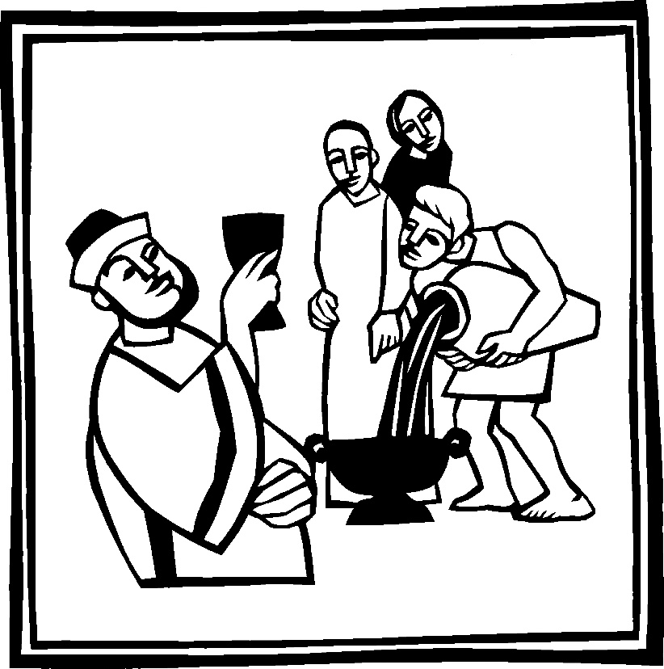
Christ Lutheran Church
“A Place Where You are Always Welcome”
Services: Saturday 5:30 pm and Sunday 10:00 am
Sunday School: 9:00 am (September- May)
600 North Main Street, Stockton, IL 61085 Office: 815-947-2033
Email: christlutheranchurch70@gmail.com http://www.christlutheranstockton.com
Ministers: ALL members of the congregation
Pastor: Rev. Chrissy Salser chrissytherev@att.net 815-988-9450
From Sundays and Seasons.com. Copyright 2017 Augsburg Fortress. All rights reserved. Reprinted by permission under Augsburg Fortress Liturgies Annual License #40643.New Revised Standard Version Bible, copyright 1989, Division of Christian Education of the National Council of the Churches of Christ in the United States of America. Used by permission. All rights reserved.

WELCOME: Thank you for joining us for worship today. We are glad you are with us. Communion will be served in the aisle or in your pew. All are welcome to share this meal. Jesus is our host and invites everyone. Those who would like to come forward, bread and wine will also be available in the front. When directed by the usher, come forward down the center aisle, Pr Chrissy will give you bread (she will be masked and wearing cloves) and then you will take a cup of wine (grape juice) from the tray. After taking communion, you will return to your seat by the side aisle. For those who are unable to come forward, communion elements can be found as you entered worship. At that part of the service, you are invited to take the bread and wine (or grape juice) when Pr. Chrissy leads. On Saturday’s offering is collected as you enter or leave worship. On Sunday we will pass the plate as a response to God’s grace. Online giving is available. Please see QR code on back of bulletin or visit our website.

Gathering: The Holy Spirit calls us together as the people of God.
PRELUDE
WELCOME AND ANNOUNCEMENTS
CONFESSIONS AND FORGIVENESS (by Joanna Harader posted Spacious Faith blog)
P: Holy One, We long to be faithful stewards of your abundant grace.
C: To serve each other in love and humility. To serve your world with wisdom and energy.
P: Forgive us when we stumble over pride, when our words and actions are not guided by love.
C: Turn our hearts when we act in folly. Restore our energy when it is gone.
P: Sometimes, many times, O God, our efforts fail.
C: But your abundant grace is strong and eternal, and forgiveness is ours through Jesus Christ. Thanks be to God. Amen.
GATHERING HYMN Sing to the Lord of Harvest ELW 694 (next page)
Greeting:
P: The grace of our Lord Jesus Christ, the love of God, and the communion of the Holy Spirit be with you all. C. And, with you.
PRAYER OF THE DAY:
P: God of life and love C: We rejoice in your abundant gifts
P: God of all peoples and all places C: We celebrate your generosity and grace
P: God of the earth and the heavens C: We praise you for your provision
P: You visit the earth and water it C: Softening it with showers and blessing its growth
P: You make springs gush forth in the valleys C: From your lofty abode you water the mountains
P: God of life and love c: We bless your holy name. Amen.
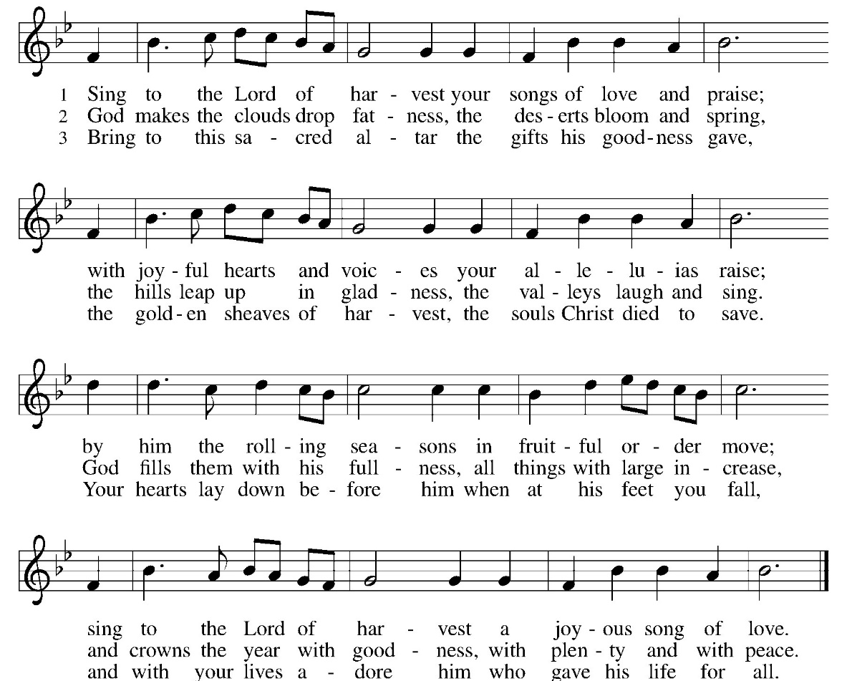
Word: God speaks to us in scripture reading, preaching, and song.
First Reading: Micah 6: 6-8

“With what shall I come before the Lord and bow myself before God on high? Shall I come before him with burnt offerings, with calves a year old? ⁷ Will the Lord be pleased with thousands of rams, with ten thousands of rivers of oil? Shall I give my firstborn for my transgression, the fruit of my body for the sin of my soul?” ⁸ He has told you, O mortal, what is good, and what does the Lord require of you but to do justice and to love kindness and to walk humbly with your God?

R: The Word of the Lord. C: Thanks be to God.

Psalm: Psalm 24

¹ The earth is the Lord’s and all that is in it, the world, and those who live in it,
² for he has founded it on the seas and established it on the rivers.
³ Who shall ascend the hill of the Lord? And who shall stand in his holy place?

⁴ Those who have clean hands and pure hearts, who do not lift up their souls to what is false and do not swear deceitfully.
⁵ They will receive blessing from the Lord and vindication from the God of their salvation.
⁶ Such is the company of those who seek him, who seek the face of the God of Jacob.
⁷ Lift up your heads, O gates! and be lifted up, O ancient doors, that the King of glory may come in!
⁸ Who is the King of glory? The Lord, strong and mighty, the Lord, mighty in battle.
⁹ Lift up your heads, O gates! and be lifted up, O ancient doors, that the King of glory may come in!
¹⁰ Who is this King of glory? The Lord of hosts, he is the King of glory.
Second Reading: 1 Peter 4:1-10
¹ Since, therefore, Christ suffered in the flesh, arm yourselves also with the same intention (for whoever has suffered in the flesh has finished with sin), ² so as to live for the rest of your time in the flesh no longer by human desires but by the will of God. ³ You have already spent enough time in doing what the gentiles like to do, living in debauchery, passions, drunkenness, revels, carousing, and lawless idolatry. ⁴ They are surprised that you no longer join them in the same excesses of dissipation, and so they blaspheme. ⁵ But they will have to give an accounting to him who stands ready to judge the living and the dead. ⁶ For this is the reason the gospel was proclaimed even to the dead, so that, though they had been judged in the flesh as everyone is judged, they might live in the spirit as God does.
⁷ The end of all things is near; therefore be serious and discipline yourselves for the sake of your prayers. ⁸ Above all, maintain constant love for one another, for love covers a multitude of sins. ⁹ Be hospitable to one another without complaining. ¹⁰ Like good stewards of the manifold grace of God, serve one another with whatever gift each of you has received.
R: The Word of the Lord. C: Thanks be to God.
GOSPEL ACCLAMATION Listen God is Calling ELW 513
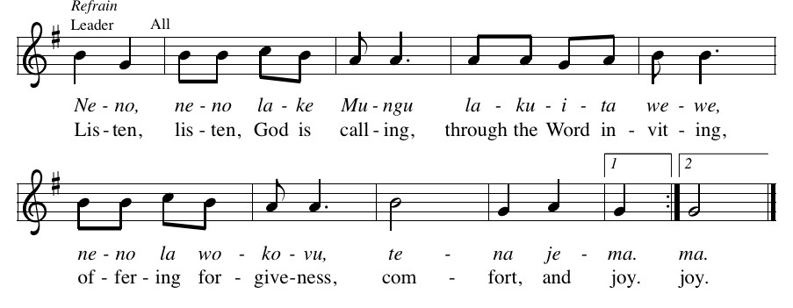

Gospel: Luke 12:22-34

P: The Gospel according to Luke C: Glory to you, O Lord
²² He said to his disciples, “Therefore I tell you, do not worry about your life, what you will eat, or about your body, what you will wear. ²³ For life is more than food and the body more than clothing. ²⁴ Consider the ravens: they neither sow nor reap, they have neither storehouse nor barn, and yet God feeds them. Of how much more value are you than the birds! ²⁵ And which of you by worrying can add a single hour to your span of life? ²⁶ If then you are not able to do so small a thing as that, why do you worry about the rest? ²⁷ Consider the lilies, how they grow: they neither toil nor spin, yet I tell you, even Solomon in all his glory was not clothed like one of these. ²⁸ But if God so clothes the grass of the field, which is alive today and tomorrow is thrown into the oven, how much more will he clothe you, you of little faith! ²⁹ And do not keep seeking what you are to eat and what you are to drink, and do not keep worrying. ³⁰ For it is the nations of the world that seek all these things, and your Father knows that you need them. ³¹ Instead, seek his kingdom, and these things will be given to you as well.
³² “Do not be afraid, little flock, for it is your Father’s good pleasure to give you the kingdom. ³³ Sell your possessions and give alms. Make purses for yourselves that do not wear out, an unfailing treasure in heaven, where no thief comes near and no moth destroys. ³⁴ For where your treasure is, there your heart will be also.
P: The Gospel of Our Lord. C. Praise to you, O Christ.
CHILDREN’S MESSAGE
MESSAGE
HYMN OF THE DAY God’s Work, Our Hands ACS 1000 (next page)
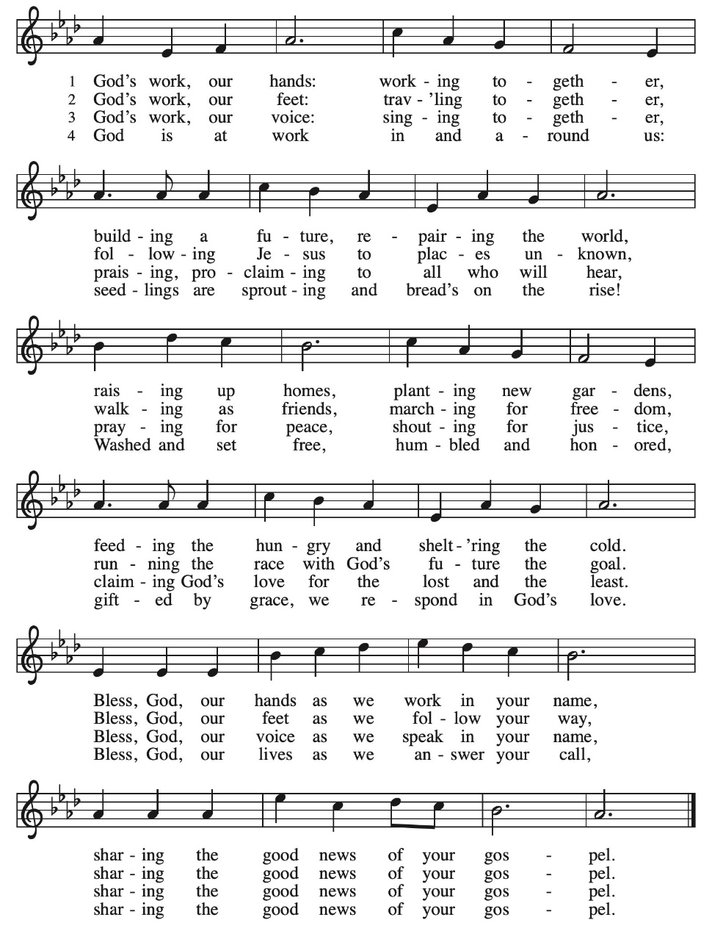
APOSTLES’ CREED:
I believe in God, the Father almighty, creator of heaven and earth.
I believe in Jesus Christ, God’s only Son, our Lord, who was conceived by the Holy Spirit, born of the virgin Mary, suffered under Pontius Pilate, was crucified, died, and was buried; he descended to the dead. On the third day he rose again; he ascended into heaven, he is seated at the right hand of the Father, and he will come to judge the living and the dead.
I believe in the Holy Spirit, the holy catholic church, the communion of saints, the forgiveness of sins, the resurrection of the body, and the life everlasting. Amen.
PRAYERS OF INTERCESSION:
P: God, we thank you for your harvest which feeds us so many times each day.
C: We are nourished with your forgiveness and hope
We are sustained with your strength and patience
We are filled with your grace and compassion
P: God, we thank you for feeding us with a harvest of plenty
C: We are restored through your generosity and healing
We are replenished with your abundance and joy
We are reminded of your selfless abandon
P: God, we thank you for feeding us with the bread of heaven
C: Your gift of Christ sustains our lives
His presence restores the promise of your love
His life fills our hearts with your everlasting light
P: God, we thank you too for filling us with the water of life
C: May we drink deeply that our thirst may be quenched
May your river continue to flow Over us, in us, through us
And out into the world you love. Amen.

PEACE
P: The peace of Christ be with you always. C. And also with you.
OFFERING: Our offering is a significant act of worship; we worship God through our giving. The ministry of this congregation is completely dependent upon your partnership and generosity. Offering is collected as you enter worship on Saturday. We will pass the offering plate on Sundays. Online giving is available.
OFFERING HYMN: Take, oh, Take Me as I Am ELW 814
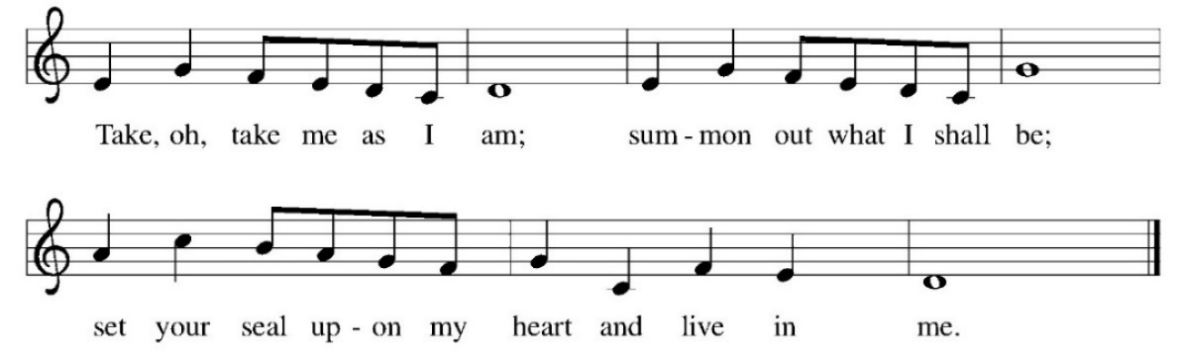
OFFERING PRAYER:
P: All good gifts around us are sent from heaven above,
C: so we lift our hearts up to you, God, in praise and thanksgiving.
P: As we count our blessings, and acknowledge your goodness,
C: our hearts go out to those who do not have, and who are in need.
P: We thank you for plentiful harvests and full refrigerators
C: and ask that you supply the needs of those who are hungry.
P:We thank you for jobs that provide for our families and supply the needs of our society,
C: and pray that you would care for those who have no work, or the dignity and purpose it brings.
P: We thank you for opportunities and choices, for meaning and challenges,
C: and pray that you would give a sense of purpose to those who feel trapped.
P: We thank you for family and friends who love us and care for us
C: and pray that you would befriend those who are alone.
P The abundance of the harvest is a symbol of the abundance of your love in our lives.
C: May we live in a spirit of gratitude to you and generosity to our neighbor.
P: Loving God, in this season and all year long, give to us the gift of a thankful heart,
C: so that we may acknowledge you as the giver of all that is good in our lives.
In the name of Jesus, we ask it. Amen.

COMMUION: Setting the Table (by Anita Monro)
P: Grain is gathered from the field; threshed and milled for flour.
C: We are formed from the grain of God’s harvest.
P: Flour is mixed with water to produce basic dough.
C: The water of baptism unites us.
P: Yeast is added to transform the mixture.
C: The vision of God’s realm draws us onwards.
P: Oil softens the dough and makes a new texture.
C: The Holy Spirit anoints us as the body of Christ.
P: A little salt improves the taste.
C: Jesus calls us to be the salt of the earth.
P: The bread is kneaded and shaped, molded and baked.
C: It is God who makes us a holy communion.
P: Grapes are harvested and crushed for juice.
C: You are the vine, we are the branches, O Christ.
P: Juice and skins are mixed with yeast for fermentation.
C: God’s reign is coming. God’s hope is here.
P: There is a time of waiting; then a time of pressing.
C: God’s new life presses forth through the sediment of our lives.
P: And finally, the feast is here!
C: Let us celebrate the feast of our life in God.
COMMUNION LITURGY:
In the night in which he was betrayed, our Lord Jesus took bread, and gave thanks, broke it and gave it to his disciples, saying: take and eat; this is my body, given for you. Do this for the remembrance of me. Again, after supper, he took the cup, gave thanks and gave it for all the drink, saying: this cup is the new covenant in my blood, shed for you and for all people for the forgiveness of sin. Do this for the remembrance of me.
THE LORD’S PRAYER:
Our Father, who art in heaven, hallowed be thy name, thy kingdom come, thy will be done on earth as it is in heaven. Give us this day our daily bread; and forgive us our trespasses, as we forgive those who trespass against us; and lead us not into temptation but deliver us from evil. For thine is the kingdom, and power, and the glory, forever and ever. Amen
INVITATION TO COMMUNION:
P: Jesus welcomes sinners and eats with them. Come to this meal of mercy.
Please come down the center aisle, take the bread, then receive a cup (wine is dark, juice is light, return to your seats via side aisle.) Those who prefer to take communion in your pews, we will take all together after all are served.
DISTRIBUTION OF COMMUNION:
P: This is the body of Christ given for you. (All take bread).
P: This is the blood of Christ shed for you. (All take the wine).

COMMUNION HYMN: Jesus Calls us Over the Tumult ELW 696
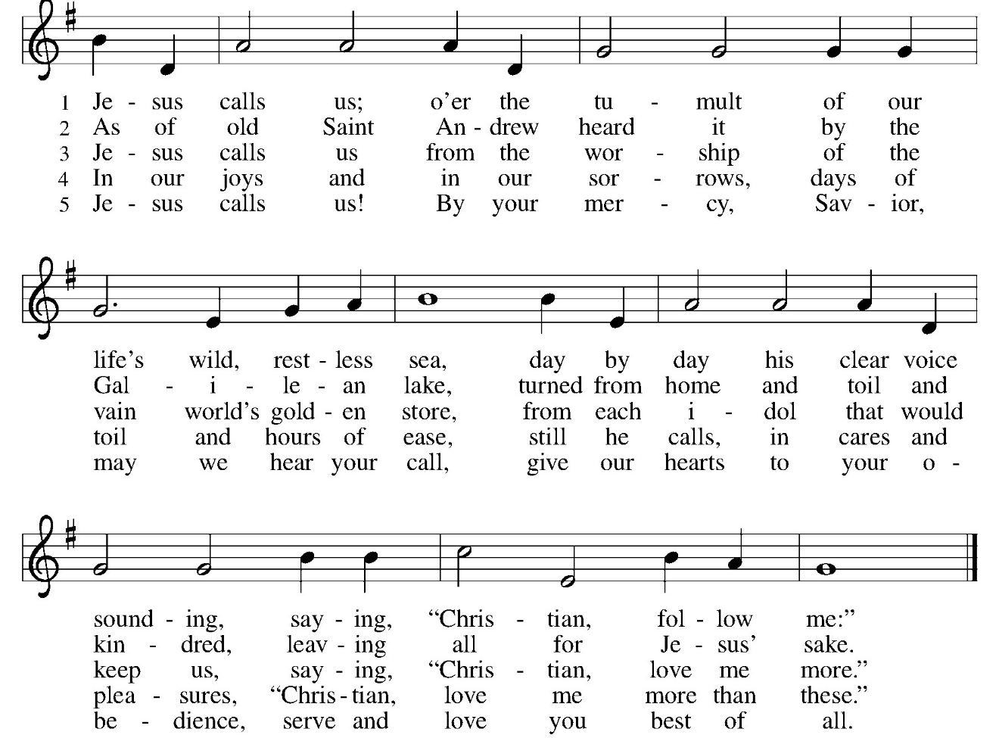

TABLE BLESSING:
P: May the body and blood of our Lord Jesus Christ strengthen you and keep you in His grace. C: Amen.
PRAYER AFTER COMMUNION:
P: O God, C: through this meal you have strengthened us and appointed us to be your servants. Send us to do good and to share our possessions with all in need. We ask this in Jesus’ name. Amen
SENDING: God blesses us and sends us in mission to the world.
BLESSING:
P: The God of righteousness, who gives justice to the oppressed, who gives food to the hungry, who sets the prisoners free, ☩ bless you now and forever. C: Amen.
SENDING HYMN Praise and Thanksgiving ELW 689
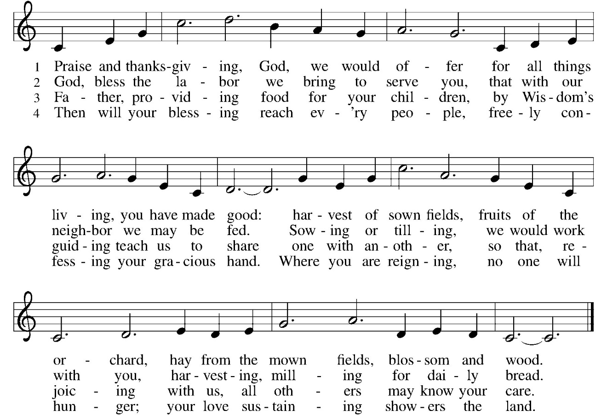

DISMISSAL:
P: Go in peace. Do not lose heart.
C: Thanks be to God.
POSTLUDE
IN OUR PRAYERS TODAY: Teresa Hesselbacher, Elaine Schlicting, Darlene and Walt Steffes, Bob Schreck, Delores Wampfler, Marge and Gerald Arnold, Don & Judy Brudi, Diego Gonzalez, Grayson Raab, James Dieter, Christine Happ, Kay Hesselbacher, Mary Lou Bunker, Lillian Sefford, Jeff Encheff, Judy Wilson, Russ Synder, Don Kunz, Johnny Blair, Jim Sullivan, Sally Duran Salser, Darrell Lindstrom To add someone to the prayer list please contact Pastor Chrissy

CELEBRATING BIRTHDAYS / ANNIVERSARIES:
DeeDee Larson, Jared Dvorak, Amanda Stitch, Samantha Brunner, Grayson Wagner, Shawn Powers, Jeanna Tucker, Huntlee Burris

Thanks be to God for your gifts for the ministry of  Christ Lutheran Church *these numbers do not reflect online giving- only offering in worship |  |  |  | Offering/ Attendance  Sat Nov 1  Sunday Nov 2
Current Expense | $1,230.00 | Building Fund | $10.00 | Nov 1 | 18
Benevolence  Sunday School | $15.00  $20.00 | Community Table | $140.00 | Nov 2  Sunday School | 37  15
 |  | Total |  | Community Dinner | 41
  $ 1,415.00

October Totals: As a way to improve communication around finances, we are sharing the following information: *these numbers reflect online giving contribution
2025
 | October | Year to date
Offerings: | $7,484 | $96,952
Expenses: | $9,104 | $102,444
Overall Gain / Loss | ($1,621) | ($5,492)

ONLINE GIVING: Your gift has a big impact on our ministries and those we serve. Scan this code or visit our website to give online today.


AMAZON WISH LIST: did you know that everyday items used at the church are items you could contribute? Find our list here or on our Facebook page. Thank you! https://www.amazon.com/hz/wishlist/ls/TWP5U0RAGGAY?ref_=wl_share

