Triple T Sports Center

Hybrid School Day Camp

Good afternoon parents,

We will be offering care during the Hybrid/Virtual School time frame, currently scheduled to begin Mar 15th.

Care will be available Mon – Fri 6am-6pm

There will be a number of options:

Virtual only:

Full time – 5 days $150 / $135 member

3 full days – 5 half days $110 / $ 95 member

Hybrid

Full time: 2 days B/A – 3 days virtual $120 / $90

3 Days: 2 days B/A – 1 day virtual $ 94 / $72

Suffolk Public Schools is going back to school March 15th. From our understanding, this is still being worked out, that the students will be in school 2 days a week and virtual the other 2 days. Either Mon / Wed or Tue/Thr for school days.

On virtual days the students will have designated time in both the morning and afternoon to complete their work. Coaches/Teachers will assist – it is our goal to get their work completed however this is ultimately not our responsibility. We will use the gym play time as an incentive for them to get their work done quickly, and correctly. However, if a child is having a particularly hard time focusing or unwilling to do their work, we will not force them. They will still be required to sit and attempt their work during the allotted school time. Please reinforce to them at home that they are only hurting themselves if they do not do their work and encourage them to complete it. If they do not have their own work during that time, we will give them some to do to occupy their time. It makes it harder for those actively doing schoolwork to have others in the room that are playing or not doing their work.

Chromebooks – please have them labeled with their name and grade. These also need to be sent fully charged and ready for use as we cannot have cords out in the room for students to possibly trip on.

Thank you for your understanding. If you have any questions, please contact me at 839-9108.

Mrs. Cheryl

Triple T Sports Center

Hybrid/Virtual School Day Camp Registration Form

# Date: _____________

# Student: _________________________________Male / Female

# Address: _____________________________________________

Phone # : _____________________________________________

Child’s Birthdate: ________________________________________

Allergies: _____________________________________________

Prescriptions: ____________________________________________

Existing Medical Conditions: _______________________________

Has this child or any other family member ever been enrolled in Triple T? _____

Primary Email address: ____________________________________

(will be used **only** to distribute gym information)

**Mother:** _________________________ Phone: _______________

**Father:** _________________________ Phone: _______________

**Emergency Contact Information: (other than parent)**

Name: ______________________________________________

Address: ______________________________________________

Phone #: ______________________________________________

Relationship to child: _______________________________________

Code Word for pick up :_____________________________________

School : ___________________________________ Grade______________

Teacher:___________________________________

Full Day(s): (Circle all that apply) Mon Tues Wed Thrs Fri - AM / PM / Full Day

Before/After School Days Mon Tues Wed Thrs Fri - AM / PM / Full Day

Triple T Member: Yes / No Currently Enrolled in : _____________ class

**For Office Use only:**

Amount Paid: $_______ Check #: ______ Cash: _____ Rec’d By: _______

Registered for Before/After School Progam _____ Payment Entered: _____

**Copy of Birth Certificate _______ Copy of Shot Record _________ Copy of Physical ______________**

**\*I understand that a 2 week written notice is required to remove my child from program, otherwise I am responsible for payment for the full tuition for those 2 weeks. ______ (*Initial). If the child is not to be picked up on a regularly scheduled day, I am responsible for notifying Triple T prior to pick up, if no notice is given a $10 fee will be charged. __________ (*Initial)**

Waiver of Liability:

I hereby release Triple T Sports Center from any and all liability for any injury (or loss of property) incurred while practicing, training, taking class, competing, participating in after school program, open gym, sleepovers, birthday parties, special events, demonstrations or shows, or in any other way involved in gymnastics, karate, dance, cheerleading, cheertumble, preschool or teams at Triple T for any reason whatsoever, including ordinary negligence on the part of Triple T Sports Center, its owners, volunteers, or employees.

I give permission for Triple T staff to sign my child into licensed/unlicensed areas of the facility.

_______________________________ ___________

Signature of parent/legal guardian Date

**Triple T Sports Center**

**Day Camp Medical Release Form**

**(All Information Very Important-Please Fill Out Completely)**

Child’s Name

______________________________________ DOB ___________ Age __________

Medical Conditions / Restrictions / Allergies: (all medicines kept at TTT require med admin form – if prescription needs to be completed by physician) _____________________________________________________________________

_____________________________________________________________________

Medications: __________________________________________________________

Special Instructions: _____________________________________________________________________

_____________________________________________________________________

**Physician ___________________________________ Telephone # (_____) _______-_________**

**Dentist _____________________________________ Telephone # (_____) _______-_________**

**Primary Email: __________________________________________________________________**

Father:_______________________________________________________________

Address ______________________________________________________________

City _____________________________________State__________ Zip___________

Home (____) ______-______ Cell (____) _____-______ Work (____) _____-______

Mother: ______________________________________________________________

Address (if different) ________________________________________________________

City _____________________________________State__________ Zip___________

Home (____) ______-______ Cell (____) _____-______ Work (____) _____-______

**Code Word ______________________________________________________________**

(This word is used to verify your authorization for them to pick up your child when you cannot. Persons other than parent will be required to produce driver’s license as identification)

Insurance (Copy of Insurance Card—Front and Back Required)

I certify that my child is up to date on all state required immunizations.

I am fully aware of and appreciate the risks of catastrophic injury, paralysis and even death, as well as damages and losses, associated with participation in gymnastics and other sports. I further agree that Triple T Sports Center, corporations, employees, agents, officers and directors shall not be liable for any losses or damages occurring as a result of camper’s participation in the “Summer Sports Day Camp”.

I hereby give consent for Triple T to provide customary medical/athletic attentions, transportation and emergency medical services as warranty in the course of my child’s participation at Triple T. I will maintain and uphold up-to-date primary medical health insurance during the entire camp enrollment at Triple T Sports Center.

_____________________________________________________ ______________________________

Parent/Legal Guardian Signature Date

**Triple T Sports Center**

***Hybrid School Day Camp***

**Day Camp Registration Fee:** $35 / $25 add’l children (includes camp t-shirt required for field trips, additional shirts may be purchased at registration if available for $15 each)

**Non-Member Registration:** $50.00 / $40.00 Additional Children

**Day Camp Rates:** 5 Day Full Day $90 / $120 Non-Member

**3 Day Full Days** $72.00 / $94.00 Non-Member

**5 Day Half Day (Virtual)** $95.00 / $110.00 Non-Member,

**5% Discount for each sibling**

**Before/After School**

**Cash, Check, Debit Cards, MasterCard, Visa, Discover Accepted**

**Camp Hours 6:00am – 6:00pm Half Day 6:00am – 1:00pm**

**Deposit:** A $25 deposit is due upon registration to hold your child’s space in each camp week. This is applied to the total due for the week. Balances must be paid on the Wednesday before each week they are attending. Your credit card will be charged for the balance for the week on Thursday if payment has not been received. If payment is not able to be made your child will not be able to attend camp until payment is received. ***Full week will be charged unless 2 week written notice is given to release the spot.***

**Licensed/Non Licensed Areas: I understand that there are licensed and non licensed areas of Triple T Sports Center. The licensed areas include the lobby, kitchen/party room, dance room, and back karate room. I give Triple T staff my permission to sign my child in and out of licensed and non-licensed areas during camp based on the activities they are participating in.**

**Campers will not be allowed to participate if tuition is not current.**

**Payment must be received by the Wednesday before your child’s care for each week. A guaranteed form of payment in the form of a credit card for day camp is required. If payment is not received Wednesday your child’s camp week will be charged to your credit card on file on Thursday Morning. Without valid Credit Card on file – student cannot be dropped off without payment in full for the week, no later than Wednesday. You will be responsible for payment of the time registered for.**

**Very Important: Signing your child IN and OUT of camp is very important. The child is not allowed to sign themselves in or out. Only the parent or authorized person is permitted to Sign in and Sign out. If an authorized person is picking up your child please note this on the sign in form and notify the front desk when you sign in. If a person is picking up that is not on the authorized persons list we will not release the child without written permission from the parent or correct code word is given.**

**Credit Card # ________- _______-________-_______Exp Date__________ (MC Visa Discover) __ __ __**

**3 digit code from back**

**Authorized Signature _________________________________ ___________________________**

**Signature Print Name**

**I have read and understand the Triple T Camp policies and agree my credit card will be processed for the amount due for the current week of day camp if not paid. This will be processed on the   
Thursday before your child’s camp for the following week. A $10 late fee will be due if payment is declined.**

**Signature Date**

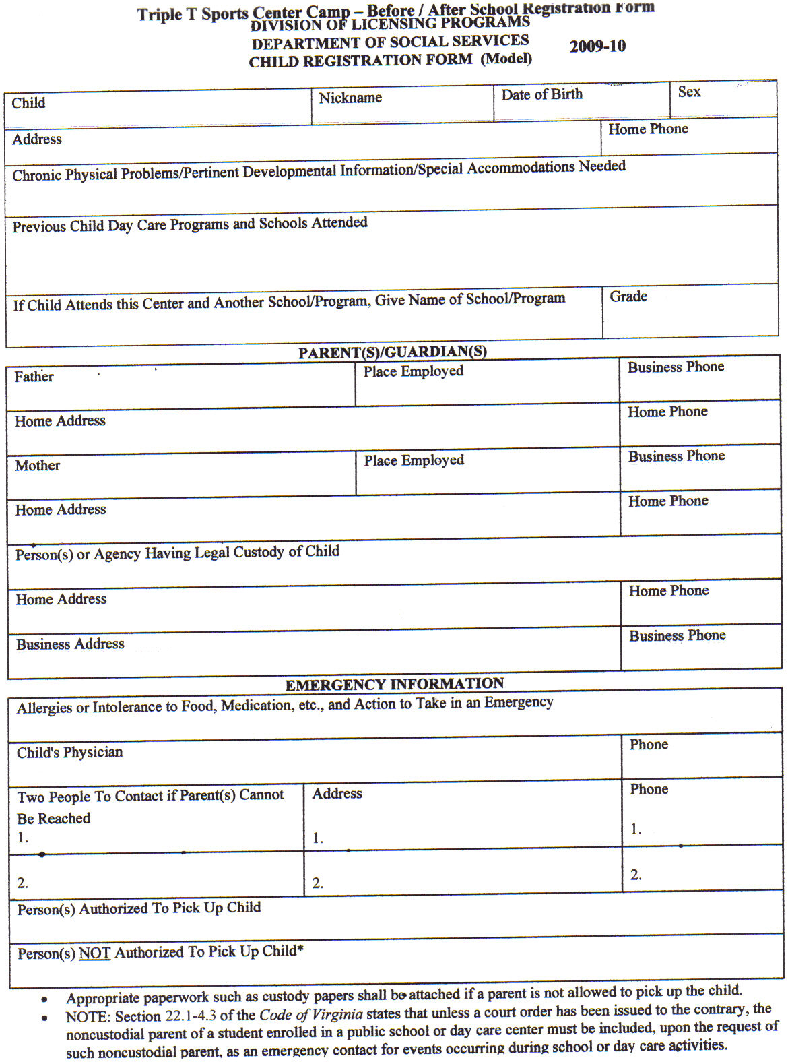

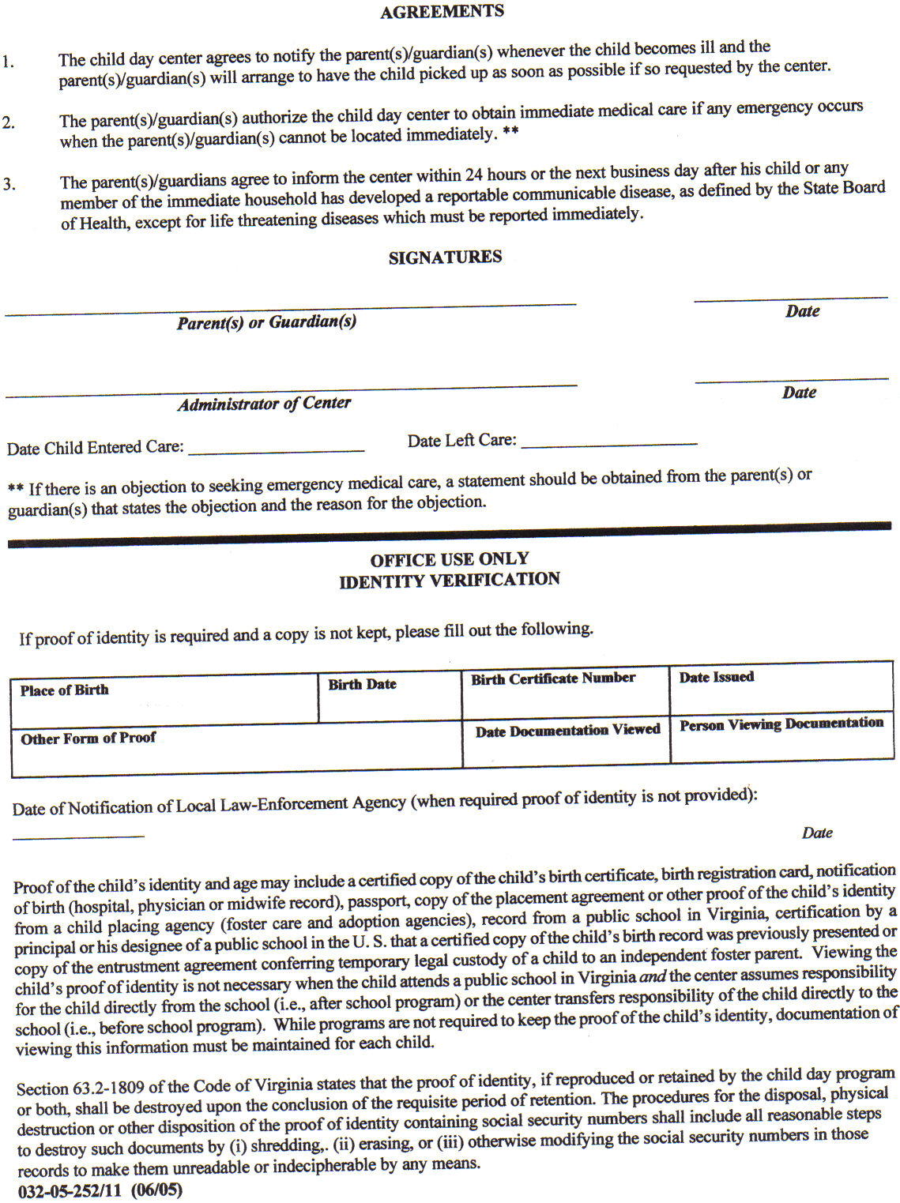

 Triple T Sports Center 

*619 East Constance Rd. Suffolk, Virginia 23434*

*(757) 923-5150 (757) 923-5185 Fax*

Nansemond Parkway Elementary

Nansemond Suffolk Academy (after school only)

Elephants Fork Elementary

Kilby Shores Elementary

Hill Point Elementary

Booker T Elementary

Mack Benn Elementary (need transportations approval to ride their bus)

Pioneer Elementary

Re: After School Pick Up

I authorize Triple T Sports Center, Cheryl and Tyrone Burks to pick up my child, __________________________, from school for after school care starting on ______________.

______________________________ _________

Parent (Legal Guardian) Signature Date

______________________________

Printed Name

Days of the week for Triple T pick up: (circle all days)

Monday Tuesday Wednesday Thursday Friday

Cost: (due the wed the week prior)

Hybrid:

3 Days per week $94 non member / $72 member

5 days per week $120 non member / $90 member

**WAIVER/RELEASE FOR COMMUNICABLE DISEASES INCLUDING COVID-19 ASSUMPTION OF RISK / WAIVER OF LIABILITY / INDEMNIFICATION AGREEMENT**

**Participants Names:__________________________________________________________**

In consideration of being allowed to participate on behalf of TTT Sports Center and related events and activities, the undersigned acknowledges, appreciates, and agrees that:

1. Participation includes possible exposure to and illness from infectious diseases including but not limited to MRSA, influenza, and COVID-19. While particular rules and personal discipline may reduce this risk, the risk of serious illness and death does exist; and,

2. I KNOWINGLY AND FREELY ASSUME ALL SUCH RISKS, both known and unknown, EVEN IF ARISING FROM THE NEGLIGENCE OF THE RELEASEES or others, and assume full responsibility for my participation; and,

3. I willingly agree to comply with the stated and customary terms and conditions for participation as regards protection against infectious diseases. If, however, I observe any unusual or significant hazard during my presence or participation, I will remove myself from participation and bring such to the attention of the nearest staff member immediately; and,

4. I, for myself and on behalf of my heirs, assigns, personal representatives and next of kin, HEREBY RELEASE AND HOLD HARMLESS TTT Sports Center, their officials, agents, and/or employees, other participants, sponsoring agencies, sponsors, advertisers, and if applicable, owners and lessors of premises used to conduct the event (“RELEASEES”), WITH RESPECT TO ANY AND ALL ILLNESS, DISABILITY, DEATH, or loss or damage to person or property, WHETHER ARISING FROM THE NEGLIGENCE OF RELEASEES OR OTHERWISE, to the fullest extent permitted by law.

I HAVE READ THIS RELEASE OF LIABILITY AND ASSUMPTION OF RISK AGREEMENT, FULLY UNDERSTAND ITS TERMS, UNDERSTAND THAT I HAVE GIVEN UP SUBSTANTIAL RIGHTS BY SIGNING IT, AND SIGN IF FREELY AND VOLUNTARILY WITHOUT ANY INDUCEMENT.

Parent signature:________________________________________________

Parent Name Printed: ____________________________________________

Date signed: _____________

MASKS/COVID: If your family is highly concerned about coronavirus or has immunocompromised family members, then our programs may not be a good fit for your family. TTT Sports Center (TTT) has always had a thorough daily cleaning schedule and follows all childcare licensing protocols for cleanliness, sanitizing, and hand washing. Parents will be required to submit the regular daily health check prior to bringing their child to the program (temperature, symptoms, etc..). Per executive order children 4 and older are required to wear masks during childcare. Coaches, staff, and parents/guardians are required to wear masks while inside the building.

TTT Covid Protocols – reminder - these are mandatory for all people inside TTT. No exceptions

Snack shack – everyone is to **clean and sanitize** their hands prior to touching anything in the office! There is sanitizer on the counter in the office for parents and staff to use as well as a jug on the desk on the vault runway that is to be used by kids prior to entering the office. They also need to have washed their hands prior to coming to snack area. Washing is not the same as sanitizing – both must be done. Tables and chairs in the snack area are to be done as well – after each use. Coaches are responsible for making sure this gets done as well as maintaining proper social distancing between the children during break. There should be no more than 9 in the kitchen at a time. 3 per table

You are to submit daily health screen upon arrival. It is your responsibility to check in on Himama app as well. Make sure you read and answer the questions daily – do not just answer no to everything out of habit. I have on several occasions had staff or parents say they didn’t think about something and had answered no to questions that should have been yes. It is a new screening daily and is important to the future of the gym that everyone is doing their part to avoid unnecessary shut downs. If experiencing any symptoms, of unknown origin, please keep them home.

Wash / sanitize your hands regularly. All employees wear gloves when touching either a child or their belongings. With some of the computers it is hard to use them with gloves in that case their hands will be sanitized before and after touching the child’s computer. The children’s computers are also being wiped down in the morning prior to turning them on. School time – hand sanitizer and disinfecting wipes are kept on each table that a staff member is at so that they are readily available as needed.

Everyone is to maintain **minimum of 6’** distance between each other at all times. If there is ever a covid exposure - there is no reason for anyone to be considered to have been in “close contact” with another member. Please reinforce this with your child. When at desks they also have barriers between each other to help as well.

Masks are to be covering both nose and mouth at all times unless eating or separated by partition. This has been a struggle. Please remind your child of the importance of wearing the masks correctly. I do have some new masks for them that I will be sending home Tuesday that are adjustable and should stay on better than the ones that don’t adjust.

We know this past year has been tough on everyone – the kids, you as parents, as well as us as a facility. Together we will get through this. We unfortunately have had a few occasions that parents knowingly brought their child after a covid exposure. This absolutely cannot happen. We do understand sometimes you find out after the child is in our care and this is out of your control however as soon as you know the child must be removed from the center. However, if a child is knowingly brought or left after finding out then your childcare services will be terminated. Also, if you do find out that your child has come into contact with a known positive person, and was at our center in the previous 48 hours, then it is your responsibility notify Cheryl Burks (757)839-9108 directly and to take the child in for Covid testing within 24 hours. The child would still need to quarantine even if test is negative due to exposure per CDC Guidelines however this will determine the need for the rest of the families, students, and our staff to quarantine. Failure provide test results will result in immediate termination of care. You would still be responsible for payment of the full 2 week notice, and would not be covered by social services. We unfortunately feel that both of these policies need to be put into place to protect the staff, students, and the facility itself. Our main goal, as has always been, is to provide the safest possible environment for the children in our care – in the midst of this pandemic we need your help and cooperation for that to happen. Thank you for all you do to help keep everyone safe and healthy.

I __________________________________, parent or guardian of __________________________________ _____________________________________have read, understand, and agree to abide by the Covid policies stated above.

Signature _________________________________ Date _____________________

Received by:

Staff Member_______________________________ Date________________________