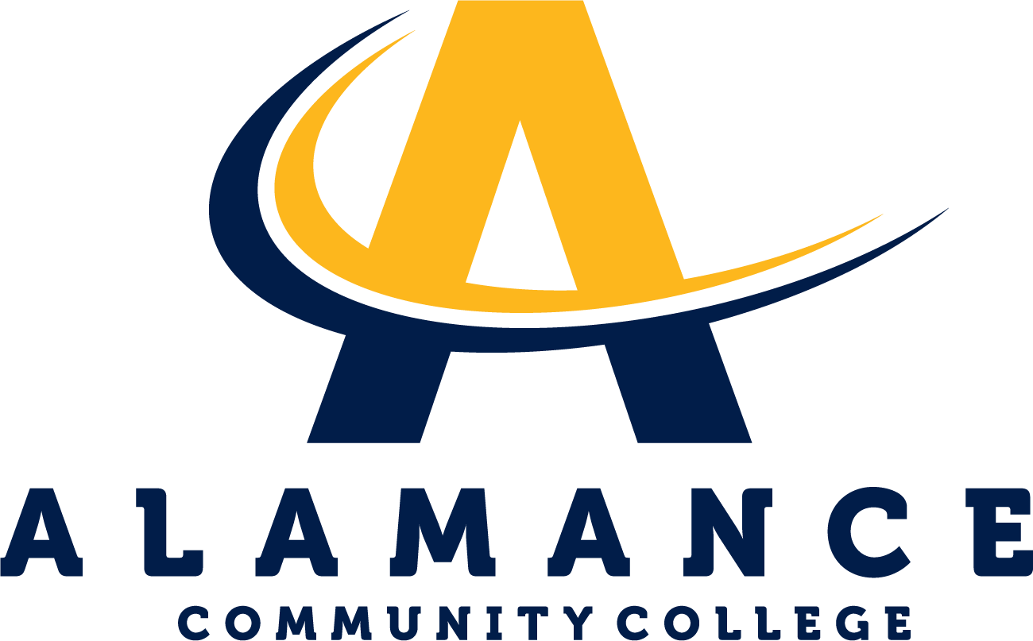
Natural Sciences Department

Basic Anatomy & Physiology: Bio 163
T/Th 9:30 AM - 12:20 PM Online Asynchronous TBD
5/21/2025 - 7/18/2025
Contact Information
Instructor: Dr. Kate Brilakis
Phone: 703.498.9997
Email: ---------------------
Course Website: http://www.katebrilakis.com/home.html
Department Head: Mary Beth Morgan
Office: H122 - Powell Building
Phone: 336-506-4275
Email: mkmorgan784@alamancecc.edu
Course Description
This course provides a basic study of the structure and function of the human body. Topics include a basic study of the body systems as well as an introduction to homeostasis, cells, tissues, nutrition, acid-base balance, and electrolytes. Upon completion, students should be able to demonstrate a basic understanding of the fundamental principles of anatomy and physiology and their interrelationships.
Accessibility Services
Alamance Community College is committed to providing equal educational opportunities for students with documented disabilities. Students who require accessibility services or reasonable accommodations are required to identify themselves as having a disability and provide current diagnostic documentation to the Student Support Center in the Main Building,
Room 233. All information is confidential. For more information, please contact Kirsten Garrison, Accessibility Services Coordinator, at 336-506-4130 or email at kmgarrison728@alamancecc.edu.

Course Competencies
By the end of this course student will be able to:
Competency: Demonstrate knowledge of body organization.
Competency: Be able to recognize and identify regions of the body.
Competency: Be able to define homeostasis and relate it to functioning at the cellular
level and whole-body level.
Competency: Know the major parts of a eukaryotic cell.
Competency: Be able to list the four main classes of organic molecules and explain their
functions in living systems.
Competency: Identify the names and locations of major bones and muscles.
Competency: Describe blood flow through the body and heart.
Competency: Be able to identify the form and function of the organs in major body
systems (integumentary, skeletal, muscular, nervous, digestive, lymphatic,
cardiovascular, endocrine, reproductive, and respiratory).

Course Credit
Class: 4.00
Lab: 0.00
Clinical: 0.00
Work: 0.00
Credit: 5.00
Skills Development
Soft Skills: Critical Thinking
Hard Skills: Understanding the role of each organ system role in maintaining homeostasis

Required Text
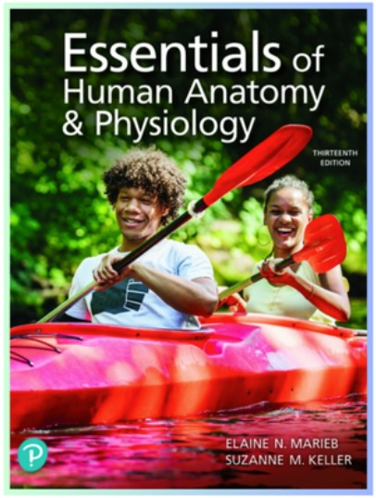
Title:
Essentials of Human Anatomy and Physiology
ISBN:
9780135625606
Authors:
Elaine Marieb
Publisher:
Pearson
Edition:
13
th
Mastering A&P with Pearson eText for Essentials of Human Anatomy &
Physiology
Course Grading and Requirements
Lecture (70% of grade): 4 Lecture Tests (52% of total grade)
Mastering Chapter Homework Assignments (18% of total grade)
Laboratory (30% of grade): 3 Lab Practical Tests (30% of total grade)
Grading Scale: course averages will be applied to the following scale.
89.6 – 100% = A
79.6 – 89.5% = B
69.6 – 79.5% = C
59.6 – 69.5% = D
Below 59.6% = F

Student Success
We want you to succeed in this course, and ACC offers a variety of free resources to help you, including the Academic Support Center, the Writing Lab, and the STEM Lab. The Academic Support Center (Main 348) provides free tutoring and an open computer lab where you can complete your coursework. The Writing Lab (Main 349) offers individual sessions with a writing consultant who can assist with the development, organization, grammar, and mechanics of your assignments. The STEM Lab (Main 391) provides a walk-in environment with experienced tutors to help with math and many STEM-related courses. No appointments are required to use the STEM Lab.

Attendance
You’re expected to attend and be on time for all scheduled classes and labs. If you must be absent, please let me know. If you have not attended at least one face-to-face class meeting or completed one assignment/activity for an online class by ACC’s 10% date, you’ll be recorded as “never attended” and will be no longer enrolled in the class.
Under extenuating circumstances, if you’ve never attended by the 10% date, you may petition for reinstatement in the class and earn course credit. Please notify me, in writing, of the extenuating circumstances prior to the 10% percent date of the class and provide compelling documentation to support the request for reinstatement. Reinstatement will only be considered
when the absences were due to unforeseeable and uncontrollable circumstances. A decision
regarding reinstatement may be appealed to the appropriate Dean within two (2) business days. The Dean’s decision is final.
Any student who has been absent for 20% or more of the total contact hours prior to the withdrawal date of the course may be administratively withdrawn from the course. A student in an online or hybrid course may be administratively withdrawn following two consecutive weeks in a 16-week term (or one week in shorter academic terms) of missed assignments, missed attendance, and lack of communication with the instructor regarding course participation. Consistent with policies establishing attendance in online courses, logging into a course site but failing to perform the assignments does not constitute attendance. A grade of “WP” will be assigned for any course from which the student is administratively withdrawn.
Administrative withdrawals will be allowed up to the published Administrative Withdrawal deadline each semester (the 80% point of the semester). Thereafter, the earned grade will be posted. Under extenuating circumstances, a student may petition, in writing, the instructor, for reinstatement in the course upon demonstrating the capacity and likelihood of satisfactorily completing requirements as indicated on the course syllabus.
Tuition refunds or credits will not result from an administrative withdrawal.
For more information, consult Policy 5.2.1 - Attendance at Alamance CC College Catalog.

Dates for Assignments and Tests
All online assignments must be completed by the posted due date.
Extensions will not be available.
All lecture test and lab practical test dates are listed on our course schedule on the following page. If you are absent for a test, please let me know. If you are planning to request a make-up test, you must submit a request in writing prior to 9am on the day of the test. A make-up test for a lecture test may be available on a case-by-case basis if the reason for the absence is compelling. This does not include vacations. Period. If approved to take a make-up test, you must complete the test within two days following your absence.
Lab practical tests cannot be made up under any circumstances since setting up the practical test requires a significant amount of time and access to the lab classroom on an unassigned day/time.

BIO 163 Lecture Schedule Summer, 2025 May 22st to July 18
Date Chapter(s) Topic
Section 1:
May 22 1 Human Body: An Orientation
May 27, (28) 2 Basic Chemistry
May 29, June 3, (4) 3 & 4 Cells, Tissues, Membranes and Skin
Thursday, June 5 Section 1 Test
Section 2:
June 10 5 Skeletal Physiology
June (11) 6 Muscular Physiology
June 12, (17) 7 Nerve Function
June (18) 8 Special Senses
June 19 ACC Closed/National Independence Day
June 24 Section 2 Test
Section 3:
June (25) 9 Endocrine System
June 26 10 Blood
July 1 11 Cardiovascular System
July (2) 12 Lymphatic System and Immunity
July 8 Section 3 Test
Section 4:
July (9) 13 Respiration
July 10 14 Digestion and Metabolism
July 15 15 Urinary System
July 16 16 Reproductive Systems
July 17 Section 4 Test

BIO 163 Lab Schedule Summer, 2025 T/Th May 22 to July 18
Lab # Date Topic
Lab 1 May 22 Intro to Our Lab
Lab 2 May 27 Tissues
Lab 3 May 29 Axial Skeleton
Lab 4 June 3 Appendicular Skeleton
Lab 5 June 5 Muscles I (on practical 2)
June 10 Practical 1 on labs 1,2,3 & 4
Lab 6 June 12 Muscles II
Lab 7 June 17 Brain/Spinal Cord
June 19th ACC closed: National Independence Day
Lab 8 June 24 Special Senses
June 26 Practical 2 on labs 5,6,7,& 8
Lab 9 July 1 Circulation: the Heart
Lab 10 July 3 Circulation: Blood Vessels
Lab 11 July 8 Respiratory System & Digestive System
Lab 12 July 10 Urogenital Systems
Lab 13 July 15 Practical 3 on labs 9,10,11 & 12

Classroom Conduct/Participation
If you engage in any behavior during class that is disruptive, you may be instructed to leave the classroom and/or be restricted from online access of the course The Disturbance Warning Memo provides a list of disruptive behavior. Continuous disruptive behavior will result in dismissal from the course.
The Biology courses offered at ACC are conducted from the standpoint of science as a specific method of investigating the natural and physical world. The content of science courses emphasizes current scientific understanding of the living & non-living world derived from the rigorous collection and analysis of data. As an active process, science is continually updating, refining, and re-testing its body of knowledge. ACC Science classes do not include the presentation or discussion of alternative explanations rooted in theology.

Veteran Services
Alamance Community College is dedicated to serving the men and women, who have served and currently serve, in the armed forces. All students eligible for Military Education benefits, including Spouses and Dependents, are treated with the utmost respect for their sacrifices. Veterans, Guardsmen, and active-duty military personnel with special circumstances (e.g., upcoming deployments, drill requirements, disabilities) are welcome and encouraged to communicate these to the instructor. Please contact Brian Barringer, Veterans Coordinator, for more information at 336506-4398 or email bmbarringer477@alamancecc.edu.

Title IX
Alamance Community College is committed to fostering a safe, productive learning environment. Title IX provides that no person in the United States shall, on the basis of gender, be excluded from participation in, be denied the benefits of, or be subjected to discrimination under any education program or activity receiving Federal financial assistance. As part of Title IX protections, sexual misconduct — including harassment, domestic and dating violence, sexual assault, and stalking — is also prohibited on our campus.
ACC encourages anyone experiencing sexual misconduct to talk to someone about what happened, so they can get the support they need and we can respond appropriately. If you wish to speak confidentially about an incident of sexual misconduct, please contact one of the following campus resources:
College counselors/advisors - Student Support Center, Main 233
Jenny Brownell, Student Support Center, 336-506-4146 jennifer.b rownell@alamancecc.edu
Brian Barringer, Student Support Center, 336-506-4398 brian.barringer@alamancecc.edu
Dr. Patricia Alghali, Student Support Center, 336-290-0502 patricia.alghali@alamancecc.edu
Crossroad Sexual Assault Response and Resource Center, 336-228-0813
Alamance Community College is legally obligated to investigate reports of sexual misconduct, and therefore it cannot guarantee the confidentiality of a report, but it will consider a request for confidentiality and respect it to the extent possible. If you wish to report sexual misconduct or have questions about campus policies and procedures regarding sexual misconduct, please contact our school’s Title IX coordinator, Valerie Fearrington, Gee Bldg. 105, 336-506-4133, vfearrington969@alamancecc.edu.
As a member of the faculty, I am also required to report incidents of sexual misconduct and thus cannot guarantee confidentiality. I must provide our Title IX coordinator with relevant details such as the names of those involved in the incident.
Belonging
To help support a welcoming environment, Alamance Community College uses Inclusive Practices. Inclusive Practices is a self-assessment where staff and faculty intentionally focus on the student experience to help foster a sense of belonging. The four tenets of Inclusive Practices are below:
* Do you see me?
* Do you hear me?
* Will you treat me fairly?
* Will you protect me?
We are committed to your success because YOU BELONG HERE.
For more information on ACC's Office of Belonging or for questions, please contact Josefvon Jones at 336-506-4289 or by emailing, jjones827@alamancecc.edu.

Student Support Services
TimelyCare is ACC's free, virtual mental health platform. Curriculum students can access TimelyCare by downloading the app on their phone or going to timelycare.com/alamancecc and logging in with their ACC email address. Access begins the first day of the semester. Services include scheduled counseling sessions, on-demand (talk-now) counseling sessions and self-care resources on things like sleep habits, healthy eating, anxiety, depression, yoga and more! Contact the Student Support Center at studentsupport@alamancecc.edu or 336-506-4362 for more information or for any access issues.
TRiO Student Support Services (SSS) is a federally funded program granted by the U.S. Department of Education. TRiO services provide opportunities for academic development, assist students with basic college requirements, and motivate students toward the successful completion of their postsecondary education. The goal of the TRiO SSS program is to increase student retention and graduation rates. Learn more about the TRiO program
The PACE Success Coaches support and inspire students to engage in self-discovery, mitigate barriers, persist from application to completion, and become lifelong learners and global citizens. PACE coaches provide academic support and college and community resources to meet the needs of students. Learn more about PACE Success Coaching
ACC’s Food Pantry distributes food to currently enrolled students. Food is free; no income information is required. Students are welcome to pick up a bag of groceries once a week from the Student Success Center, Main 233 or at the Dillingham Campus, Room 108.
Learn more about the ACC Food Pantry
ACC Public Safety: Sign up for ACC alerts to stay connected and informed of emergency and inclement weather notifications and campus closures. Learn more about ACC Alerts
Alamance Community College has partnered with Single Stop, a non-profit organization, to provide students with easier access to a wide range of resources and benefits. Students can be quickly and conveniently screened for resources related to food, housing, earned income and child care tax credits, childcare-related resources, health care resources, and more. Kristen
Sutherland, Single Stop coordinator, at 336-506-4039 or at kmsutherland239@alamancecc.edu .
The Student Support Center is your resource for a variety of important student services. Located in the Main Building (Room 233) of the Graham Campus, the center is committed to your success by making available programs and resources focused on student’s academic, vocational, and personal growth and achievement. For more information, please visit the Student Support Center online, or call 336-506-4362

Virtual Conferencing
Our course will use Collaborate to conduct virtual meetings and/or office hours.
Instructions on how to access this platform will be provided.

Classroom Technology Policy
A laptop or desktop is required for this course to access online and electronic class materials.

Communication Policy
Communication between students and the college will be conducted using ACC’s ACCess Email addresses. You are expected to set up your ACCess email account and check it regularly for instructor, advisor and college emails. Course announcements sent through Moodle will go to your access account.
Communication between students and the college will be conducted using ACC’s ACCess Email addresses. You are expected to set up your ACCess email account and check it regularly for instructor, advisor and college emails. Course announcements sent through Moodle will go to your access account.
I will do my best to respond to emails within 24 hours. If you don’t hear from me within that time frame, chances are I didn’t get your email. Please try again! If it is an emergency, feel free to text me.

Academic Dishonesty and Plagiarism
Alamance Community College expects every student to be committed to honesty and academic integrity. To ensure that all students understand ACC's expectations, specific examples of cheating and plagiarism, two common forms of dishonesty, are outlined below. The lists are representative, but not all-inclusive of various types of academic dishonesty.
Cheating includes copying tests, assignments, projects, presentations, and similar work; submitting work that was previously submitted in another course or at another institution without instructor approval; changing grades without the instructor's knowledge; using unapproved sources (print, electronic, or web materials, etc.) during tests; receiving and giving assistance with tests or other assignments without instructor approval; and any action which misrepresents or defrauds.
Plagiarism includes representing others' work (papers, tests, assignments, projects, etc.) in any form, print, electronic, web, etc., as your own; not giving credit to work created or composed by another author (refer to The Publication Manual of the American Psychological Association, the MLA Handbook for Writers of Research Papers, or other approved style guide); or submitting a purchased paper, project, or presentation as your own original work.
Other academic honesty violations include allowing others to copy your work, providing your work to others for submission as their own, lying to improve your grade or others' grades, changing a graded work and submitting it for regrading, stealing or destroying others' work, collaborating on work without instructor approval, and impersonating another by taking their examination.
If a student commits an act of academic dishonesty, the consequences may include one or more of the following at the discretion of ACC administrators: receive a zero grade on that assignment, receive an "F" in that course, and/or be suspended or expelled from the college. View the entire policy in ACC's Course Catalog

Honors Statement
Students interested in becoming participants in the honors program should contact John Neathery, Program Coordinator at 336.506.4242 or john.neathery@alamancecc.edu. To learn more, visit the Honors Program on the ACC website,
Students interested in becoming participants in the honors program should contact John Neathery, Program Coordinator at 336.506.4242 or john.neathery@alamancecc.edu.
Please visit www.alamancecc.edu/honors for more information.

