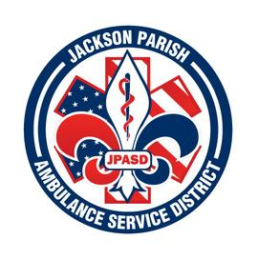

**Jackson Parish Ambulance Service District**

**115 Watts Street**

**Jonesboro, LA 71251**

**Office: (318)-259-2877 Fax: (318)-259-2099**

**jacksonparishambulance@jpasd.com**

**Aaron K. Johnson, Jr. Paula Parkerson,MD**

**EMS Director Medical Director**

**Governing Board: Joe Vail, Allen Lindsay, Alma Williams, Conchita Doyle, Deidre Hollis**

Meeting Minutes for Regular Scheduled Board Meeting: Thursday, January 12, 2023 @ 12:00 noon

Present: Allen Lindsay, Joe Vail, Conchita Doyle, Amber Swanner, Aaron Johnson, Jeff Carpenter, Michelle Bartlett

Absent: Alma Williams and Deidre Hollis

Guests: None

Meeting was called to order by Allen Lindsay. Roll call by Aaron Johnson: Present: Allen Lindsay, Conchita Doyle, and Joe Vail. Absent: Alma Williams and Deidre Hollis. No Guest present. No comments. Invocation led by Conchita Doyle. Pledge of Allegiance led by Joe Vail. Motion made by Joe Vail and seconded by Conchita Doyle to accept Meeting Minutes for December 8, 2022. All in favor motion carried. Motion made by Conchita Doyle and seconded by Joe Vail to approve and accept the financials and pay bills for December 2022. All in favor motion carried. Director’s report given by Aaron Johnson. Director’s report includes maintenance report, January schedule, Employee Status update, Water pipe busted, EMT class update, Parish Ambulance coverage, Stand-by generator, Mutual Aid requests, Upcoming meetings. Motion made by Joe Vail and seconded by Conchita Doyle to accept the Director’s report. All in favor motion carried. No Old Business. No New Business. Motion made by Joe Vail to adjourn meeting. All in favor motion carried.

Next Regular Board Meeting will be held:

Thursday, February 9, 2023 @ 12:00 noon

Thursday, March 9, 2023 @ 12:00 noon Aaron Johnson /Secretary-Treasurer

@ JPASD – 115 Watts Street – Jonesboro, LA Unofficial Minutes