
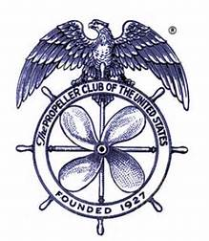
Tacoma Propeller Club
April General Membership Meeting

Wednesday, April 22, 2026

The Past Presidents’ Club is proud to announce their commitment to
education by presenting the 2026 Tacoma Propeller Club
Memorial Scholarships at its April 22 meeting.

Our very special Guest Speaker is
Olu Ikuesan, Ed. S.
Account Manager, Alaska & Washington
Savvas Learning Company
Official Title: Education Visionary

Social Time ~ 5:00 pm
Buffet Dinner ~ 6:00 pm
Program ~ 6:30 pm

Tacoma Yacht Club
5401 Yacht Club Road

Specialty 2-Entrée Buffet Dinner
Cost ~ $45.00

Please RSVP to tacomapropellerclubap@gmail.com
by Wednesday, April 15
(If you do not cancel your reservation by noon April 17 you will be charged)

Please plan to attend and show your support of the Pierce County
high school students who applied for these awards.
The recipient of the first-place award, a $4,000.00 scholarship,
will present their winning speech.

We hope you can join us and support our
DEDICATION TO EDUCATION!

