YaHuWaH Elohim inspired me just a day or two ago to look again at the International Morse Code function of the current lunar eclipse sequence. He embedded cryptic information into the earth-moon orbital parameters at the time of the creation of heaven and earth. Order does not arise out of chaos without the intervention of an intelligent being. The attached files show that in 1910 order did indeed arise out of centuries of chaos in the earth - moon orbital system, thus providing evidence of the workings of a vastly powerful and intelligent Creator. The year 1910 is exactly 6000 x 360 day years (6000 prophetic years) from 4004 BC. In other words, we entered the prophetic 7th 1000 year day in 1910, and immediately the earth-moon orbital system began delivering encoded information to us from our Almighty Creator.

I'm attaching an XLS file with an International Morse Code translation of the current 700 year wide lunar eclipse sequence. I hope it won't overwhelm you. If you're unable to view XLS files on your computer, I'm also attaching JPEG images of the XLS file so that you can print and piece together a copy of the XLS file for examination.

A Short History of the Morse Code

Samuel F.B. Morse was the son of a Baptist minister. His invention of the telegraph and the Morse telegraph code was the very beginning of electrical data transmission. Even our computers today still use the same on-off binary function of the Morse code, but with computer languages instead of the Morse language.

I'm a ham radio operator and I recognized the Morse code function embedded in the current lunar eclipse sequence when YaHuWaH Elohim revealed the sequence to me on 12/08/2009. As a ham radio operator I have communicated with people in many other languages in Europe, Asia, South America, Japan, etc. Radio amateurs send three letter groups in Morse code that mean the same thing in all languages, such as the letters "QTH Tiblisi" which means "My location is Tiblisi". Because Morse Code is globally accepted, we may possibly expect our Creator to use this method to communicate to the entire world.

I've ignored the Morse code aspect of the eclipse sequences until now, but decided to check it out a few days ago.

The results were very surprising.

The lunar eclipse sequence contains random triads (three eclipses in a row), translated as Morse code "dots", from the 17th century to 1910. Then in 1910 a coherent sequence of lunar total eclipses emerges to tell a story in Morse coded ancient Hebrew. The code is made up of triad and tetrad (four eclipses in a row) lunar eclipse groups which represent the dots and dashes of international Morse code. The Morse code is then applied to the ancient pictographic proto-Sinaitic Hebrew from the times of Moses, and a message appears that we can understand.

In the attached files, there are two Morse letters, "L" and N" squashed together in the triads and tetrads from the year 2000 to 2019, unlike the rest of the eclipse sequence which has 7 year spacing between the Morse code letters, and their central date is 2/11/2013, the day that Pope Benedict resigned and lightning struck the Vatican. Link: http://newsfeed.time.com/2013/02/13/lightning-strikes-st-peters-basilica-the-day-pope-benedict-xvi-resigns/

Then there is the central date from the last blood moon tetrad on 9/28/2015 to the first lunar eclipse of the next triad on 1/31/2018. The central date of that pair of lunar eclipses is 11/29/2016, exactly the same date as the central date of the end times Four Tavs Solar Eclipses of 1999 and 2034. By means of Solar and Lunar eclipse sequences, our Creator Elohim is doubly emphasizing the date of 11/29/2016, which is the anniversary of the United Nations partitioning of YaHuWaH 's land into Arab and Israeli portions. YaHuWaH Elohim has warned that He will cut in pieces those nations who partition His land, and through the message revealed in these solar and lunar eclipse sequences He delivers a message of warning to the peoples and governments of the earth. To ignore His emphatic warnings is foolish and the results can be deadly.

The attached XLS file and JPEG images explain some of the morse code translation and the meanings of ancient Paleo Hebrew pictographic letters.

Here are some of the graphics included in the attached files:

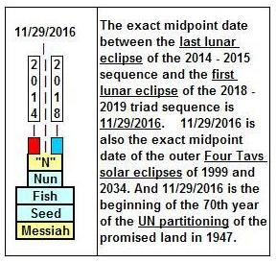

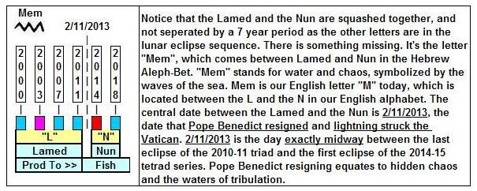

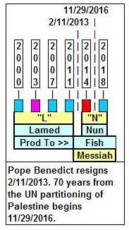

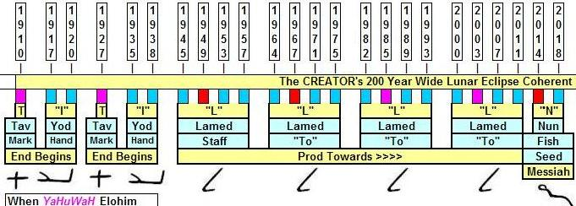

There is information concerning the Four Tavs Solar Eclipse sequences which dovetails with the Lunar Eclipse information presented here, both pointing to 11/29/2016, available on the JoyBySurprise.com website at this link: http://www.joybysurprise.com/Sign_of_Messiah_s_Return.html

May we all begin to understand the amazing capabilities of a Supernatural Being who is able to make separate solar and lunar eclipse events both point to the same exact day, to a day that marks the beginning of the 70th year of an event that infuriates Him. That event being the partitioning of the land that YaHuWaH Elohim promised entirely to the descendants of Jacob (Israel).

One last note. Not included in the attached graphics is the fact available on the webpage listed above that on 9/23/2017 an astronomical event occurs which indicates the birth of the "manchild" of Revelation 12. That sign would confirm and tie in with the Hebrew letter "Nun" embedded in the current lunar eclipse sequence from 2014 to 2019 in the graphic above.

The ancient Hebrew letter "Nun" means "fish" or "seed" or "Son". Yehoshua (Joshua) was the son, or "seed" of Nun who led the tribes of Israel into the promised land after the passing of Moses. Yehoshua (Joshua) who led Israel into the promised land was supposed to be a prophetic type of YAHUSHUA our Messiah who would lead us spiritually into the promised land, but the prophetic type and name link between the the two "Joshuas" was obscured by Christian translators who came up with the non-name "Jesus" instead. Our Messiah YAHUSHUA may be indicated on the attached graphics as a "seed", the Hebrew letter "Nun", ( the seed or son of Nun, referring back to the ancient days of Moses) appearing in the graphic between 2014 and 2019.

