8th Annual Orphan Car Show Registration
sponsored by Packards VA and The Lyceum

Date: Saturday, September 21, 2024
Location: 201 S. Washington Street, Old Town Alexandria
Time: 10:00 am – 1:00 pm
No Entry Fee
Entry due on or before September 12, 2024

Name: ____________________________________

Address: ____________________________________

____________________________________

Phone: ____________________________________

Email: ____________________________________

Make of Vehicle: _______________________________

Year: __________ Body Style: _____________________

Scan and Email Entry To: leafdds@aol.com

Contact Person: Scott Leaf
504 Prince Street, Alexandria VA 22314
Phone: (703) 424-5871

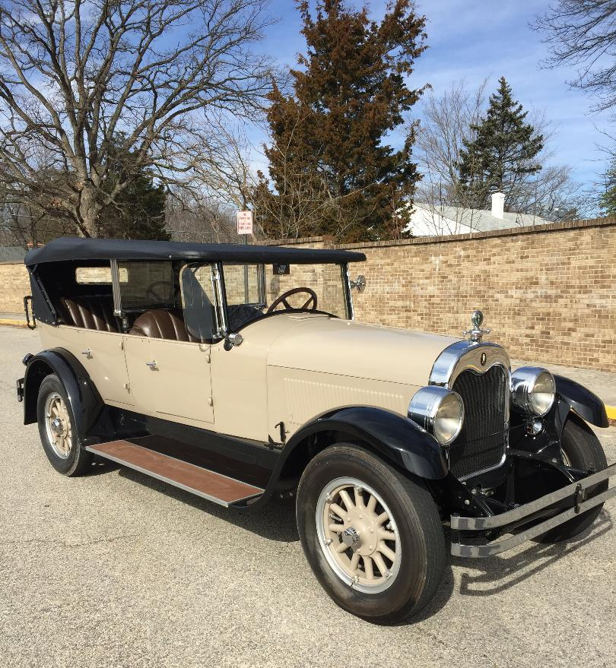

Registration deadline is September 12, 2024

