**Reminder: Annual Dues**

Annual dues are just around the corner.All homeowners should have received the annual letter by now. They are due July 1st, are still 120 dollars and can be sent to FARM AT CREEKSIDE HOA 1067 SO. HOVER ST., UNIT E-131 LONGMONT, CO 80501

**Dumpster Rental**

The dumpster rental has been scheduled for mid-July, around July 17. It will be located across the street from 2206 Eagleview Circle. It will be around for approximately two weeks or until it fills up. If you miss it the next free landfill day is August 5, from 6 am to 2 pm.

**Yard-of-the-Month Winner for June**

The HOA is sponsoring a friendly yard of the month competition. The June winner was 2333 Barn Swallow Drive, on the corner of Barn Swallow and Eagleview Circle, belonging to Nina and Adam Kuyt. Of the finalists, the Kuyt’s large yard won for having great curb appeal with a variety of bushes and flowering plants in multiple beds, a water feature (“Jillian Creek”), rocks and cobblestones of various sizes, a few interesting container gardens, and a neat appearance. The perennial flowers include clematis, lupines, irises, lilies, bell flowers, phlox, peonies, lavender, ice plants, and hydrangeas. Two honey locust trees, a dwarf Alberta spruce, and an Eastern redbud add shade and interest. The grass is lush and healthy. On the Eagleview side of the yard by the sidewalk is a compact vegetable garden composed of 3 boxed beds with a gravel walkway. Through the split rail fence, a neat back yard is visible. The far (right) side of the driveway is not neglected, with variegated dogwood, forsythia, and redbuds.

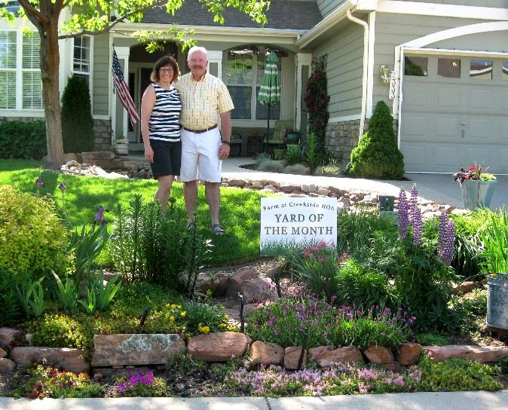

**July 4 Neighborhood Parade**

The 4th of July neighborhood parade will start at 9:30 a.m. at the Eagleview Circle Island. Kids can ride their bikes, walk, or be pulled in wagons by doting parents. A light breakfast will follow. The parade route will be a loop around Eagleview Circle and Bluebird Drive. Drivers should watch for bicyclists and pedestrians in the street.

**Neighborhood Oktoberfest Will Be Saturday, September 30, 2017**

Save the date for this event, which will include a chili contest and homebrew contest. Clothing (socks, underwear, men’s jeans) will be collected for HOPE, a charity that provides life-sustaining support to the homeless in Longmont and promotes self-sufficiency.

**Neighborhood Car Break-ins**

Recently, the board has been notified of several car break-ins. They appear to mostly happen with unlocked cars left in driveways and streets. Make sure you are locking your car at night and closing your garages. Please report any suspicious activity to the police.