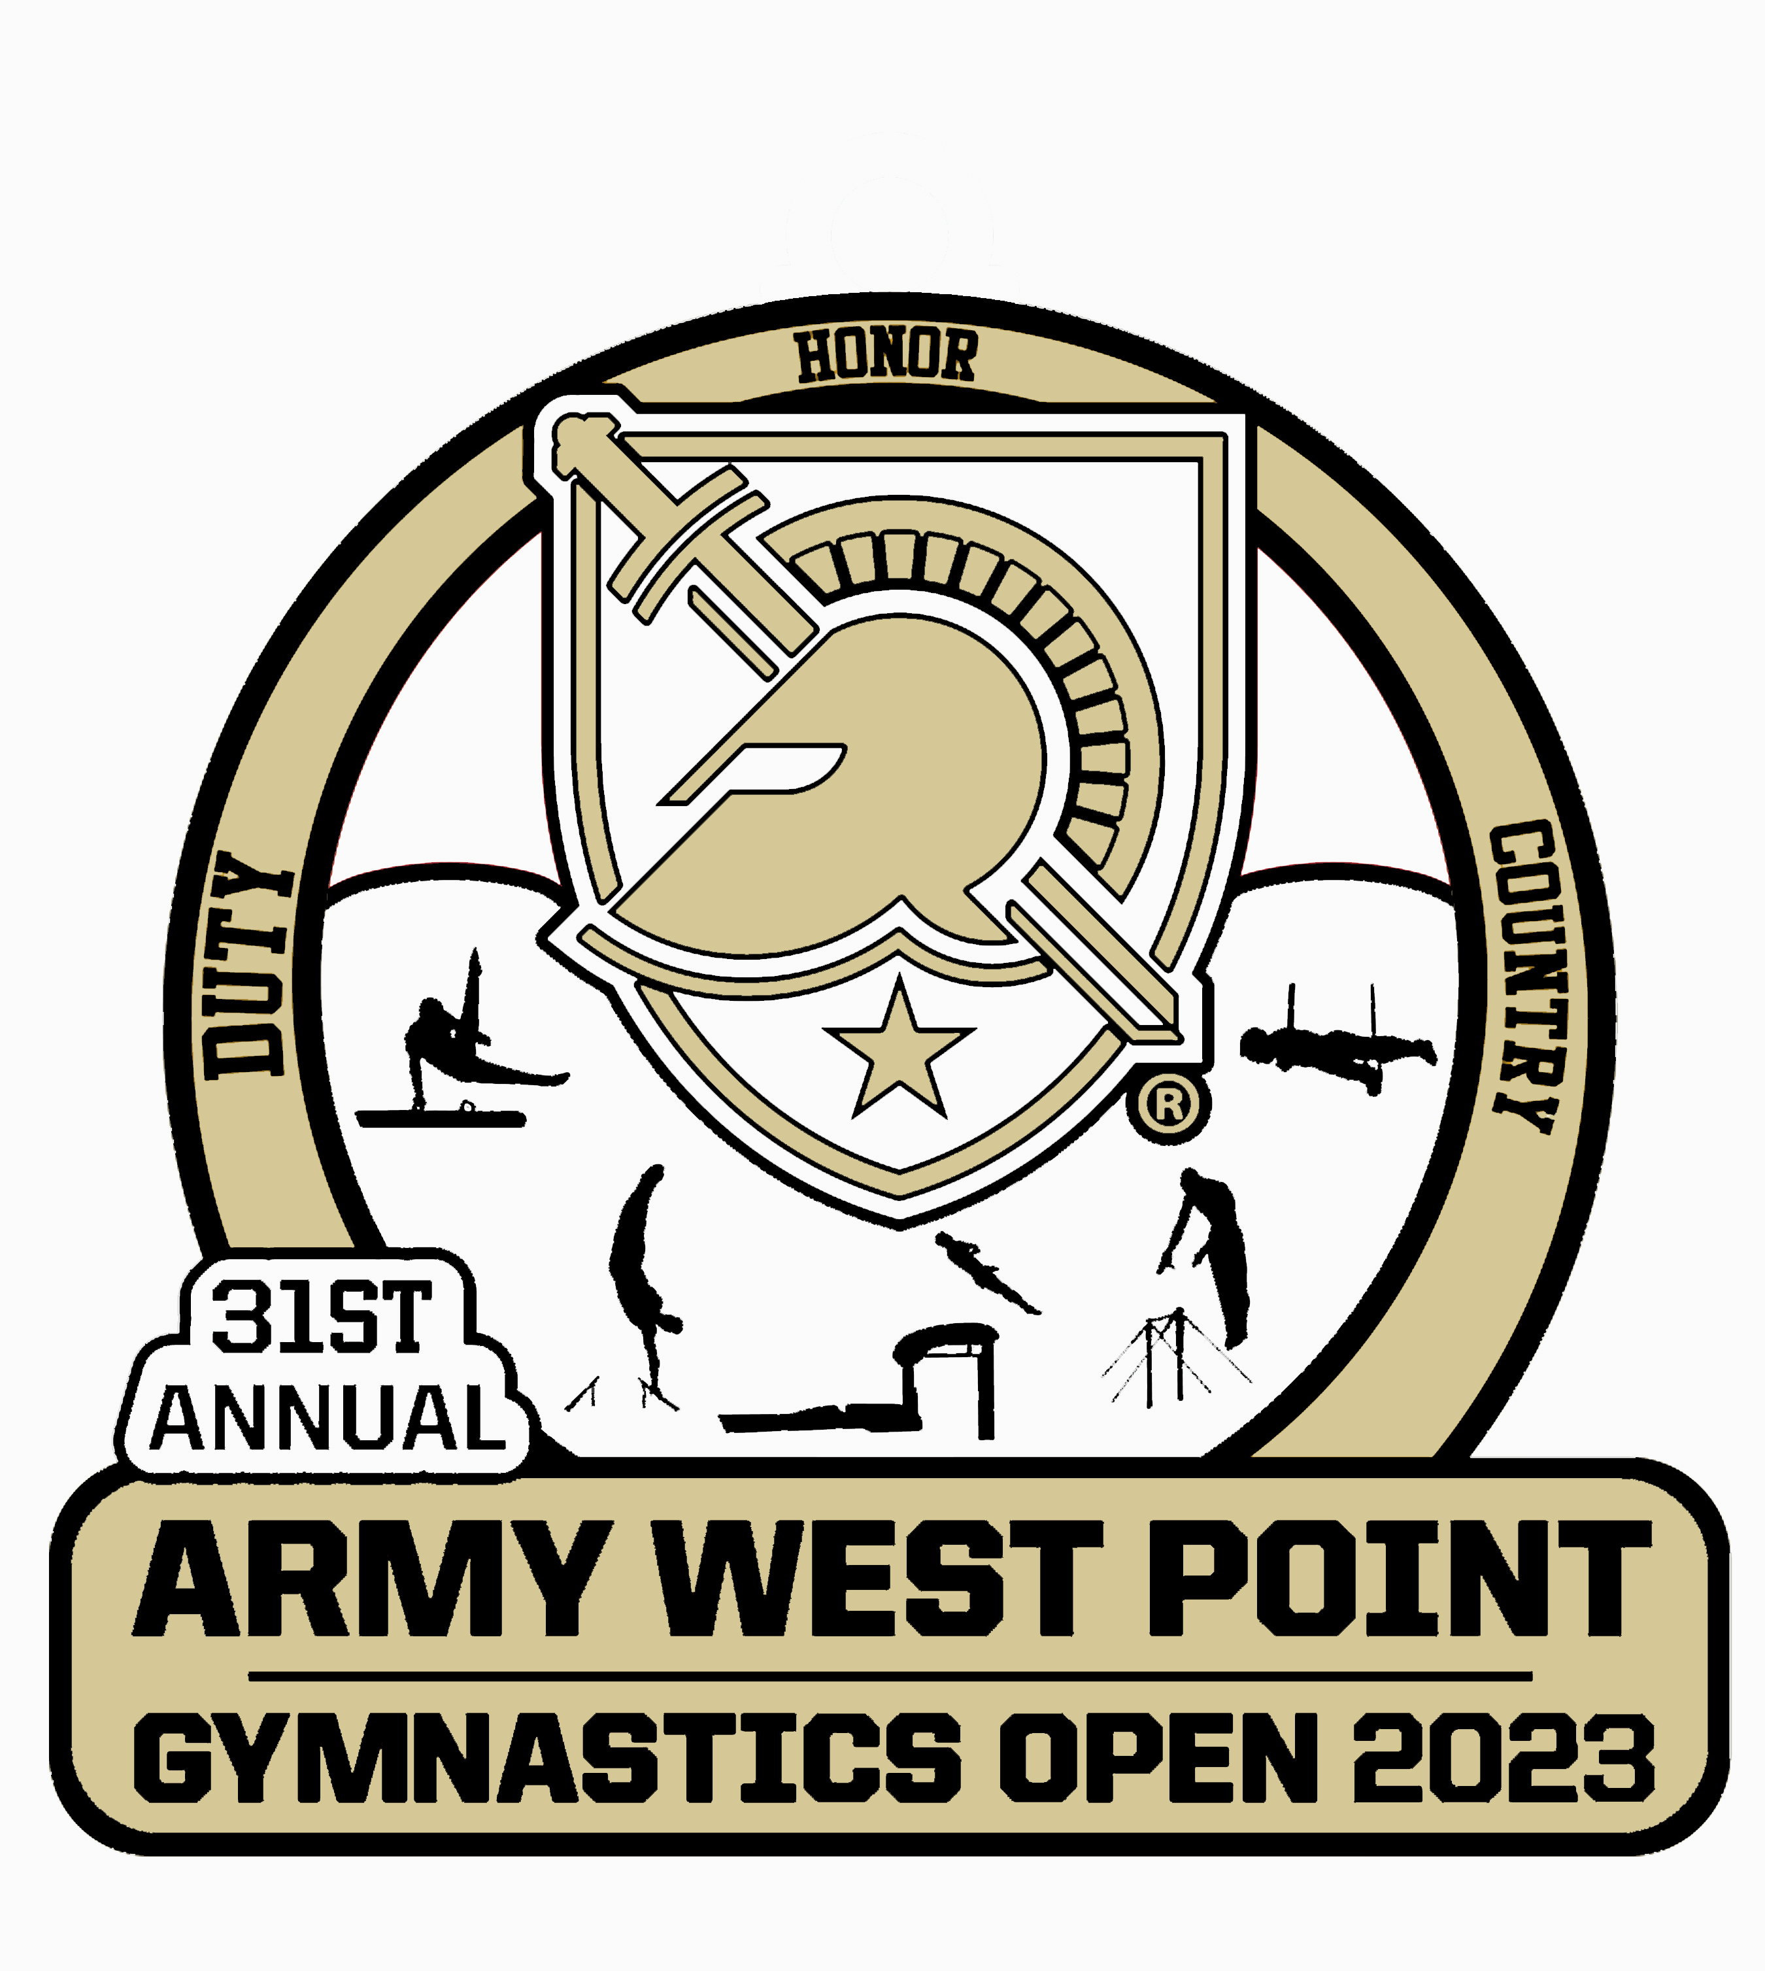

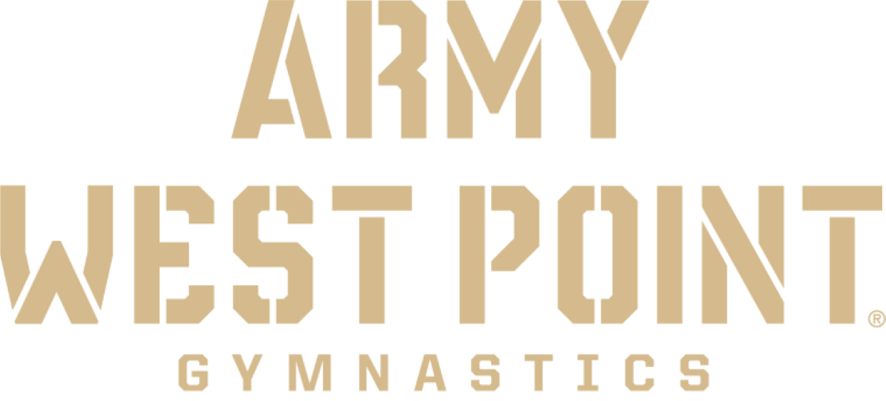

Dates: January 13th – 15th, 2023

Competition Director: Douglas Van Everen

Location: Holleder Center & Lou Gross Sports Center, United States Military Academy, West Point, NY 10996. Use Thayer Gate to enter West Point and have a picture I.D. for ages 16 and older. Note: Using two facilities. The Friday and Saturday sessions will be held in the Holleder Center, and Sunday sessions will be held in the Lou Gross Sports Center.

For Information: Call the gymnastics office at (845) 938-6623 or email evan.eigner@westpoint.edu

Registration: *The only way to register is through USA Gymnastics “Meet Reservations” starting in August. The address to mail the payment is: Army West Point Gymnastics; 639 Howard Road; West Point, NY 10996

Entry Fee: $140.00 per gymnast. Make check payable to: "Army West Point Gymnastics”. Payment is due prior to December 1st.

Awards: All teams are included for team awards (no additional fee).

- Any Foreign International Teams: Coaches, parents, and family members must have a valid US driver license or valid US passport to enter The United States Military Academy.

Refunds: No refunds after December 1st, 2022.

- Web Access: www.goArmyWestPoint.com (click onto Gymnastics)
- Host Hotel: Hotel Thayer is the competition headquarters. The Thayer Hotel at West Point is offering a preferred rate for the West Point Gymnastics Open. The rate is $179 per night plus $14.99 per night for a facility fee. Call 845-446-4731, Ext. 1 to make a reservation. To book a reservation the code “23GYM23” must be entered in the rate access code on the booking engine.

Schedule of Events
(Tentative Schedule)

Youth Session 1 - Friday, January 13th - Holleder Center - *Warm-up/compete

Level 9 (14-15), (16+)

7:00 AM - Open Stretch

7:30 AM - 1st Event Timed Warm Up (15 minutes per event)

7:45 AM - Competition - Warm Up/Compete

11:30 AM - Awards

Youth Session 2 - Friday, January 13th - Holleder Center - *Warm-up/compete

Level 10 (16-17), (18+)

12:00 PM - Open Stretch

12:30 PM - 1st Event Timed Warm Up (15 minutes per event)

12:45 PM - Competition - Warm Up/Compete

4:30 PM - Awards

* Level 10 Qualification into Saturday Event Finals * - Level 10 - Top 8 on each event regardless of age. Coaches, please let the head table know immediately after Friday’s session if your gymnast plans to compete in finals on Saturday.

College Team Session: Friday, January 13th - Holleder Center

4:45 PM - Open Warm Up

5:45 PM - Timed Warm Up

7:00 PM - Competition

Collegiate teams attending – Army West Point, Navy, Nebraska, Penn State, and Springfield.

Youth Session 3 - Saturday, January 14th - Holleder Center - *Warm-up/compete

Level 8 (12-13), (14+) and Level 6 Division 1 & 2 (10-11), (12+)

7:00 AM - Open Stretch

7:30 AM - 1st Event Timed Warm Up (15 minutes per event)

7:45 AM - Competition - Warm Up/Compete

11:30 AM - Awards

Youth Session 4 - Saturday, January 14th - Holleder Center - *Warm-up/compete

Level 7 JN (12-13), (14-15), (16+)

12:00 PM - Open Stretch

12:30 PM - 1st Event Timed Warm Up (15 minutes per event)

12:45 PM - Competition – Warm Up/Compete

4:30 PM - Awards

Collegiate and Level 10 Finals - Saturday, January 14th ⁻ Holleder Center

Top 8 collegiate competitors and Top 8 Level 10 competitors in each event.

5:30 PM - Open Warm up

7:00 PM - Event Finals

Youth Session 5 - Sunday, January 15th - Lou Gross Sports Center

Level 5 - Division 1 & 2 (8-9), (10-11), (12+)

7:00 AM - Open Stretch

7:30 AM - Timed Warm Up (15 minutes per event)

9:00 AM - Competition

11:30 AM - Awards

Youth Session 6 - Sunday, January 15th - Lou Gross Sports Center

Level 4 - Division 1 & 2 (7-8), (9-10), (11+)

12:30 PM - Open Stretch

1:00 PM - Timed Warm Up (15 minutes per event)

2:30 PM - Competition

5:00 PM - Awards

Team awards will be given for each level:

Level 4 - Number of scores TBD

Level 5 - Number of scores TBD

Level 6 - Number of scores TBD

Level 7 - Number of scores TBD
Level 8 - Number of scores TBD

Level 9 - Number of scores TBD

Level 10 - Number of scores TBD

Traveling to West Point

From the New York State Thruway (Route 87):
Take exit 16-Harriman to Route 6-East to Route 293 to 9W south. Follow signs for West Point.

From the West (Western New York):
Take Route 17 East to Exit 131 (Harriman). Take Route 6-East to Route 293-East. Take Route 9W-South and follow signs for West Point.

From the Massachusetts Turnpike:
Take the New York State Thruway (Route 87) South to Exit 16-Harriman to Route 6-East to Route 293 to Route 9W-South. Follow signs for West Point.

From the Danbury, Connecticut Area:
Take Interstate 84-West to Exit 10-South (Newburgh, NY). Follow Route 9W south and follow signs for West Point.

From Southern Connecticut:
Take Route 95-South to Route 287-West across the Tappan Zee Bridge. Take New York State Thruway (Route 87)-North to Exit 16-Harriman. Take Route 6-East to Route 293 to Route 9W South. Follow signs for West Point.

From Western New Jersey:
Take Route 94-East to Route 17-East to Route 6-East to Route 293-East to 9W-South. Follow signs for West Point.

From Central/South Jersey:
Take the New Jersey Turnpike North. Follow signs for George Washington Bridge lower level. Take exit Palisades Parkway North to Bear Mountain Parkway to Route 6 East. Take third right on the roundabout to 9W north and follow signs to West Point.

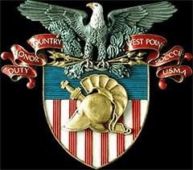

Parking at West Point

Enter West Point by using Thayer Gate

The Holleder Center parking for the team bus is on Fenton Place between the Holleder Center and Howze Field. Spectator parking is located at A & F lots.

Lou Gross Sports Center Facility parking is adjacent to parking lot G up the hill from the Holleder Center.

Please obey all parking rules and regulations. The Military Police have jurisdiction over West Point.

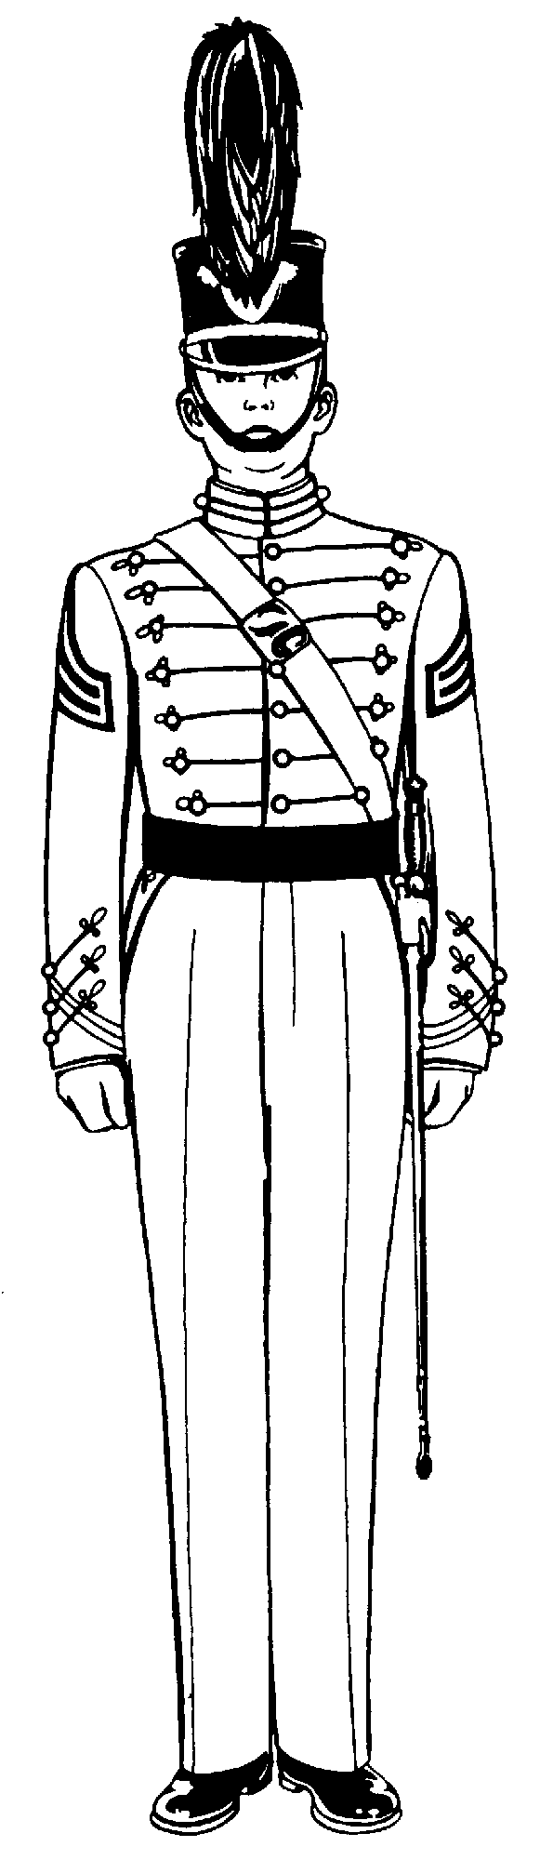
West Point Area:

Hotel Thayer Holiday Inn Express
Thayer Road 1106 Route 9W
West Point, NY Fort Montgomery, NY
(845) 446-4731 (845) 446-4277
(Host Hotel)

West Point Motel Best Western Palisades
156 Main Street Route 218 & 9W
Highland Falls, NY Highland Falls, NY
(845) 446-4180 (845) 446-9400

U.S. Academy Motel Bear Mountain Inn
41 Main Street Route 9W
Highland Falls, NY Bear Mountain, NY
(845) 446-2021 (854) 786-2731

North of West Point: - approximately 15-30 minutes from West Point

Hampton Inn –
60 Centre Drive
Central Valley, NY
(845) 782-9600

Hudson Valley Hotel Howard Johnson Lodge
90 Route 17K 95 Route 17K
Newburgh, NY Newburgh, NY
(845) 564-9020 (845) 564-4000

Ramada Inn Days Inn
1055 Union Avenue 845 Union Avenue
Newburgh, NY Newburgh, NY
(845) 564-4500 (845) 564-7550

Super 8 Motel Comfort Inn
1287 Route 300 5 Lakeside Road
Newburgh, NY Newburgh, NY
(845) 564-5700 (845) 567-0567

Econo Lodg Econo Lodge Courtyard by Marriott
31 Windsor 31 Windsor Drive 4 Governor Drive
New New Windsor, NY Newburgh, NY
(845) 561-6 (845) 561-6620 (845) 567-4800

New
Hampton Inn of Newburgh
1054 Union Avenue
Newburgh, NY
(845) 567-9100

New Jersey Hotels: -approximately 40-45 minutes to West Point

Ramada Inn Sheraton International
180 Rt. 17S One International Blvd.
Mahwah, NJ Mahwah, NJ
(201) 529-5880 (201) 529-1660

Courtyard Marriott
140 Route 17S
Mahwah, NJ
(201) 529-5200

South of West Point: -approximately 40-50 minutes to West Point

Marriott-Westchester Holiday Inn
670 White Plains Road 3 Executive Blvd.
Tarrytown, NY Suffern, NY
(914) 631-2200 (914) 357-4800

Marriott Park Ridge Pearl River Hilton
300 Brae Blvd. 500 Veterans Memorial
Park Ridge, NJ Pearl River, NY
(201) 307-0800 (914) 735-9000

LOCAL AREA RESTAURANTS

Highland Falls

Hacienda Restaurant Thayer Hotel McDonald’s

145 Main Street Thayer Road Main Street
(845) 446-8257 (845) 446-4731 (845) 446-4935

Park Restaurant Schade’s Restaurant American Burrito
64 Main Street 54 Main Street 467 Main Street
(845) 446-8709 (845) 446-2626 (845) 446-2345

Dong Fong Restaurant Maria Bonita Mexican Restaurant
78 Main Street 315 Main Street
(845) 446-0763 (845) 446-5393

Subs/Pizza:

West Point Pizza Highland Falls Market
282 Main Street 447 Main Street
(845) 446-5544 (845) 446-3992

