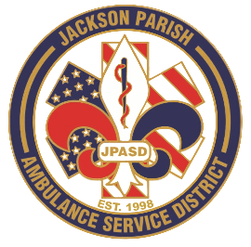
Aaron K. Johnson, Jr - EMS Director

Paula Parkerson, MD - Medical Director

Governing Board
Allen Lindsay, Conchita Doyle, Joe Vail, Alma Williams, Deidre Hollis
Jackson Parish Ambulance Service District
115 Watts Street
Jonesboro, LA 71251
Office: (318) 259-2877
Fax: (318) 259-2099

jacksonparishambulance@jpasd.com

Notice Posted: Tuesday, November 11, 2025 @ 12:00 PM

NOTICE OF PUBLIC HEARING

A public hearing will be held as follows:
DATE: November 13, 2025
TIME: 12:00 PM (Noon)
PLACE OF MEETING:
Jackson Parish Ambulance Service District
115 Watts Street, Jonesboro, LA 71251
Public Hearing 2026 Proposed Budget 12:00 PM (Noon) AGENDA:
1. Call to Order
2. Roll Call
3. Invocation
4. Pledge of Allegiance
5. Recognition of guests
6. Open floor for public comments on the Proposed 2026 Financial Budget.
7. Adjournment

In accordance with the Americans with Disabilities Act, if you need special assistance, please contact Aaron Johnson, EMS Director at 318-259-2891 describing the assistance that is necessary.

