El Cajon Gem & Mineral Society
Trip Report for Turquoise (off Halloran Summit Rd) and Chrysocolla (off Zzyzx Rd).

The weather report predicted a cold, windy and rainy weekend in San Diego on March 10 and 11. So, it’s always a gamble to head into the So Cal mountains for collecting during that time, because you never know if the coastal range will leech the moisture from the clouds or not.

The Stoddard Wells show was happening that same weekend. My friend John and I left San Diego on Friday and drove north on I-15 to the show, near Victorville. There, we met up with Dave and Richard. About 100 vendors were somewhat haphazardly parked along the sides of a few seemingly random dirt roads that wound through the low-laying brush; with goods displayed for all to see. Rocks were admired, traded, and sold.

That evening, Richard and Dave camped at Stoddard Wells while John and I continued up I-15 past Baker to the Turquoise site, off Halloran Summit Rd. The site is near the Stone Hammer Mine (a prehistoric Turquoise collecting area). We arrived after dark, but still had the energy to pound on the rhyolite for a bit. We discovered that our target mineral fluoresces white, making it easy to find veins of Turquoise to exploit the following day.

Richard and Dave arrived the next morning, bright eyed, caffeinated and ready to dig. The digging consisted of using hand sledges with gads, to cleave chucks of host material from the deposit. Then, we would break that down in search of the light blue veins. The site was easy to access with 4WD and comfortable to work; in that one could sit on the ground, on a bucket, or stand and have unimpeded access to the work area. We spent about six hours collecting in the desert rain (you know, those big sparsely-placed drops that make everything smell sweet and fresh, but don’t get you soaked to the skin). We decided that with the rain beginning to fall more heavily, we should to get to our next site during daylight. I don’t think anyone took photos or video at the Turquoise location (but just close your eyes and imagine lots of light brown rock with blue veins running through it, sagebrush and Joshua trees scattered across the gently rolling hills, and the rhythmic plinking of four sledges driving gads into the stone).

The rain continued as we drove south on I-15 to Zzyzx Rd then headed north toward the Blue Bell Claim. We arrived well before sunset, so John and I hiked to the target site—a mine bored about 40-feet into the mountainside. It was mostly a moderate hike, with one very difficult part at a ridge that must be traversed. There are more accessible sites along the way where one could collect, as well. We returned before dark and settled in to story-telling around the warm fire while eating a delicious dinner (one of Richard’s many camping talents). The rain and wind increased throughout the night and most of us awoke drenched, for one reason or another.

The next day, we all hiked to the collecting site where the Chrysocolla was so plentiful it was just a matter of deciding which pieces to keep. We extracted many incredible specimens. The interesting (and for me, problematic) characteristic of this locality is that there are over 60 minerals to be found. That makes it difficult to leave any rock behind! Traversing the trail back to camp with two 5-gallon buckets and a backpack of rock was a workout, to say the least. After about 10 trips back and forth, we were all exhausted and ready to call it a (successful) day. John and I headed back to San Diego that evening while Richard and Dave stayed until Monday.

On Monday, Richard and Dave climbed up the mountain, above the initial Chrysocolla site, and found Linerite as well. Some of the specimens we collected have at least a half dozen minerals of varying sorts. It was an exhausting, sometimes dangerous, and always enjoyable trip.

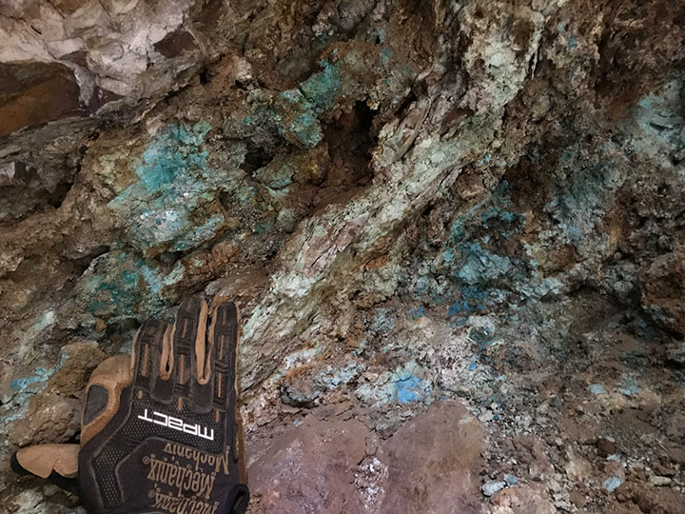
Inside the mine… no shortage of quality Chrysocolla (glove for scale).

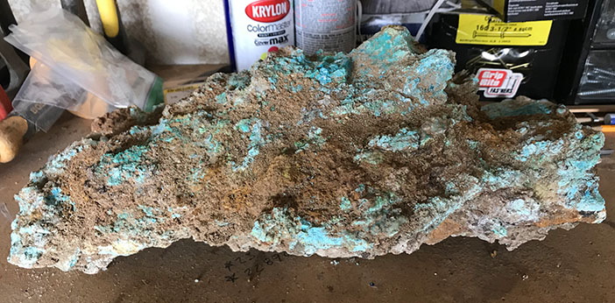
This piece weighs just over 25 pounds.

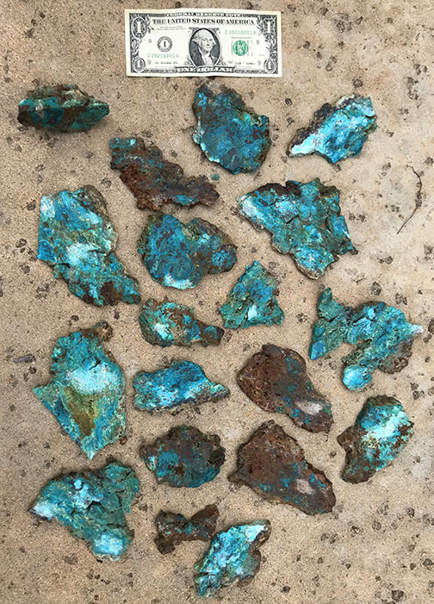
Some of the slabs cut from a high-quality chunk.

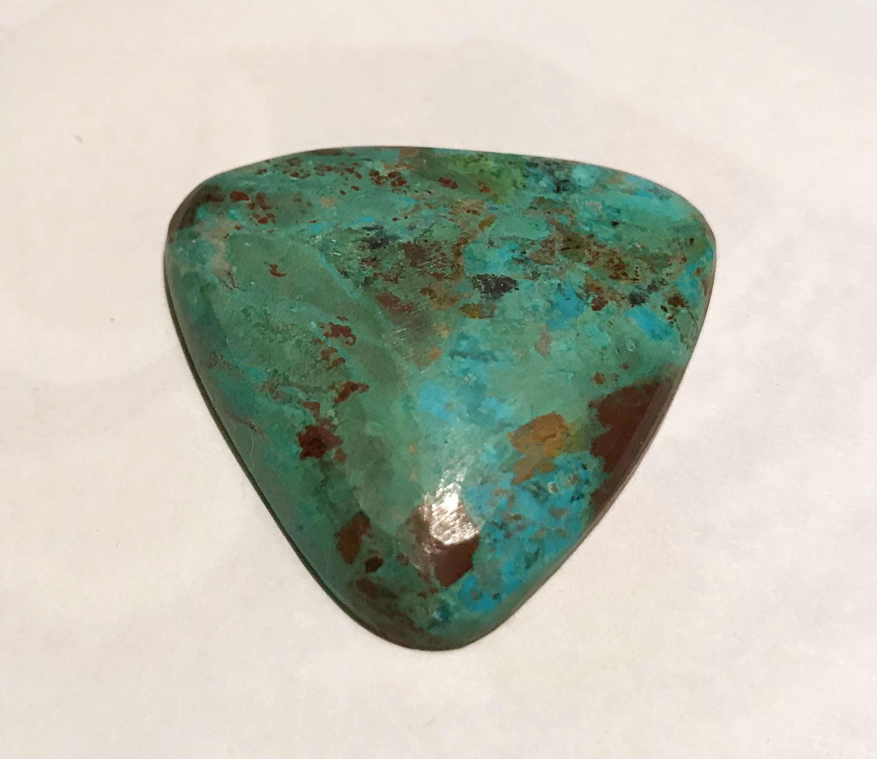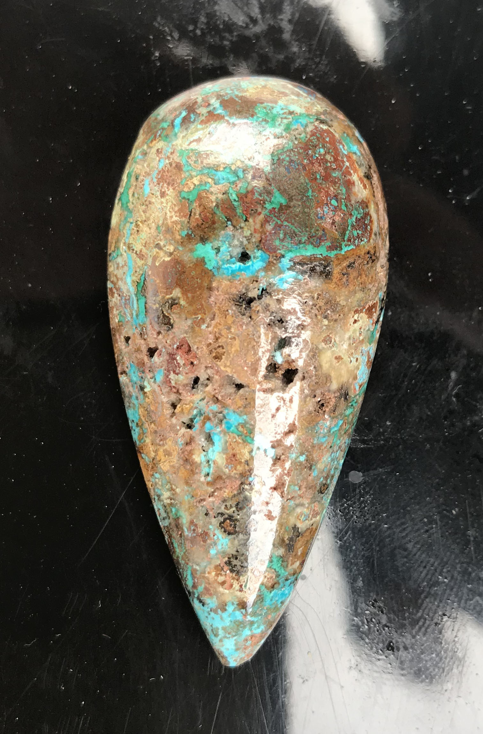
An unfinished cab of Chrysocolla. Nicholai’s first cab.

