ATTENTION STUDENT ARTISTS

Bubblethon is here and

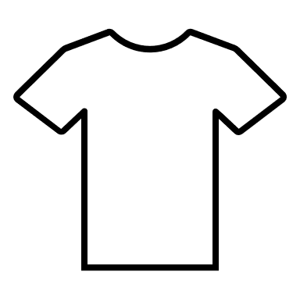 we need your help!

Students are invited to submit designs

For the 2023 BUBBLETHON T-Shirt design.

The winning design will be printed

on all of the t-shirts given to all students who raise $40 during the Bubblethon Donation Period.

**T-SHIRT DESIGN**

**CONTEST **

DESIGN REQUIREMENTS:

1. Must be submitted on a white 8 ½ x 11 sheet of paper.
2. Must be drawn in 1 color only! (it will only be printed in one color)
3. A picture containing text, clipart

   Description automatically generatedStudent must put full name, classroom and grade on back of design paper.



THE DEADLINE FOR SUBMISSIONS IS SEPT. 15