WELCOME TO
HOLY SPIRIT LUTHERAN CHURCH
A Member of the Evangelical Lutheran Church in America, New Jersey Synod
1220 Bayshore Rd., Villas, NJ 08251, 609-886-2414,
holyspiritlutheran@comcast.net, holyspiritvillas.com, facebook.com/holyspiritvillas
Vicar Vince Piekarski can be contacted at any time for conversation or prayer through call or text at 412-225-0287, or through email at vpie8282@gmail.com.
SUNDAY, APRIL 5TH, 2026
RESURRECTION OF OUR LORD: EASTER DAY
10:30AM WORSHIP SERVICE WITH HOLY COMMUNION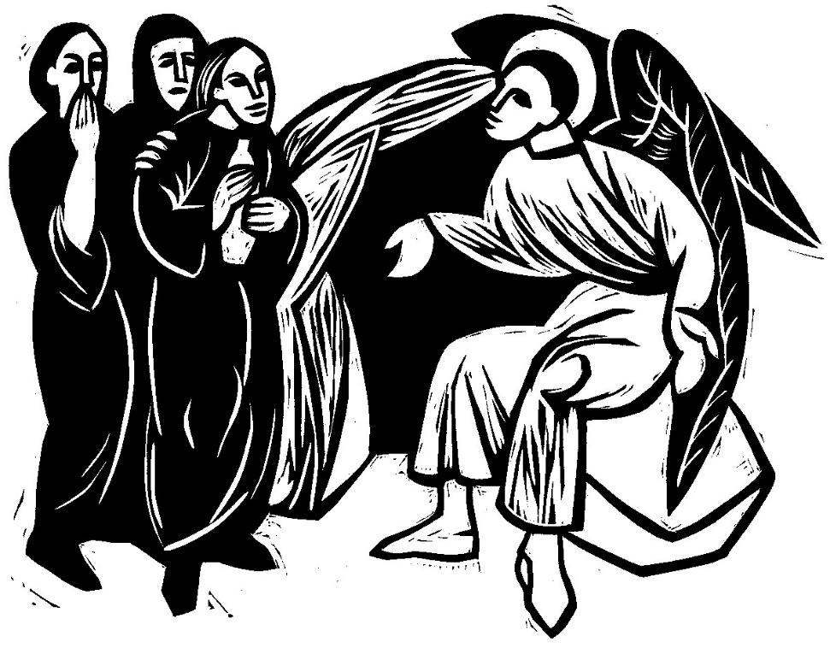

We, the Evangelical Lutheran Church of the Holy Spirit, are People of God, who
are called by the Holy Spirit to pray, worship, joyfully proclaim Jesus Christ,
and compassionately witness and serve others in Christian Love.


We are glad that you joined us for Worship today! Thank you for enriching our time together! We would like to get to know you better, and for you to get to know us better too. Brochures, welcome gifts, prayer shawls, Bibles, and other items are available throughout the church. We would be happy to show you around and share about our ministries. Please do not hesitate to speak up and ask questions.
Also, please make sure you sign-in on our clipboard on the podium in the lobby.


Our Worship Services are conducted in coordination with our Conference Call.
Join us at 657-390-7423 or 701-802-5170, with access code 8221190#.
You may need to dial 1 first depending on your phone plan. After logging in please announce your name and feel free to talk with others until we get started.


SANCTUARY CANDLE FOR APRIL
Given to the Glory of God & In Memory of
EDWARD & LINDA SCHUBERT by Vicki, Bob, Evan Rinier.
ALTAR CANDLES FOR APRIL
Given to the Glory of God & In Memory of
JOSEPH “MAC” MCKENNA & JAMES P ROONEY by Del McKenna & Children.
CONFERENCE CALL CHECK-IN, WELCOME, & ANNOUNCEMENTS
(Vicar (V), Assistant (A), Reader (R), and Congregation (C).)


V. We invite you to stand as you are able.

INTRODUCTION & BLESSING OF THE PASCHAL CANDLE
V. Since we joined our neighbors at the Easter Vigil, we will have the Introduction
& Blessing of The Paschal Candle this morning as we start our Worship Service.

V. Fire has long been a sign of God’s presence. The Old Testament is full of
examples: the burning bush on Mount Sinai, the pillar of fire in the desert, the
tabernacle lamps, and the sacrificial fires on the altar of the temple in Jerusalem.
Early Christians rather naturally viewed the kindling of new fire of the presence of
their resurrected Lord, the new pillar of fire.

(The five wounds of Christ are traced as the words below are spoken.)

V. Christ yesterday and today (cross), the beginning and the end (Alpha and
Omega). His are all times (2) and ages (0); to Christ be glory and dominion (2),
through endless ages (6).
C. Amen.

(The candle is lifted high)

V. The Light of Christ.
C. Thanks be to God.

V. Throughout the fifty days of Easter, the paschal candle will stand near the altar as
a symbol of the resurrection.

(We invite you to be seated.)

INTRODUCTION
A. This is the day the Lord has made! Christ is risen, and through him all creation is
made new! Indeed, “God shows no partiality” (Acts 10:34): Christ’s resurrection
truly brings life to everyone. We sing hymns of praise, gather around sacred
words, and proclaim God’s faithfulness, power, and love in the feast of holy
communion. With the women at the tomb, we are astonished, elated, and
grateful. We depart with joy to proclaim the good news of God’s endless love.

(Assistant lights Altar Candles from the Paschal Candle.)

PRELUDE
(Music offered by our Organist at the start of our Worship Service.)
Come Ye Faithful, Raise the Strain/Jesus Lives and So Shall I

CHIMES
(Music offered by our Organist at the start of our Worship Service.)
Alleluia! Alleluia!

(We invite you to stand as you are able.)

THANKSGIVING FOR BAPTISM
(All may make the sign of the cross, the sign that is marked at baptism.)
V. Alleluia! Christ is risen.
C. Christ is risen, indeed. Alleluia!

V. Salvation belongs to our God who is seated on the throne and to the Lamb!
C. Amen.

V. Let us give thanks for the gifts of baptism.

(Water may be poured into the font as the presiding minister continues.)

V. Merciful God,
you are the one who was, who is, and who is to come.
You lead us beside still waters.
We thank you for the waters of creation:
morning dew, gentle rain, roaring waves.
We thank you for the waters that nourish us (local waters may be named).
Blessed are you.
C. You guide us to springs of the water of life.

V. Jesus Christ, you are the faithful witness
who accompanies us on our journeys.
We give you thanks for your life-giving death and resurrection.
We praise you for joining us in joy and sorrow.
Blessed are you.
C. You guide us to springs of the water of life.

V. Holy Spirit, you anoint our head with oil and our cup overflows.
Break down barriers that divide us.
Fill us with the breath of peace.
Blessed are you.
C. You guide us to springs of the water of life.

V. Holy One, we thank you for the gifts and grace of baptism,
and for making us a new creation.
We join with saints and angels, giving you honor and praise,
now and forever.
C. Amen.

(We invite you to remain standing as you are able.)

BRIEF ORDER FOR CONFESSION AND FORGIVENESS
V. God hears us when we cry, and draws us close in Jesus Christ. Let us return to
the one who is full of compassion.

(Silence is kept for reflection.)

V. Fountain of living water,
C. pour out your mercy over us. Our sin is heavy, and we long to be free.
Rebuild what we have ruined and mend what we have torn. Wash us in your
cleansing flood. Make us alive in the Spirit to follow in the way of Jesus, as
healers and restorers of the world you so love. Amen.

V. Beloved, God’s word never fails. The promise rests on grace: by the saving love
of Jesus Christ, the wisdom and power of God, ☩ your sins are forgiven, and God
remembers them no more. Journey in the way of Jesus.
C. Amen

GATHERING HYMN
(We invite you to sing along.)
Lutheran Book of Worship—Green Book
151—Jesus Christ Is Risen Today

APOSTOLIC GREETING
V. May the grace of our Lord Jesus Christ, the love of God,
and the communion of the Holy Spirit be with you all.
C. And also with you.

KYRIE
V. In peace, let us pray to the Lord.
C. Lord, have mercy.

V. For the peace from above, and for our salvation, let us pray to the Lord.
C. Lord, have mercy.

V. For the peace of the whole world, for the well-being of the church of God,
and for the unity of all, let us pray to the Lord.
C. Lord, have mercy.

V. For this holy house, and for all who offer here their worship and praise,
let us pray to the Lord.
C. Lord, have mercy.

V. Help, save, comfort, and defend us, gracious Lord.
C. Amen.

HYMN OF PRAISE
PRAYER OF THE DAY
V. The Lord be with you.
C. And also with you.

V. Let us pray,
O God, you gave your only Son to suffer death on the cross for our redemption,
and by his glorious resurrection you delivered us from the power of death. Make
us die every day to sin, that we may live with him forever in the joy of the
resurrection, through your Son, Jesus Christ our Lord, who lives and reigns with
you and the Holy Spirit, one God, now and forever.
C. Amen.

(We invite you to be seated for our Readings and Psalm.)

FIRST READING
Peter’s sermon, delivered at the home of Cornelius, a Roman army officer, is a
summary of the essential message of Christianity: Everyone who believes in
Jesus, whose life, death, and resurrection fulfilled the words of the prophets,
“receives forgiveness of sins through his name.”

R. Our First Reading is from Acts (Chapter 10, Verses 34-43).

R. 34 Peter began to speak to [Cornelius and his household]: “I truly understand that
God shows no partiality, 35 but in every people anyone who fears him and
practices righteousness is acceptable to him. 36 You know the message he sent
to the people of Israel, preaching peace by Jesus Christ—he is Lord of all.
37 That message spread throughout Judea, beginning in Galilee after the baptism
that John announced: 38 how God anointed Jesus of Nazareth with the Holy
Spirit and with power; how he went about doing good and healing all who were
oppressed by the devil, for God was with him. 39 We are witnesses to all that he
did both in Judea and in Jerusalem. They put him to death by hanging him on a
tree, 40 but God raised him on the third day and allowed him to appear, 41 not to
all the people but to us who were chosen by God as witnesses and who ate and
drank with him after he rose from the dead. 42 He commanded us to preach to
the people and to testify that he is the one ordained by God as judge of the living
and the dead. 43 All the prophets testify about him that everyone who believes in
him receives forgiveness of sins through his name.”

R. This is the Word of the Lord.
C. Thanks be to God.
PSALM
R. Our Responsorial Psalm is from the 118th Psalm (Verses 1-2, 14-24).
C. This is the day that the Lord has made; let us rejoice and be glad in it.
(Ps. 118:24)

R. 1 Give thanks to the Lord, for the Lord is good;
God’s mercy endures forever.
2 Let Israel now declare,
“God’s mercy endures forever.”
14 The Lord is my strength and my song,
and has become my salvation.
15 Shouts of rejoicing and salvation echo in the tents of the righteous:
“The right hand of the Lord acts valiantly!
16 The right hand of the Lord is exalted!
The right hand of the Lord acts valiantly!”
17 I shall not die, but live,
and declare the works of the Lord.
C. This is the day that the Lord has made; let us rejoice and be glad in it.
(Ps. 118:24)

R. 18 The Lord indeed punished me sorely,
but did not hand me over to death.
19 Open for me the gates of righteousness;
I will enter them and give thanks to the Lord.
20 “This is the gate of the Lord;
here the righteous may enter.”
21 I give thanks to you, for you have answered me
and you have become my salvation.
C. This is the day that the Lord has made; let us rejoice and be glad in it.
(Ps. 118:24)

R. 22 The stone that the builders rejected
has become the chief cornerstone.
23 By the Lord has this been done;
it is marvelous in our eyes.
24 This is the day that the Lord has made;
let us rejoice and be glad in it.
C. This is the day that the Lord has made; let us rejoice and be glad in it.
(Ps. 118:24)

SECOND READING
Easter means new life for us as it first meant new life for Christ. His resurrection
reshapes the entire focus and motivation for our lives since we are now hidden
with the risen Christ in God.

R. Our Second Reading is from Colossians (Chapter 3, Verses 1-4).

R. 1 If you have been raised with Christ, seek the things that are above, where Christ
is, seated at the right hand of God. 2 Set your minds on the things that are above,
not on the things that are on earth, 3 for you have died, and your life is hidden
with Christ in God. 4 When Christ who is your life is revealed, then you also will
be revealed with him in glory.

R. This is the Word of the Lord.
C. Thanks be to God.

V. I invite you to stand as you are able, and I invite you to announce the Gospel
Acclamation with me.

GOSPEL ACCLAMATION
C. Alleluia. Christ, our paschal lamb, has been sacrificed. Therefore, let us
keep the feast. Alleluia. (1 Cor. 5:7, 8)

GOSPEL READING
Sorrow gives way to “fear and great joy” when two women are sent by an angel
to proclaim the good news: Jesus is risen!

V. The Holy Gospel According to Matthew (Chapter 28, Verses 1-10).
C. Hosanna in the highest.

V. 1 After the Sabbath, as the first day of the week was dawning, Mary Magdalene
and the other Mary went to see the tomb. 2 And suddenly there was a great
earthquake, for an angel of the Lord, descending from heaven, came and rolled
back the stone and sat on it. 3 His appearance was like lightning and his clothing
white as snow. 4 For fear of him the guards shook and became like dead men.
5 But the angel said to the women, “Do not be afraid, for I know that you are
looking for Jesus who was crucified. 6 He is not here, for he has been raised, as
he said. Come, see the place where he lay. 7 Then go quickly and tell his
disciples, ‘He has been raised from the dead, and indeed he is going ahead of
you to Galilee; there you will see him.’ This is my message for you.” 8 So they left
the tomb quickly with fear and great joy and ran to tell his disciples. 9 Suddenly
Jesus met them and said, “Greetings!” And they came to him, took hold of his
feet, and worshiped him. 10 Then Jesus said to them, “Do not be afraid; go and
tell my brothers and sisters to go to Galilee; there they will see me.”

V. This is the Gospel of the Lord,
C. Praise to you, O Christ.

SERMON
(Delivered by Vicar Vince Piekarski.)

(Following the Sermon, we invite you to stand as you are able.)

HYMN OF THE DAY
(We invite you to sing along.)
Lutheran Book of Worship—Green Book
131—Christ Is Risen! Alleluia!

APOSTLES’ CREED
V. God has made us his people through our Baptism into Christ. Living together in
trust and hope let us confess our faith together using the Apostles’ Creed.
C. I believe in God, the Father almighty,
creator of heaven and earth.

I believe in Jesus Christ, God’s only Son, our Lord,
who was conceived by the Holy Spirit,
born of the Virgin Mary,
suffered under Pontius Pilate,
was crucified, died, and was buried;
he descended to the dead.
On the third day he rose again;
he ascended into heaven,
he is seated at the right hand of the Father,
and he will come to judge the living and the dead.

I believe in the Holy Spirit,
the holy catholic church,
the communion of saints,
the forgiveness of sins,

the resurrection of the body,
and the life everlasting. Amen.

PRAYERS OF INTERCESSION
(The prayers are prepared locally for each occasion.)
V. Trusting in the power of Christ’s resurrection to heal and redeem our broken
world, let us pray for the needs of all creation.

(A brief silence.)

A. Risen Savior, you have conquered death and opened the gates of everlasting life.
Dispel our doubts and fears and renew our faith and hope in you. Merciful God,
C. receive our prayer.

A. Life-giving God, the created world rejoices in Christ’s victory over death. May all
the earth be renewed by the light of Jesus’ resurrection, and may we be faithful
stewards of all you have made. Merciful God,
C. receive our prayer.

A. Sovereign God, let the nations acknowledge your reign of justice and truth. Where
violence, oppression, and corruption hold sway, pour out your holy and life-giving
Spirit to transform and redeem. Merciful God,
C. receive our prayer.

A. Gentle Shepherd, like the women at the empty tomb, many grieve or feel lost and
afraid. Draw near to those who are ill or in pain; especially:
BettyAnn Rich-White (Church Member)
Chip & Marie Hand (Church Members)
Lynn Bargstadt (Church Member)
Frank Ford (Church Member)
Carol Amundsen (Church Member)
Kim & Theresa McGinley (Church Member)
Anthony DeLuca (Church Member)
Frank Brunner (Church Member)
Paul Bowker (Church Member)
Joan Sommerman (Church Family)
Rick Lang (Church Family)
Suzie Clark (Rose Lang's Friend)
Francis Clock (Dianna DeNote’s Family)
Andrew Hudak (Rose Lang’s Friend)
Viena Murtha (Bob Fritsch’s Friend)
Sharon Waicus (Skip & Bonnie Millard's Friend)
Karen O'Brien (Paul Bowker's Friend)
Dustin Irizzary (Mary Melnicoff's Family)
The Bryan Family (Wanda Bryan's Family)
Craig Brearey (Judy Brannan & Mary Melnicoff's Friend)
Sarah Dutton (Frank Ford's Family)
Christina McNasby (Fran Green’s Family)
Mark Stephen Dennis (Diana DeNote's Family)
Bill Lodge (Skip & Bonnie Millard's Friend)
Ron Anderson (Bill Kelly's Friend)
Bud Brearey (Judy Brannan & Mary Melnicoff's Friend)
Mary Skain (Kathy Poehler's Friend)
Robert Chaplin (Mary Melnicoff's Friend)
Jack Wieckouski (Theresa & Kim McGinley's Family)
Carolyn Santarpio (Bob Fritsch's Friend)
Harry (Judy Brannan's Friend)
Michael Hart (Diana DeNote's Friend)
Rocco Leonard DeNote (Diana DeNote's Family)
Sherri Lynn (Bob Fritsch's Friend)
John Bannco (Bob Fritsch's Friend)
Nancy Pazarinie (Bob Fritsch's Family)
Jane & Paul Eiben (Rose Lang's Friend)
Joe DiMassimo (Judy Brannan & Mary Melnicoff's Friend)
Denny Papst (Rose Lang’s Friend)
Mike & Alice Rhoades (Rose Lang’s Friends)
Chris (Judy Brannan's Friend)
Helen Ehlers (Judy Brannan's Friend)
Leanne Bueth (Joan Kilcoyne's Family)
Janett MacFarlane (Carol Amundsen's Friend)
Thish Kelly (Theresa & Kim McGinley's Family)
Scott Levin (Rose Lang's Friend)
Alice Ann Dennis (Diana DeNote's Family)
Nancy Taylor (Ted & Diane Bell's Family)
​​​​​ Santa Isabel Lutheran Church (Elizabeth, NJ)
Messiah Lutheran Church (Oakland, NJ)
Joyce Thompson (TDPWC Member)
Barbara Paynter (Leon Stitt’s Family)
Bob Poole (Kathy Poehler's Family)
David Smith (Heather & Vicar Vince Piekarski’s Family)
Barbara Hoitink (Lucas & Sabrina Munson's Family)
Kathy Raynor (Philomena Noak & Mary Melnicoff’s Friend)
Jordan (Carol Amundsen's Friend)
Ann Wieckouski (Theresa & Kim McGinley's Family)
Rich (Kim McGinley's Friend)
Amy Johnson (Ted Bell's Sister)
Jerry & Marlana (Carol Amundsen's Friends)
Theresa Dolan (Joan Kilcoyne's Family)
Sandy Bloomberg (Judy Brannan's Family)
Simon (Carol Amundsen's Family)
Bill Ransing & Family (Frank Ford’s Friends)
Barbara Brosius (Philomena Noak's Friend)
Barbara Schmiedel (Bob Fritsch's Family)
Cathy Bell (Ted & Diane Bell's Family)
Linda Stonelake (Kathy & Butch Poehler's Friend)
Anne Pfaff (Bonnie Millard & Vicki Rinier's Friend)
Anna Perez (Bob Fritsch's Family)
Ann Duhadway (Community Member)
Louise Helmes (Wayne & Eleanor Rand's Family)
Marion & Ernie Rink (Fran Green's Friends)
Paul Rand (Wayne & Eleanor Rand's Family)
Dr. Ed. Tinney (Bonnie & Skip Millard's Friend)
Dorothy (Carol Amundsen's Friend)
Tommy Mieluchowski (Philomena Noak's Friend)
(Additional Names Added Prior to the Worship Service.)
A. Reveal yourself to them as the Risen One. Merciful God,
C. receive our prayer.

A. Faithful God, we thank you for the living hope you give us through Christ’s
resurrection. Bless this community, that we may boldly proclaim Christ’s victory
over death in word and deed. Merciful God,
C. receive our prayer.

A. Eternal One, we give thanks for all who have died and now share in the joy of
your resurrection. Bring us, with them, to the unending feast of your victory.
Merciful God,
C. receive our prayer.

(Here other intercessions may be offered.)

V. Watch over all of us who are worried and suffering, and especially those whose
names we now say aloud or hold within our hearts (extended pause). Merciful
God,
C. receive our prayer.

V. God of resurrection power, use us and these prayers to proclaim the good news
of new life to all the world, through Jesus Christ, our risen Savior.
C. Amen.

SHARING OF THE PEACE
V. May the peace of the Lord be with you always.
C. And also with you.
V. Now, let us share God’s Peace with one another.



(Please respect your neighbor if they desire to still only offer a peace sign or wave.)

(Following the Sharing of the Peace, we invite you to be seated.)

OFFERING
V. We now worship God with our tithes and offerings, wine and bread for use in holy
communion, and monetary gifts to support our ministry for service in God’s name.
Our Ushers will be around to your pews to pass the Offering Plates.

(Ushers come forward to get the Offering Plates from the Assistant.)

(Vicar and Assistant prepare the Altar for Communion.)

OFFERING SONG
(We invite you to sing along.)
Worship & Praise
156—What Have We to Offer?
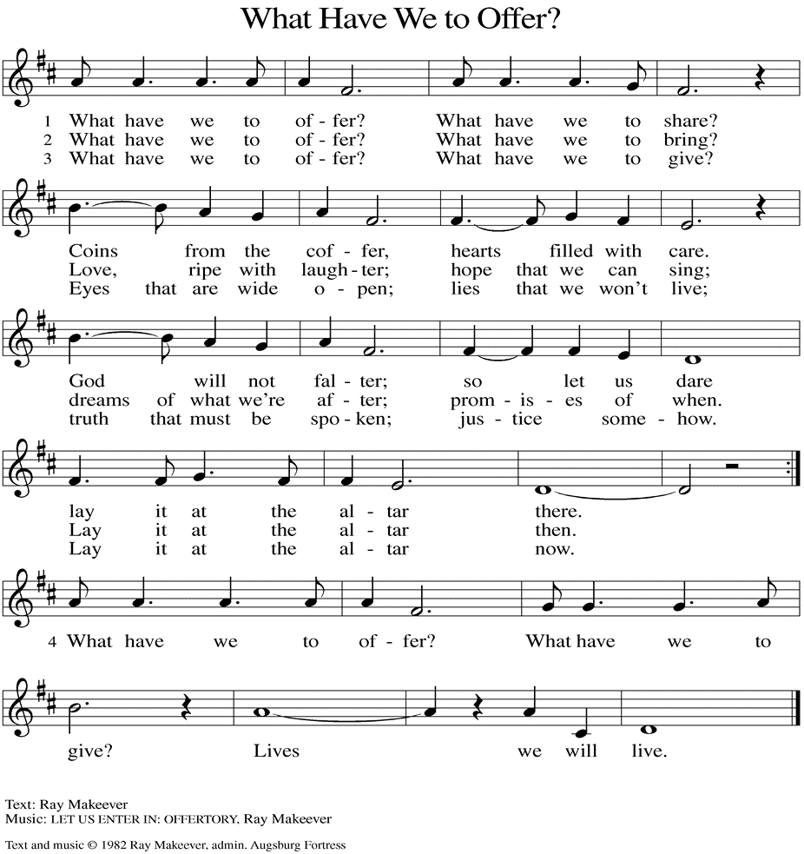
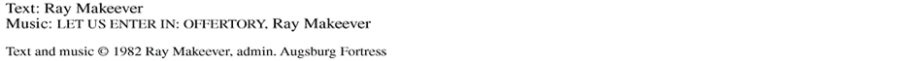

(Usher(s) brings the Tithes and Offerings up front to the Assistant.)
V. We invite you to stand as you are able.

OFFERING PRAYER
V. Let us pray,
Merciful God,
accept the fruits of our labor, gathered to give you glory.
You have set a table before us, a glimpse of that great day
when we will hunger and thirst no more.
Nourish us with the body and blood of Jesus,
that goodness and mercy may follow us
and bless the world you love.
In the name of Jesus,
C. Amen.

GREAT THANKSGIVING
V. The Lord be with you.
C. And also with you.

V. Lift up your hearts.
C. We lift them to the Lord.

V. Let us give thanks to the Lord our God.
C. It is right to give him thanks and praise.

V. It is indeed right and salutary that we should at all times and in all places offer
thanks and praise to you, O Lord, holy Father, almighty and everliving God. But
chiefly we are bound to praise you for the glorious resurrection of our Lord; for he
is the true Passover Lamb who gave himself to take away our sin, who by his
death has destroyed death, and by his rising has brought us to eternal life. And
so, with Mary Magdalene and Peter and all the witnesses of the resurrection, with
earth and sea and all their creatures, and with angels and archangels, cherubim
and seraphim, we praise your name and join their unending hymn:

SANCTUS
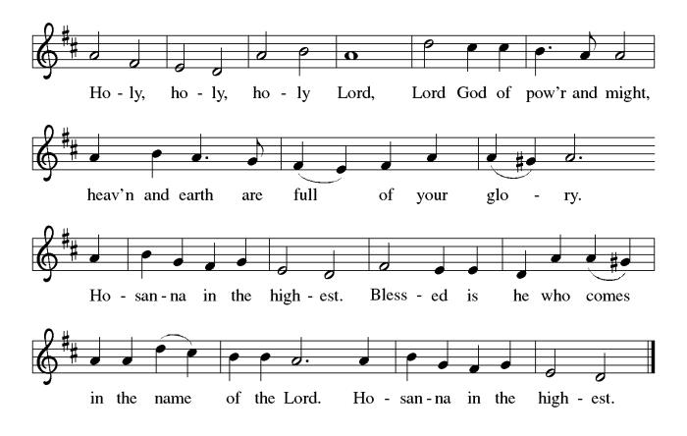

THE EUCHARISTIC PRAYER
V. Blessed are you, Lord of heaven and earth, in mercy for our fallen world you gave
your only Son, that all those who believe in Him should not perish, but have
eternal life. We give thanks to you for the salvation you have prepared for us
through Jesus Christ. Send now your Holy Spirit into our hearts that we may
receive our Lord with a living faith as He comes to us in His holy supper.
C. Amen. Come, Lord Jesus.

V. In the night in which he was betrayed our Lord Jesus took bread,
he gave thanks; broke it, and gave it to his disciples, saying:
Take and eat; this is my body, given for you.
Do this for the remembrance of me.

V. Again, after supper, He took the cup, he gave thanks,
and gave it for all to drink, saying:
This cup is the new covenant in my blood,
shed for you and for all people for the forgiveness of sin.
Do this for the remembrance of me.

THE LORD’S PRAYER
(We ring the bell throughout the Lord’s Prayer at all services to
invite those in the community to join in praying the Lord’s Prayer.)
V. May we now join with one another and pray together as Jesus has taught us.
C. Our Father, who art in heaven, hallowed be thy name, thy kingdom come,
thy will be done, on earth as it is in heaven. Give us this day our daily
bread; and forgive us our trespasses, as we forgive those who trespass
against us; and lead us not into temptation, but deliver us from evil. For
thine is the kingdom, and the power, and the glory, forever and ever.
Amen.

LAMB OF GOD

(We invite you to be seated.)

HOLY COMMUNION
V. We extend the invitation to Communion to all who are baptized and believe in
Jesus Christ.

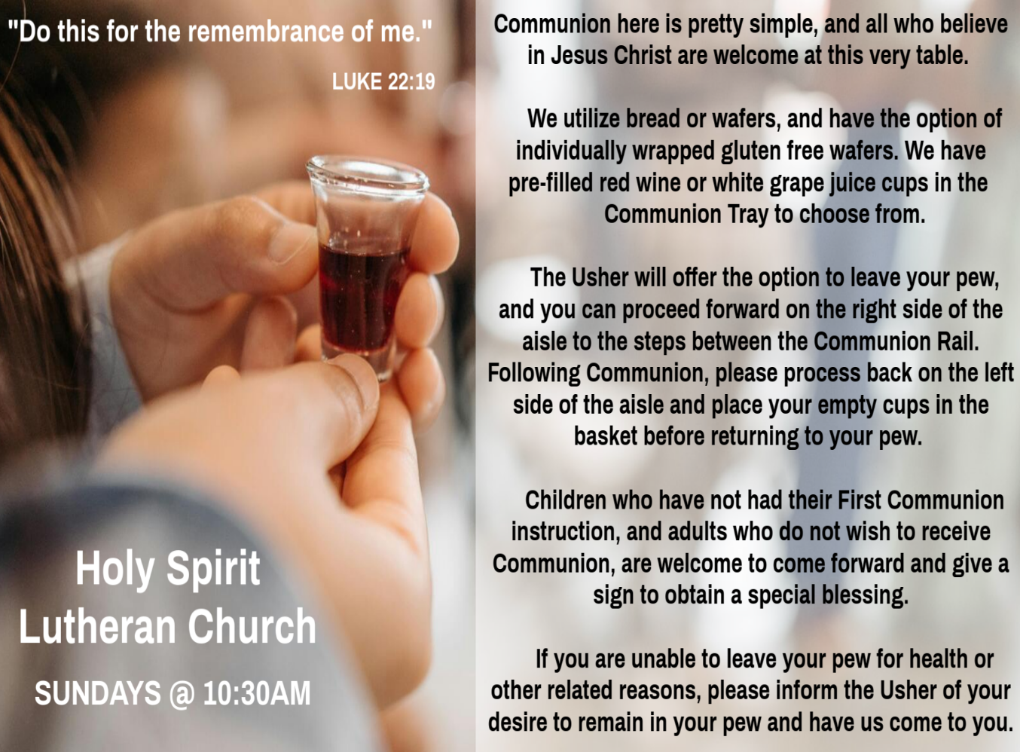

INVITATION TO COMMUNION
V. Come to the table of new life.
Receive the risen Lord.
C. Amen.

(Distribution of Holy Communion)

COMMUNION HYMN
(Please enjoy various music offered by our Organist during your
quiet time, prayer, and reflection following Holy Communion.)

(Vicar and Assistant remove Communion Vessels from the Altar.)

V. We invite you to stand as you are able.

POST COMMUNION BLESSING
V. May the body and blood of our Lord Jesus Christ strengthen us and keep us
always in His grace.
C. Amen.

POST COMMUNION CANTICLE
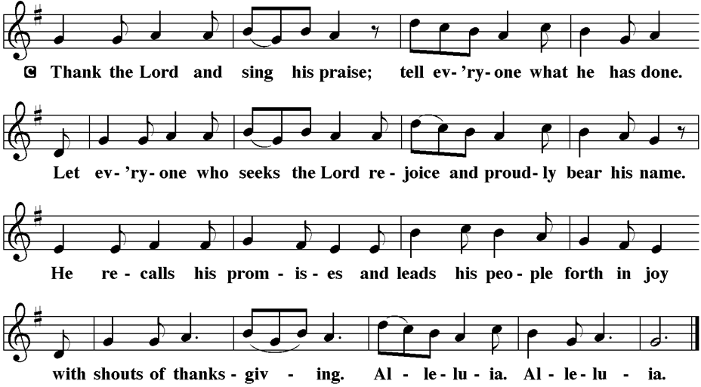

PRAYER AFTER COMMUNION
A. Let us pray,
Holy One,
through this meal you have made your home among us
and are making all things new.
Send us now to speak peace to anxious hearts,
to love our enemies,
and to bring your healing to the nations.
In the name of Jesus,
C. Amen.

BLESSING
V. God Almighty, who is the beginning and the end,
Jesus Christ, the firstborn of the dead,
and the Spirit, our advocate and peace,
☩ bless you now and forever.
C. Amen.
SENDING HYMN
(We invite you to sing along.)
Lutheran Book of Worship—Green Book
145—Thine Is the Glory

(Assistant extinguishes only the Altar Candles half way through the Sending Hymn.)

(The Paschal Candle remains lit.)

(Vicar processes out once the Altar Candles have been extinguished.)

(We invite you to be seated.)

BIRTHDAYS, ANNIVERSARIES, & ANNOUNCEMENTS
(Offered by Assistant and Congregation.)

BIRTHDAYS
3rd Vicki Schaller
4th Gloria Sutton
8th Wanda Bryan

DISMISSAL
A. Go in peace. Praise the Lord. Alleluia!
C. Thanks be to God. Alleluia!

POSTLUDE
(Music offered by our Organist as we depart following our Worship Service.)
The Strife Is O’er

LICENSES & EXPIRATION DATES
Worship Service Content is used via permission through Augsburg Fortress Liturgies Annual License #SB144368. The next Subscription Renewal Date is 2/28/2027.
Our Hymns and Worship Music are used via permission through CCLI One
License #11327166. The next Subscription Renewal Date is 1/31/2027.



WORSHIP MINISTRY
The most important thing we do each week is gather together as God's people to Worship. God is the center and focus of everything we do. Participating in Worship is active, as Liturgy means the work and actions of the people gathered. Everything we do during the week to prepare for Worship, and everything we do as we Assist in leading Worship is important. We are thankful for all the wonderful work being done. If you have questions, or are interested in any position, reach out to Vicar Vince.
Sign-up sheets are located on the bulletin board between the church offices.

BIBLE STUDY & FAITH DISCUSSIONS
Bible Study & Faith Discussions focuses on various readings, books, Bible verses, people of faith, and other general topics. Group Members offer various points of view while being respectful and supportive of one another. Join us on Tuesdays at 6PM.

BULLETIN ENTRY DEADLINE
The Bulletin is printed on Thursdays during Church Office Hours. Changes need to be submitted to Vicar Vince no later than Thursday by 4PM. Thank you!

CHURCH OFFICE HOURS
Open Thursdays from 6PM to 8PM. It is open to serve the Congregation, the Community, and to handle the business of the Church. Feel free to stop in to talk, pick-up or drop off something, pray in the Sanctuary, or for whatever reason.

FOOD PANTRY
Open every Thursday, and the last Saturday of every month, from 10AM to 1PM. 106 people were served in February and 240 people have been served in 2026. Donations can be dropped in the outdoor drop-box, in the money jug in the back of the Church, mailed into the Church Office, or placed in the Offering Plate. Volunteers are needed. Sign-up sheets are located on the bulletin board between the church offices. If you have questions or need training see Heather, Vicar Vince, or Bonnie.
A special thank you goes out to all who donate, pray, and help in any way!

Thursday, 4/9 | Thursday, 4/16 | Thursday, 4/23
Garnet & Joe | Theresa, Kim, & Bob | Skip & Bonnie

COMMUNITY FOOD DONATIONS, DELIVERIES, & MORE
North Cape May Acme provides us with Expiring, Recently Expired, and Slightly Damaged Food and Items. Kathy delivers on Saturdays in the community, brings items to church and the food pantry, and to the Branches Outreach in Rio Grande.

CONFIRMATION & SUNDAY SCHOOL
“Here We Stand” allows our young folks to go through a 2-year process focusing on the Bible and Luther’s Small Catechism. Classes are on Sundays from 9-10AM.
Sunday School Returns following our Easter Break!

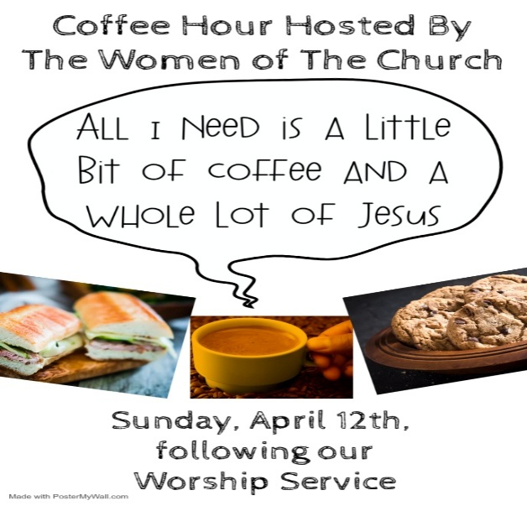
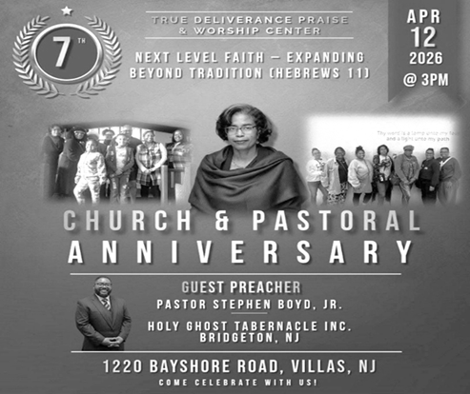
What a blessing it has been to have TDPWC as our Church Family and Ministry Partners. 7 years and many more to go! Congratulations and many more blessings to this Congregation! Come join us on this special day!

CHURCH COUNCIL
Share your comments, concerns, questions, or joys with one of our Church Council Members who can bring them back to our meetings. Visitors are always welcome to attend and listen to what is going on in and around the church. Join us In- Person or on our Conference Call at our next Meeting on Tuesday, April 21st, at 6PM.

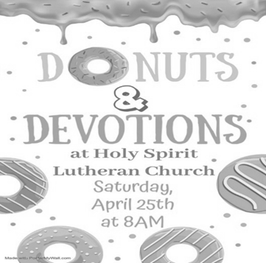
SPECIAL PREACHER
Chip Hand is looking forward to Preaching on Sunday, April 26th, as Vicar Vince will be back in Pittsburgh for a few days for the NFL Draft and some vacation time. Please be aware that there will not be Holy Communion this Sunday as a result.

DONATION STATION
Get on the train and place all purchased items in the specified project donation bins located on the counter by the front doors. See Heather for more information.


WOMEN OF THE CHURCH
Their next meeting is on Monday, May 4th, at 6PM. New members are always invited and welcome to attend! Contact Judy for more information.

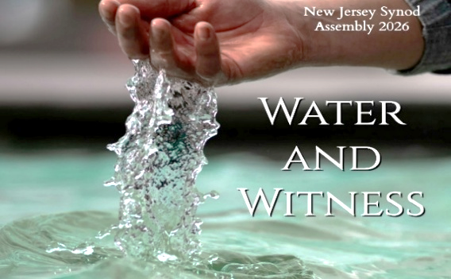
Our NJ Synod Assembly will be on Saturday, May 30th, 2026. Wayne & Judy are attending with Vicar Vince. Registration will need completed and paid for soon.


Confirmation is a journey of faith filled with new questions and answers, new discoveries, new relationships, new responsibilities, and new possibilities. Clearly confirmation is intended to be a milestone, not a destination; it is not graduation! Rather, Confirmation is a tool that equips for the life-long process of living out Christian identity. Traditionally we would be celebrating Confirmation on Pentecost Sunday. However, due to it falling on Memorial Day Weekend, and the schedules of our young folks, we will be moving it to Sunday, June 14th, during our 10:30AM Worship Service. Please come out and join Caylee Thomas and Robert Thomas on this special day and celebrate with them at the Coffee Hour afterwards.

INTERESTED IN BECOMING A NEW MEMBER
Have you been attending our church for a while? Have you just recently returned to church after being away for a bit? Maybe you transitioned from another church, or just started to recently attend our church. We are glad to have you, and would love to have you as a member of our Congregation. We are looking forward to
having new member classes in the near future. Please stay posted.
Feel free to ask Vicar Vince any questions or for more information as well.

NEWSLETTER
Collect information, stories, pictures, and reports for our next publication. Everything needs submitted to Vicar Vince in-person or via email at vpie8282@gmail.com.

CHURCH DIRECTORY
2026 Church Directories are by the Church Office on the bookshelves. We continue keeping it updated, but we undoubtedly miss a few changes or have made a few errors. Please inform the Church Office of updates or changes to keep us up to date.

TITHES, OFFERINGS, & ENVELOPES
We worship God with our tithes and offerings. We hear in scripture, “Each of you must give as you have made up your mind, not reluctantly or under compulsion, for God loves a cheerful giver.” (2 Corinthians 9:7) Envelopes can be dropped in the offering plate, mailed to the church, or dropped in the locked mailbox. Thanks for your support in the mission of our church, its ministries, the NJ Synod, etc!

SPACE AVAILABLE
​​​​​Interested in utilizing our Fellowship Hall for a Party or Event? There is a suggested $50 refundable security deposit, and it is $250 for facility use. No alcohol or games of chance permitted due to ELCA policy. Please contact Vicar Vince for more info.

ED GREEN CAPITAL IMPROVEMENT FUND
We continue to raise money for any unforeseen costs or repairs. We are currently exploring a new Annual Fundraising opportunity where we will be handing out coffee cans to raise money at home. We also have the donation bin in the back of the church. Thanks for your continued prayers, support, and donations!

HOME COMMUNION MINISTRY
A Minister is available if you have a loved one, or if you desire services. We look forward in sharing the Word and Holy Communion! Please inform Vicar Vince, Kathy, or the Church Office so plans can be made for visits.

PRAYER SHAWL MINISTRY
Prayer Shawls, Lap Quilts, Scarves, and other items have been made with love. Blessed items are located in the Narthex, and are free for anyone. Members of the group continue working at home on new stitches and patterns. We are blessed to be able to continue collecting new items. We have a donation station of yarn and other items located in the Narthex. You can find some new supplies for your next creation!

PRAYER LIST
Our Prayer List continues to lengthen and we realize the important need for prayers and healing. Sometimes the unfortunate result is that someone has passed away, and the words “The Family & Friends of” appear before someone’s name. However, sometimes we forget names are still on the list and their health has improved and they can be removed. Please share various stories as we continue to pray for strength and healing. Names can be added or removed from the list on the clipboard in the Narthex prior to the Worship Service, by calling the church office, or addressing it on the Conference Call. Please let us know the relation to the person(s) you listed so we can be more mindful with our prayers.

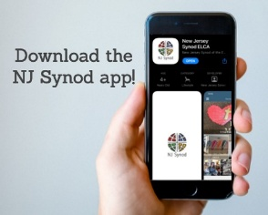
There is a weekly e-newsletter connecting our synod together with weekly prayer, upcoming events, synod and churchwide activities, mission stories, congregational activities, & more. Download the app or sign up at www.njsynod.org/stay-connected.

BAPTISM
We are a church whose unity is in Jesus Christ, who gathers us around word and water, wine and bread. Baptism is a significant part of our faith journey as we come from the baptismal waters to live a new life as children of God. Our baptism sets us out on a lifelong journey that is characterized by our relationship to God, our relationship to our faith community, our relationships in our community and the wider world. Living our baptismal covenant means living a life of growth in the faith practices of discipleship. Please see Vicar Vince for more information.
FIRST COMMUNION
Although no particular age for first communion is prescribed by The Use of the Means of Grace, one guideline is offered. Because admission to the Sacrament is by invitation of the Lord to the baptized, "baptized children begin to commune on a regular basis at a time determined through mutual conversation that includes the pastor/vicar, the child, and the parents or sponsors involved, within the accepted practices of the congregation.” Each congregation is encouraged to ask the question of readiness for first communion, establish their own policies regarding age and practice, and accompany that practice with catechesis appropriate to the age of the communicant. If anyone has questions, please see Vicar Vince.

LIBRARY
New books are added to our library from time to time. Several are borrowed and read and exchanged. Who knows, you might find one particularly interesting and share that with someone. Reading is a great way to pass spare time, learn, and explore. You may find some fresh ideas for prayer, ways to grow more spiritually, ways to grow closer to God, or some opportunities to understand our faith more. We have an extended library located in Vicar Vince’s office. There are Bibles of various translations, books from his personal collection, books inherited from Pastor Leah, movies, past Bible Study Curriculums, and more. Come check things out.

FAVORITE HYMNS
Carol is willing to play some of your favorite hymns for the Prelude & Postlude each Sunday during our Worship Service. Feel free to let her know of your suggestions.

VICE PASTOR UPDATE
Pastor William Hodgetts continues to attend our Church Council Meetings
and provides Supervision and Support to Vicar Vince.


VICAR VINCE’S DAY OF REST
A day of rest can have physical, mental, and spiritual benefits. “Mittwoch,” German for mid-week, or Wednesday, is the day that Vicar Vince will use to recharge and do some other things. Please do not hesitate to reach out if there is an emergency!
VICAR APPOINTMENT ON MARCH 19TH, 2023
A Memorandum of Understanding on the Matter of Pastoral Appointment
In Theological Education for Emerging Ministries (TEEM) Candidacy
TO: Congregation Council, Holy Spirit Lutheran Church, Villas
FROM: The Rev. Tracie L. Bartholomew, Bishop, New Jersey Synod

Dear Brother and Sisters in Christ,
This memorandum is in support of your discussions with Vincent Piekarski as pastor of Holy Spirit, Villas. Because this is not the usual pattern for completing the educational and candidacy requirements for ordination, it is my hope that this memorandum will both provide guidelines and engage in conversation with those who are invested in this process.

I would say at the outset that because Vincent is an outstanding candidate for the Ministry of Word and Sacrament, we will all want to do whatever is necessary to assure that his placement serves the mission of the church in the best possible fashion.

The following notes reflect my own understanding of this matter:
(1) The appointment for Vincent will begin on April 1, 2023. At this time, Vincent
will assume all responsibilities of a regularly called pastor, including presiding at
the Sacrament of Holy Communion and Baptism at Holy Spirit, Villas.
(2) A pastoral appointment in the TEEM process is an option for completing
seminary educational requirements and the steps of the candidacy process.
Upon completion of the candidacy process and seminary education, the
candidate may receive and accept a call to ordained ministry from the
congregation where the appointment is being served.
(3) This appointment is jointly supervised by the Office of the Bishop and the TEEM
pastor’s seminary. A mentoring relationship with a local pastor is required for the
length of this appointment.
(4) The synod of candidacy origin will be responsible for the approval process.
(5) Upon approval for ordination, the congregation would be expected to extend a
call to the pastoral appointee.
(6) Compensation for the TEEM pastor will be according to the guidelines of the New
Jersey Synod. All normal forms of compensation should be in place for the term
of the appointment, including stipulation that base salary and housing shall be in
accord with synod guidelines for first call at time of ordination.
(7) The ELCA Portico benefit plan for lay persons in full-time church service should
be used for the pastoral appointee up to the time of ordination, whereupon the
benefit package is to be converted to the plan for ELCA clergy.

(8) A decision for Pastoral Appointment is made with the agreement of a synod and
its candidacy committee, and the ELCA, normally represented by the regional
staff person of each in consultation with the seminary and its Director for
Contextual Education.
(9) Pastoral Appointment in a TEEM Candidacy is an option that is to serve the
mission of the Church in a particular and vital way and is not to be viewed or
used as a means to circumvent the normal candidacy process and/or first call
placement process.

In the specific case of Vincent, the New Jersey Synod remains responsible for the candidacy and approval process, and has agreed to this proposal for Appointment at Holy Spirit, Villas.

Continued blessings to both Holy Spirit and Vincent Piekarski as you embark on this journey of mutual ministry. As partners in ministry, we walk with you and rejoice in this new relationship.

2026 FINANCIAL STANDING
FEBRUARY INCOME | $8,570.00
FEBRUARY SPENDING | $6,702.26
FEBRUARY GAIN OR (LOSS) | $1,867.74
2026 INCOME | $11,480.00
2026 SPENDING | $12,124.07
2026 GAIN OR (LOSS) | ($644.07)
ED GREEN CAPITAL IMPROVEMENT FUND | $2,958.55
FOOD PANTRY FUND (SOCIAL MINISTRY) | $13,515.13
CD | $26,414.45

WHAT IS THE EVANGELICAL LUTHERAN CHURCH IN AMERICA?
The ELCA was formed in 1987 by the merger of three Lutheran Church bodies –
the ALC (American Lutheran Church), the LCA (Lutheran Church in America), and the AELC (Association of Evangelical Lutheran Churches). Learn more at elca.org.


The New Jersey Synod is a geographical grouping of Evangelical Lutheran Church in America (ELCA) congregations that share the mission and ministry of the Church on the New Jersey territory. It is one of 65 synods in the ELCA. The NJ Synod is comprised of 143 congregations, which include over 45,000 baptized members.
TRUE DELIVERANCE PRAISE & WORSHIP CENTER
TDPWC utilizes our facilities from 1-4PM on Sundays. TDPWC hosts or assists with other events. TDPWC hosts a Prayer Line on Mondays, Wednesdays, & Fridays at 5PM on the Conference Call 1-657-390-7957; & Bible Study on Thursdays at 6:30PM on Zoom. See Rev. Brooks for more information.

JUST FRIENDS
The group promotes a spirit of fellowship among adults 50 years and older. Bring your own lunch, beverages and deserts are provided. Everyone is welcome. The group meets in Our Lady Star of The Sea Parish Hall on the last Wednesday of the month from 12Noon to 2PM from September through May. For information, please call Martine Simonis 609-884-5312 x 110.

ADDITIONAL OFFERINGS FROM OUR FRIENDS & NEIGHBORS
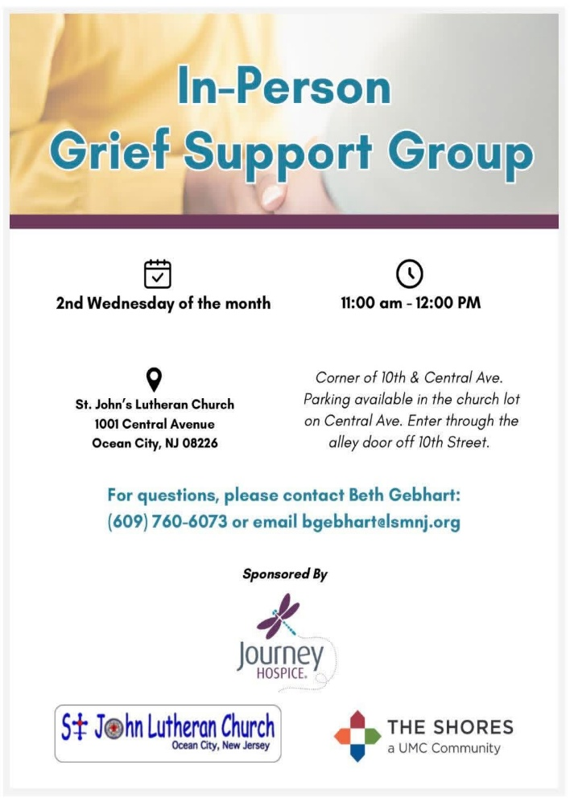

CHURCH STAFF & VOLUNTEERS
VICAR
Vicar Vince Piekarski
VICE PASTOR
Pastor William Hodgetts
ORGANIST & PIANIST
Carol Amundsen
CHURCH OFFICE, SUNDAY SCHOOL, & FOOD PANTRY
Heather Piekarski
CHURCH COUNCIL PRESIDENT & CHURCH PROPERTY
Wayne Rand
CHURCH COUNCIL VICE PRESIDENT & WOMEN OF THE CHURCH
Judy Brannan
CHURCH COUNCIL TREASURER
Bonnie Millard
CHURCH COUNCIL SECRETARY
Vicki Rinier



