We would like to congratulate all families who are considering joining our Holy Family Parish First Holy Communion Programme this year 2022. The title of the programme is I Belong and becoming literally part of the Body of Christ is the aim. If you have got out of the habit of coming to Mass and Holy Communion, this is the opportunity to start again.
What’s involved?
Receiving First Holy Communion is a very significant step on the Journey of Faith that parents committed to at children’s baptism. Prayer is at the heart of the preparation and encouraging children and praying with them before they go to bed is an important first part of their preparation.
Receiving First Holy Communion is when a child in a unique way receives the Body and Blood of Jesus Christ our Saviour. This makes them literally part of the Body of Christ. Becoming an active member of the Church is what is implied by this Sacrament, and regularly coming to Mass and receiving Holy Communion is clearly implied. This may challenge us with so many demands on the very brief time families have together at the weekend, with different activities, sports and clubs but getting our priorities right is clearly part of the commitment involved.
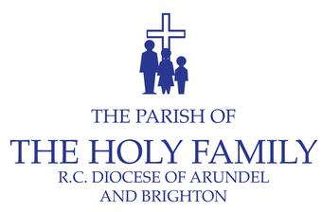

Our Programme
The programme will be based on the ‘I Belong’ Programme which has a lovely coloured book for children to fill in and a parents’ Guide and online resources with videos and quizzes for families to complete at home.
Our programme has three strands.
- At home, Parents should try to watch the videos and help their children to complete the online quizzes. These can be found on this webpage https://rcstortford.org.uk/sacraments/fhc/fhc2021/

- Mr Tindall, Mrs Holt and some of the Staff at Holy Family School will be running an After School First Communion Club starting on Ash Wednesday 2nd March and continuing every Wednesday till May 7th First Communion Day apart from the Easter Holidays. Children at other schools can complete the course, I Belong Book at home.

- We will celebrate the beginning of our Programme at all our Weekend Masses on Saturday and Sunday 5th and 6th March. We will be presenting both children and parents with their copy of the I Belong course books. Then at all the Sunday 10am Masses in Lent we will focus on one aspect of the programme each Sunday so that this is a good way to get children and families involved in our Sunday Services

If you wold like your child to be enrolled on the Holy Family Parish First Communion Programme

To join the programme, parents should fill in the form available from the parish secretary
Email secretary@holy-family-parish.net

Our First Communion Day Masses will be celebrated
on Saturday 7th May at 11am and 1pm.

Thanks for considering our First Holy Communion Programme, this is a very important aspect of our life together as Holy Family Parish, but clearly involves commitment from both children and parents. Any questions please contact me through the Secretary. Our prayers and good wishes for a further step on our Journey of Faith together
Fr John Dickson SDB

Holy Family Parish First Holy Communion Programme 2022
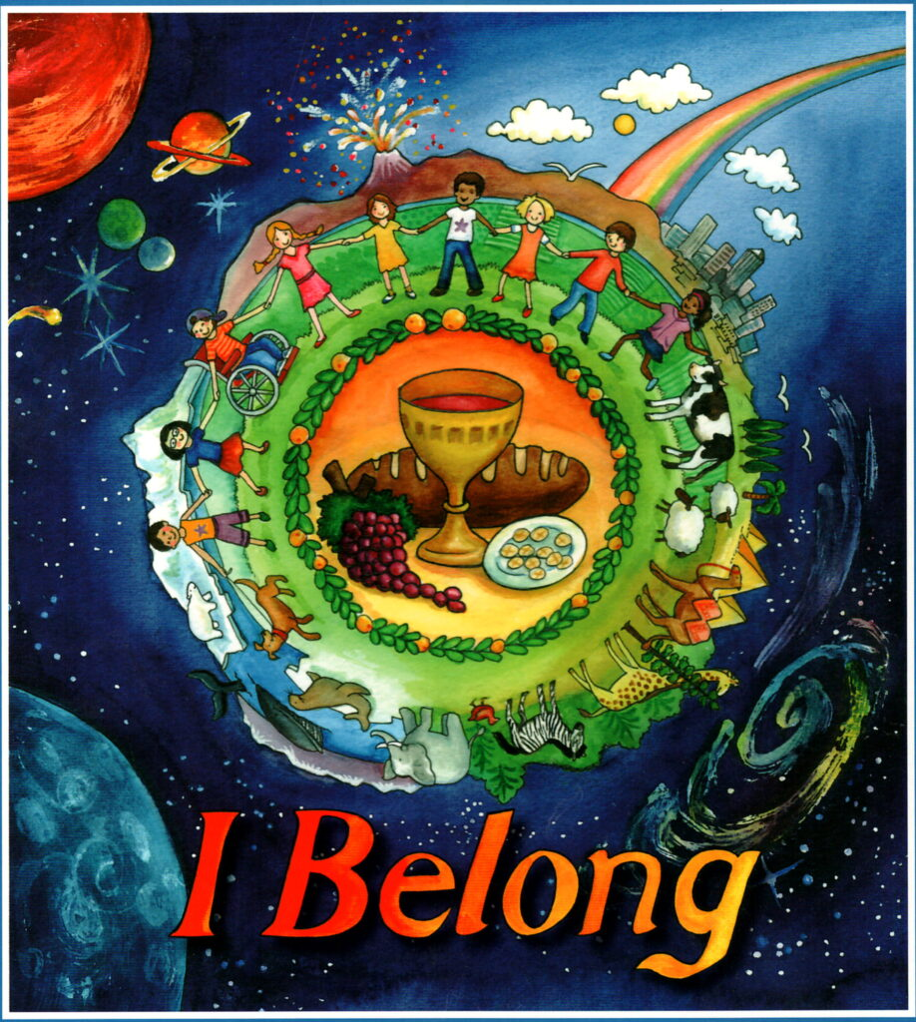

Belonging to the Body of Christ

