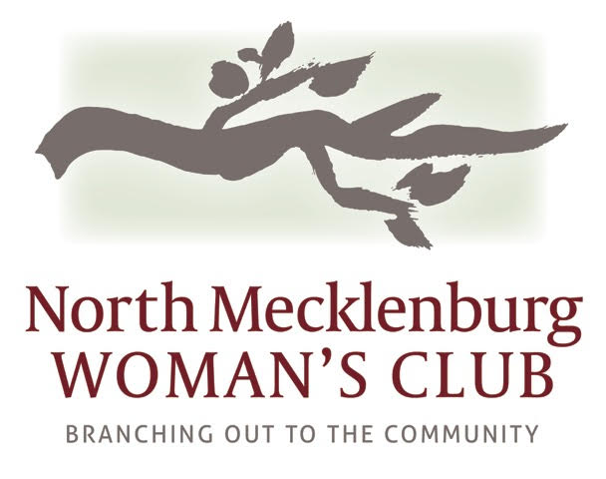 2016-2017 Sponsorship Benefits

Sponsorship is your way of giving back to our community.
Sponsorship benefits are North Mecklenburg Woman’s Club way of saying THANK YOU!

Friends of NMWC $250 Sponsors and NMWC Partners benefits include:
*Business Card Listing in NMWC online business directory *Signage at NMWC meetings and events
*NMWC Website post *Name In NMWC Weekly Newsletter *Local Glossy Magazine Recognition
*501c3 Tax deductible charitable contribution

In addition Partnership levels include:
Platinum Partner  $5000 | Gold Partner  $2500 | Silver Partner  $1000
Full page ad in the  NMWC directory | ½ page ad in the  NMWC directory | 1/4 page ad in the  NMWC directory
Royal Flush  Casino Night Package  Your 10 free Casino Night tickets will include the  Royal Treatment  for you and your guests. A beautifully decorated private table with roses, chocolates, and champagne for all.  -Introduced and acknowledged  -Named as an event sponsor on posters, tickets & event schedule  -Recognized in all press releases  -Individual banner at entrance  -Corporate representative to help call out  raffle prize winners | Four Aces  Casino Night Package  - 4 Free Casino Night Tickets  - 4 Free Raffle Tickets  -Included on Partner display banner  -Introduced and acknowledged  -logo on event schedule  -Corporate representative to help call out  raffle prize winners | Pair of Kings  Casino Night Package  -Two Free Casino Night Tickets  -Two Free Raffle Tickets  -Included on Partner display banner  -Introduced and acknowledged
Sponsorship Impact Celebration  Be our guest at a  Special Head Table at our May event  as we celebrate our charities  and learn how your  contributions have improved lives.  Presented with Platinum Partner Award | Sponsorship Impact Celebration  Be our guest at our  May event where we  celebrate our charities and  learn how your contributions  have improved lives.  Presented with Gold Partner Award | Sponsorship Impact Celebration  Be our guest at our May event where we celebrate our charities and  learn how your contributions  have improved lives.  Presented with Silver Partner Certificate

