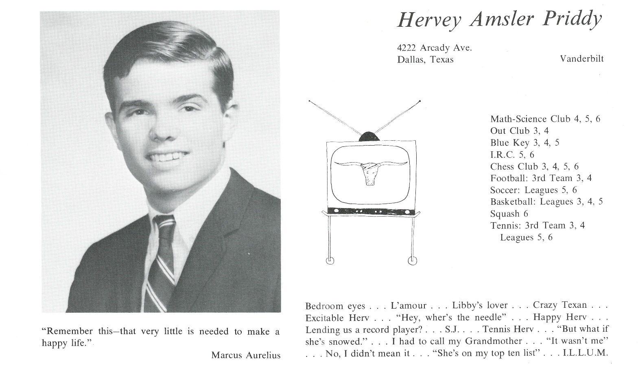

Hervey A. Priddy, Ph.D.

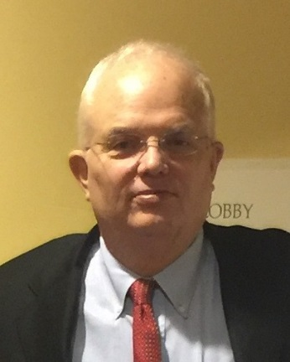Following our June 1967 graduation, I enrolled at Vanderbilt University, with an engineering major. After two years in Nashville, I had “homesick blues” for The University of Texas at Austin. If you can remember that far back, in the Fall of 1963, the Longhorns were the #1 team in the Nation, defeating Navy and Roger Staubach in the 1964 Cotton Bowl. In the Fall of 1969, I started at Texas, on cloud nine. I graduated with a B.B.A. in May 1972, having met my soon-to-be wife in one of my final classes. In fact, our first date was after I had completed my last final exam. Obsessed with investment banking, I obtained jobs at two different regional firms. I worked a year and married Dianne just weeks before graduate business school started at UT-Austin in the Fall of 1973. Graduating in 1975, we moved to New York City where I started work as an associate in investment banking at Smith Barney, Harris Upham & Co. Both our children were born in NYC: Amsler, our daughter, in 1976, and Ashley, our son, in 1980. Intrigued with Washington, D.C. and the federal government, I accepted a position in December 1980 with the brand new corporate entity, the United States Synthetic Fuels Corporation (SFC), chartered by Congress and signed into law by then-President Carter in June 1980. It was quite an exhilarating experience to be part of that organization at its inception. Once President Reagan assumed the office and with the precipitous decline in crude oil prices, the SFC became a doomed corporation, dying in April 1986. I left the SFC for Dallas in early 1982 to join an oil and gas exploration and production company. In 1988, the company had an unfriendly tender offer, but we were able to find a “white knight.” Departing in 1988, I was in somewhat of a quandary, and eventually decided to go back to school at Southern Methodist University (SMU) for a Masters in American History. I graduated in December 1999, with my master’s thesis on the SFC. While in graduate school, I ran for public office to become a member of the board of trustees of our local school district, Highland Park Independent School District (HPISD). This was remarkable, defeating an incumbent in the HPISD, a feat that has never been achieved before or since. The term is three years, and I served two consecutive terms. A true highlight of that experience as trustee was working with the other highly educated professionals of the board to maintain our district’s exemplary status, as well as presenting high school diplomas to both of our children. Following the MA, the possibility of a PhD lured us to return to UT-Austin. We moved there in 2001 and returned to Dallas in 2013, after graduating with the doctorate in May 2013. In 2015, I was appointed a Fellow at SMU’s Center for Presidential History, and reappointed in 2017. There have been two exhibits of my collection of Presidential Campaign Memorabilia and Presidential Inauguration Memorabilia at the George W. Bush Presidential Library and Museum. Both our children and their families live close by, as well as both of my sisters and my 90-year-old mother, who is now unfortunately in the advanced stages of Alzheimer’s. The success of our children and grandchildren is a source of amazement and gratitude to both Dianne and me, for it is beyond anything we could hope for or deserve…truly our greatest blessing. We have four grandchildren, two boys, two girls, ranging in age from 2 to 11. Additionally, we have two wonderful and loving Golden Retrievers to brighten our days in this chapter of life and they are our “Golden Girls.”



______________________________________________________________

______________________________________________________________ ______________________________________________________________ ______________________________________________________________ ______________________________________________________________ ______________________________________________________________ ______________________________________________________________ ______________________________________________________________ ______________________________________________________________

Attach Picture in .jpg Format

______________________________________________________________

______________________________________________________________

___________________________________________________________________________________ _________________________________________________________________________________________________________________________________________________________________________________________________________________________________________________________________________________________________________________________________________________________________________________________________________________________________________________________________________________________________________________________________________________________________________________________________________________________________________________________________________________________________________________________________________________________________________________________________________________________________________________________________________________________________________________________________________________________________________________________________________________________________________________________________________________________________________________________________________________________________________________________________________________________________________________________________________________________________________________________________________________________________________________________________________________________________________________________________________________________________________________________________________________________________________________________________________________________________________

___________________________________________________________________________________