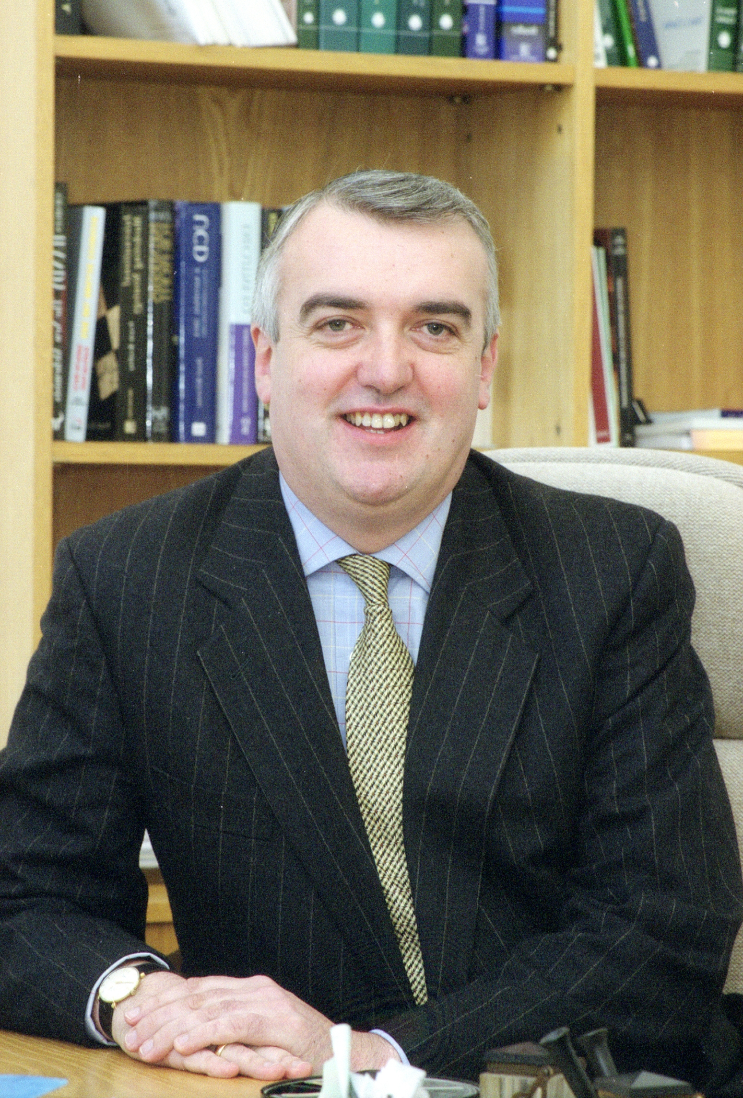
Professor Patrick T Gibbons
Patrick is the Jefferson Smurfit Professor of Strategic Management and is currently the Academic Director of Executive Development and Programmes at the UCD Smurfit School of Business. Between 2008 and 2013 he was a member of both the UCD Governing Authority and its principal sub-Committee, the Finance, Remuneration and Asset Management Committee (FRAMC). He was also the Vice-President of the University, overseeing Staff and Administration between 2004-2006, overseeing a period of significant structural change at the institution. He also served as Associate Dean-Academic of UCD Busines School between 2007 and 2011.

International Experience

Patrick is a Visiting Professor at Nanyang Business School. In addition, he actively contributes to UCD Business School’s programmes in Singapore, Hong Kong and Sri Lanka. Moreover, in 2012, he taught on the University of Pittburgh’s Global MBA Programme in Sao Paolo, Brazil. In 2009, he taught at Peking University and in 2007, Patrick was Visiting Professor at the Hong Kong University of Science and Technology (HKUST). In 2002 he was a Visiting Scholar at the Smeal College of Business, Pennsylvania State University. His previous academic appointments have also included the University of Pittsburgh (1987-1992), and Nanyang Business School (1992-1997) in Singapore. While at Nanyang, he was Director of both the MBA (International Business) and subsequently, the MBA (Strategic Management) Programmes. He has served as an external examiner at Warwick Business School; Macquarie University and the Open University.

Academic and Research Achievements

His research, teaching and consulting interests are in the areas of Strategic Management, Competitive Intelligence, Organisational Change, International Business and Leadership Development. He graduated with a Ph.D. in Strategic Planning and Policy from the University of Pittsburgh. Prior educational qualifications at bachelor’s and master’s levels were gained at UCD.

He has presented academic papers at over 80 international conferences, has published two books and his articles have been published in journals such as the Journal of Management Studies, Journal of International Management, British Journal of Management; Journal of Small Business Management; Accounting, Auditing and Accountability; Group and Organization Management; Journal of Asian Business; Asia-Pacific Journal of Management; Asia-Pacific Journal of Case Research; Journal of High Technology Management Research; Journal of Technology Management; Journal of Business Strategy; Irish Journal of Management; Irish Marketing Review and Human Relations.

Patrick is/was on the editorial boards of the Journal of Competitive Intelligence and Management, Journal of Strategy and Management and the Journal of Enterprising Culture.

Business Experience and Impact

Patrick is active in both consulting and executive education. His clients have included: Abbott Laboratories; Allied Irish Banks; Alltech; Amana Bank (Sri Lanka); Bar Council of Northern Ireland; Bank of Ireland; Bausch&Lomb; BOC Gases; Bord Bia; CIE Group; Coopers and Lybrand; The Courts Service; Department of Jobs, Enterprise and Innovation; Department of the Taoiseach (Irish Prime Minister’s Office); Dimension Data: Dellatta Group; DuPont Asia-Pacific; DuPont Korea; EJ; Enterprise Ireland; ESB; Essilor; Failte Ireland; Gaelic Athletic Association (GAA); GSK Pharmaceuticals; Google; ICON; Industrial and Commercial Bank of China; Irish Pharmaceutical and Healthcare Association (IPHA); Keppel-FELS Corporation; KPMG; Microsoft; Port Authority of Singapore; PWC; Volvo Construction Equipment APAC and a number of other small and medium-sized enterprises, professional service firms and non-profit organisations both in Ireland and Singapore.

He is an Associate at the Competitiveness Forum at Harvard Business School. He is also an associate of the Leadership Forum, a group of academics and consultants focussed on helping companies achieve strategic insight.

Between 1993 and 1995 he was an Associate Director of Capital Resources Asia, a firm specialising in facilitating trade and investment in South East Asia.

Before entering academia, Patrick worked in a number of financial and corporate strategy roles with KPMG; the Jefferson Smurfit Group; The Investment Bank of Ireland and An Post (The Irish Post Office).

He has actively contributed to media such as RTE, The Sunday Times and The Irish Times.

