Book Trailers

(Click on the cover or the associated link)

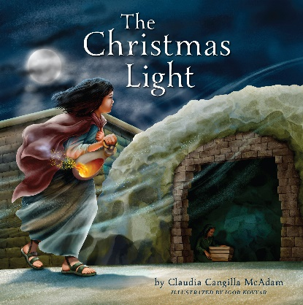 https://www.youtube.com/watch?v=720AlqEzwho

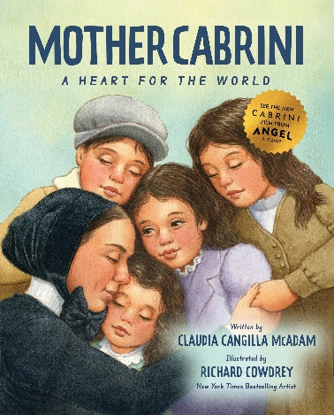 https://www.youtube.com/watch?v=-M5YbokYGxQ

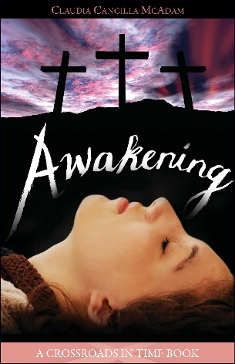 https://www.youtube.com/watch?v=rWQLz90Yno8

