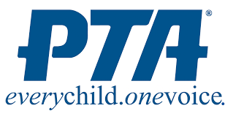
My 30-Second “Elevator Speech”
If you meet someone in an elevator, can you convince them in a short 30-second ride to join PTA? Can you at least make them interested enough to learn more? Here’s an outline to craft your own elevator speech, that can be used anywhere!

Hi, I’m ______________________________________________________ Tell me your name and PTA affiliation

“Did you know______________________________________________” Hook me with an interesting fact or question

“PTA______________________________________________________” Briefly explain what we do (mission – purpose – vision)

“When you join______________________________________________” Share your favorite benefit!

“Did you know______________________________________________” Ask an engaging question that challenges me to learn more

“Can I show you / join us at _______________________________________________________________________________________________________________________” Take Action! Offer the next step – or a membership form!

