**St. Luke’s Episcopal Church**

**The 4th Sunday after Pentecost**

**20 June 2021  10:00 A.M.**

**Holy Eucharist**

The Reverend Michael L. Delk, *Celebrant & Preacher*

***Wearing a mask on the St. Luke's campus is no longer required if you are fully vaccinated. However, if you feel more comfortable wearing a mask and maintaining social distancing, please let the ushers know and they have reserved pews for distancing.***

***Congregational singing is allowed, but you must wear a mask while singing.***

***Please bring your own mask or ask ushers for a disposable one.***

**THE WORD OF GOD**

**Prelude “Largo” Domenico Zipoli**

**(1688-1726)**

**[ CONTINUE TO NEXT PAGE ]**

**Processional Hymn “Praise to the living God” Hymnal, 372**

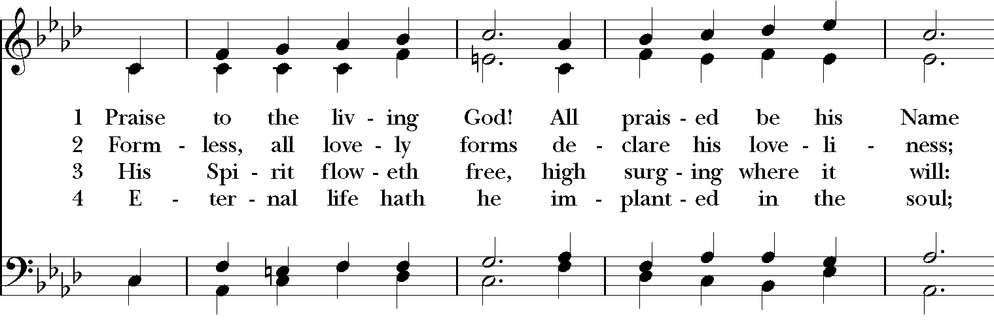

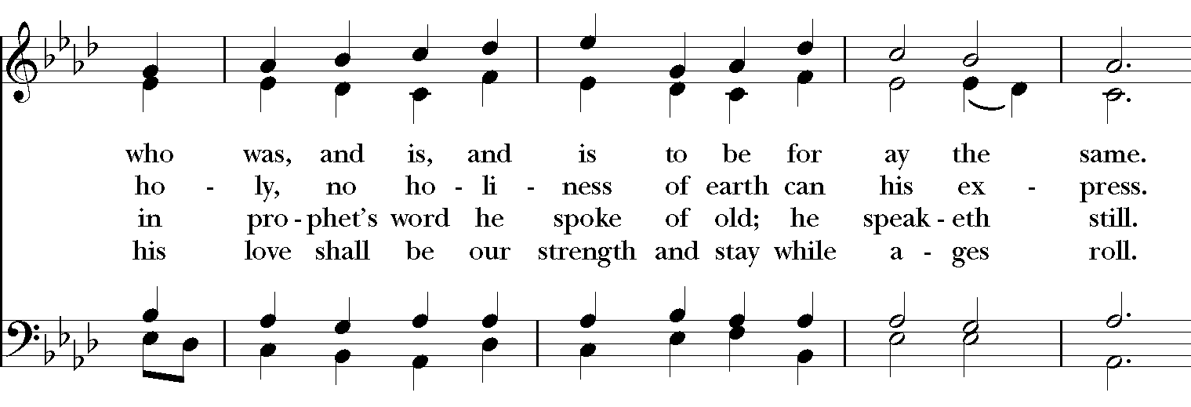

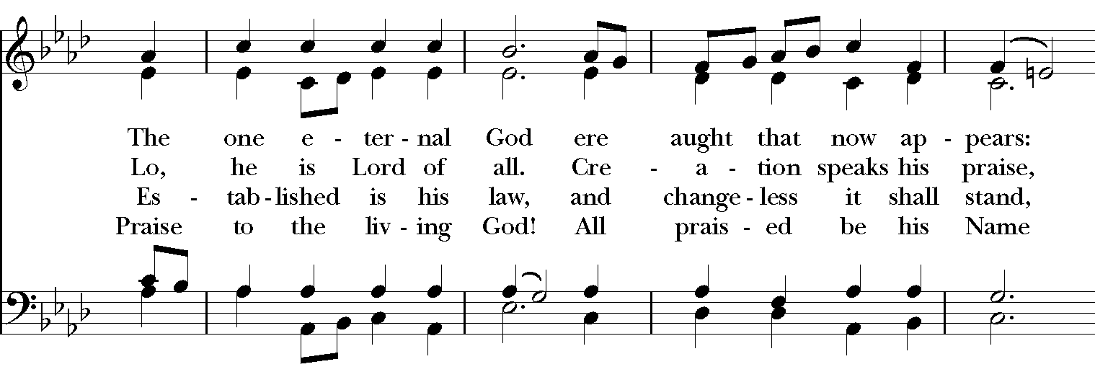

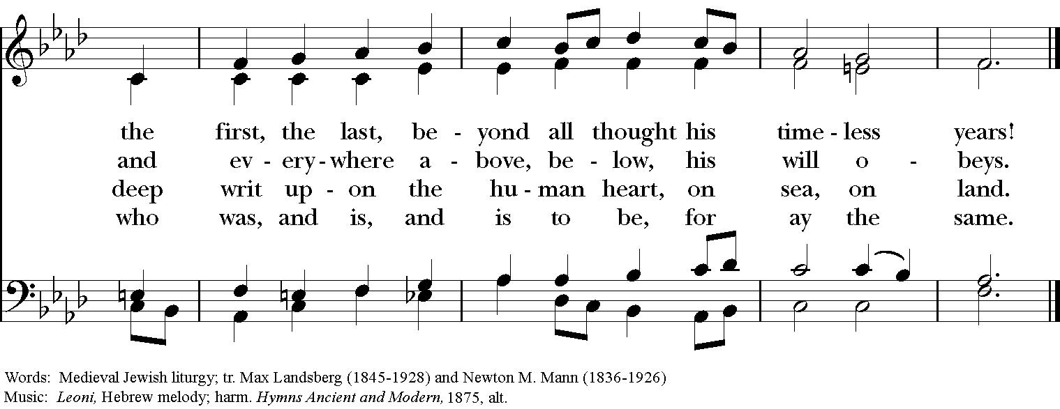

**The Opening Acclamation Page 355**

***Celebrant*** Blessed be God: Father, Son, and Holy Spirit.

***People* And blessed be his kingdom, now and forever. Amen.**

**The Collect for Purity**

**The Gloria: S-280 in the Hymnal 1982**

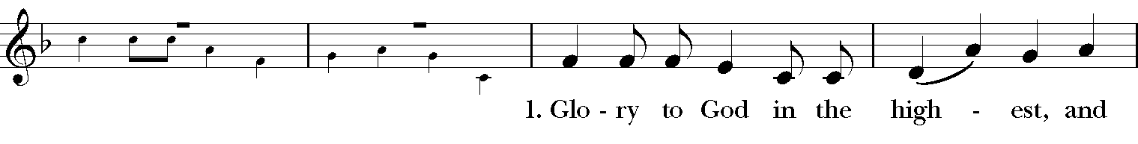

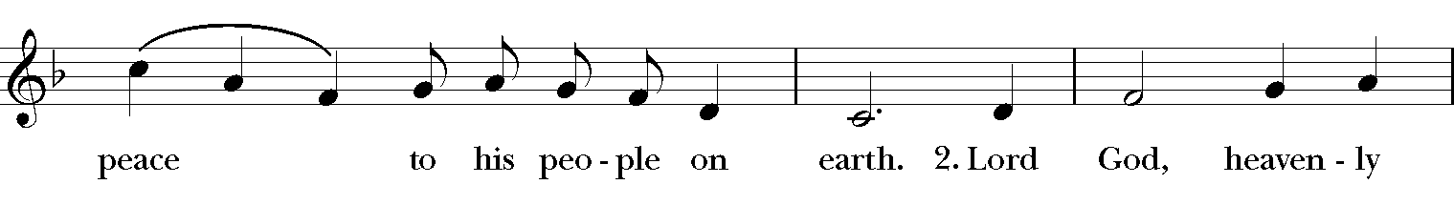

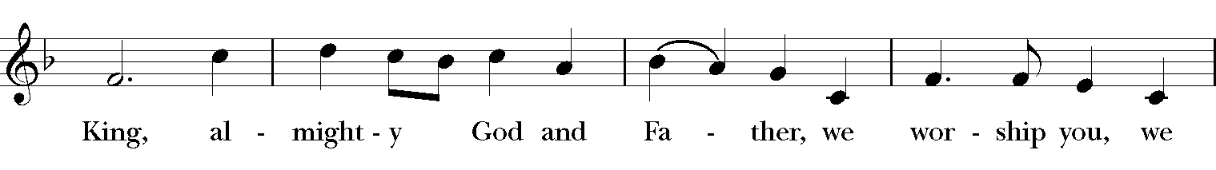

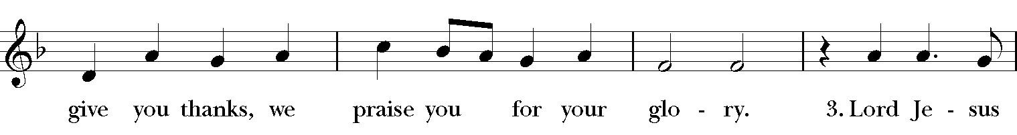

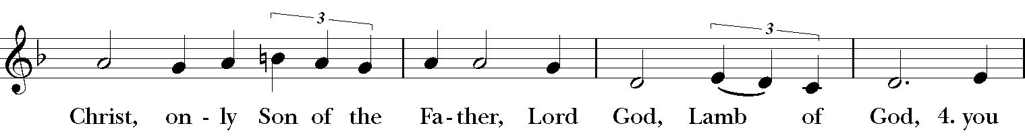

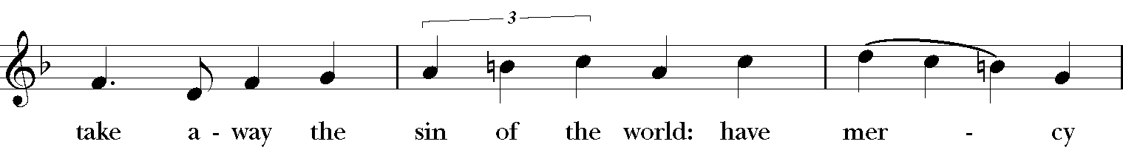

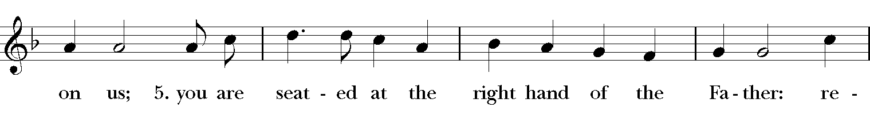



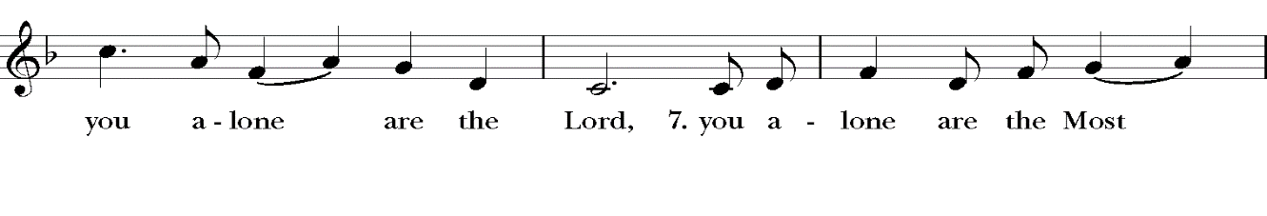



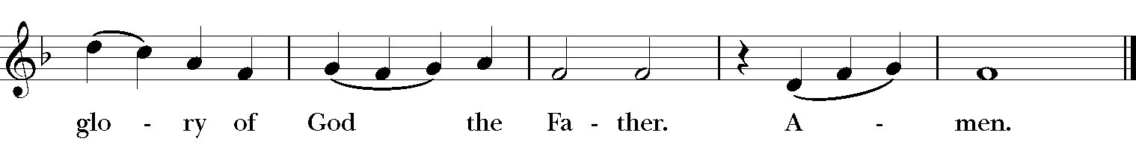

**The Salutation & Collect of the Day Page 357**

***Celebrant*** The Lord be with you.

***People* And also with you.**

***Celebrant*** Let us pray.

O Lord, make us have perpetual love and reverence for your holy Name, for you never fail to help and govern those whom you have set upon the sure foundation of your loving-kindness; through Jesus Christ our Lord, who lives and reigns with you and the Holy Spirit, one God, for ever and ever. ***Amen***

**The First Lesson I Samuel 17:1a, 4-11, 19-23, 32-49**

Now the Philistines gathered their armies for battle; they were gathered at Socoh, which belongs to Judah, and encamped between Socoh and Azekah, in Ephes-dammim. And there came out from the camp of the Philistines a champion named Goliath, of Gath, whose height was six cubits and a span. He had a helmet of bronze on his head, and he was armed with a coat of mail; the weight of the coat was five thousand shekels of bronze. He had greaves of bronze on his legs and a javelin of bronze slung between his shoulders. The shaft of his spear was like a weaver's beam, and his spear's head weighed six hundred shekels of iron; and his shield-bearer went before him. He stood and shouted to the ranks of Israel, "Why have you come out to draw up for battle? Am I not a Philistine, and are you not servants of Saul? Choose a man for yourselves, and let him come down to me. If he is able to fight with me and kill me, then we will be your servants; but if I prevail against him and kill him, then you shall be our servants and serve us." And the Philistine said, "Today I defy the ranks of Israel! Give me a man, that we may fight together." When Saul and all Israel heard these words of the Philistine, they were dismayed and greatly afraid. Now Saul, and they, and all the men of Israel, were in the valley of Elah, fighting with the Philistines.  
  
David rose early in the morning, left the sheep with a keeper, took the provisions, and went as Jesse had commanded him. He came to the encampment as the army was going forth to the battle line, shouting the war cry. Israel and the Philistines drew up for battle, army against army. David left the things in charge of the keeper of the baggage, ran to the ranks, and went and greeted his brothers. As he talked with them, the champion, the Philistine of Gath, Goliath by name, came up out of the ranks of the Philistines, and spoke the same words as before. And David heard him. David said to Saul, "Let no one's heart fail because of him; your servant will go and fight with this Philistine." Saul said to David, "You are not able to go against this Philistine to fight with him; for you are just a boy, and he has been a warrior from his youth." But David said to Saul, "Your servant used to keep sheep for his father; and whenever a lion or a bear came, and took a lamb from the flock, I went after it and struck it down, rescuing the lamb from its mouth; and if it turned against me, I would catch it by the jaw, strike it down, and kill it. Your servant has killed both lions and bears; and this uncircumcised Philistine shall be like one of them, since he has defied the armies of the living God." David said, "The LORD, who saved me from the paw of the lion and from the paw of the bear, will save me from the hand of this Philistine." So Saul said to David, "Go, and may the LORD be with you!" Saul clothed David with his armor; he put a bronze helmet on his head and clothed him with a coat of mail. David strapped Saul's sword over the armor, and he tried in vain to walk, for he was not used to them. Then David said to Saul, "I cannot walk with these; for I am not used to them." So David removed them.  
  
Then he took his staff in his hand, and chose five smooth stones from the wadi, and put them in his shepherd's bag, in the pouch; his sling was in his hand, and he drew near to the Philistine. The Philistine came on and drew near to David, with his shield-bearer in front of him. When the Philistine looked and saw David, he disdained him, for he was only a youth, ruddy and handsome in appearance. The Philistine said to David, "Am I a dog, that you come to me with sticks?" And the Philistine cursed David by his gods. The Philistine said to David, "Come to me, and I will give your flesh to the birds of the air and to the wild animals of the field." But David said to the Philistine, "You come to me with sword and spear and javelin; but I come to you in the name of the LORD of hosts, the God of the armies of Israel, whom you have defied. This very day the LORD will deliver you into my hand, and I will strike you down and cut off your head; and I will give the dead bodies of the Philistine army this very day to the birds of the air and to the wild animals of the earth, so that all the earth may know that there is a God in Israel, and that all this assembly may know that the LORD does not save by sword and spear; for the battle is the Lord's and he will give you into our hand." When the Philistine drew nearer to meet David, David ran quickly toward the battle line to meet the Philistine. David put his hand in his bag, took out a stone, slung it, and struck the Philistine on his forehead; the stone sank into his forehead, and he fell face down on the ground.

The Word of the Lord.

***People* Thanks be to God.**

**Psalm 9:9-20 Page 593**

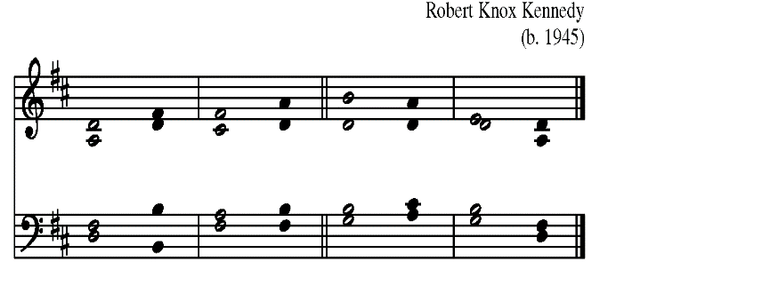



9 The LORD will be a refuge for the op-**pressed**,  *  
      a refuge in time of **trouble**.

10 Those who know your Name will put their trust in **you**,  *  
      for you never forsake those who seek you, O **LORD**.

11 Sing praise to the LORD who dwells in **Zion**;  *  
      proclaim to the peoples the things he has **done**.

12 The Avenger of blood will re-**member them**;  *  
      he will not forget the cry of the af-**flicted**.

13 Have pity on me, O **LORD**;  *  
      see the misery I suffer from those who hate me, O you who lift me up from the

gate of **death**;

14 So that I may tell of all your praises and rejoice in your sal-**vation**  *  
      in the gates of the city of **Zion**.

15 The ungodly have fallen into the pit they **dug**,  *  
      and in the snare they set is their own foot **caught**.

16 The LORD is known by his acts of **justice**;  *  
      the wicked are trapped in the works of their own **hands**.

17 The wicked shall be given over to the **grave**,  *  
      and also all the people that forget **God**.

18 For the needy shall not always be for-**gotten**,  *  
      and the hope of the poor shall not perish for **ever**.

19 Rise up, O LORD, let not the ungodly have the upper **hand**;  *  
      let them be judged be-**fore you**.

20 Put fear upon them, O **LORD**;  *  
      let the ungodly know they are but **mortal**.

**The Second Lesson II Corinthians 6:1-13**

As we work together with him, we urge you also not to accept the grace of God in vain.   
For he says, "At an acceptable time I have listened to you, and on a day of salvation I have helped you." See, now is the acceptable time; see, now is the day of salvation! We are putting no obstacle in anyone's way, so that no fault may be found with our ministry, but as servants of God we have commended ourselves in every way: through great endurance, in afflictions, hardships, calamities, beatings, imprisonments, riots, labors, sleepless nights, hunger; by purity, knowledge, patience, kindness, holiness of spirit, genuine love, truthful speech, and the power of God; with the weapons of righteousness for the right hand and for the left; in honor and dishonor, in ill repute and good repute. We are treated as impostors, and yet are true; as unknown, and yet are well known; as dying, and see--we are alive; as punished, and yet not killed; as sorrowful, yet always rejoicing; as poor, yet making many rich; as having nothing, and yet possessing everything. We have spoken frankly to you Corinthians; our heart is wide open to you. There is no restriction in our affections, but only in yours. In return--I speak as to children--open wide your hearts also.

The Word of the Lord.

***People* Thanks be to God.**

**The Sequence “He who would valiant be” Hymnal, 564**

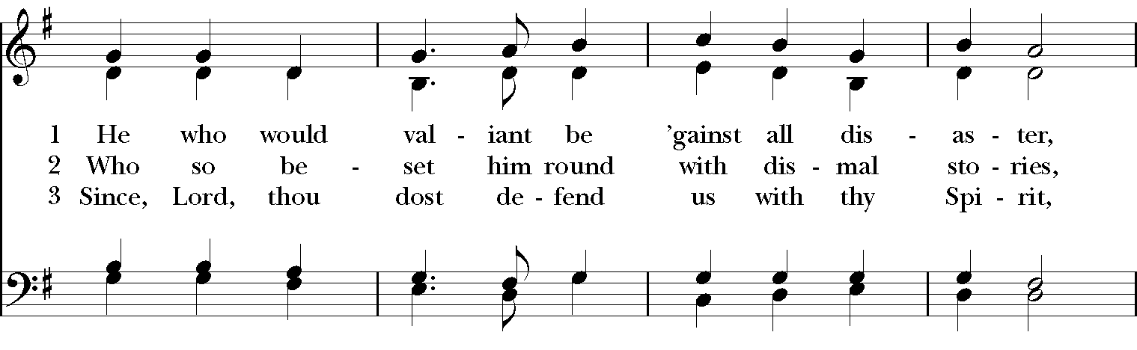

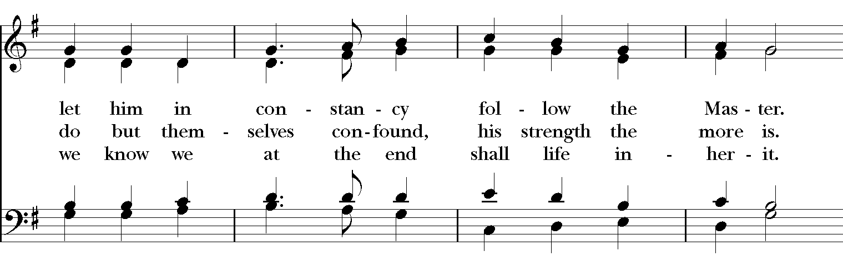

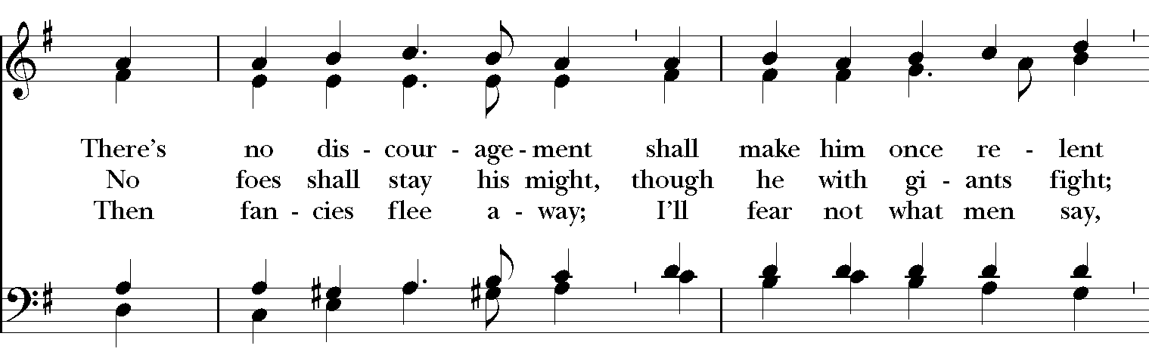

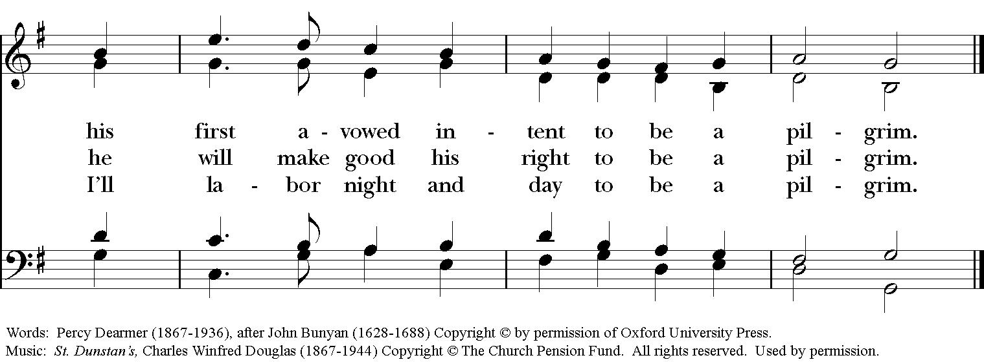

**The Holy Gospel Mark 4:35-41**

***The people remain standing. The Celebrant says***

The Holy Gospel of our Lord Jesus Christ according to Mark.

***People* Glory to you, Lord Christ.**

On that day, when evening had come, he said to them, "Let us go across to the other side." And leaving the crowd behind, they took him with them in the boat, just as he was. Other boats were with him. A great windstorm arose, and the waves beat into the boat, so that the boat was already being swamped. But he was in the stern, asleep on the cushion; and they woke him up and said to him, "Teacher, do you not care that we are perishing?" He woke up and rebuked the wind, and said to the sea, "Peace! Be still!" Then the wind ceased, and there was a dead calm. He said to them, "Why are you afraid? Have you still no faith?" And they were filled with great awe and said to one another, "Who then is this, that even the wind and the sea obey him?"

***After the reading, the Celebrant says***

The Gospel of the Lord.

***People* Praise to you, Lord Christ.**

**The Sermon**

**The Nicene Creed**

*Said by all, standing*

**We believe in one God, the Father, the Almighty, maker of heaven and earth, of all that is, seen and unseen.**

**We believe in one Lord, Jesus Christ, the only Son of God, eternally begotten of the Father, God from God, Light from Light, true God from true God, begotten, not made, of one Being with the Father. Through him all things were made. For us and for our salvation he came down from heaven: by the power of the Holy Spirit he became Incarnate from the Virgin Mary, and was made man. For our sake he was crucified under Pontius Pilate; he suffered death and was buried. On the third day he rose again in accordance with the Scriptures; He ascended into heaven and is seated at the right hand of the Father. He will come again in glory to judge the living and the dead, and his kingdom will have no end.**

**We believe in the Holy Spirit, the Lord, the giver of life, who proceeds from the Father and the Son. With the Father and the Son he is worshiped and glorified. He has spoken through the Prophets. We believe in one holy catholic and apostolic Church. We acknowledge one baptism for the forgiveness of sins. We look for the resurrection of the dead, and the life of the world to come. Amen.**

**Prayers of the People, Form VI Page 392**

*The Leader and People pray responsively*

In peace, we pray to you, Lord God.

*Silence*

For all people in their daily life and work;

***For our families, friends, and neighbors, and for those who are alone*.**

For Joe our President, Andy our Governor, and Neil & Greg our Mayors, and for this community, the nation, and the world;

***For all who work for justice, freedom, and peace.***

For the just and proper use of your creation;

***For the victims of hunger, fear, injustice, and oppression*.**

For all who are in danger, sorrow, or any kind of trouble;

***For those who minister to the sick, the friendless, and the needy*.**

For the peace and unity of the Church of God;

***For all who proclaim the Gospel, and all who seek the Truth.***

For Justin, the Archbishop of Canterbury, Michael, our Presiding Bishop, Terry, our Bishop, for Michael, Anne, Art, Dru, and Jim our clergy and all bishops and other ministers;

***For all who serve God in his Church*.**

For the special needs and concerns of this congregation. For **Al, Allen, Amy, Ann, Annie, Beecher, Bethann, Beverly, Bill, Braden, Bud, Carol, Cathy, Chris, Christy, Danny, Dave, David, Dawn, Diana, Dorothy, Doug, E.J., Eleanor, Elizabeth, Erma, Gene, Helga, Hugh, Ira, Jen, Jenni, Jerry, Jewell, Jim, Joan, Joe, John, Joyce, Karen, Kathy, Kelly, Ken, Laura, Lauren, Lee, Linda, Lisette, Liz, Lynn, Martha, Mary, MaryBeth, Matt, Meg, Mike, Milo, Monica, Morgan, Nancy, Nelson, Nina (Nine-ah), Patricia, Rob, Ronald, Rueben, Sandy, Stefanie, Steve, Sue, Susan, Susie, Terry, Tim, Tracy, Trent, Ursula, Vicki, Walt, Whitney, Wynn; for the men and women of our armed forces, especially Alex, Casey, Christian, Griffin, Pat, Seth, Sinclair, Trey.**

*Silence*

*The People may add their own petitions*

Hear us, Lord;

***For your mercy is great*.**

We thank you, Lord, for all the blessings of this life.

*Silence*

*The People may add their own thanksgivings*

We will exalt you, O God our King;

***And praise your Name for ever and ever*.**

We pray for all who have died, **..** , that they may have a place in your eternal kingdom.

*Silence*

*The People may add their own petitions*

Lord, let your loving‑kindness be upon them;

***Who put their trust in you*.**

We pray to you also for the forgiveness of our sins.

*Silence may be kept*.

*Leader and People*

Have mercy upon us, most merciful Father; in your compassion forgive us our sins, known and unknown, things done and left undone; and so uphold us by your Spirit that we may live and serve you in newness of life, to the honor and glory of your Name; through Jesus Christ our Lord. Amen.

The Celebrant concludes with an absolution or a suitable Collect.

**The Peace**

***Celebrant*** The peace of the Lord be always with you.

***People* And also with you.**

**Healing Prayer**

**Birthday and Anniversary Prayers**

**THE HOLY COMMUNION**

**Offertory Sentence**

**Offertory Solo “His eye is on the sparrow” Luigi Zaninelli**

Dylon Crain, *tenor*

**The Great Thanksgiving: Eucharistic Prayer B Page 367**

*S120a*

*Celebrant* It is right, and a good and joyful thing, always and everywhere to give thanks to you, Father Almighty, Creator of heaven and earth.

*Here the Celebrant adds a Proper Preface*

Therefore we praise you, joining our voices with Angels and Archangels and with all the company of heaven, who for ever sing this hymn to proclaim the glory of your Name:

*Celebrant and People*

**Sanctus: S-129 in the Hymnal 1982**

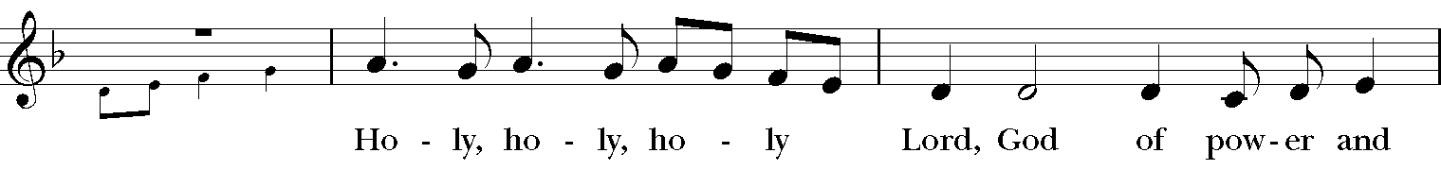

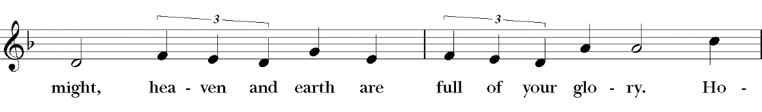

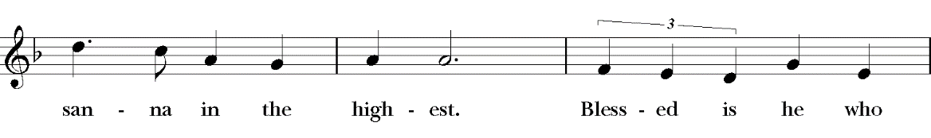

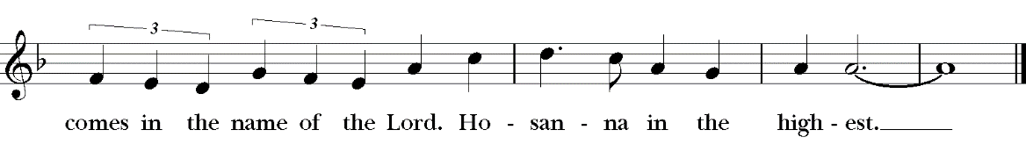

*The people stand or kneel.*

*Then the Celebrant continues*

We give thanks to you, O God, for the goodness and love which you have made known to us in creation; in the calling of Israel to be your people; in your Word spoken through the prophets; and above all in the Word made flesh, Jesus, your Son. For in these last days you sent him to be incarnate from the Virgin Mary, to be the Savior and Redeemer of the world. In him, you have delivered us from evil, and made us worthy to stand before you. In him, you have brought us out of error into truth, out of sin into righteousness, out of death into life.

On the night before he died for us, our Lord Jesus Christ took bread; and when he had given thanks to you, he broke it, and gave it to his disciples, and said, "Take, eat: This is my Body, which is given for you. Do this for the remembrance of me."

After supper he took the cup of wine; and when he had given thanks, he gave it to them, and said, "Drink this, all of you: This is my Blood of the new Covenant, which is shed for you and for many for the forgiveness of sins. Whenever you drink it, do this for the remembrance of me."

Therefore, according to his command, O Father,

*Celebrant and People*

**We remember his death, We proclaim his resurrection, We await his coming in glory;**

*The Celebrant continues*

And we offer our sacrifice of praise and thanksgiving to you, O Lord of all; presenting to you, from your creation, this bread and this wine.

We pray you, gracious God, to send your Holy Spirit upon these gifts that they may be the Sacrament of the Body of Christ and his Blood of the new Covenant. Unite us to your Son in his sacrifice, that we may be acceptable through him, being sanctified by the Holy Spirit. In the fullness of time, put all things in subjection under your Christ, and bring us to that heavenly country where, with [St. Luke, __________ and] all your saints, we may enter the everlasting heritage of your sons and daughters; through Jesus Christ our Lord, the firstborn of all creation, the head of the Church, and the author of our salvation.

By him, and with him, and in him, in the unity of the Holy Spirit all honor and glory is yours, Almighty Father, now and forever. ***Amen****.*

And now, as our Savior Christ has taught us, we are bold to say,

**The Lord’s Prayer**

**Our Father, who art in heaven, hallowed be Thy Name. Thy kingdom come, Thy will be done, on Earth as it is in heaven. Give us this day our daily bread, and forgive us our trespasses, as we forgive those who trespass against us, and lead us not into temptation, but deliver us from evil, for thine is the kingdom and the power and the glory, for ever and ever. Amen.**

**The Breaking of the Bread**

A period of silence is kept.

**The Fraction Anthem: S-155*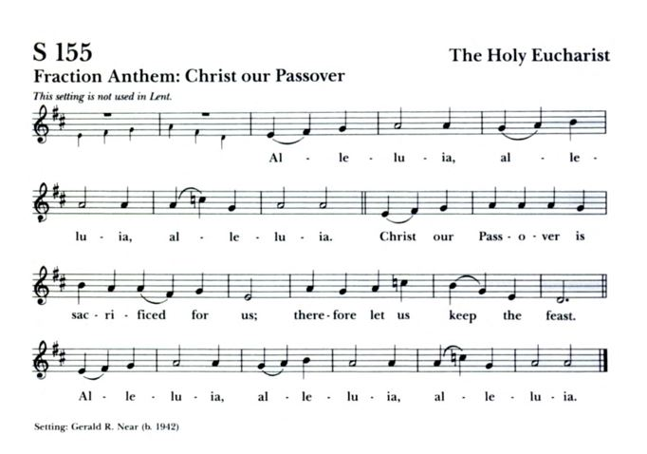***

***Holy Communion will be administered to people coming forward to receive in One Kind, the consecrated Bread. This will be done at the altar rail,***

***or if you prefer, you may stay in your pew and clergy will come to you.***

***Distribution of the chalice is still suspended.***

**Communion Solo “Nobody knows the trouble I’ve seen” H. T. Burleigh**

Dylon Crain, *tenor*

*After Communion, the Celebrant says*

Let us pray.

*Celebrant and People*

**Eternal God, heavenly Father, you have graciously accepted us as living members of your Son our Savior Jesus Christ, and you have fed us with spiritual food in the Sacrament of his Body and Blood. Send us now into the world in peace, and grant us strength and courage to love and serve you with gladness and singleness of heart; through Christ our Lord. Amen.**

**Sending Forth of Lay Eucharistic Ministers**

***Celebrant*** In the name of God and of St. Luke’s, we send you forth bearing these holy gifts, that those to whom you go may share with us in the communion of Christ’s Body and Blood.

***People* We who are many are one body, because we all share one bread, one cup.**

**The Blessing**

**Recessional Hymn “Almighty Father, strong to save” Hymnal, 608**

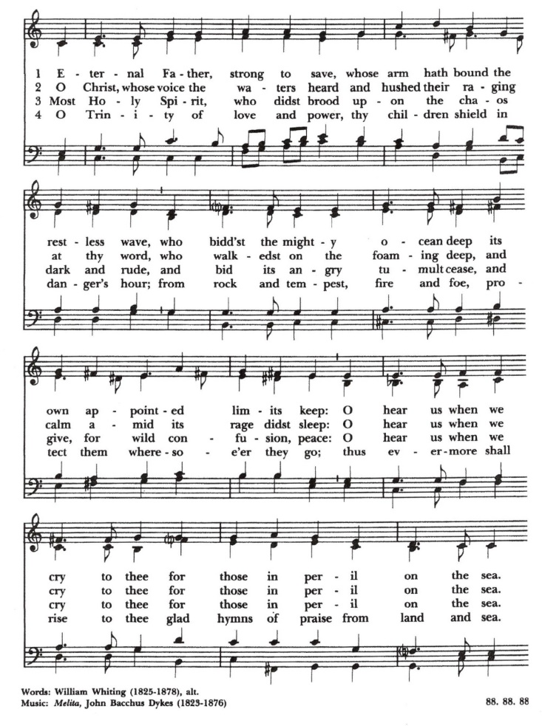

***Please remain in your pew to enjoy the Postlude.***

***We are so grateful you have joined us today and look forward***

***to gathering again very soon.***

**Postlude “Nun last in’s Gott dem Herren Dank geben” F. W. Zachary**

**(1633-1712)**

**The Dismissal**

***People* Thanks be to God.**

Permission to reprint, podcast, and/or stream the music in the service obtained from ONE LICENSE # A-736775. All rights reserved.

To Give, go to

**https://www.stlukesanchorage.org/giving.html**

**ANNOUNCEMENTS**

*Here at St. Luke’s, we welcome everyone to participate in everything freely, member or non-member. If you are a visitor, please fill out one of the visitor cards and place it in the offering plate. If you would like to become an official member of our parish family, please call our office, 245-8827, or speak with Father Michael.*

**Wednesday AM Bible Study**

The Wednesday morning 9:45 am bible study meets in person in the **LYMAN HOUSE**. You can join this lay-led discussion of the core stories of our faith **either in person or on Zoom** every Wednesday at 9:45. We are currently using The Path, a Bible Study published by Forward Movement, as a guide among other sources. It is not necessary to have a copy of The Path to participate. Just bring your Bible.

**Contemporary Anglican Saints**

**JUNE 27, while Dave is gone, Fr. Michael will facilitate the class.**

We will meet in person on the church campus in the Dudley House (the house attached to the back side of Board Hall) as we continue to broadcast on Zoom for those who do not or cannot come in person, to create a Hybrid class.

The British Isles and the greater Anglican Communion has been the home and origin of many great saints. These saints are people with fascinating stories, and great impact on global Christianity. Please join us as we learn about these saints and discuss their influence and ideas. For more information, email Dave Kirchinger at [**episcopaliandave@gmail.com**](mailto:episcopaliandave@gmail.com).

The link to the class is: [**https://us02web.zoom.us/j/85144530030**](https://us02web.zoom.us/j/85144530030) / Meeting ID: **851 4453 0030**

If prompted to enter a password, please enter our parish office phone number - 2458827

**Centering Prayer**

**Beginning July, we will meet back at the Lyman House and no longer on Zoom.**

Centering Prayer has changed to every **FIRST** and **THIRD** Tuesday. Join us on **July 6 & 20 from 6 – 7pm** in the Lyman Office.

**Birthdays & Anniversaries**

**If you've had a birthday or anniversary over the past several weeks, or have one coming up in the weeks ahead,** please let Dawn know, [admin@stlukesanchorage.org](mailto:admin@stlukesanchorage.org).  Let her know your birthday, or the date of your wedding anniversary and how many years you've been married, and we will offer a blessing over you during our recorded worship.

**LAY PASTORAL CARE MINISTRY**

Pastoral care is a ministry provided by volunteer parishioners to individuals needing home, hospital, nursing home or rehabilitation facility visitations. Arrangements can be made for communion and meals as requested. All information is confidential unless you give permission to share with others.

**CALL THE CHURCH OFFICE TO LET US KNOW YOUR NEEDS**.

Reminder, if you do go to the hospital, let the hospital know your church affiliation or try to have your caregiver do so. Our ministry is here for you in time of need so remember to call the church office at 245-8827 or e-mail at [admin@stlukesanchorage.org](mailto:admin@stlukesanchorage.org)

***The Flowers on the Altar*** are given by Mike Berry in loving memory of his parents, Edward & Helen Berry.

In our prayers ... **for Al, Allen, Amy, Ann, Annie, Beecher, Bethann, Beverly, Bill, Braden, Bud, Carol, Cathy, Chris, Christy, Danny, Dave, David, Dawn, Diana, Dorothy, Doug, E.J., Eleanor, Elizabeth, Erma, Gene, Helga, Hugh, Ira, Jen, Jenni, Jerry, Jewell, Jim, Joan, Joe, John, Joyce, Karen, Kathy, Kelly, Ken, Laura, Lauren, Lee, Linda, Lisette, Liz, Lynn, Martha, Mary, MaryBeth, Matt, Meg, Mike, Milo, Monica, Morgan, Nancy, Nelson, Nina (Nine-ah), Patricia, Rob, Ronald, Rueben, Sandy, Stefanie, Steve, Sue, Susan, Susie, Terry, Tim, Tracy, Trent, Ursula, Vicki, Walt, Whitney, Wynn;** and our men and women serving in our armed forces and their families. We offer prayers of blessing and thanksgiving for all men and women serving in the armed services, especially these persons known to us: **Alex, Casey, Christian, Griffin, Pat, Seth, Sinclair, Trey**. We pray that they have safe journeys and know the loving concern of friends and family. May God watch over them and grant them strength and courage to face perils which beset them.

**Readings for:**

**June 27: II Samuel 1:1, 17-27; Psalm 130;**

**Pentecost 5 II Corinthians 8:7-15; Mark 5:21-43.**

**ST. LUKE’S EPISCOPAL CHURCH**

**DIOCESE OF KENTUCKY**

The Right Reverend Terry Allen White, *Bishop*

STAFF

The Reverend Michael L. Delk, *Rector*

The Reverend Art Chard, *Priest Associate*

Lisa Lewis, *Minister of Music*

Brench Boden, *Parish Composer*

Judy Chard*, Bookkeeper*

Dawn White, *Parish Administrator*

William Tsueda, *Sexton*

**St. Luke’s Vestry Members**

Term Expires 2022 Term Expires 2023 Term Expires 2024

Walt Anderson Fofo Johnson Jane Casada, **VPOD**

Priscilla Bond* John F. Ridoux** Caroline Eddleman

Lynn Cline Barbara Staats Bob LaMontagne

Shaun McEntire Nelson Toebbe Doug Sanders

**\*** Senior Warden; **\*\*** Junior Warden

The Vestry Person On Duty (**VPOD**) has the responsibility for assisting the Rector with

welcoming newcomers and closing the church after worship has concluded.

St. Luke’s Episcopal Church

1206 Maple Lane

Anchorage, KY 40223

SERVICE TIMES

Saturday: 5:30pm (Rite II); Sunday: 8am (Rite I) & Sunday: 10am (Rite II)

OFFICE HOURS

Office Staff are currently working from home.

Call to arrange an appointment.

Phone: 502-245-8827 Fax: 502-245-5595

Email: [admin@stlukesanchorage.org](mailto:admin@stlukesanchorage.org)

[www.stlukesanchorage.org](http://www.stlukesanchorage.org)