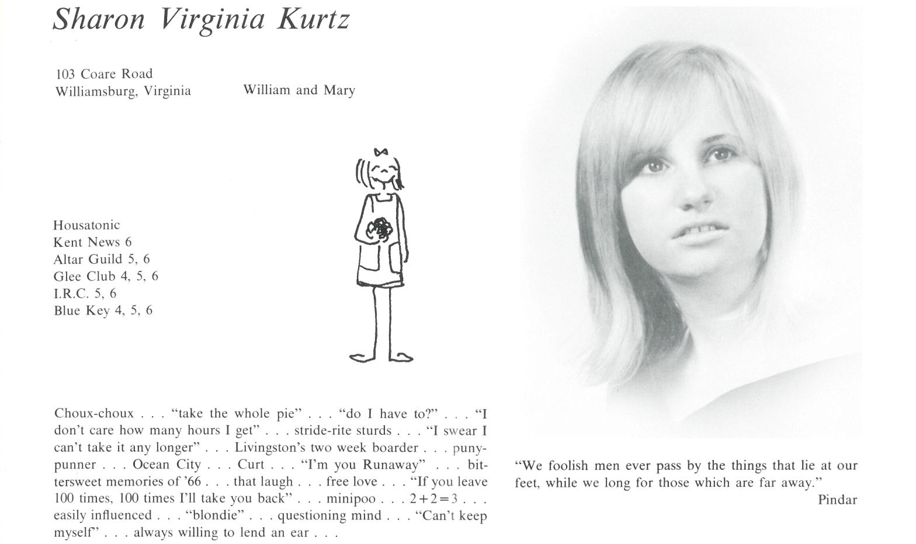

Sharon V. Kurtz Thompson

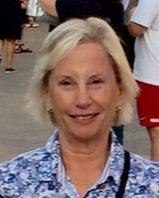In a nutshell: After Kent I attended the College of William and Mary, where I majored in English. Following graduation, I worked for the William and Mary News Office, interviewing professors about their research and writing news releases. In late 1974 I moved to Alexandria, Virginia, where I met my first husband; we were married in the summer of 1975 and I have lived in Alexandria ever since. I have two daughters, and a grandson, named Duke. My younger daughter, Julia, lives near me in Alexandria, and my older daughter, Katie, in Richmond, Virginia.

I spent what I found to be a very rewarding career in publishing: first as a researcher/writer for Time Life Books, in Alexandria, and then at the National Geographic Society, in Washington, D.C., where I was a researcher/writer and copy editor on *National Geographic KIDS Magazine.* I left the staff of *National Geographic KIDS* in 2012 and freelanced for the National Geographic Books Division until the end of 2016.

I was divorced in 1992 and married my second husband, Blake, in 1997. I now spend my free time taking a variety of exercise classes, playing with my grandson, visiting with friends, and travelling. My husband and I have taken some wonderful trips and just recently returned from a river cruise in Provence. In addition, my brothers and I inherited a house on the Maine coast some years ago, and I go up there every summer.



______________________________________________________________

______________________________________________________________ ______________________________________________________________ ______________________________________________________________ ______________________________________________________________ ______________________________________________________________ ______________________________________________________________ ______________________________________________________________ ______________________________________________________________

Attach Picture in .jpg Format

______________________________________________________________

______________________________________________________________

___________________________________________________________________________________ _________________________________________________________________________________________________________________________________________________________________________________________________________________________________________________________________________________________________________________________________________________________________________________________________________________________________________________________________________________________________________________________________________________________________________________________________________________________________________________________________________________________________________________________________________________________________________________________________________________________________________________________________________________________________________________________________________________________________________________________________________________________________________________________________________________________________________________________________________________________________________________________________________________________________________________________________________________________________________________________________________________________________________________________________________________________________________________________________________________________________________________________________________________________________________________________________________________________________________

___________________________________________________________________________________