Phylum Chordata

Non-vertebrate chordates

1. Tunicates/Sea squirts – Observe specimen. P.202, top.

2. Amphioxus, lancelet w.m. – prepared slide – Observe notochord, gill slits/bars, dorsal nerve cord; p.203, top and middle.

3. Lamprey – Observe preserved specimen. Label eye, buccal funnel/mouth, teeth, gill slits. p.205.

Class Chondrichthyes

4. Dogfish shark- external structures: Identify mouth, nostril, gill slits, anterior and posterior dorsal fins, pectoral fin, pelvic fin (male or female?), caudal fin p. 223 and provided shark diagrams.
Q: How many chambers does the heart have?

5. Observe preserved Stingray and Skate – What are the differences in their tails? No page reference.

Class Osteichthyes

6. Taxidermy bass - external – Identify nostril, operculum, dorsal fins, caudal fin, rays on fins, p.229, top.

Class Amphibia

7. Contrasting a leopard frog and toad – circle answers in the table below:
Structure | Frog | Toad
skin | smooth/bumpy | smooth/bumpy
parotid glands? | yes/no | yes/no
toes on back feet | webbed/separated | webbed/separated

8. Bull frog – external structures – Identify nares, tympanic membrane (male or female?)
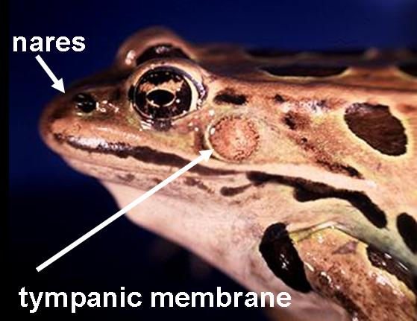

Q: How many heart chambers?

9. Contrasting a leopard frog and a salamander – Fill out the table below by circling the correct answers.
Structure | Frog | Salamander
Jumping legs? | yes / no | yes / no
Head on trunk | fused/ not fused | fused / not fused
Tail? | yes / no | yes / no

Class Reptilia

10. Turtle – Dorsal view: Identify carapace and scales;
Ventral view: Identify plastron and scales. p. 239

11. Contrasting a lizard and a salamander – Fill out the table below:

Structure | lizard (reptile) | salamander (amphibian)
# of toes on front?
scales or smooth?
claws or toes?

Class Aves and Mammalia

12. On the table are articulated (assembled) skeletons of a pigeon and a rat. These two species represent the generalized skeletal structure of birds and mammals. Examine each skeleton.

Contrast the following skeletal elements:
 | Pigeon | Rat
Cervical vertebrae

Back feet

Sternum

Q:
a. Why is there such a big difference in the sternum design of each animal

b. Why are the cervical vertebrate different in a bird and mammal?

Mammal Teeth

On the table you will find 3 mammal skulls. Examine the skulls and observe the different types of teeth found.

14. What do you think the function is of each tooth type?
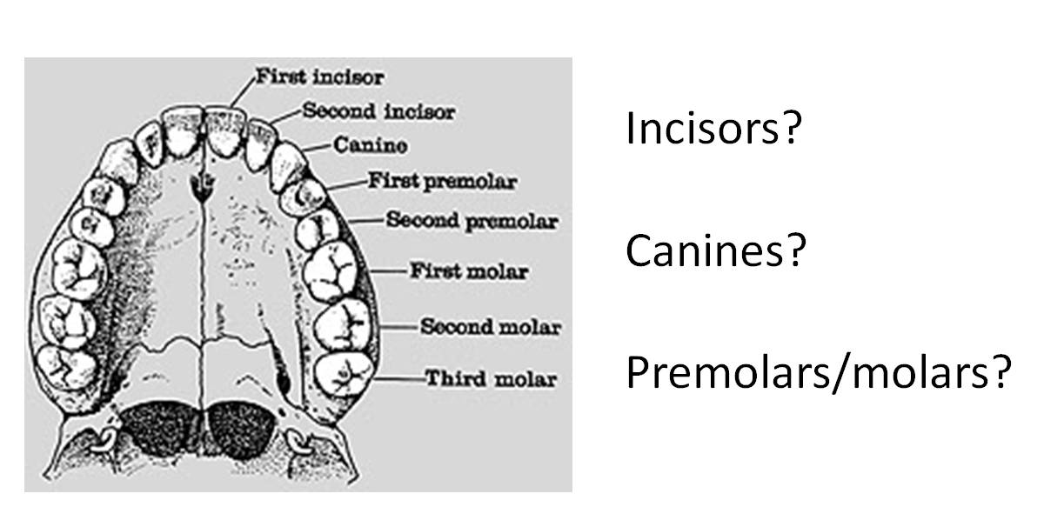
15. Check off the types of teeth you find in each skull. The skulls are numbered on their tags. Each specimen may have more than one type of tooth.

 | Incisors? | Canines? | Premolar/Molars?
Specimen 1
Specimen 2
Specimen 3

16. For each specimen, decide whether it is an herbivore, carnivore or omnivore. Fill out the last column guessing which animal is represented by each skull.
 | Herbivore? | Carnivore? | Omnivore? | Guess animal?
Specimen 1
Specimen 2
Specimen 3

