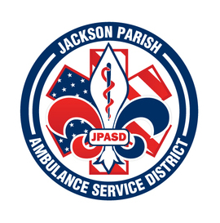
JACKSON PARISH AMBULANCE SERVICE DISTRICT
115 Watts Street
Jonesboro, LA 71251
Office: (318)-259-2877 Fax: (318)-259-2099
jacksonparishambulance@jpasd.com
Aaron Johnson BOARD MEMBERS
EMS Director Allen Lindsay, Chairman
Paula Parkerson , MD Joe Vail, Vice-Chairman
Medical Director Conchita Doyle
Alma Williams
Deidre Hollis
Notice Posted: Tuesday, November 8, 2022 @ 12:00 PM

NOTICE OF PUBLIC MEETING
A public meeting will be held as follows:
DATE: November 10, 2022
TIME: 12:00 PM
PLACE OF MEETING: Jackson Parish Ambulance Service District
115 Watts Street, Jonesboro, LA 71251
Public Meeting AGENDA
1. Call to Order
2. Roll Call
3. Invocation
4. Pledge of Allegiance
5. Recognition of Guests/Public Comments
6. Approval of Minutes from October 13, 2022
7. Approval of Financials and payment of bills October 2022
8. EMS Director’s Report
9. Old Business
10. New Business
A) Propose the 2023 Financial Budget
B) Stretcher Purchase Sole Source/Bid
C) Employee Health Allowance Increase
11. Adjournment
Reminder: Next Meeting: December 8, 2022 @ 12 Noon
In accordance with the Americans with Disabilities Act, if you need special assistance, please contact Aaron Johnson, EMS Director at 318-259-2891 describing the assistance that is necessary. Due to the Covid-19 virus visitors are asked to not present to the meeting with fever, cough, diarrhea, or general weakness. Masks will be provided for visitors.

