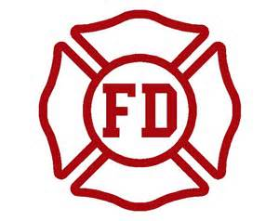
General Safety
Are you and your family up to date on your fire safety? Fire safety is for all ages, young and old. Be sure your family knows what to do. Here are a few things to consider.
- Make sure smoke detectors are working and tested.
- Clean dryer vents and filter. (make sure you don’t have lint build up).
- Ensure space heaters are away from curtains, rugs, and anything that can burn.
- Ensure all exits and escape routes are clear and free of clutter.

Recent Changes
Our department has recently updated our website. You can now find more information such as our ISO ratings, important forms, and more at Greenbackfire.com.

Serving Our Community
We know vacation Bible schools will be starting in the coming months. If you would like us to bring Sparky the fire dog and speak to your group feel free to contact us.
Warmer Weather
As the weather continues to warm up many of us will be enjoying those summer activities. Make sure your loved ones stay safe.
- Always wear a life vest when boating.
- Be sure all gates and doors that lead to water are closed and secured.
- Never leave children alone in or near water.
- When biking be sure to wear a helmet.
- Motorcycles will be sharing our roads, so please take an extra second and look twice when driving.

