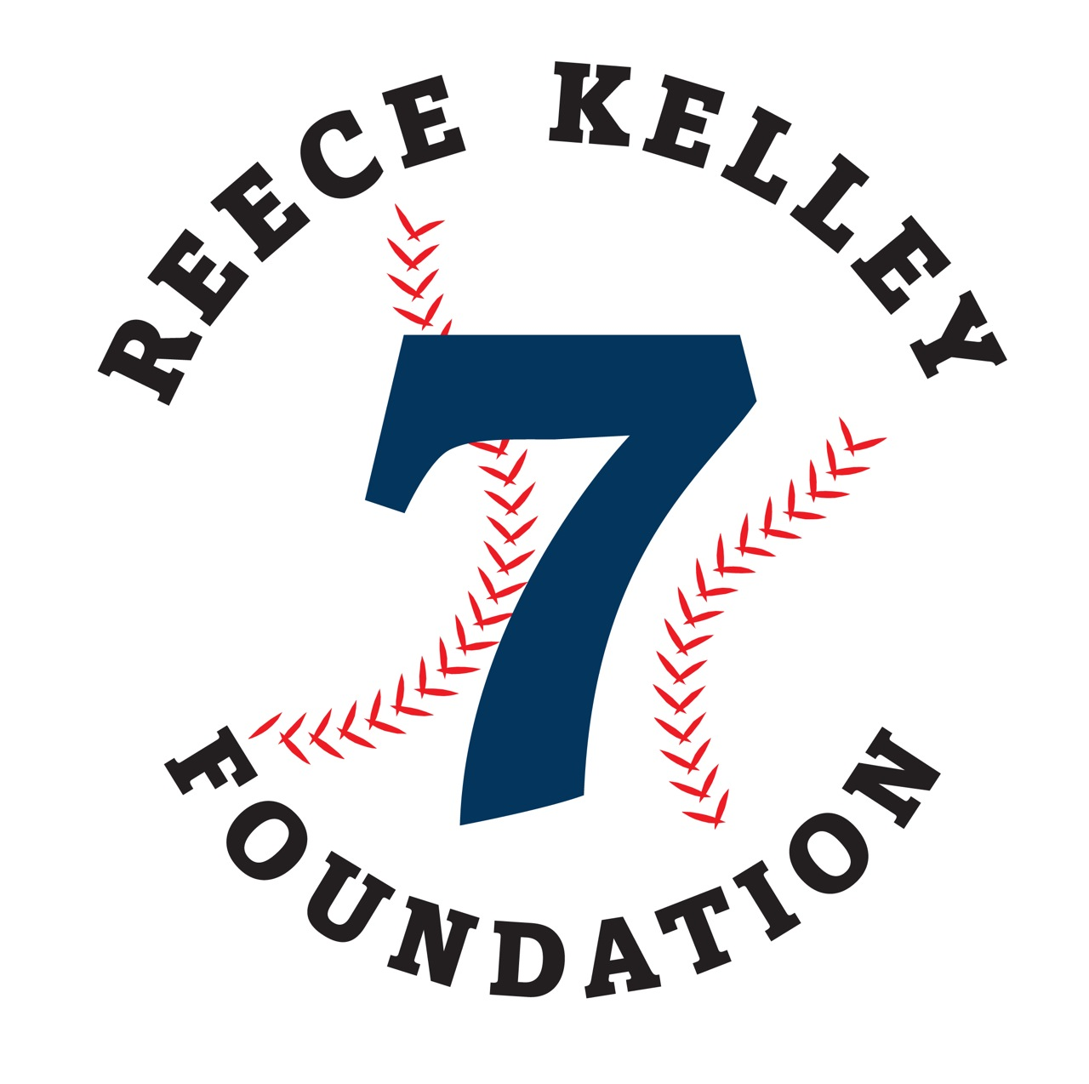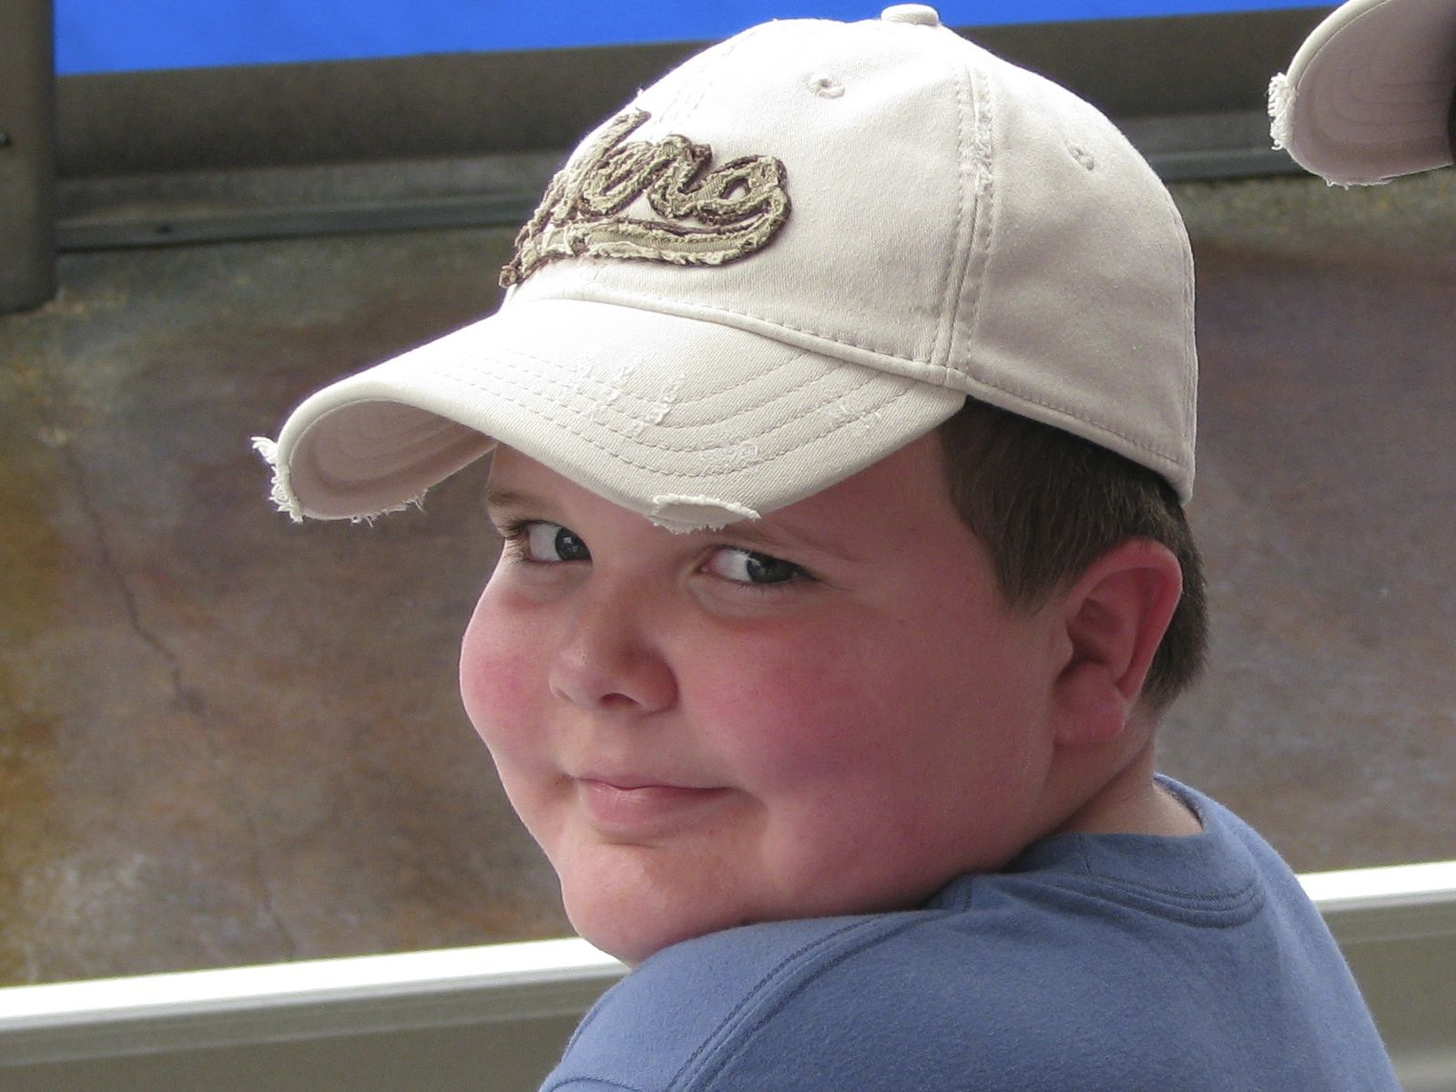

### Please send form and check to:

### Reece Kelley Foundation

### 6 Oaktree Road,

### Hummelstown, PA 17036

### Email: info@reecekelleyfoundation.org

☐ $500 for FOUR GOLFERS

☐ $150 SINGLE (HOLE SPONSOR)

☐ Other Sponsorship

☐ MONETARY DONATION

TOTAL AMT ENCLOSED: __________

To the recipients of the 2019 Reece Kelley Foundation Scholarship Awards...

Justin Lontz, Stephen Jones, Ryan Kutz, & Avery Cassel

**Grand Slam Sponsors**

Congratulations!

### ***Join us at*...**

### Colonial Golf and Tennis Club

### 4901 Linglestown Road

### Harrisburg, PA 17112

### ReeceKelleyFoundation.org

***7th Annual***

**Memorial Golf Tournament**

**Monday October 14, 2019**

Registration • 10:30AM

Shot Gun Start • 11:30AM

Contact Person: _____________________

Company: __________________________

Address: ___________________________

City: _______________________________

State: _______ Zip Code: ____________

Phone: _____________________________

Email: _____________________________

Names of Golfers:

1. _________________________________

2. _________________________________

3. _________________________________

4. _________________________________

MAKE A DIFFERENCE

WWW.CESCLEAN.COM

Registration Form

TOURNAMENT INFORMATION

Includes four golfers, logo displayed on gift provided to all golfers.

Includes four golfers, a (4) player “Greens and Cart Pass” for future use at the Club, VIP check in, 2 drink tickets per golfer, reserved table at dinner, logo displayed on main tournament banner, Hole Sign on green and driving range.

Includes four golfers, 1 drink ticket per golfer, reserved table at dinner, logo displayed on signage at dinner, Hole Signs on the putting green and driving range.

**Triple Sponsor: $1200 Double Sponsor: $500**

Includes four golfers, logo displayed on signage at dinner, Hole Sign.

Includes a (2) player “Greens and Cart Pass” for future use at the Club, name displayed on signage at dinner, Hole Sign.

**Gift Sponsor: $1500 Golf Cart Sponsor: $1500**

Includes four golfers, logo displayed in all golf carts.

**All sponsorship levels include advertisement on the website and in the golf brochure. For more information, call Mel at 717-979-8646.**

**Grand Slam Sponsor: $2500 Home Run Sponsor: $2000**

SPONSORSHIP OPPORTUNITIES

**COST: $500 per FOURSOME**

Registration • 10:30 AM

Shotgun Start • 11:30 AM

**GOLF FEE INCLUDES:**

Driving Range prior to event

Light Lunch during Registration

Green Fees and Cart

Gift Bag

Buffet Style Dinner immediately following golf

**CONTESTS INCLUDE:**

Longest Drive (male and female)

Closest to the Pin

Four (4) Hole-in-One Prizes

**DINNER AND EVENTS:**

Cash Bar at Dinner

Amazing Raffle Items

Reece Kelley was a happy, fun-loving boy who passed away after a tragic accident in the summer of 2008, four days before he was to start fourth grade. Reece had a big heart, a bright smile, and a sense of integrity. In his nine short years he made a difference to all who knew him. In his honor and memory, a Foundation bearing his name has been created. The primary goal of this Foundation is to raise money to provide college scholarships to students who are Making a Difference in their communities. We hope you will get involved in making this event a success!