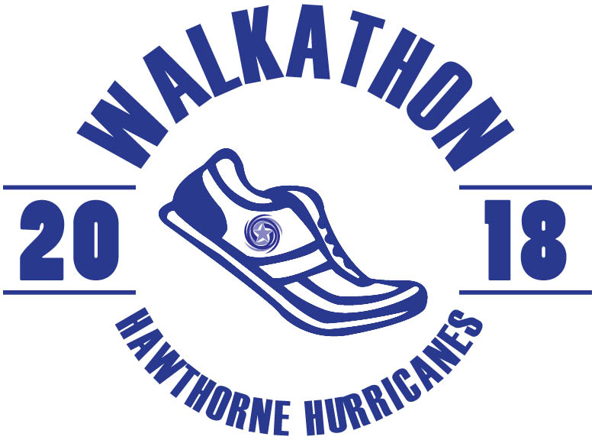
Introducing Hawthorne Walk-A-Thon 2018, Hawthorne’s Annual Fall Fundraiser, returns on Friday, October 12. This event promotes healthy eating and activity and shows our students how much fun a healthy lifestyle can be as all of our students walk or run laps around our school turf. This event also raises money for our wonderful school. The money raised from Walk-A-Thon allows the PTA to continue bridging the monetary gap of decreased funding to support things like technology in the classrooms, arts partnership program, funds for a new and improved playground and many, many more important things for our students. This year our fundraising goal is $40,000. We need YOUR help to reach our goal!
Business Sponsorship: $300
Every Hawthorne Scholastic Academy student, teacher and staff member will receive a Hawthorne Walk-A-Thon 2018 T-shirt. A business can add its name AND a logo (a pdf of the logo is required) to the Walk-A-Thon 2018 T-shirt AND add their logo on a vinyl banner thanking all Walk-A-Thon 2018 sponsors. The banner will hang on the school playground fence throughout the school year. The company’s logo will also be featured on the Hawthorne Scholastic Academy PTA website thanking all of our sponsors.
Company Name: ___________________________________
Company Contact Name: ____________________________ Phone Number: __________________
Email Address: ____________________________________
Check Enclosed: $_________ (Please make check payable to Hawthorne Scholastic Academy PTA)
ALL SPONSORSHIPS MUST BE RECEIVED BY FRIDAY, OCTOBER 12, 2018
If you have questions or to send your business sponsorship logo, please contact:
Christine Lee (chrissoolee@yahoo.com)
Beth Lee (bethmlee@hotmail.com)

