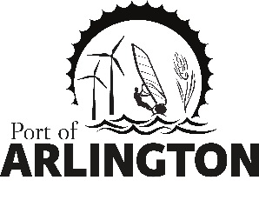

Work Session Agenda
Tuesday, January 26, 2021
4:00 pm
Meeting Location:
Port of Arlington -100 Port Island Rd.
Arlington, OR 97812

- Call the Work Session to Order
- Discuss Port of Arlington’s Goals & Priorities
- Discuss Hiring Plans for Port Manager / EDO and Timeline

Upcoming Meetings:
Regular Commission Meeting on Tuesday, February 16, 2021 at 5pm – Port of Arlington, Arlington, OR.
This meeting location is accessible to persons with disabilities. A request for an interpreter for the hearing impaired or for other accommodations for persons with disabilities should be made at least 48 hours before the meeting by contacting Kelly.margheim@portofarlington.com / 541-705-2004
Posted: Tuesday, January 19, 2021: Bank of Eastern Oregon - Condon & Arlington; U.S. Post Office - Condon & Arlington;
Condon Times-Journal; Arlington City Hall; Port Office and Website.
PO Box 279, Arlington, Oregon 97812

