Dunn’s valve tester inc (DVT) – Company Brochure
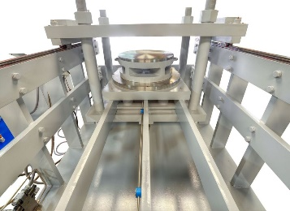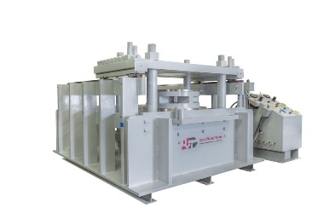
Brief History:
Dunn’s Valve Testers Inc have been manufacturing Valve Testers since 1978. We were the first to introduce valve testers and set the standard for all valve testing. We strive to maintain that level of Durability Value and Technology well into the future.
Our Valve Testers provide a method of accurately and speedily testing valves at a relatively low cost per unit and designed with the test operator in mind.
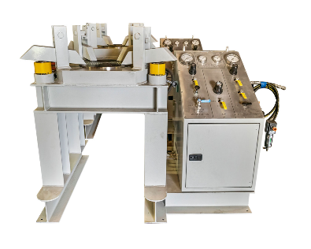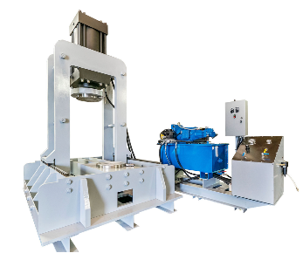
DVT Tester Capabilities:
We’ve manufactured over 850 valve testers:
- Our testers have been distributed to over 15 countries
- Industries - US Navy, Oil & Gas Refineries, Utility, Nuclear, Chemical and Valve Manufactures/rebuilders.
- Patented Hydraulic Clamp Arms and Stainless Seal Plate #xxx1038; xxx2227
- Valve Range - from ¼” through 60”
- Test Pressure Range - 50 PSI to 60,000 PSI (Test Pressure)
- Sealing Force - applying up to 2240 tons
- Our valve testers are custom made to our customer’s specifications.
- Proven Environments – Desert, Tropics, Offshore, Equator, Mountains
- Simple and easy to maintain
- The Model # 006 is approved by U.S. Navy (Stock # xxxxxx-01-148-9913) and is used aboard most navy vessels since 1979.
- It’s not uncommon to have a DVT tester from the 1980’s being used on a daily basis only having to change out some spare parts.
DVT Products:
- Control Valve Testers
- Relief Valve Testers
- Roll Frame Valve Testers
- Vertical Valve Testers
- Horizontal Valve Testers
- Flange Clamp Valve Testers
- Data Acquisition System
DVT Services:
- Leasing Agreements
- Maintenance Program
- After Sales OEM Spares Procurement
- After Sales Technical Support
- Technical Training and Materials
DVT product range
control valve testers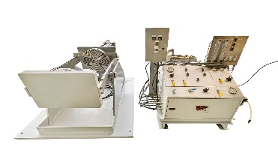 | TYPES | valve range |  | Test system (PSI) |  | clamping Force
 | CV004 | 2” to 6” |  | 3,000 and up |  | 60
 | cv005 | 2” to 12” |  | 3,000 and up |  | 100
 | CV200 | 2” to 16” |  | 3,000 and up |  | 200
 | Height – 42” ; length – 60” ; table height – 33”
horizontal valve press testers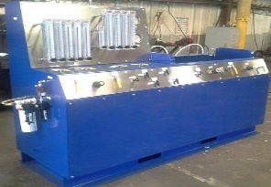 | hP types | Valve range |  |  | Test system (PSI) | Ton clamping
 | hp004 | 1/2” to 4” |  |  | 3,000 and up | 100
 | hp100 | 2” to 16” |  |  | 3,000 and up | 200
 | hp200 | 4” to 24” |  |  | 3,000 and up | 300
 | hp400 | 8 to 36” |  |  | 3,000 and up | 400
roll frame testers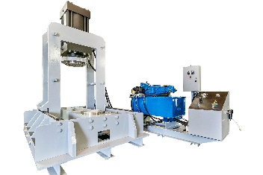 | Rf types | Valve range |  |  | Test system (PSI) | Ton clamping
 | rf100 | 2” to 12” |  |  | 3,000 and up | 100
 | rf200 | 2” to 16” |  |  | 3,000 and up | 200
 | rf300 | 4” to 24” |  |  | 3,000 and up | 300
 | rf400 | 8” to 36” |  |  | 3,000 and up | 400
 | rf800 | 14” to 48” |  |  | 3,000 and up | 800
flange clamp testers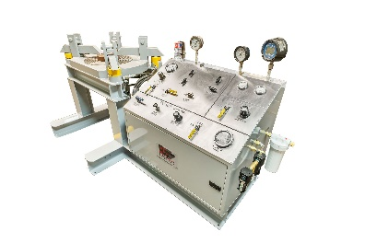 | TYPES | valve range |  |  | Test system (PSI) | clamping Force
 | FT006 | 1/2” to 12” |  |  | 3,000 and up | 4 ea. 30 ton
 | FT011 | 1/2” to 16” |  |  | 3,000 and up | 4 ea. 30 ton
TABLE Height – 33.5” ; length – 45” ; WIDTH – 36”; WEIGHT 1400lBs
TABLE Height – 34” ; length – 53” ; WIDTH – 62”; WEIGHT 1800lBs
relief valve testers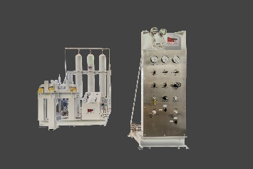 | TYPES |  | valve range |  | Test system (PSI) | clamping Force
 | rv006 |  | 1/2” to 12” ANSI 300 inlet |  | 3,000 and up | 240,000 Lbs
 | rv011 |  | 1/2” to 16”ANSI 600 inlet |  | 3,000 and up | 340,000 Lbs
 | Height – 42” ; length – 60” ; table height – 33” ; weight 1500Lbs
vertical valve press testers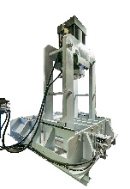 | types |  | Valve range |  | Test system (PSI) | Ton clamping
 | VP009 |  | 2” to 12” |  | 3,000 and up | 100
 | vp010 |  | 2” to 16” |  | 3,000 and up | 200
 | vp020 |  | 8” to 36” |  | 3,000 and up | 300

Dunn’s valve testers additional services
Maintenance program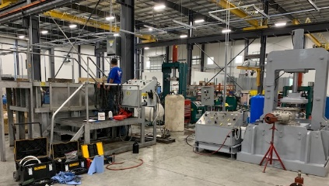 | We currently have a small maintenance program with some of our local customers. To help you achieve a “Fit for Life” DVT unit. We recommend every 6 monthly visit, to maintain its working capability. We also offer a full overhaul refit and upgrade packages as client production requirements change.
data acquisition system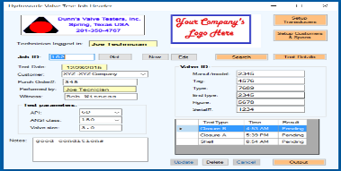 | The system is designed to capture, display and store data during a test. This system is designed around an eight channel Sensor Interface Board on a PC platform. The software serves the function of file management, calibrating and zeroing the transducers and capable of printing a final report.
leasing program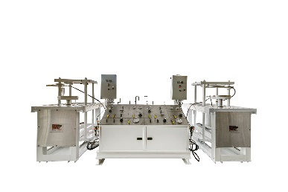 | DVT want to partner with our new and existing customers. We can help during the busy times without purchasing a new machine, by offering a DVT Leasing program.  Leasing terms will be flexible and tailored to your business needs.
OEM SPARES PROGRAM  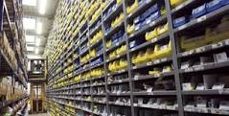 | DVT value and take pride in the build quality and the reliability of our machines. We’ve got machines being used daily for more than 20 years and only with the replacement of some parts. The best way to help guarantee this record of performance is to ensure you use DVT OEM spares. We ship international direct from our warehouse.
TECHNICAL TRAINING & MATERIAL  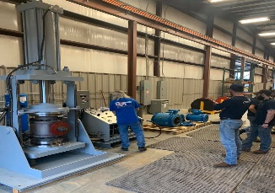 | DVT provide client training either onsite with the delivery of our testers or we invite our client to our facility to witness handover commissioning and training which will be at no cost. We provide material that steps the operator through the process. As client personnel change we’re available to provide an easy transition.
TECHNICAL SUPPORT | Full service length of life support is a guarantee for all our customers. We use modern media technics (example- text us a picture using your cell phone) and we walk you through the solution.
Standards - All Dunn’s Valve Testers are built to test valves in accordance with USA and International Standards – API 526 ; ANSI/API RP 576 ; API 520 & 527 ; API 6D

The heart of these efficient and durable systems is the test vessel connected to the hydraulic clamp seal plate that allows the operator to functionally test the safety relief valve with high volume test methods as required by the National Board of Boiler and Pressure Vessel Inspectors.

According to the National Board of Boiler and Pressure Vessel Inspectors – To preclude UNSAFE and UNSTABLE valve operations or erroneous performance test results, it is recommended that low volume testing equipment (e.g. gas cylinders without a test vessels, hand pumps, tubing etc) should be avoided. Also included in the code is the statement “The performance testing equipment shall include a pressure vessel of adequate size, volume and pressure source capacity to cause the disk to lift significantly (e.g. pop open) and reclose”. The code states “Valves marked for liquid service shall be tested with water or other suitable liquid”.

Data Acquisition Module – will provide a report certificate that is compliant with ISO 9000

Delivery – Approx. 10 to 14 work weeks

Start Time - based on payment terms being agreed and complete technical specifications.

Guarantee – All parts, machined parts for 12 months

