4/5/2016 The Return

The Vision of the Angelic Arm

Last night, 4/5/2016, I awoke in the middle of the night to see a long arm stretched out across the bedroom ceiling toward the south. The huge arm was holding a sword, but the blade of the sword was outside the bedroom wall and couldn’t be seen. I quietly whispered “Wow”, so as not to disturb my wife. I knew it was the arm of an angelic being.

I had begun writing this article concerning the Nephilim earlier that day. I don’t like writing about Nephilim. I had a very bad salvation experience that involved UFO’s and demonic beings. The vision of the large outstretched arm holding the sword was comforting, reassuring me of YaHuWaH Elohim’s protection. However, the vision may also mean that angelic warfare is about to commence. An angel doesn’t draw his sword without a reason.

Joshua 5:13 And it came to pass, when Yehoshua was by Jericho, that he lifted up his eyes and looked, and, behold, there stood a man over against him with his sword drawn in his hand: and Joshua went unto him, and said unto him, Art thou for us, or for our adversaries?
14 And he said, Nay; but as captain of the army of YaHuWaH am I now come. And Yehoshua fell on his face to the earth, and did worship, and said unto him, What saith my lord unto his servant?

One caution concerning guardian angels to those who are yet unsaved – According to Enoch 56:3 ,the same angel who would have been our guardian angel if we had been saved, born again of the Spirit of YaHuWaH Elohim, will also deliver us to destruction unless we repent of our sins.

The Year of Return

It’s the year of return. It’s the year for the Temple Mount to be returned to the nation of Israel in the 50th year.

Some bible students are also waiting for the return of the Nephilim. The Nephilim were the descendants of fallen angels in the days of Noah. They were part human and part not human, giant in stature. Rogue genetic information had been introduced into the DNA of the human race that was descended from Adam. Angelic beings (sons of God) had come to earth and began cohabiting with human women, in disobedience to the instructions of YaHuWaH Elohim their Creator.

The book of Enoch expands on the account given in Genesis chapter 6. The book of Enoch also says in its opening verses that it was written to those who will be living in a distant generation, at a time when the eternal Elohim will walk the earth. The Elohim who created the universe are coming to the earth.

The book of Enoch was banned by the Roman Catholic Church around 400 AD, with every known copy being destroyed. It was missing for over a thousand years until an explorer found 3 copies in Ethiopia in 1773. The book of Enoch is quoted many times in the New Testament, especially in the book of Jude, and fragments were found in the Dead Sea Scrolls. That means that it was considered an acceptable text by the disciples themselves.

Here’s a link to information about the book of Enoch: http://www.sherryshriner.com/church-coverup.htm

Here’s a link where you can purchase a good large print commentary on Enoch: http://www.christianbook.com/commentary-the-book-enoch-and-paraphrase/john-ladd/9781606474518/pd/474518?product_redirect=1&Ntt=474518&item_code=&Ntk=keywords&event=ESRCP

Enoch writes about the Son of man who he sees in Heaven, but doesn’t know the Name of that “Son of man”. Today we know His Name, and we’re living in that distant generation that the message of Enoch was written to, the generation when the eternal Elohim will walk the earth. The eternal Elohim will descend from the sky over Jerusalem. The earth will quake and split as His feet touch the Mount of Olives. And He will walk across the valley to the Temple Mount and claim His property.

The Times of Return

Genesis 6:3 mentions a 120 year period of time in context with the description of the Nephilim, the descendants of the fallen angels.

Many people think that the 120 year period has to do with the longevity of normal human life, but that doesn’t make sense. Why would YaHuWaH Elohim interrupt an explanation concerning the abnormal Nephilim and put a single verse in the middle of the scripture sequence concerning normal humans. Let’s take the verse in context and apply the 120 year period to the Nephilim themselves.

Here’s a paraphrase compilation taken from the King James, the Septuagint, and the Hebrew Interlinear bibles. There was no punctuation in the ancient Hebrew manuscripts, allowing the first word of Genesis 4 to be tacked on to the end of Genesis 3. In Genesis 6:3 paraphrase below: KJV Septuagint Hebrew Interlinear

Genesis 6:3 And YaHuWaH Elohim said, My Spirit shall not always strive with man, for that he also is flesh: but their days shall be an hundred and twenty years 6:4 the Nephilim.

Notice that the word also in Genesis 6:3 above indicates that the verse is speaking of someone other than man. A being who is flesh, like man is flesh. In other words, the Nephilim are also flesh, like man. However the Nephilim are different, having partial DNA from rogue angelic beings in each cell of their body. This renders them separate from the pure bloodline of Adam.

Genesis 6:4 tells of these part human-part angelic beings and calls them Nephil (giant).

Genesis 6:4 There were Nephil in the earth in those days; and also after that, when the sons of the Elohim came in unto the daughters of Adam (the human), and they gave birth for them, the masterful which were of eons, mortals of name.

The Ancient Mighty Ones

From ancient history until now, mankind has always wanted a god, a super hero, to look up to and to worship. Idol worship, animal sacrifice, and child sacrifice were commonplace among the peoples of the Middle East.

Physical giants were scattered among the peoples of the Middle East in ancient times. Goliath, a Philistine, was 9 1/2 feet tall. Og, King of Bashan, had a bed 13 feet long. These giants were the reason that Israel was afraid to enter the Promised Land soon after coming out of Egypt.

Today’s Mighty Ones

Today’s real life mighty ones are the physically strong athletes. Today’s fictional mighty ones are Superman, Batman, etc.

Sporting events are the temples where masses of people go to worship the real life mighty ones. Television and the movie theater are where modern people go to worship the fictional mighty ones.

The increase in technology that began in the 19th century has given rise to a global culture that venerates the mighty ones of the Olympics, the Super Bowl, etc.

The book of Enoch tells us that technology was given to man by fallen angels for the purpose of fighting wars.

The book of Enoch also tells us that the spirits of the giants will fight against each other at the end of the age.

The Mighty Ones of the Modern Olympics

The first modern Olympic games began on 4/6/1896 and ended on 4/15/1896. The opening and closing ceremonies of the Olympics contain a great deal of ancient paganism. The modern Olympics enjoy a global congregation. The satanic ceremonies involved that invoke devils would influence people around the world without their knowledge.

4/6/1896 + 120 Years = 4/6/2016

If we account the modern Olympics as symbolic modern “mighty ones” then the 120 years allotted to the Nephilim of Genesis 6:3 would expire 4/6/2016, during the current Jubilee year, the year of return.

If 4/6/2016, the end of 120 years since the beginning of the modern Olympic games is of any real significance, then we might expect our Creator Elohim to give us an indication of that significance.

There are some rare events that do fall on 4/6/2016.

1. The moon will pass between the earth and the planet Venus, hiding the planet on 4/6/2016. Venus will be “hiding” behind the moon from 10:30 AM to 11:49 AM local time in Jerusalem on 4/6/2016.


Venus as it will emerge from hiding behind the moon at 11:49 AM LDT on 4/6/2016 in Jerusalem. Both the moon and Venus will be invisible in the pre-noon sky in Jerusalem.

2. The moon will also be “hiding” on 4/6/2016, which is the 27th day of the month according to Karaite reckoning. The moon goes into hiding on the 27th day of each Karaite month as it approaches conjunction with the sun.

3. In the Septuagint, Genesis 8:4, we find that Noah’s Ark settled on the mountains of Ararat on the 27th day of the 7th month. The 7th month of Noah’s time is the 1st biblical month today. For those of us who observed the early aviv month this year, 4/6/2016 would have been the day that Noah’s ark settled on the mountains of Ararat, if Noah’s flood had started in the autumn of 2015.

The Mighty Ones of the Super Bowl

NFL Super Bowl # 1 was played 1/15/1967, the same year that Israel acquired control of Jerusalem in the Six Days War. Bart Starr was the most valuable player. Super Bowl #1 was played in Los Angeles, the city of the angels. The word Star is also associated with angels.

NFL Super Bowl #50 was played 2/7/2016 at Levi’s Stadium.

NFL in Hebrew is pronounced Nephil. This again associates the NFL Super Bowl with the ancient Nephilim, the descendants of fallen angels. Nephilim is the plural of Nephil.

Timelines of the Mighty Ones Converge in 2016

We have two timelines concerning the modern mighty ones that converge in 2016. The 120 years allotted to the mighty ones of Genesis 6:3 relate to the 120 years of the modern Olympics that expire in 2016. The 50 year “Jerusalem Jubilee” coincides with the 50th year of the Super Bowl.

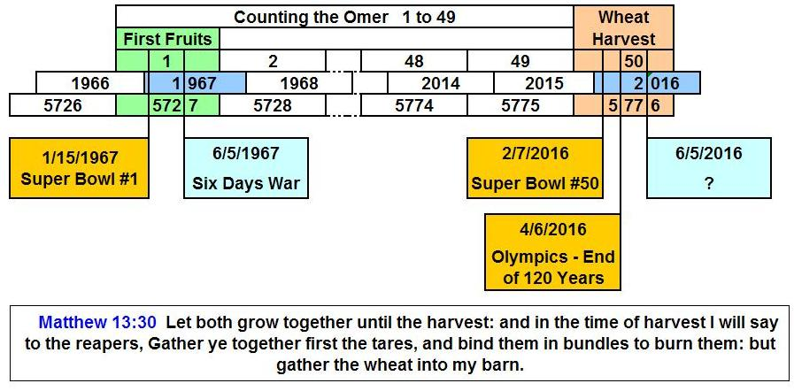

The Fictional Mighty Ones

On 3/25/2016 the movie “Batman vs Superman” was released. Note that for the first time in movie history, this movie pits one super hero against another super hero. This relates to the account in the book of Enoch concerning the fallen angels who would fight against each other in the last days. Note also that the release is in the 2016 “year of return”.

Please be aware that the book of Daniel chapter 10 indicates that there are angelic powers in control of the various nations. An angel had to fight with the angelic prince of Persia on his way to deliver a message to Daniel. Upon leaving Daniel, he said he would have to deal with the angelic prince of Grecia.

The fallen angelic powers now governing the various nations encourage war and hostilities among the humans under their charge. Because many of these biblically related timelines are expiring in 2016, and in the months ahead, please don’t be surprised if we see world war, and worse.

The Arches of Baal

Replicas of the Arch from Syria’s Temple of Baal are being constructed in London and New York City in April, 2016 for World Heritage Week. The International Day for Sites and Monuments is 4/18/2016.

The day for pagan child sacrifice is April 19 each year. Remember that 19 children under the age of 16 were burned to death at the hands of Bill Clinton on 4/19/1993 in Waco, Texas. Religious leader David Koresh had observed Passover and the Feast of Unleavened Bread with his congregation one week earlier. April 19, 1993, was also Yom HaShoah, Holocaust Remembrance Day, in Israel.

