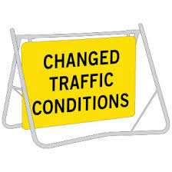
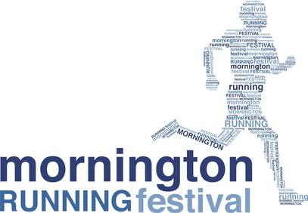
PUBLIC NOTICE:
FUN RUN EVENT IN MORNINGTON/MT MARTHA
Community Fun Run Event raising money for many charities for 12 years now

When: Sunday 3 May 2026
What: Mornington Running Festival www.morningtonrunningfestival.com
As a result, there will be:
- Approximately 5000+ athletes, supporters, family and friends in the area over this weekend
- Competitors of all ages on The Esplanade
- Closure of Northbound lane (beach side lane) on the Esplanade (between Main St and Bradford Rd)
- Closure of Southbound Lane on the Esplanade (Wilson Rd Roundabout to Coolangatta Rd)
- Traffic Management Control by Miepol Traffic Control and Event Management by Event People
EVENT DETAILS
The Mornington Running Festival is now in its 12th YEAR which attracts participants from all over Australia (+international visitors). It consists of a 5km Run/Walk, 10km Run, 21.1km Half Marathon, and a Kids 1km Dash, raising money for many charities. This event will deliver a major economic benefit to the area, and we are excited we have been able to share this with the Mornington Peninsula local community for the past 12 years. Detailed maps and information can be viewed on the website www.runthepen.com.au
CHANGED TRAFFIC CONDITIONS / ROAD CLOSURES
To ensure the event is run safely, there will be changed traffic conditions along The Esplanade (Mt Martha to Mornington) with some partial and full road closures on Sunday 3 May 2026

Road | Section | Type | Road Closed | Road Opened
The Esplanade  Mornington - Mount Martha | Closed between  Main St (Mornington) to Bradford Rd, (Mt Martha) | Northbound Lane on the Esplanade (beachside lane) | From 6.00am  Sunday 4 May | Reopens 10.00am  Sunday 4 May
The Esplanade  Mornington - Mount Martha | Between Roundabout (Wilson/Barkley Rd) to Coolangatta Rd | Southbound Lane on the Esplanade | From 6.45am  Sunday 4 May | Reopens 9.00am  Sunday 4 May

ACCESS IN AND OUT OF YOUR PROPERTY
Occupants (residing on the Esplanade) who are affected by these road closures will still have Full Access in and out of their properties during these road closures. You will only be able to turn left via your property onto The Esplanade during the event. To re-enter your property during these closure times you must turn onto The Esplanade via a northern street/road and turn left onto The Esplanade and head South to your property entrance. Please only do so when safe. Traffic controllers and volunteers will be present at all times to assist pedestrians and residents if and when required.
Please contact us on event day (Event Control number below) if you have any issues during event.

MARSHALL OPPORTUNITIES
Want to get involved in our event? We are searching for enthusiastic members of the community to join our Volunteer Crew. No experience is required. To find out more please contact us at email info@eventpeople.com.au.
If you have any questions regarding traffic management or the event, please contact Event People on 5988 4040 or email info@eventpeople.com.au

Thank you for your continued support and cooperation.

Pre event Contact: 03 59884040 During Event Contact: Event Control – 0458151306

