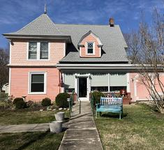
Kent Island Federation of Arts, Inc.
405 Main Street, Stevensville, MD 21666
410-643-7424|arthousekifa@gmail.com | www.kifa.us​​​
9th Annual …
Paint Kent Island
May 13-16, 2026

Welcome to the Kent Island Federation of Arts plein air event where artists paint the scenic harbors, marshes and historic sites of the Chesapeake Bay region here on the Island.
“En plein air” is a French expression that means “in the open air” and is used to describe the art of painting outdoors. Plein Air events take place wherever the scenery is inspirational and artists congregate to paint and patrons gather alongside to see beautiful art created right before their eyes.
This is a four-day event. Paint all day Wednesday through Friday and top it off with the Quick Draw on Saturday morning. Both parts of the event are followed by awards and a wet paint sale, and a reception for artists and patrons will take place on Saturday evening with food and live music.

Be a part of the event!! Non-painting art lovers are invited to the reception or you can just come down during the week to enjoy the town of Stevensville and see how many artists you can spot! No registration required.

Artists can register online, stop in, or call the Kent Island Federation of Arts.

Entry Fees:
$45 Individuals … includes participation in the Quick Draw Competition on Saturday
$40 KIFA Members
$10 Quick Draw Only

Name________________________________________________________________________
Address __________________________________ City_______________ Zipcode _________ Phone ___________________________ Email _______________________________________
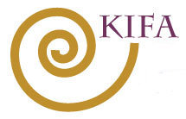
Amount _________________________ Check / Cash / Charge

Register Online at www.kifa.us
Contact Us at arthousekifa@gmail.com, or call (410) 643-7424
Pamela Chase, Chair pjchase1@verizon.net

