10/13/2017 The 8/21/2017 Solar Eclipse Report

My wife and I traveled to southern Illinois to experience the total solar eclipse of 8/21/2017.

We live in northern Michigan and the shortest route (650 miles) for us to view the eclipse in it's totality took us precisely to southern Illinois where the next total solar eclipse on 4/8/2024 will cross the path of the 8/21/2017 eclipse.

I had planned to stop at a Rest Area along I-57 in the path of totality so the there would be toilet facilities available if needed. About 200,000 people were expected to visit the Carbondale, Illinois, area to view the eclipse.

We arrived at the Rest Area on Interstate 57 south about 7 miles south of the path of totality and pulled into the one and only parking space left. The Rest Area was filled with cars. There were tents in the grass near some of the cars where people had spent the night camped out.

It turned out the Rest Area was a good choice to view the eclipse as the toilet facilities weren't overwhelmed by the 200 or so people there, and being only 7 miles south of the centerline of totality meant that we had 2 minutes and 39 seconds available to view totality out of the 2 minutes 42 seconds maximim available on the precise centerline.
We were located on ahill and could see the moon's shadow approaching from the northwest as it raced across the ground at over 1,000 miles per hour.

About 3 minutes before totality the crickets began to chirp as the sky darkened.
When totality came we were able to look directly at the sun. At our location the sun was about 61 degrees high above the horizon, high in the sky. The planet Venus was brightly visible off to the west.

Along with totality there appeared in the sky overhead 2 red lights accompanied by 2 flashing green lights. At first I thought it was a helicopter, but there was no motor sound, just the crickets chirping. The red and green lights disappeared when totality ended. I assume it was a drone being used to perhaps observe the effects of the eclipse from above.

Below is a picture of the eclipse during totality:

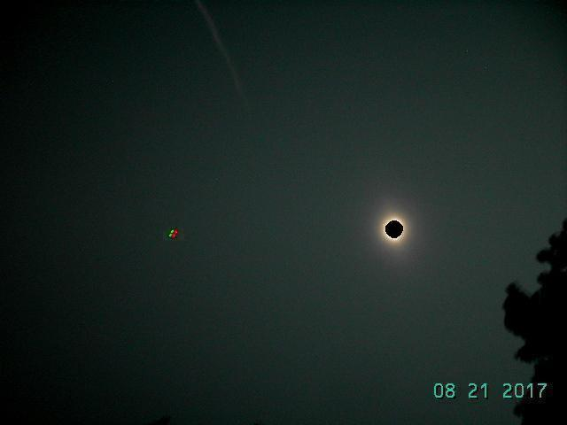

Above: The red and green lights of a silent stationary drone suddenly appeared at the beginning of totality and disappeared when the sun poked out from behind the moon 2 minutes and 39 seconds later.

It turned out that the choice of the Rest Area along I-57 for a viewing place was the right decision, as the eclipse totality period was obscured by clouds for tens of thousands of people who had gathered 15 miles north in Carbondale to observe the eclipse. Our skies at the Rest Area remained clear with just a bit of faint haze, allowing good viewing of the entire eclipse.

During the latter half of eclipse totality, which marked the precise astronomical beginning of the Hebrew month of Elul, I sounded the ram's horn shofar to announce the beginning of the new month.

Because this particular solar eclipse is the first of a pair that places an "X", an ancient Hebrew Paleo Tav end mark, on the United States, angelic beings were also summoned at the blowing of the shofar.
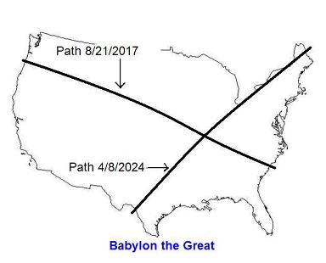

Our Rest Area viewing location was just about 15 miles from the exact point on the map where the center path of the solar eclipse of 4/8/2024 will intersect the center path of the eclipse of 8/21/2017. The path of totality of the 4/8/2014 total solar eclipse will also pass over the same Rest Area location we viewed the 8/21/2017 eclipse from.

A Strange Happening

A strange thing happened on the way home to northern Michigan. We were travelling north on route 131 and I hadn't seen the signs for Big Rapids and was wondering how far it would be before we would pass by the town. I saw a sign for Kalkaska as we entered a small town and pulled off to look at the map to see how far it would be to Big Rapids.

I was surprised to see that Kalkaska was far north of Big Rapids, about 82 miles north of Big Rapids to be exact. I had planned to pass by Big Rapids and exit Rt. 131 onto Rt. 55 near Cadillac. Somehow I had missed the signs for Big Rapids and Cadillac and our turn off at route 55. I have absolutely no memory of driving by Big Rapids or Cadillac or Rt. 55. Somehow at least 82 miles of road are missing from my memory.

After arriving home I looked at a map and saw that it was 36 miles on Rt. 131 from our planned turn off near Cadillac at Rt. 55 to Kalkaska. Then it was 36 miles from Kalkaska to our home travelling eastward along Rt. 72.

The two 36's and double 36 (72) miles involved and the memory loss concerning at least 82 miles of road from somewhere below Big Rapids to Kalkaska makes me wonder about angelic activity and a translation experience. The 36's relate to ancient Babylon and modern Babylon the great in ways mentioned in previous articles, and this solar eclipse trip relates to the judgment of modern Babylon the great.

I had a previous translation experience noted in a former article. During that experience my footprints in the snow confirmed that as a Christian TV engineer I had been instantly shuttled about 15' up Illinois mountain across from Poughkeepsie, New York, as I rushed on foot up the mountain to get the TV transmitter for Christian broadcaster TBN back on the air precisely at 2:00 PM during a freak early season snow storm on October 4, 1986.

So, I don't know how I could have driven for about an hour and a half (82+ miles) coming back from the solar eclipse of 8/21/2017 and have absolutely no memory of it at all.

As we walk with YaHuWaH Elohim, He will see that His purposes, whatever they are, are implemented in the earth. Nothing is impossible with Him.

