**February 2022 Member Program**

**Denver Art Museum**

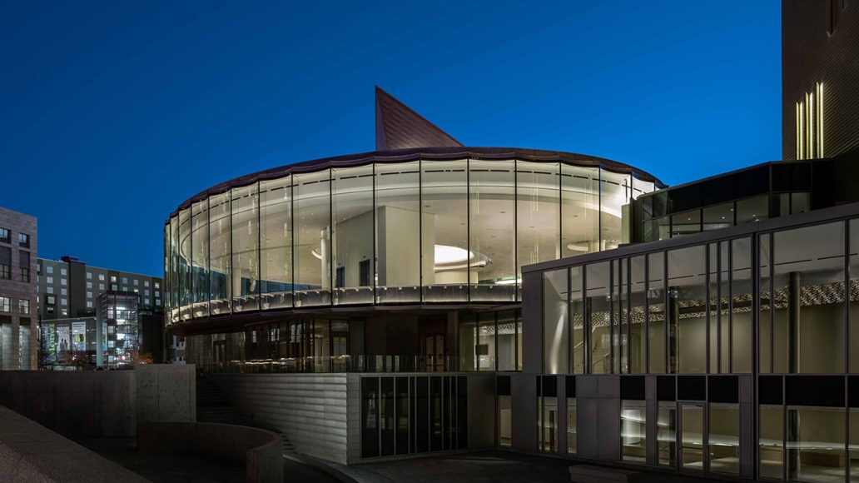

**WHAT: RMGA MEMBERSHIP MEETING –**

**WHEN: February 14, 2022**

**6:00 pm – Networking**

**6:30 pm – Short Meeting**

**6:45 pm – Program: Denver Art Museum**

**WHERE: Via Zoom:** [**https://us06web.zoom.us/j/89426737852**](https://us06web.zoom.us/j/89426737852)

Meeting ID: 89426737852

One tap mobile phone: +17207072699,, 89426737852# US (Denver)

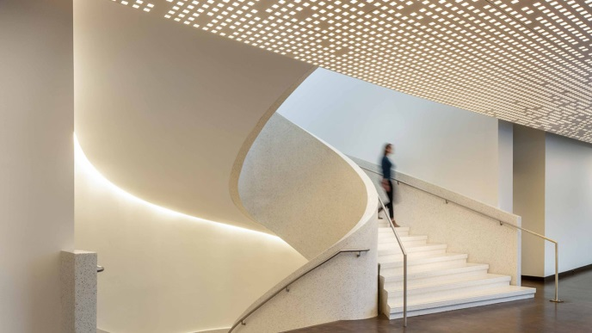**PROGRAM:** Learn about the Denver Art Museum’s collections, programs and upcoming exhibitions as well as highlights from the recently reopened Martin Building. The DAM’s Martin Building project—including the renovation of the iconic Martin Building and the construction of the new Sie Welcome Center—expands the museum’s ability to serve the community, welcome guests to our city, and preserve and present priceless works of art from cultures around the world and throughout history for generations to come.

**GUESTS:** Members are encouraged to invite potential members as a guest to the meeting.

**MEETING NIGHT CONTACT: J. Mark Blaising, Program Chair 303-830-8440 (voice) 303-263-8647 (text)**

