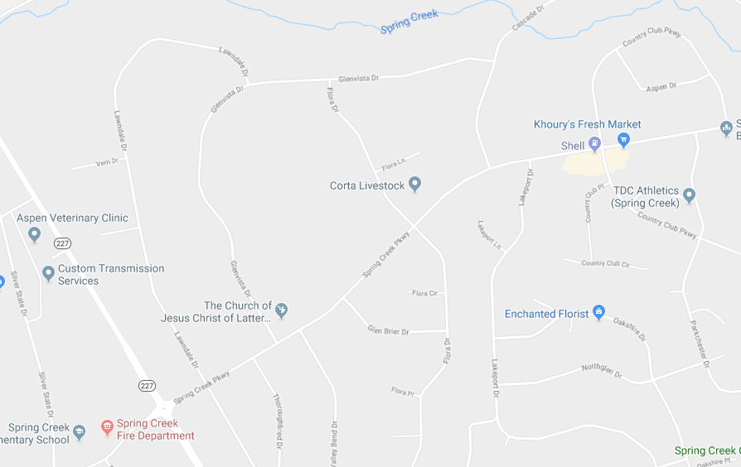
LINE UP
PARADE ROUTE
To Parade Check In
= PARADE CHECK IN = ROAD CLOSED = PARADE ENDS 6/25/19

