Memo to RSAI Leaders with Summary of final Draft of ESSA state plan and Directions on submitting public comment
The last draft of the ESSA plan is now available for review and comment. Special thanks to Bob Olson, Superintendent, Clarion-Goldfield-Dows and Chair, RSAI, and Kevin Fiene, Superintendent, I-35 Community School District, as representatives of the Rural School Advocates of Iowa, for being part of the ESSA Advisory Committee to provide stakeholder input to the DE in developing the state plan.
In the second draft of the ESSA plan, which was reviewed by the Advisory Committee on July 25, the DE had proposed a new Post-Secondary Readiness measure, the percent of graduates who enrolled in an Iowa public college/university who took at least one remedial English or math course within one year of high school graduation. That proposal received some push back by the committee members and others.
The DE states in this draft, rather than moving forward with the Post-Secondary Readiness remediation measure in the plan that has to be submitted on September 18, they will spend the 2017-18 school year developing an index of Post-Secondary Readiness. They plan to work with both experts and key stakeholders to define it and then, scale it up over time.
How to submit Public Comment (deadline September 11, 2017:
- ONLINE. Access DE’s online feedback form at https://www.surveymonkey.com/r/V27MB78 (DE states this is the best way to provide input for consideration! )
- EMAIL. Send questions, clarifications or general feedback to essa@iowa.gov
- MAIL. Send your feedback via mail to: Iowa Department of Education 400 East 14th Street Grimes Office Building Des Moines, IA 50319-0146 ATTN: Deputy Director David Tilly – ESSA Feedback
The following provides suggested talking points, points out changes to the drafts over time, provides a timeline for implementation, and then details highlights of the plan and where those details can be found in the draft. Please don’t hesitate to ask any questions,
Margaret Buckton, RSAI Professional Advocate
margaret@iowaschoolfinance.com
Some suggested talking points to include in comments:
- Thanks to the DE and the State Board of Education for a rigorous process of including stakeholder feedback and listening to the concerns, especially regarding the post-secondary readiness indicator. The next phase of this conversation will be critical in building consensus. DE and the Advisory Group should make an effort to include career readiness in addition to college readiness indicators.
- RSAI members are appreciative of lowering the N-size for reporting purposes to 10, so that more districts meet a measurable level to avoid being excluded from the state report card while still protecting student privacy. Additionally, RSAI appreciates retaining the N-size at 20 students for accountability purposes so that the measures are valid and reliable.
- Elevation of Student Growth to a higher level of weighting in the accountability index gives credit when due to educators and schools across Iowa working hard every day to educate students who come to school behind their peers. RSAI applauds the importance of growth in our ESSA plan.
- Including the Conditions for Learning index is appreciated, as another way to celebrate schools creating welcoming environments for staff and students and building on the strengths of diversity.
Changes to the ESSA drafts along the way:
- New template was released in March 2017 by the USED was used, requiring less stakeholder involvement, but Iowa’s plan development process stakeholder involvement so exceeds the minimum required.
- Long-term goals: USED requires establishing long-term goals despite our transition to a new state test. The ESSA draft includes initial goals based on Iowa tests which will be administered in Spring 2018, with the 5-year long-term goal timeline beginning in the 2017-18 school year. Once a new test is chosen, there will likely be some transition effort with the goals as appropriate.
- In the second draft, a Post-Secondary Readiness measure was added but has since been revised, planning to define and then scale up over three years.
- The Conditions for Learning indicator, based on the Iowa Youth Survey, will be scaled up over three years, within the ESSA accountability Index, giving districts and the state some time to effectively scale up and implement an annual student survey. One of the challenges will be adapting the survey to apply to third and fourth grade students with potential companion staff and parent/guardian surveys.
- All federal Title program descriptions are now in the draft.
Timeline:
- Public comment on this final draft is due by September 11.
- Final draft will be submitted to USED on September 18, 2017
- USED has 120 days to review
- The 2017-18 school year is Iowa’s transition year.
- The implementation of Differentiated Accountability and Supports across identified schools will begin in 2018-19.
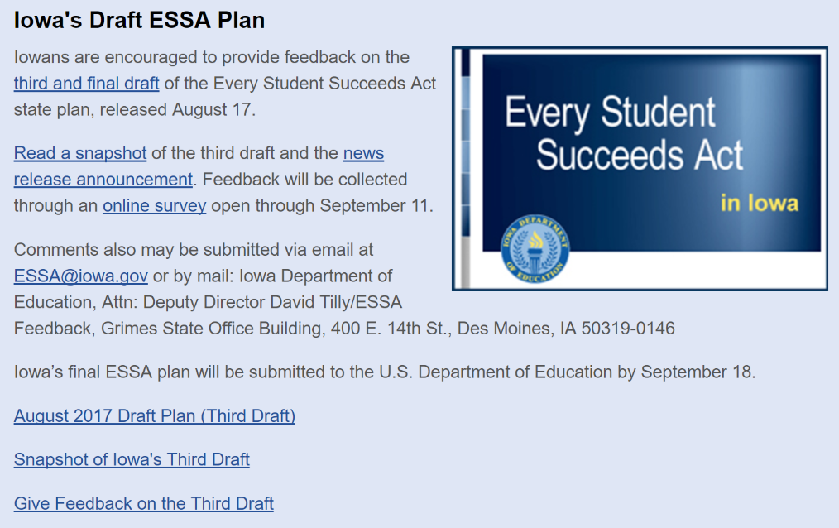
- The new State Assessment RFP was released prior to the July 1, 2017 deadline. The Iowa DE will review proposals, release a decision, issue a contract, and deliver training for the new Assessment during the 2017-18 school year. The New Statewide Summative Assessment will be implemented during the 2018-19 school year.

The Iowa DE has a web page dedicated to sharing information about and gathering feedback concerning development of Iowa’s ESSA plan. Find it here: https://www.educateiowa.gov/pk-12/every-student-succeeds-act (the following picture shows that page, but is just a pic, so links are not active.)

Page 9 of the Draft plan includes a table describing the Unified Differentiated Accountability and Support System.
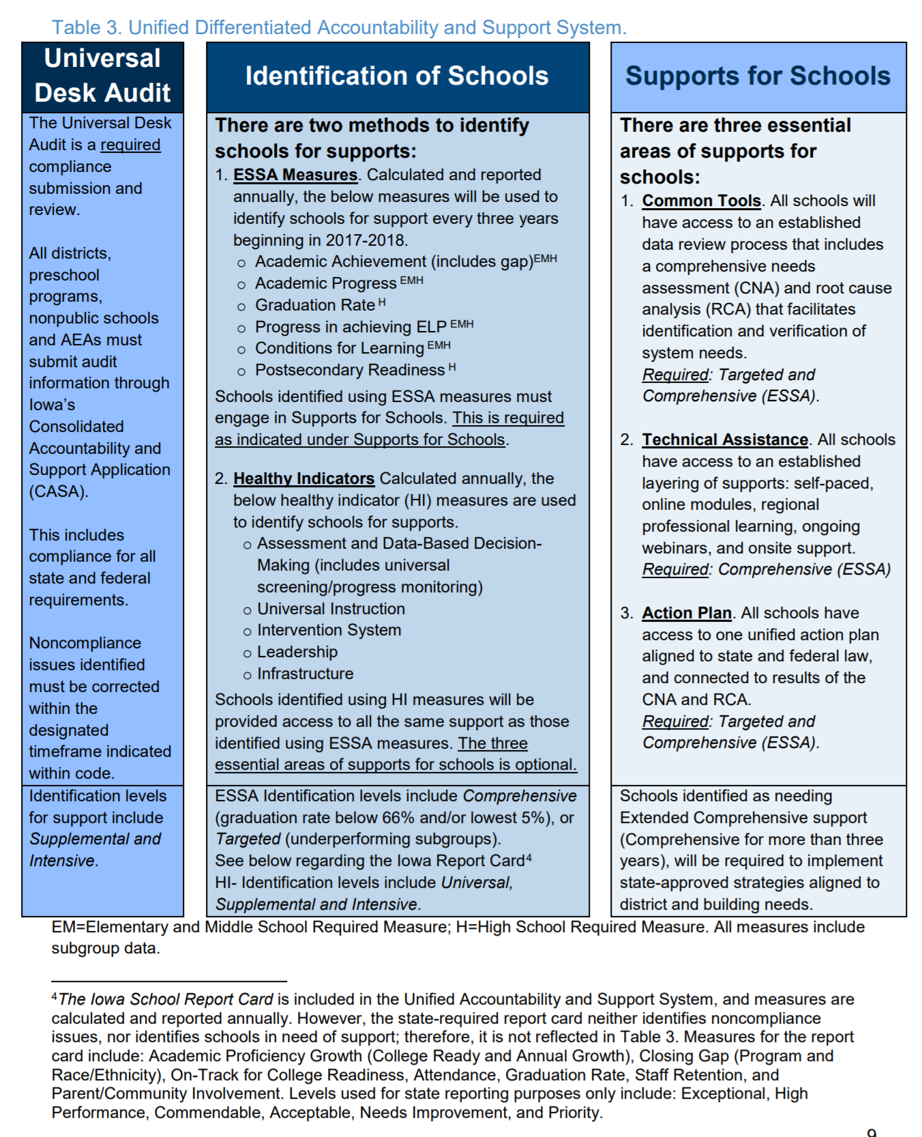
Page 36: Iowa’s plan uses an N-size of 20 for accountability purposes (which is the number chosen based on validity yielding a statistically reliable result) and an N-size of 10 for public reporting purposes to protect the identify of individual students.
Page 37-38: The ultimate goal is that all students and subgroups are proficient or higher in reading and mathematics. The long-term goal in reading and mathematics is that all students will increase percent proficiency by half a percent each year over five years and sets a higher expectation that all subgroups will grow one percentage point in proficiency rate per year over five years. The difference in these two goals is aimed at closing the gap. DE describes these goals as ambitious since “Iowa’s proficiency has flat-lined in reading and mathematics, regardless of subgroup and grade.”
Page 41: Long term goal for graduation rate, for the four-year adjusted cohort, is 95% for all students and for subgroups. On page 42, Table 7 shows the plan for the five-year adjusted cohort at 97% for all students and for subgroups.
Page 42: English Language Proficiency: Iowa’s plan includes a goal of 1% increase in proficiency per year, for a long-term goal of 23.7% proficiency on the ELPA21 assessment (Baseline of 18.7% in 2015-16)
Page 44: Academic Achievement Indicator includes average scale score, proficiency and progress (student growth percentile)
Page 46-47: Descriptions of student growth using student growth percentiles and the thinking on the post-secondary readiness index, including some proposed indicators for expert and stakeholder consideration (Concurrent Enrollment, Post-secondary Enrollment within one-year after graduation, Post-secondary remediation in math and reading, Successful completion of 15 credits or receipt of an award within the first year of enrollment.) Also included is the timeline for developing the index and scale up plan.
Page 50-53: School Quality or Student Success Indicator is the Iowa Youth Survey Conditions for Learning, which measures the three domains of Safety, Engagement and Environment. The scale up begins with grades 5-12 in Spring of 2018. Grades 3-4 for will added in the 2018-19 school year.
Page 53: Outlines how the DE will use all of the above indicators to meet the federal requirement of annual meaningful differentiation (identification of schools needing Comprehensive Support and Improvement. Step one is based on graduation (>66% or in the bottom 5% for all students), Step two is targeted based on subgroups, Step three is public reporting of the ESSA accountability index results of all schools in the state, and Step four is Support provided to schools identified as in need of comprehensive or targeted support and improvement.
Page 57: Table 14 details the ESSA Indicators and Weights for the Accountability Index. Note the increased weighting of the Student Growth measure relative to Academic Achievement (proficiency and scale score) Picture of Year 1 measures and weightings follows:
