On August 2nd the Alex Eligh Community Center Park Program held its end of season event at Perkins Park. In addition to food and friends, it included an inflatable bounce house, water slide and plenty of games and smiles.

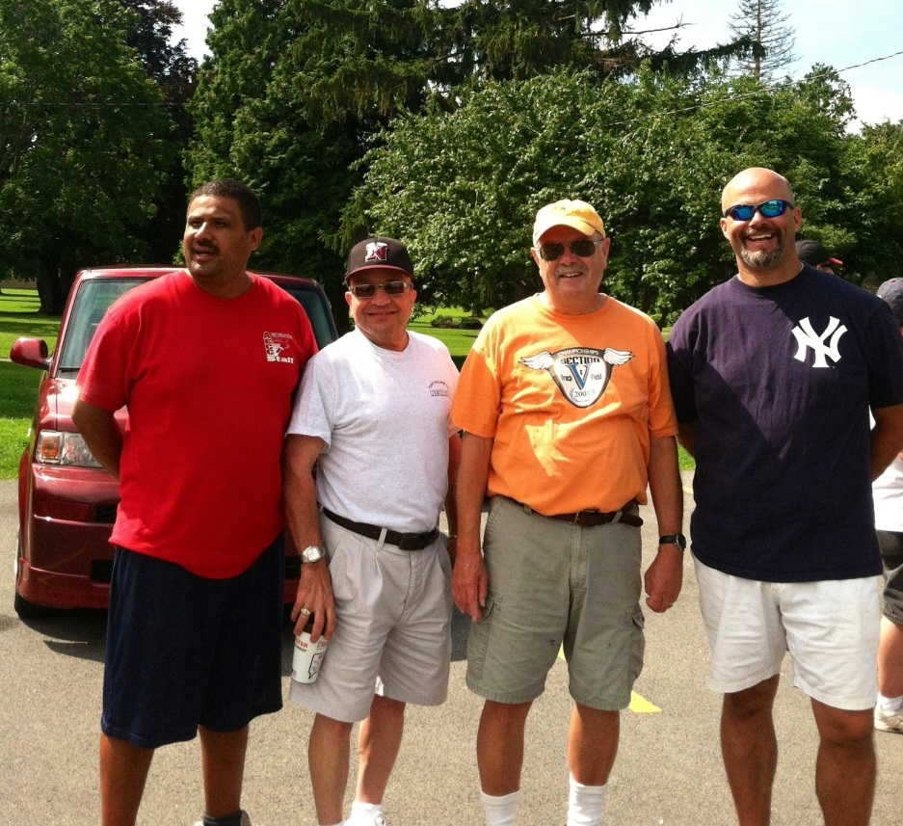
Jorge Bueso, Mayor Blandino, Trustee Werts, and Judge Mike Miller
enjoying the festivities.

