1199 Lilac Street, Broomfield, CO 80020 303 438 1936 fredmsd@aol.com

Fred T. Martin

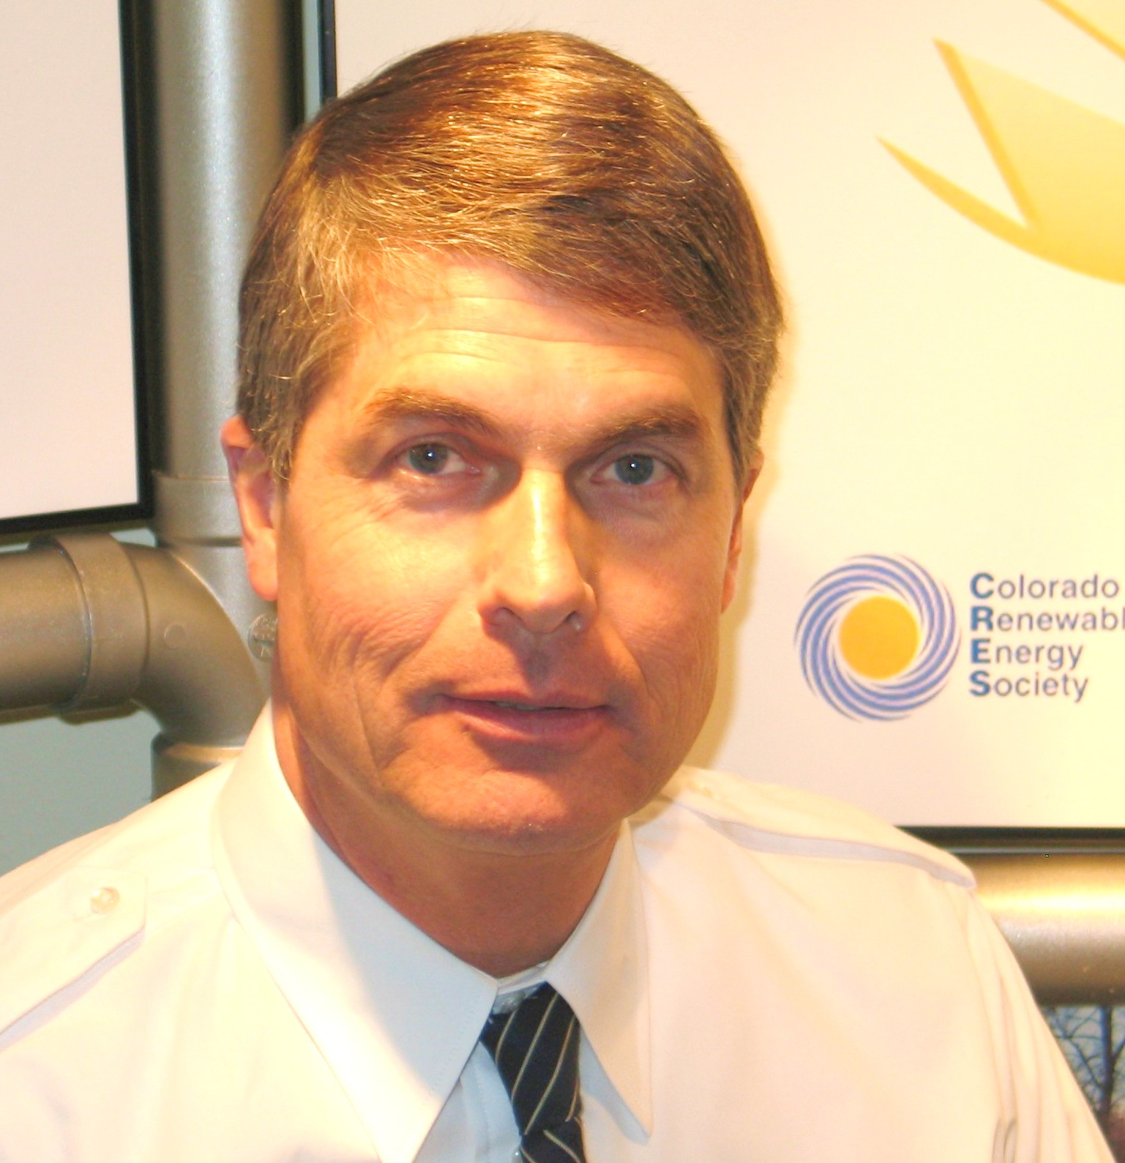

Career History & Professional Endorsements

PROVEN EXPERTISE: Marketing of Business Opportunities, Professional Services and Technical Products to individuals, industry and all levels of government; Sales Management; Sales Training; Seminar & Webinar Designer & Presenter; Computer Marketing and Management Systems.

CERTIFIED in INTERNET & SOCIAL MEDIA MARKETING:

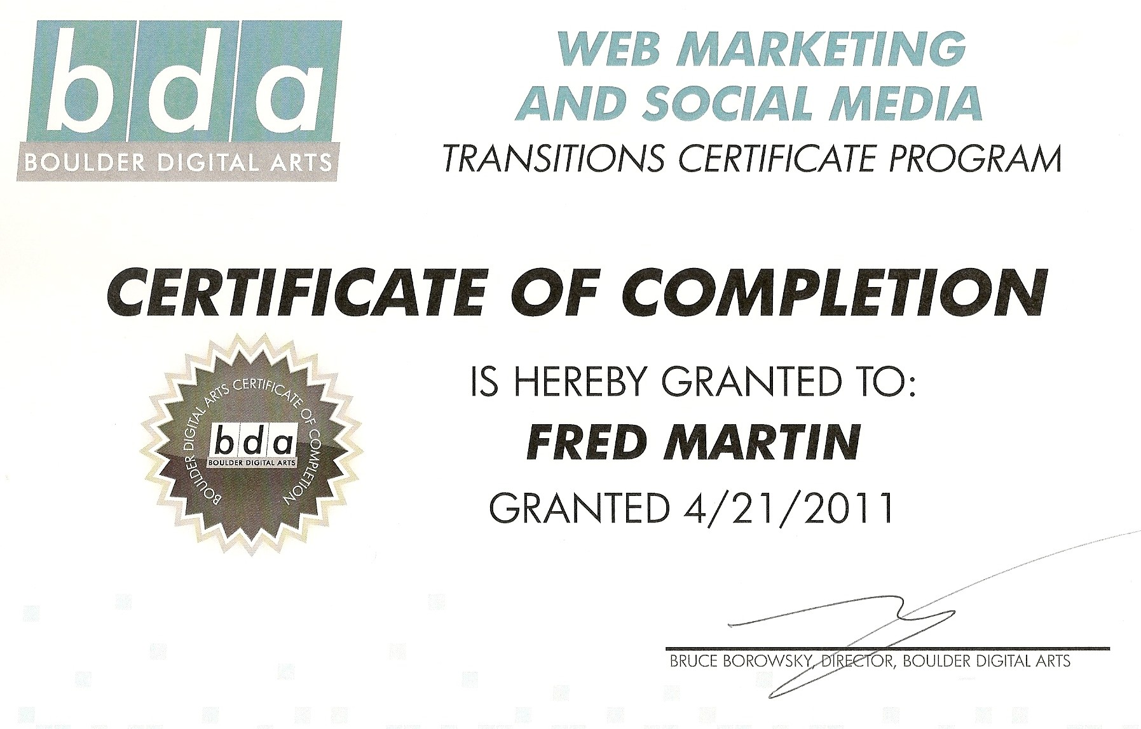
Personal / References web site:

RECENT EXPERIENCE:
Currently, Sales and Marketing Manager for Bentley Wellness Technologies,\
Denver, Colorado. www.BentleyBaths.com
In-Home Sales and sale closing; Event lead generation; Web site marketing programs; Strategic Planning; Presentation Developer.for aging-in-place comfort and safety systems.

PRIOR EXPERIENCE:
1996 to 2015: Independent Contractor Representative for Press-A-Print International,
Idaho Falls, Idaho. www.pressaprint.com
Home-Based Business Opportunity. Consistently in the company's "24 Carat Club" working 20 to 24 trade shows per year in the U.S, and Canada. Designer of the company’s main marketing programs, including Seminars, Webinars, Web Site capture page & video content, and Sale Closing Procedures, with supporting ad programs, promotional videos, and complete on-line marketing content.
Speaker; Trainer; Writer on success and motivational topics for clients and sales representatives.
“Some approach marketing business opportunities as a life commitment and a genuine chance to help others and really make a difference in people’s lives. Fred is the ultimate example of this and his sales numbers bear this out . . . . what emerges from his sales development work is a glimpse of the brilliance of this man.”
Jay Hebdon, National Sales Manager, Press-A-Print International

2008-2010 Astralux (in a consulting stint) and prior, 1981 to 1986: First American Solar,
Denver, Colorado:
Management Consultant in the later period; before: Top Producing Salesman among 60 in three states. Salesman Of The Year, 1985. Sales Manager. Owner and General Manager of the Longmont, Colorado dealership producing $2.2MM in sales as the company’s top-producing office.
“Fred was our top salesperson until he was surpassed by the pugnacious Anthos Jordan. When the two of them joined forces and requested their own dealership demanding that we waive our $25,000 franchise fee, we had no choice; we couldn’t risk losing them. So we gave them what we considered to be a low-value, back water territory, Longmont, Colorado. That year Longmont became our largest selling dealership. I never imagined that almost 25 years later I would want to re create First American for the 21st century solar energy boom, yet when I did, it was Fred I recruited to develop our marketing programs.
John Homburger, President and Founder, First American Solar, Denver, Colorado

1993 to 1996: Marketing Consultant and Sales Trainer for Moore And Company, Denver, Colorado Denver’s largest commercial and residential real estate firm at that time.

“I want to thank you for the wonderful professional service you gave our customers and clients. You added so much to our reputation and development while you were here”.
William M. Moore, CEO, Moore And Company, Denver, Colorado

Fred Martin

Page 2

PRIOR
EXPERIENCE:
Continued

1989 to 1993: Marketing Manager, Environmental, Health Sciences and Radiological Services Division; Intermountain Region, Dames & Moore,
then a firm with over 1600 practitioners and offices on 5 continents.
Wrote and published a number of articles in environmental technical and trade journals; Landed contracts for environmental assessments with school districts, Federal Government agencies and commercial clients.
“Mr. Martin developed a professional and energetic marketing approach along with the project management systems needed to carry out large assessment projects. As a result, Dames & Moore has been one of the largest providers of environmental assessment and diagnostic services in Colorado, for school districts, commercial workplaces and public access buildings”.
Steven H. Brown, CHP, Division Manager, Dames & Moore

1986 to 1989: National Marketing Manager: RDS Environmental, Boulder, Colorado.

Hired at company start-up, member of a staff of 4. When I was recruited by Dames & Moore three

years later, RDS had agents in all 50 States and 3 in Canada, and was one of the nation’s largest

environmental home inspection companies. Wrote technical articles published in environmental and

real estate industry journals. Developed technical protocols for U.S. EPA for radiological assessment.
“Mr. Martin has been instrumental in securing and servicing our major national accounts. His work with the Relocation Industry, risk managers and corporate policy makers across the U.S. has secured our market position.”
And this: “Losing you to Dames & Moore cost me hundreds of thousands of dollars”.
Loren E. Smith, President, RDS Environmental, Boulder, Colorado

1983 to Present: Assistant to the Manager in charge of raising high-achieving women.
Daughter Elan: Master’s degree from George Washington University, now: Executive Health Care Policy Administrator for the U.S. D.O.D. Tri-Care Administration.
Daughter Dana: Graduate of the University of Iowa, now: Asst Vice President for General Electric. Daughter Alexa: Graduate student; Occupational Therapy; Creigton College, Omaha.
Daughter Cherie: Portland State University, Political Science.
“Mr. Martin did a passable job as a father considering the daunting challenges he faced. We did lots of traveling and camping and flying around in Cessna airplanes, and he paid a lot of college tuitions.”
Elan Martin
“Best Daddy in the world.”
Cherie Martin

EDUCATION: Bachelor of Science, Environmental Conservation and Engineering,
University of Colorado, Boulder, 1980.
Married to the lovely Glenna Jean FAA Private Pilot
Aviation Author / Museum Presenter / Researcher on WWII aviation topics
Various Federal inspector certifications pertaining to hazardous waste, radon
assessment and asbestos. D.O.E. certified “UNCNI” nuclear facilities security clearance.
EPA Certified for radon assessment and mitigation engineering Health: Excellent Active Member: Lutheran Church of Hope, Broomfield, Colorado
Active mountaineering and mountain bicycling enthusiast.

CREDIT RATING: February 2015: Experian: 799 Equifax: 811 TransUnion: 811

Complete Reference Portfolio and Published Article Reprints upon request

