New Patient Intake Form

Name: Date:
Address: DOB:
City, State, Zip: Home phone:
Email: Cell:
Occupation: Work phone:
Emergency Contact: (name & phone)
Referred by: Have you had acupuncture/herbal medicine?
Reason for today's visit:
How long have you had this condition?
What other treatment have you received for this condition?
Please list your family physician & phone number:
Allergies:
Height: Weight:
Family History: (mark all that apply)

Arteriosclerosis | Cancer | Hypertension | Asthma
Diabetes | Seizures | Alcoholism | Heart Disease
Stroke

Your Past Medical History: (mark all that apply)

Aids/HIV | Pacemaker | Alcoholism | Rheumatic Fever
Cancer | Thyroid Disorders | Diabetes | Tuberculosis
Emphysema | Arteriosclerosis | Food allergies | Kidney or Gallstones
Multiple Sclerosis | Stroke | Ulcers | Fractures
Epilepsy/seizures | Venereal Disease | Heart Disease | Seasonal allergies
Hypertension | Hernias | Herpes | Hepatitis

When was your last physical?
List any major traumas?
Major Surgeries:
Have you had a colonoscopy? Yes / No An EGD? (for upper digestive tract) Yes / No

Please list your current daily medications / supplements:

Please describe your average daily menu:

Breakfast : Lunch: Dinner:

Coffee | Tea | Sugar | Artificial sweetener | Chocolate

Do you want information on nutritional counseling to create a healthier lifestyle?
Yes | No | Not at this time

History of Pain

0 = none | 5 = moderate | 10= severe
Please rate your pain below using the scale:

- 1 2 3 4 5 6 7 8 9 10 (circle one number or the range)

Please describe your pain. (mark all that apply)

Stabbing/sharp | Dull/aching | Numbness/tingling | Throbbing
Spasm | Burning | Heaviness | Pulling/tight
Fixed Location | Moves around | Pain is constant | Pain comes & goes
Worse in morning | Worse end of day | Worse at night | Better w/movement
Worse w/movement | Interrupts sleep | Worse sitting | Worse standing
Worse lying down | Worse lifting/grasp | Worse w/pressure | Better w/pressure
Better w/heat | Better w/cold | Worse walking | Worse driving

PLEASE MARK THE LOCATIONS OF YOUR PAIN ON THE MODEL BELOW:
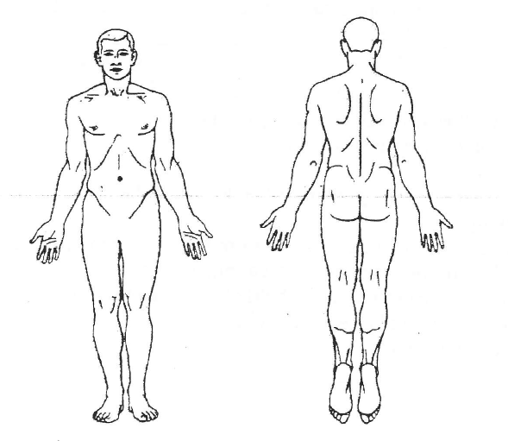

Please check all that apply

Respiratory
Cough | Short of breath | Asthma | Chest tightness
Difficult inhale | Difficult exhale | Sneezing | Sinus congestion
Nasal congestion | Sore throat | Frequent colds | Loss of voice
Weak voice | Hoarse voice | Other

Dizziness
Standing up | Severe, loss of balance | worse w/fatigue

Sweating
Spontaneous | Night | Daytime | Hands & feet
Only head | Only arms/legs | Only hands | Only feet

Head/eyes/ears/throat
Headaches | Frontal | Temple | Back of neck
Top of head | Whole head | Frequency? | Migraines
Bleeding gums | Mouth sores | Tongue sores
TMJ | Ringing in ears

Gastrointestinal
Poor appetite | Gnawing hunger | Stomach rumbling | Indigestion
Acid reflux | Nausea/vomiting | Belching | Gas
Bloating/distention | Abdominal pain | Stomach pain | Intestinal pain
Bad breath | Diarrhea | Constipation | Laxative use
Rectal pain | Hemorrhoid | Bitter taste | Always hungry
Sticky sweet taste | Other

Bowel Patterns
Frequency: ___________________________________
Please describe the stool: (mark all that apply)
Soft & formed | Loose pieces | Hard dry | Pebbles
Alternates | Foul odor | Black, tarry | Blood streaked
Stool floats | Other

Urine patterns
Frequency: _________________________________________
Urgency | Pain/burning | Scant amount | Too frequent
Dribbling | Blood in urine | Yellow | Clear
Dark | Cloudy | Incontinent

Cardiovascular
High blood pressure | Low blood pressure | Palpitations | Chest pain
Dizziness | Irregular heartbeat | Rapid heart rate | Sweat easily

Sleep
Easy to fall asleep | Sleep through night | Difficult to wake up
Difficulty falling asleep | Difficult staying asleep | Vivid disturbed dreams

Up during the night ? Yes / No
If Yes then:
Frequency:
What wakes you?:
What time?

Energy level

0 = no energy | 10= running a marathon
Please rate your energy level below using the scale:

0 1 2 3 4 5 6 7 8 9 10 (circle one number or the range)

Fatigue | Fatigue on waking | Body feels heavy
Limbs feel heavy | Fatigue, sleepy after eating

Neuro

Tics | Trembling | Poor memory | Fuzzy thinking
Indecisive | Nervous | Frequent sighing | Easily startled
Depression | Anxiety | Easy anger | Easy irritability

General symptoms

Thirsty all the time | Thirsty but don't drink | Prefer hot drinks only
Prefer cold drinks only | Feel too full to drink | Feel weak, lack of strength
Feel hot mostly | Feel cold mostly | Cold hands/feet
Hot hands/feet | Hot flashes | Feel warm in the evening
Bleed, bruise easily | Nosebleeds | Varicose veins
Dry skin | Itchy skin | Dry scalp
Dry hair | Teeth feel dry | Sticky saliva
Dry mouth | Psoriasis | Eczema
Acne | Rashes | Lymphatic swellings
Nodules, masses | Boils, carbuncles, sores | Hair loss
Easily cracked nails | Nail ridges | Facial edema
Warm in head/chest/neck | Feet swell | Overall edema

Cravings (mark all that apply)

Sweet | Salty | Sour
Spicy/hot | Bitter | Chew ice

Pain issues (mark all that apply)

Muscle spasms | Numbness/tingling | Head/neck | Upper body
Neck tight/tense | Chest | Below the sternum | Along the ribcage
Stomach | Abdominal | Groin | Leg/foot/ankle
Joint pain | Low back | Knee soreness | Bone pain

Social

Single | Partnered | Divorced
Abuse survivor | Considered/attempted suicide | Seeing a therapist

Your lifestyle: (mark all that apply)

Alcohol | Marijuana | Stress
Tobacco | Drugs | Occupational hazards

Regular exercise: frequency:
Type frequency:

For Men: (mark all that apply)

Impotence | Nocturnal emission | Premature ejaculation
Increased libido | Decreased libido | ED

When was your last prostate exam?

Gynecology for Women:

Age menses began: Length of cycle: Duration of flow:
# of Pregnancies: # Live births: Premature births:
Date last period began: Date of last PAP: Age at menopause:

Irregular periods | Painful periods | PMS
Small clots | Large clots | Hot flash/night sweats
Increased libido | Decreased libido | Vaginal discharge
Frequent yeast infections

When was your last complete pelvic exam?

Other:

Thank you for completing the questionnaire.

