2026 Sha-Mel-Lon Recreation Center Rental Information

The pool is available for event rentals for members.
To check availability email Jackie Alverson at shamellonevents@gmail.com

Rental Fees and Deposits (please initial):

- $50 Cleaning Deposit - Due when rental is reserved. Deposit will be refunded by check within 5 days after the event, if clean up was done appropriately and there were no rules violations.

_________
- $150 Rental Fee (SML Member):
Rental includes shared use of the pool and exclusive use of the pavilion/picnic tables for 2 hours. Fee is for up to 30 guests. Each additional guest is $3 per person. Please Note: This is not a private pool rental and Sha-Mel-Lon Recreation Center Members will be permitted to use the pool facility.

______________
Fees are due 5 days prior to the event. Failure to remit payment 5 days prior to the event will result in cancellation of the event without deposit refund.

All Events must end by 8:00PM.

Event guests are expected to be respectful to all members enjoying the pool. Host must be available via phone at all times.

Event host is responsible for the clean up of all facilities used during the event, including but not limited to: emptying trash, removing decorations, returning any moved furniture to it’s original area, removing all personal belongings, etc.

Lifeguards are strongly recommended and suggestions may be available upon request. Please note that all suggested lifeguards set their own fees and all payment will be paid directly to them. Sha-Mel-Lon Recreation Center Inc is not responsible or liable for any lifeguard event host hires. Additionally, if the host waives the presence of a lifeguard they agree to be responsible and liable for any situation that could and might occur while swimming. Sha-Mel-Lon Recreation Center, LLC waives all responsibility and liability.
2026 Sha-Mel-Lon Recreation Center Rental Agreement

Event Date: _____________________________________________
Event Time: _____________________________________________
Host Information:
Address: ___________________________________________________
Phone #: ___________________________________________________
Email: _____________________________________________________

Deposit Fee (due today) $50_______

Rental Fee (up to 30 guests) $____150__

# of additional guests _______ X $3 = $__________
TOTAL AMOUNT DUE $__________

Payment Options:

Checks - Please make payable to Sha-Mel-Lon Recreation Center.

Venmo
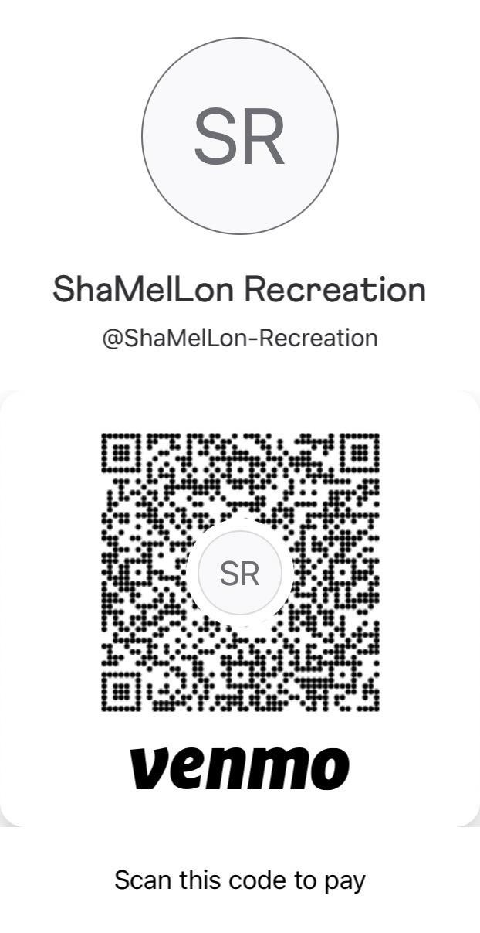
By signing below, the host agrees to all requirements listed both above and the rules and regulations listed on the following pages.

Signature __________________________________ Date_____________
FACILITY RULES / GUIDELINES
- No glass, alcohol, tobacco, or vaping allowed anywhere on the premises. This includes the pool deck, parking lot, tennis courts and green areas.
- No weapons or drugs of any kind allowed on the premises.
- Children under 18 MUST be accompanied by an adult when lifeguards are not present. Parents are responsible for their minor children and should be vigilant, recognizing that drowning can occur in as little as thirty seconds.
- Any unaccompanied minors will be asked to leave the pool area immediately and the event host will be contacted.
- It is recommended that an adult always accompany children, even when a lifeguard is present.
- Children not toilet trained are required to wear securely fitted, waterproof swim diapers. Parents are responsible for keeping sick children out of the pool. Fecal accidents may require the pool to be closed for more than a day depending on the required disinfection procedure. Fecal accidents must be reported immediately to the pool operator. Swimmers must exit the water until it is properly disinfected.
- Pick up all personal belongings prior to leaving as Sha-Mel-Lon Recreation Center is not responsible for anything left unattended or overnight.
- Dispose of all trash and waste in provided trash bins.
- Please close any open umbrellas prior to leaving the facility.
- Music is permitted but please be respectful of our neighbors who reside nearby. Remember that we are a “radio-edit” friendly Center. If it’s NSFW, it’s NSFSML. Excessive noise complaints may result in the host and all guests being asked to leave and therefore forfeiting all fees and deposits.
- If you notice anything out of place or broken please contact the Board immediately.
- A phone dedicated to 911 emergencies is located on the wall between the bathroom entrances. This phone is strictly for emergency use. Non-emergencies should be reported to the pool committee via email at shamellon@gmail.com.
- Host and all event guests must adhere to listed pool safety rules and regulations. Failure to do so may result in the host and all guests being asked to leave and therefore forfeiting all fees and deposits.
- All swimming is At Risk and Sha-Mel-Lon is not responsible for any injuries or death.
- Security cameras are continuously monitored for the safety and security of the facility and it’s guests.

Sha-Mel-Lon Recreation Center Inc WAIVER AND RELEASE OF ALL CLAIMS AND ASSUMPTION OF RISK

Please read this form carefully and be aware that in utilizing the swimming pool amenities, you will be expressly assuming the risk and legal liability and waiving and releasing all claims for injuries, damages or loss which you, your family members, or your guests might sustain as a result of utilizing any and all amenities connected with and associated with the neighborhood swimming pool. I agree to familiarize myself, my family members, and my guests with the rules of the Sha-Mel-Lon Recreation Center Inc and agree to abide by them. I understand the Sha-Mel-Lon Recreation Center Inc, its

officials, directors, agents, volunteers and representatives retain the right to suspend or expel swimming pool users from use of the swimming pool amenities for failure to comply with the pool rules.

DISCLAIMER CLAUSE

The Sha-Mel-Lon Recreation Center Inc, its officials, directors, agents, employees, volunteers and representatives (hereafter referred to as the “Center”) are not responsible for any injury, loss or damage of any kind sustained by any person while utilizing the Center’s swimming pool amenities, including injury, loss or damage which might be caused by the negligence of the Center.

WARNING! THERE ARE OBVIOUS KNOWN DANGERS INHERENT IN SWIMMING POOL ACTIVITIES. FOR EXAMPLE: DROWNING, NEAR DROWNING, SPINAL INJURY AND IN SOME CASES, DEATH. DESCRIPTION OF RISKS

I recognize and acknowledge that there are certain dangers and risks of physical injury while swimming and using the pool amenities. I also understand that in order to be allowed to use the swimming pool I must give up my rights to hold the Center liable for any injury or damage, which my family members, my guests, or I may suffer while utilizing the swimming pool amenities. I voluntarily agree to assume the full risk of any and all injuries, damages or loss, regardless of severity, that my family members, my guests, or I may sustain as a result of using the swimming pool. I further agree to waive and relinquish all claims against the Center that I, my family members, or my guests may have as a result of using the swimming pool.

INDEMNIFICATION AND RELEASE OF LIABILITY

In return for the Center allowing me to voluntarily utilize its swimming pool amenity, I agree:
1. TO ASSUME AND ACCEPT ALL RISKS arising out of, associated with or related to my use of the swimming pool amenities, even though such risks may have been caused by the negligence of the Center;
2. TO BE SOLELY RESPONSIBLE FOR ANY INJURY, LOSS OR DAMAGE which my family members, my guests, or I may sustain while using the swimming pool amenities, even though such injury, loss or damage may have been caused by the negligence of the Center;
3. TO INDEMNIFY AND HOLD HARMLESS the Center, its officials, directors, agents, employees, volunteers and representatives from any and all claims, demands, actions and costs which might arise out of my use of the Center's swimming pool amenities, even though such claims, demands, actions and costs may have been caused by the negligence of the Center. I understand and agree that this Agreement will have the effect of releasing, discharging, waiving, and forever relinquishing any and all actions or causes of action that I may have or have had, whether past, present or future, whether known or unknown, and whether anticipated or unanticipated by me, arising out of my use of the swimming pool amenity. This Release constitutes a complete release, discharge and waiver of any and all actions or causes of action against the Center. I understand and agree that this Agreement applies to personal injury, property damage, or wrongful death which my family members, my guests, or I may suffer, even if caused by the negligent acts or omissions of others. I understand that there is NO LIFEGUARD ON DUTY and that an adult must accompany children at all times. I understand and agree that by signing this Agreement, I am assuming full responsibility for any and all risk of death or personal injury or property damage suffered by me, my family members, or my guests while utilizing the swimming pool amenity. I understand and agree that this Agreement will be binding on me, my spouse, my heirs, my personal representatives, my assigns, my children and any guardian ad litem for said children. I understand and agree that by signing this Agreement, I am agreeing to release, indemnify and hold the Center harmless from any and all liability or costs, including attorney’s fees, associated with or arising from my use of the swimming pool amenities. I do hereby fully release and forever discharge the Center from any and all claims for injuries, damages, or loss that I, my family members, or my guests may have or which may accrue to me or my minor child/ward and arising out of, connected with, or in any way associated with the swimming pool amenities.

ACKNOWLEDGEMENTS

I acknowledge that I have read and understand the 2026 Sha-Mel-Lon Recreation Center Inc’s Rules and Regulations.

I acknowledge that I have read this Agreement and that I understand the words and language in it. I have been advised of the potential dangers incidental to utilizing the swimming pool amenities. Knowing this and in consideration of being permitted to use the swimming pool, I hereby voluntarily release the Center from any and all liability resulting from or arising out of my use of the swimming pool amenities.

I understand and agree that I am releasing not only the Center, but also the officials, directors, agents, employees, volunteers and representatives of that entity. I have read and fully understand the above important information, warning of risk, assumption of risk and waiver and release of all claims.

I UNDERSTAND THAT THIS IS A LEGAL AGREEMENT. It is binding upon me as well as upon my heirs, next of kin, executors, administrators, assigns and representatives, in the event of my death or incapacity.

I HAVE READ AND UNDERSTOOD ALL THE TERMS OF THIS AGREEMENT, and by signing this agreement voluntarily I am agreeing to abide by these terms.

WARNING - BY SIGNING THIS FORM YOU GIVE UP IMPORTANT LEGAL RIGHTS! PLEASE READ CAREFULLY!

I have read and voluntarily sign this release and waiver of liability and indemnity agreement, on behalf of myself and any representatives, heirs and next of kin.

_____________________________________________________________
Signature (must be over 18 years of age)

_____________________________________________________________
Printed Name

_____________________________________________________________
Date

